Warwick Workshop for Interdisciplinary German Studies
2017-18

All seminars except 8 May 2018 take place on Wednesdays, 5-7pm, H2.44

Term 1

18 October 2017
Godela Weiss-Sussex (Cambridge): 'Das doppelte Martyrium des Weibseins und des Judentums': Femininity and Jewishness in Works by Female German-Jewish Writers in Berlin (1900-1918)

1 November 2017
Katie Stone (Warwick): German Memories of Wartime Rape and the Affective Politics of Cultural Memory

15 November 2017
Carolin Duttlinger (Oxford): Threshold States: Musil, Self-Help Literature and Nachlaß zu Lebzeiten

Term 2

24 January 2018
Pia Deutsch (Warwick): Negotiating Nationhood - Mediating Identity. The Becoming of Germany’s National Radio (1989-1995)

7 February 2018
Alison Gibbons (Sheffield Hallam): Uses and Abuses of Reading Life: Morality, Fictionality, and the Trial of Ahmed Naji

28 February 2018
Helmut Schmitz (Warwick): Die eigentlich humane Leidenschaft’? Adornos und Horkheimer’s Begriff der Liebe in Dialektik der Aufklaerung

Term 3

25 April 2018
Isabelle Hertner (King's College London): (Love’s) Labour’s Lost? Social Democratic Parties and the challenge of European Union membership

Tuesday, 8 May 2018
Donna Harsch (Carnegie Mellon): Infantilizing Mothers -- or Empowering Them? The Fight against Infant Mortality in East and West Germany, 1949-1989
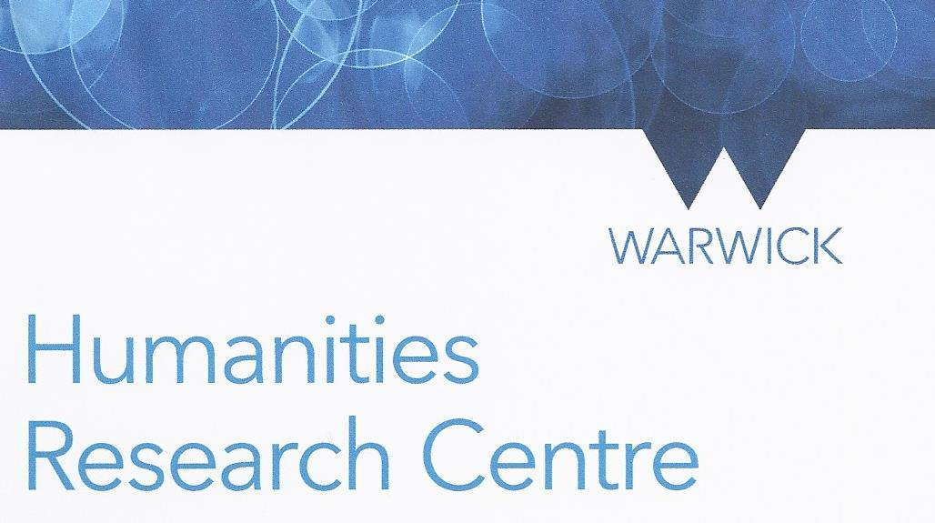
(Special event, co-sponsored with the Center for the History of Medicine)

