MASTER CLASS
What’s Your Problem?
Practical Steps for Designing Your Research Project
Christopher Rea
3:00-4:30pm, Tuesday, April 25, 2023
Venue: FAB2.43
University of Warwick
Please register to attend the talk here.

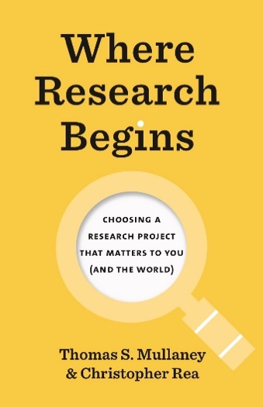
Abstract
What are the best ways to design a research project that is personally meaningful to the researcher, and that matters to the world? The same well-meaning but wrongheaded advice resounds across fields and disciplines. “Narrow down your topic.” “Fill a gap in the literature.” None of us, however, aspires to be a narrow gap-filler. How, then, can each of us discover what we want to research, while also ensuring that our project has broader significance?
Drawing on the new research guide Where Research Begins, Christopher Rea will share specific techniques that any researcher—novice or experienced—can use to escape the deadening realm of TopicLand; to identify a research problem that truly matters to them; and to build a research project in conversation with the broader research community.
Join this interactive session if you have ever:
- Had difficulty choosing a research topic
- Had a topic of interest but been unsure how to turn it into a research project
- Experienced difficulty explaining the purpose of your research
- Felt like your research topic was imposed by someone else
- Wanted to learn new ways to think about how to do research

About the Speaker
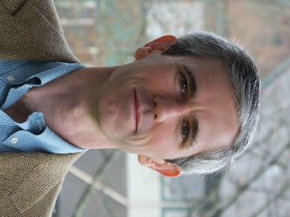
Christopher Rea (PhD, Columbia) is Professor of Chinese and former Director of the Centre for Chinese Research at the University of British Columbia. He is the author of The Age of Irreverence (California, 2015) and Chinese Film Classics, 1922-1949 (Columbia, 2021), and founder of the Chinese Film Classics Project. His most recent book, co-authored with Thomas S. Mullaney, is Where Research Begins: Choosing a Research Project That Matters to You (and the World) (University of Chicago Press, 2022), which has editions published or forthcoming in Chinese, Japanese, Korean, Polish, and Thai.

