University of Warwick
Translation and Transcultural Studies Research Seminars
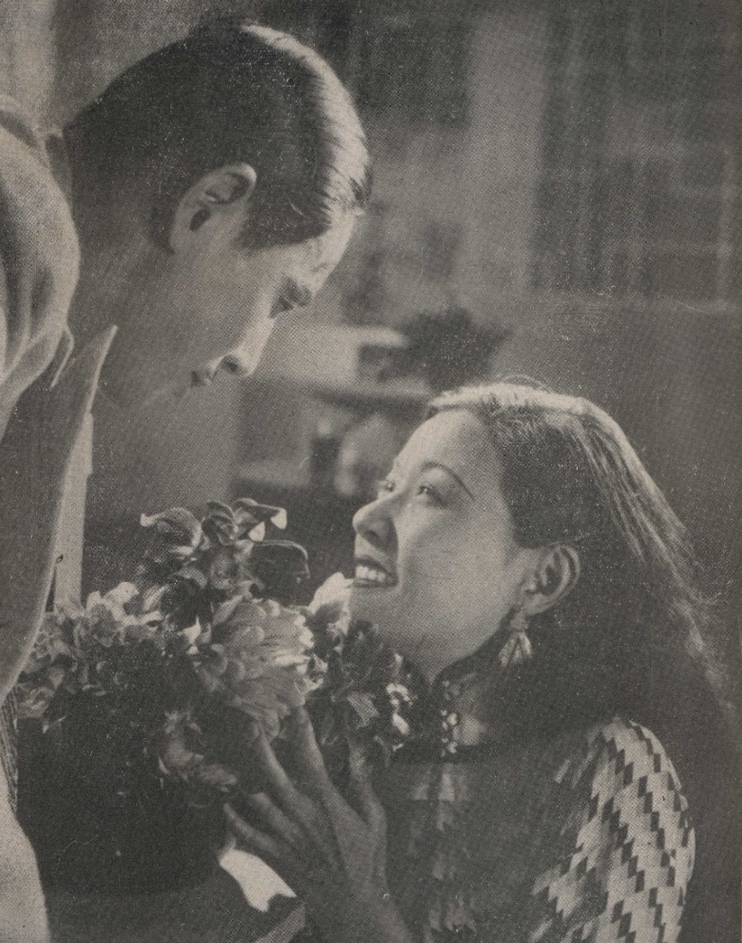
Wednesday, April 26, 2023
10:00-11:30am
Venue: OC1.04
Don’t Change Your Husband!
and Other Lessons from a New Online Archive of Early Chinese Films
Prof Christopher Rea
(University of British Columbia)

Hybrid event: Teams live (click here to join the talk)
Please register to attend the talk here.
Image: Wang Naidong and Ruan Lingyu in a promotional still for New Women (Cai Chusheng, dir., 1935)

Abstract
What can we learn about Chinese filmmaking, or global cinema culture, or Chinese popular culture from early Chinese films? What did the Shanghai film industry of the early twentieth century share in common with Hollywood or Europe, and which of its filmmaking practices were unique?
This presentation will share discoveries from the first few years of the Chinese Film Classics Project (chinesefilmclassics.org), an ongoing international effort to make early Chinese cinema history more accessible to the English-speaking world. Film historian Christopher Rea will speak about the research discoveries that emerged while he was writing the book Chinese Film Classics, 1922-1949 (2021), building an online course, and working with collaborators to create a digital archive of early Chinese films with English subtitles.
Join us for a new look at Chinese cinema history, illustrated with clips of films both renowned and obscure, from the celebrated Goddess (1934) and Spring River Flows East (1947) to the forgotten kung fu flick The Mighty Hero Gan Fengchi (1928) and the moral melodrama Don’t Change Your Husband (1929).

About the Speaker
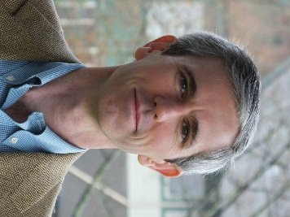
Christopher Rea is Professor of Chinese and former Director of the Centre for Chinese Research at the University of British Columbia. He is the creator of the Chinese Film Classics Project, whose website ChineseFilmClassics.org hosts the world’s largest online collection of early Chinese films with English subtitles, as well as film clips, essays, links, and a free online course on early Chinese films. The website and the course are companions to his book Chinese Film Classics, 1922-1949 (Columbia, 2021), which covers fourteen films, and has a Chinese edition forthcoming. Full films and over 200 film clips (songs, gags, superlative scenes) are viewable at the YouTube channel @ModernChineseCulturalStudies. Rea is also the author of The Age of Irreverence: A New History of Laughter in China (California, 2015) and the co-author of Where Research Begins: Choosing a Research Project That Matters to You (and the World) (with Thomas Mullaney; Chicago, 2022). He is currently working on a second volume of The Book of Swindles (Columbia, 2017) and on a cultural history of melons.

