


The Centre for the Study of the Renaissance
with the generous support of the Andrew W. Mellon Foundation

Public Lecture

Monday June 10th 2013, 5:00pm

~~~

Dario Brancato (Concordia University)

~~~

'Ideologizing History and Reading Publics
in Benedetto Varchi's Storia Fiorentina'

National Grid Room, upstairs balcony of Warwick Arts Centre
(Opposite the Mead Gallery)

The seminar will be followed by a wine reception
(RSVP to renaissance@warwick.ac.uk)

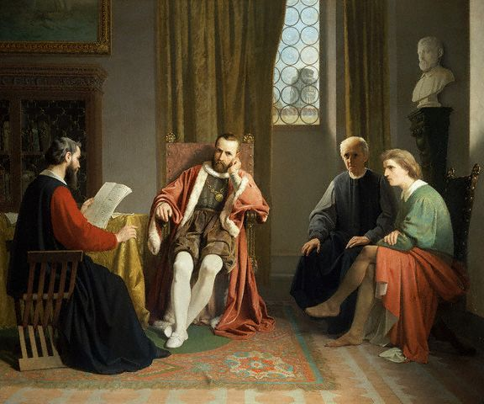

Giuseppe Ciaranfi, Benedetto Varchi legge l'istoria fiorentina a Cosimo I de' Medici (1862),
Florence, Galleria d’Arte Moderna di Palazzo Pitti

