Week 1 – Homework

I recommend that you set aside some time every day for revision (30 mins – 1 h). You decide on the pace that works best for you, but I advise that for the first few days you focus on tasks 1 and 2 and move on to 3 after you are confident in your mastery of the vocabulary and the noun endings. I recommend that you do 4 several times.

- Memorise the following vocabulary (don't forget to learn the vocabulary in task 4 as well!):

ager agri 2 m | field
amicus amici 2 m | friend
aqua aquae 1 f | water
arma armorum 2 n pl | arms
Augustus Augusti 2 m | venerable (title of Roman emperors)
bellum belli 2 n | war
Caesar Caesaris 3 m | Caesar (Roman statesman and writer)
civis civis 3 m | citizen
corpus corporis 3 n | body
deus dei 2 m | god
dies diei 5 m | day
domina dominae 1 f | lady, mistress
dominus domini 2 m | sir, master
donum doni 2 n | gift
epistola epistolae 1 f | letter
fons fontis 3 m | spring, fountain
fructus fructus 4 m | fruit
liber libri 2 m | book
manus manus 4 f | hand
mater matris 3 f | mother
miles militis 3 m | soldier
mons montis 3 f | mountain
mos moris 3 m | habit, custom
oculus oculi 2 m | eye
pater patris 3 m | father
pax pacis 3 f | peace
populus populi 2 m | the people
porta portae 1 f | door, gate
puella puellae 1 f | girl
res rei 5 f | thing, matter
rex regis 3 m | king
salus salutis 3 f | health
tempus temporis 3 n | time
Troia Troiae 1 f | Troy (ancient city in Asia Minor)
urbs urbis 3 f | city
vir viri 2 m | man

- Memorise the following table of noun declensions (also in the Nouns – Declensions handout).

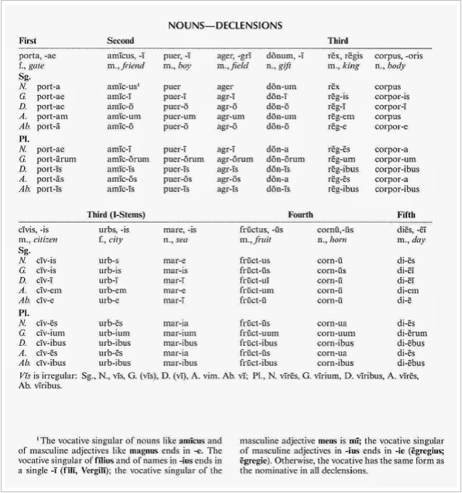

If you want to read up more on the declension of nouns, refer to the PDF on the course website ('Morwood on cases'; under Session 1).

- Determine the case and number of the following nouns. When more than one answer is possible, indicate all possible answers (e.g. agro can be both dative and ablative singular of ager agri 2 m):

amicos | mare | arma | ager | pace
portarum | urbem | Troiae | tempora | populus
agro | regibus | fontibus | mores | Augusto
regis | corpus | oculos | Caesarem | librum
fructui | puellis | rex | deus | salutem
dona | montem | aquis | pater | manus
diem | virum | milites | matrem | rem
cives | dominis | epistolae | bellum | dominas

- Go over the text we read together in class several times. Do it slowly, really paying attention to the grammar and making sure you understand it. Focus on the points about nouns and declensions; we will explain more about the verb in later sessions. If there is anything unclear, note it down and ask me about it in the next session.

