Week 1 – Nouns – Declensions

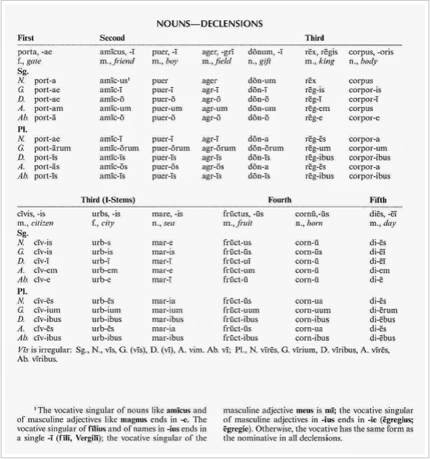

Source: Wheelock's Latin

In order to be able to recognise the case of a specific word, we must also know to which declension it belongs. This is why learning vocabulary is so important. When we don't recognise a word, we can look it up in a dictionary. The genitive ending, which all standard dictionaries give, is the clue to which declension the noun belongs:

ae 1st declension
i 2nd declension
is 3rd declension
us 4th declension
ei 5th declension

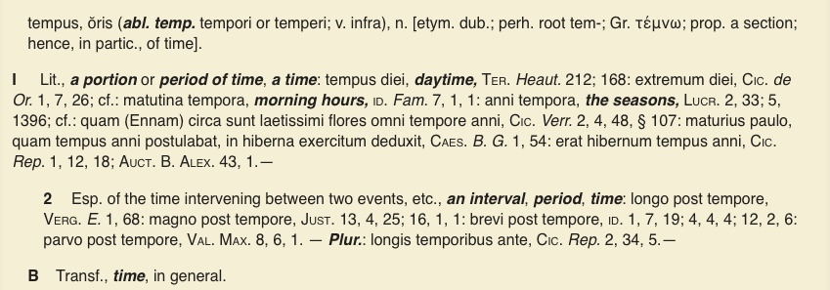

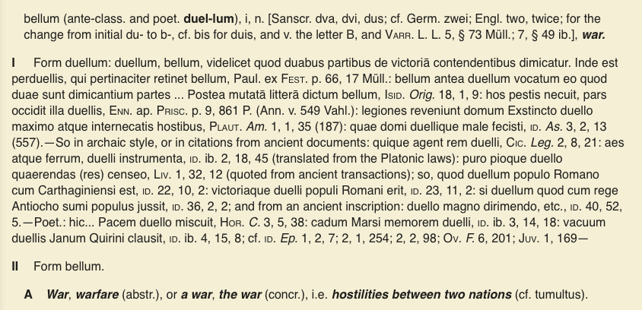

Determine the case and number of the following nouns:

milites | miles militis 3 m
domum | domus domus 4 f
pueris | puer pueri 2 m
tempora | tempus temporis 3 n

