Week 2 – Grammar and syntax points

Adjectives

Latin adjectives are either first and second declension adjectives (the 2-1-2 pattern) or third declension adjectives.

The 2-1-2 pattern

In this category, if the noun is feminine, the adjective will follow the first declension; if it is masculine or neuter, it will follow the second declension for both masculine and neuter nouns.
bonus amicus (masculine)
bona terra (feminine)
bonum oppidum (neuter)
pulcher amicus
pulchra terra
pulchrum oppidum

In a dictionary, you can identify a 2-1-2 adjective by the -us, a, um / -er, a, um endings.

Third declension adjectives

Adjectives of the third declension usually follow the declension of i-stem nouns (e.g. mare this means they have the -i ending in the ablative singular, -ia in the neuter nominative and accusative plural and -ium in the genitive plural). There are three types of third declension adjectives:
- Three terminations – one for each gender
E.g. acer acris acre (sharp) acer is masculine, acris is feminine and acre is neuter
2) Two terminations – one for masculine and feminine, one for neuter
E.g. dulcis dulce (sweet) dulcis is masculine and feminine, dulce is neuter
3) One termination for all genders
E.g. felix (happy) felix for masculine, feminine and neuter

A dictionary will tell you which of the types an adjective belongs to:
For the first two types you are given the endings for the other genders; in the case of felix, icis, you are given the genitive ending.

Of course, you can pair an adjective from any declension with a noun from any declension.

homo bonus 3rd noun + 2-1-2 adjective
puella sapiens 1st noun + 3rd adjective
domus vetus 4th noun + 3rd adjective

Adjectives always agree with the noun they are used with in gender, case and number.

hominem bonum masculine accusative singular
puellas sapientes feminine accusative plural
domus veteris feminine genitive singular

Exercise: Match the nouns with the adjectives
bonus, a, um good
domus, domus f 4 house, home
homo, hominis m 3 man, human
puella, puellae f 1 girl
sapiens, ntis clever
vetus, eris old
bonae | puella
sapientis | homini
sapiens | hominis
bonis | domus
veteri | hominibus

Some common pronouns
N.B. The below is a selection of some of the most common pronouns; Latin knows many more. For a more detailed overview, see Kennedy, pp. 48–55 (the tables below are also from Kennedy).

Pronouns stand in the place of nouns or adjectives (e.g. saying 'it' or 'that' instead of 'a table'; 'she' instead of 'my friend'; 'this house' instead of 'big house').

- Personal and reflexive
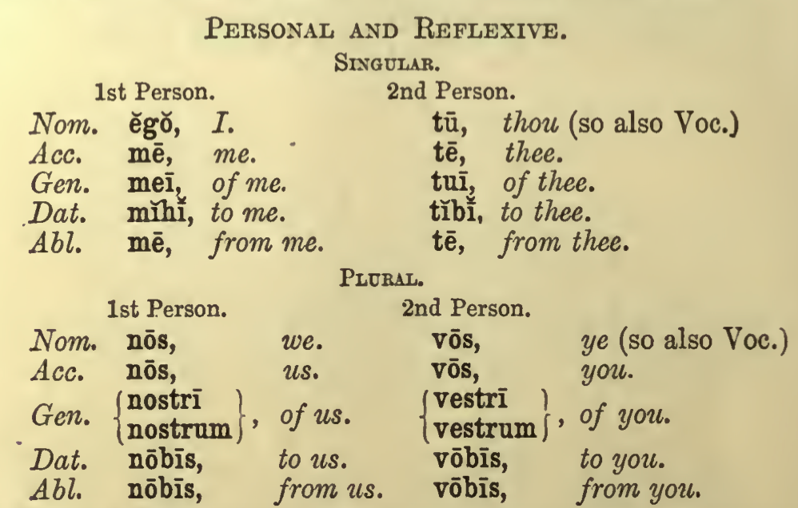
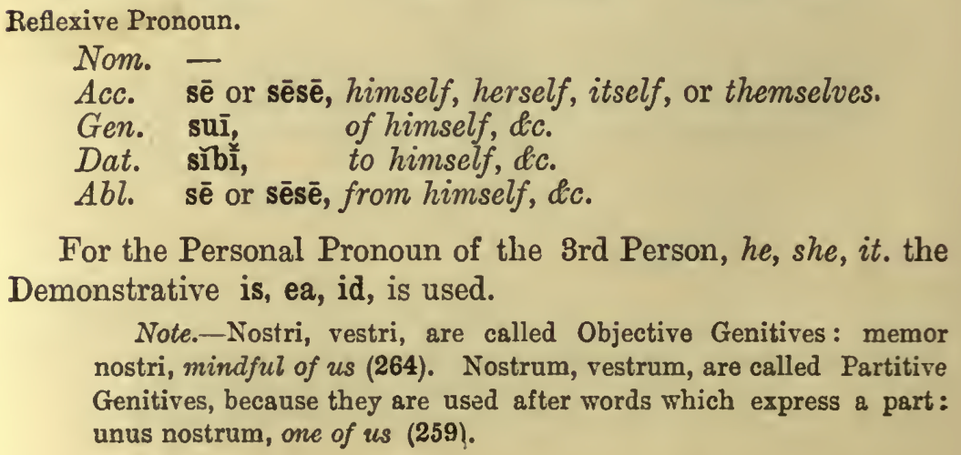
For the third person, we use the pronoun is, ea, id when it is non-reflexive; we use se as a reflexive. A reflexive pronoun refers to the subject of the sentence.
Is filium suum lavat. He is bathing his son.
Is se lavat. He is bathing himself.

- Possessive
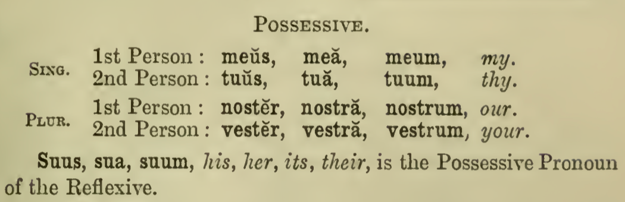
For the third person, we use the genitive of is, ea, id when it is non-reflexive; suus, a, um as a reflexive. A reflexive pronoun refers to the subject of the sentence.
(Ego) Patrem eius video. I see his / her father. (lit. father of him)
(Cornelius / Cornelia) Patrem suum videt. He / She sees his / her father.

- Demonstrative
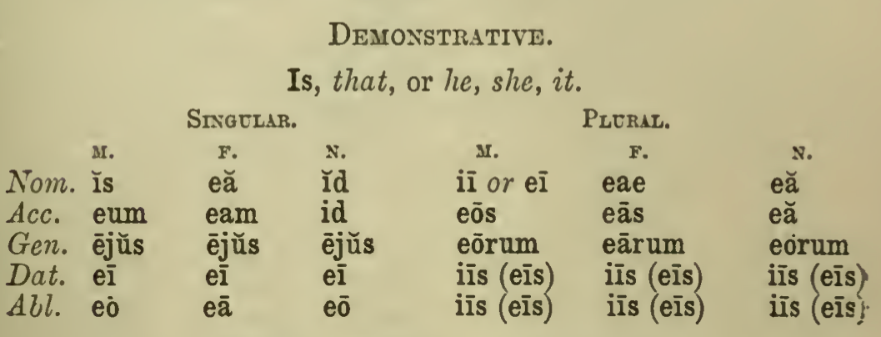
Ea verba vera non sunt. These words are not true.
Sine ea vivere non possum. I cannot live without her.
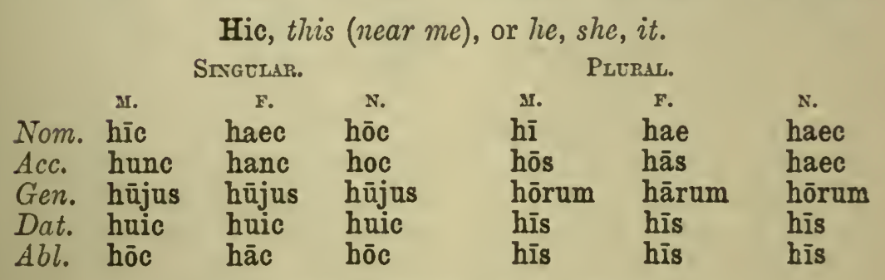
his temporibus in these days
Hic liber, quem in manu teneo, meus est. This book, which I'm holding in my hand, is mine.
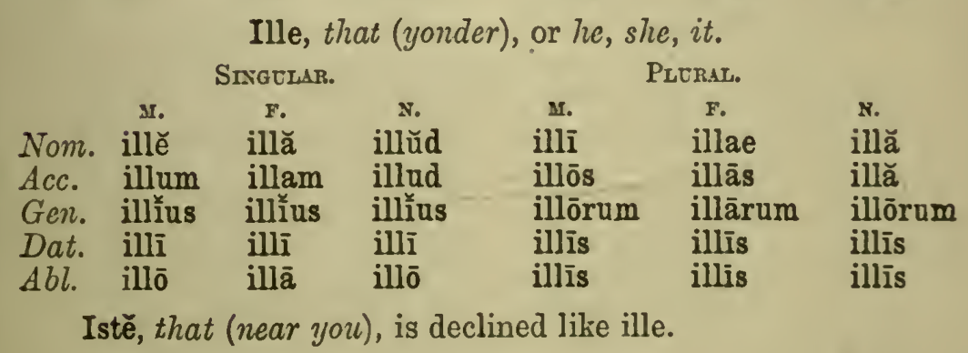
illis temporibus in those days
Ille, illa, illud can also mean something like 'the celebrated', 'the famous'.
Plato discipulus Socratis illius fuit. Plato was a disciple of the famous Socrates.
Iste, ista, istud can often have a pejorative connotation.
isti amici tui those friends of yours

- Definitive
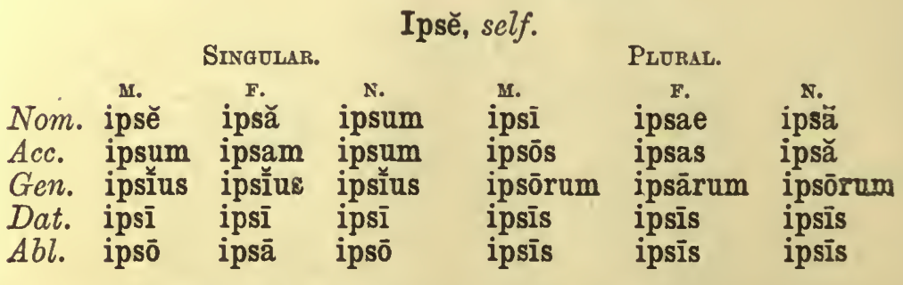
Caesar ipse venit. Caesar himself has arrived.
ea ipsa hora this very hour

- Relative and interrogative
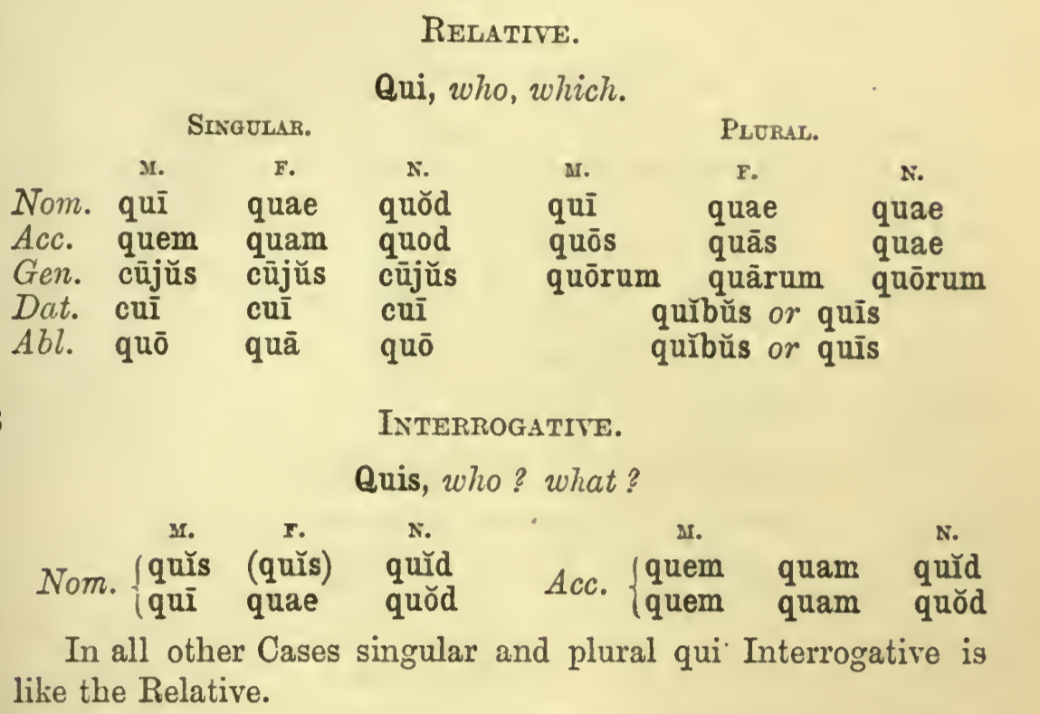
Haec puella, quae venit, amica mea est. This girl, who is approaching, is my friend. /
The girl who is approaching is my friend.
Hic liber, quem in manu teneo, meus est. This book, which I'm holding in my hand, is mine. / The book that I'm holding in my hand is mine.
Quis venit? Amica mea. Who is approaching? My friend.
Quid tenes? Librum meum. What are you holding? My book.

Asking questions

Quis? Quid? Who? What?
Quis venit? Amica mea. Who is approaching? My friend.
Quid tenes? Librum meum. What are you holding? My book.

Ubi? Where?
Ubi liber meus est? In manu tua. Where is my book? In your hand.

Quo? Where to?
Quo vadis, Domine? Where are you going, my Lord?

Unde? Where from?
Unde ea mulier est? Ex Samo. Where is this woman from? From Samos.

Cur? Quare? Quid? Why?
Cur ista quaeris? Why are you asking these things?

Quando? When?
Quando venit? Hodie. When is he arriving? Today.

Nonne Introduces questions where we expect an affirmative answer
Nonne corpus mortale est? Is the body mortal? / Is the body not mortal?

Num Introduces questions where we expect a negative answer
Num irata est? Is she angry? / Surely she's not angry?
Num quid vis? Do you want anything else? (A parting formula)

-ne Signifies a question, emphasising the word to which it is attached
Estne frater meus domi? Is my brother home?
Tune id credis? You believe that?

