Week 3 – Text

Some points on the orthography of early modern printed books

A line above a letter most commonly denotes 'm' or 'n'.

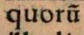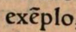

'i' and 'j' as well as 'u' and 'v' are often used interchangeably.

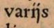

'q₃' or 'q;' = 'que'

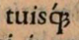

Where you would expect a diphtong ('ae', 'oe'), you may encounter 'æ', 'ę' or simply 'e'.

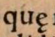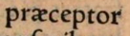

While it is primarily meant for manuscripts, Cappelli's Lexicon can help you decipher early modern Latin printed books as well.

Dedicatory letters

Many early modern authors dedicated their works to specific individuals. These could be eminent patrons, heads of state, friends or family members. The dedication often took the form of a dedicatory letter in which the author explained why he or she had chosen the dedicatee in question. Dedicatory letters and other paratexts are often useful sources of information on the circumstances of the production of a work, and often they are worthy of attention in their own right. The below is the dedicatory letter to Hermann Schottenius' Confabulationes, another sixteenth-century collection of imaginary dialogues for classroom use. Schottenius appears to have dedicated it to a student of his.

Et genere et moribus adolescenti ingenuo Gysberto Sterckenberg Hermannus Schottennius Hessus s. p. d.  Platonem quondam discipuli rogitarunt, ut ea, quae ipsis lectionibus variis tradidisset, in unum redigeret volumen.  Quorum precibus philosophiae praeceptor ille divinus facile consensit, conscribens libros complures in philosophiae consecutionem.  Huius ego excitatus exemplo, ut fidus aestimarer ingeniorum saginator, Latinas locutiones, quas hactenus satis abunde tibi tuisque commilitonibus literariis dictavi, in unum hunc confabulationum libellum congessi, quo tuam Minervam Latine loquendi copia irrigarem, ut quandoque elimatior reddita, patris tui, viri prudentissimi, mihi amicissimi, expectationi de te, tuisque aliis duobus fratribus Ioanne et Matthia, respondeat.  A cuius vestigiis te degenerare turpissimum certe esset.  Huius ut votis auscultes (fervide scilicet amplectendo litteras) aequissimum erit, tibique multo magis, quam ipsi conducet.  Et ut facilius emergas tu, ceterique tui fratres et sorores, neque umquam egestate obruamini, ipse pater vester virtutum verum domicilium, huius inclitae urbis Agrippinae de albo Senatorum prudentia nulli secundus, omni conatu, omne movendo saxum, etiam et caelibem ducendo vitam id unicum agit, quo te tuosque fratres et sorores ditet, locupletet et vobis ut congerat reliquae vitae commeatum.  Suis igitur Gysberte, discipule dilectissime, expectationibus rogo respondeas. Tunc autem respondebis, si scientia et virtute te pulchre ornaveris. Vale, Gysberte carissime. | genus, eris 3 n – family, stock, kind  mos, moris 3 m – manner, custom, practice  adolescens, ntis 3 – young man or woman  ingenuus, a, um – free-born; noble  Plato, onis 3 m – Plato  quondam – once, formerly  rogito 1 – ask  lectio, onis 3 f – reading, text  trado, didi, ditum 3 – give over, commit, deliver  redigo, egi, actum 3 – bring back, render  volumen, inis 3 n – book, volume  Some verbal forms in Latin can contract, i.e. shorten. One of the most common contractions is in the 3rd person plural perfect indicative active:  rogitaverunt rogitarunt  rogitaverunt rogitavere  Requests and commands are followed by ut + subjunctive.  Discipuli rogitarunt, ut ea in unum redigeret volumen. – His students asked him to collect these in one work.  Opto, ut mihi saepius epistolas scribas. – I want you to write me letters more frequently.  prex, precis 3 f – request, prayer  praeceptor, oris 3 m – teacher  divinus, a, um – divine  facilis, e – easy  consentio, sensi, sensum 4 – agree, consent  complures, a pl – many, several  consecutio, onis 3 f – sequence; attainment  excito 1 – excite, incite  exemplum, i 2 n – example, model  fidus, a, um – faithful, trustworthy  aestimo 1 – value, appraise, esteem  ingenium, ii 2 n – mind, talent  saginator, oris 3 m – nourisher; i.e. educator  locutio, onis 3 f – speech, discourse  hactenus – so far, up to now  satis – enough  abundus, a, um – copious, abundant  commilito, onis 3 m – fellow soldier  litterarius, a, um – literary  dicto 1 – say often; dictate  confabulatio, onis 3 f – conversation  libellus, i 2 m – little book  congero, gessi, gestum 3 – collect  loquor, locutus sum 3 – speak  copia, ae 1 f – abundance, multitude  irrigo 1 – water, irrigate  quandoque – whenever  elimatus, a, um – elaborate  reddo, didi, ditum 3 – give, grant, render  vir, i 2 m – man, husband  prudens, ntis – prudent, wise  amicus, a, um – friendly, favourable  expectatio, onis 3 f – expectation, hope  respondeo, di, sum 2 – respond, answer  In purpose clauses ('so that', 'in order to'), we find ut + subjunctive.  Ut fidus aestimarer ingeniorum saginator, Latinas locutiones in unum hunc confabulationum libellum congessi. – In order to be considered a trustworthy educator of minds, I collected Latin speeches in this little book of conversations.  Edimus, ut vivamus, non vivimus, ut edamus. – We eat in order to live, not live in order to eat.  vestigium, ii 2 n – footprint, track  degenero 1 – depart from, deteriorate  turpis, e – shameful, dishonourable  certus, a, um – certain  The subjunctive is not used only in relative clauses. It can also appear in independent sentences. Here it expresses potential:  Turpissimum certe esset. – It would certainly be most shameful.  Dicat quis aliquid. – Someone may say something.  votum, i 2 n – request, prayer  ausculto 1 – listen, obey, heed  fervidus, a, um – fiery, vehement  scilicet – of course, certainly, naturally  amplector, exus 3 – embrace  aequus, a, um – equal, like; fair, just  magis – more  conduco, duxi, ductum 3 – profit, serve  Ut + subjunctive can also introduce substantive clauses (i.e. the clause functions as the subject or object of the main clause).  Aequissimum erit, huius ut votis auscultes. – It will be most just if you listen to his wishes.  emergo, si, sum 3 – rise, emerge  umquam – ever (numquam – never)  egestas, atis 3 f – poverty, want  obruo, ui, utum 3 – overwhelm, strike down  virtus, utis 3 f – virtue  domicilium, ii 2 n – dwelling, abode  inclitus, a, um – renowned, famous  urbs Agrippinae de albo Senatorum –Cologne. Agrippina, wife of Claudius and mother of Nero, was born there.  nullus, a, um – nobody  secundus, a, um – second  conatus, us 4 m – effort  moveo, movi, motum 2 – move  saxum, i 2 n – stone  caelebs, libis – celibate, single  duco, duxi, ductum 3 – lead  dito 1 – enrich  locupleto 1 – enrich, adorn  reliquus, a, um – remaining  commeatus, us 4 m – provision, supply  dilectus, a, um – dear  rogo 1 – ask, request  tunc – then  scientia, ae 1 f – science, knowledge  pulcher, chra, chrum – beautiful, fair  orno 1 – adorn  carus, a, um – dear  When we find an indicative in conditional clauses ('if x happens ... y happens'), this conveys that the condition and the result are possible.  Suis expectationibus respondebis, si scientia et virtute te pulchre ornaveris. – You will live up to your promise if you adorn yourself with knowledge and virtue.  Si id credis, erras. – If you believe this you are wrong.

Schottenius, Hermannus. 1545. Tironum litteratorum colloquia sive confabulationes (Lyon: Theobaldus Paganus)

Et genere et moribus adolescenti ingenuo Gysberto Sterckenberg Hermannus Schottennius Hessus salutem plurimam dicit.

Platonem quondam discipuli rogitarunt, ut ea, quae ipsis lectionibus variis tradidisset, in unum redigeret volumen. Quorum precibus philosophiae praeceptor ille divinus facile consensit, conscribens libros complures in philosophiae consecutionem.Huius ego excitatus exemplo, ut fidus aestimarer ingeniorum saginator, Latinas locutiones, quas hactenus satis abunde tibi tuisque commilitionibus literariis dictavi, in unum hunc confabulationum libellum congessi, quo tuam Minervam Latine loquendi copia irrigarem, ut quandoque elimatior reddita, patris tui, viri prudentissimi, mihi amicissimi, expectationi de te, tuisque aliis duobus fratribus Ioanne et Matthia, respondeat.

A cuius vestigiis te degenerare turpissimum certe esset. Huius ut votis auscultes (fervide scilicet amplectendo litteras) aequissimum erit, tibique multo magis, quam ipsi conducet. Et ut facilius emergas tu, ceterique tui fratres et sorores, neque umquam egestate obruamini, ipse pater vester virtutum verum domicilium, huius inclitae urbis Agrippinae de albo Senatorum prudentia nulli secundus, omni conatu, omne movendo saxum, etiam et coelibem ducendo vitam id unicum agit, quo te tuosque fratres et sorores ditet, locupletet et vobis ut congerat reliquae vitae commeatum.

Suis igitur Gysberte, discipule dilectissime, expectationibus rogo respondeas. Tunc autem respondebis, si scientia et virtute te pulchre ornaveris. Vale, Gysberte carissime.

Some grammar points:

Contractions

Some verbal forms in Latin can contract, i.e. shorten. One of the most common contractions is in the 3rd person plural perfect:
rogitaverunt rogitarunt
rogitaverunt rogitavere

Uses of ut

Requests and commands are followed by ut + subjunctive.
Discipuli rogitarunt, ut ea in unum redigeret volumen. – His students asked him to collect them in one work.
Opto, ut mihi saepius epistolas scribas. – I want you to write me letters more frequently.

In purpose clauses ('so that', 'in order to'), we find ut + subjunctive.
Ut fidus aestimarer ingeniorum saginator, Latinas locutiones in unum hunc confabulationum libellum congessi. – In order to be considered a trustworthy educator of minds, I collected Latin speeches in this little book of conversations.
Edimus, ut vivamus, non vivimus, ut edamus. – We eat in order to live, not live in order to eat.

The subjunctive is not used only in relative clauses. It can also appear in independent sentences. Here it expresses potential:
Turpissimum certe esset. – It would certainly be most shameful.
Dicat quis aliquid. – Someone may say something.

Ut + subjunctive can also introduce substantive clauses (i.e. the clause functions as the subject or object of the main clause).
Aequissimum erit, huius ut votis auscultes. – It will be most just if you listen to his wishes.

Conditionals

When we find an indicative in conditional clauses ('if x happens ... y happens'), this conveys that the condition and the result are possible.
Suis expectationibus respondebis, si scientia et virtute te pulchre ornaveris. – You will live up to your promise if you adorn yourself with knowledge and virtue.
Si id credis, erras. – If you believe this you are wrong.

Homework:

- Revise verbal conjugations with the handout under 'Homework' on the website.

- Go over the text above several times. Do it slowly, really paying attention to the grammar and making sure you understand it. If there is anything unclear, note it down and ask me about it in the next session.

- Find all the verbs in the text above and determine what person, number, tense, mood and voice they are in.
Example: dicit: 3rd person singular present indicative active

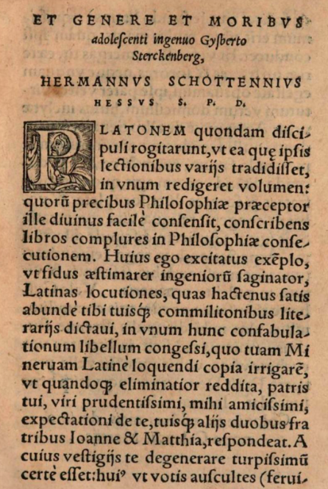 | 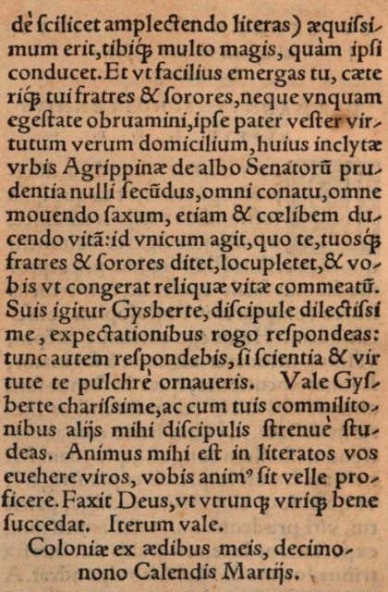

The entire book is accessible here: https://www.google.co.uk/books/edition/Tyronum_literatorum_colloquia_sive_Confa/dt5QAAAAcAAJ?hl=en&gbpv=1

