Preface of Bruni on his translation of Aristotle’s Nicomachean Ethics

Aristotle’s Nicomachean ethics was a key text in the universities in medieval times and it continued to have great traction in the renaissance. Because Greek was virtually unknown in western Europe, most readers had to study it in Latin translation.
In this preface, Bruni defends himself against accusations that he was excessively harsh in his first edition on the work of Robert Grosseteste, the previous translator of this work into Latin.

Cum Aristotelis libros ad Nicomachum scriptos  e Graeca lingua  in Latinum  vertissem,  praefationem apposui  in qua  permultos errores interpretis antiqui disserendo redargui.  Has redargutiones meas nonnulli,  ut audio,  carpunt  quasi nimium inclementes.  Aiunt enim,  etsi errores inerant,  tamen illum  quantum intellexit  bonâ fide in medium protulisse,  nec pro eo reprehensionem mereri  sed laudem:  consuevisse moderatos disputatores  etiam manifesta errata  non usque adeo aperire,  sed factis potius redarguere  quam verbis insectari.  Ego autem fateor  me paulo vehementiorem  in reprehendendo fuisse;  sed accidit indignatione animi  quod,  cum viderem eos libros in Graeco  plenos elegantiae,  plenos suavitatis,  plenos inaestimabilis cuiusdam decoris,  dolebam profecto mecum ipse  atque angebar  tanta traductionis faece coinquinatos  ac deturpatos  eosdem libros in Latino videre.  Ut enim,  si pictura quadam ornatissima et amoenissima delectarer  ceu Protogenis  aut Apellis  aut Aglaophontis,  deturpari illam graviter ferrem  ac pati non possem  et in deturpatorem ipsum voce manuque insurgerem,  ita hos Aristotelis libros,  qui omni pictura nitid|iores  ornatioresque sunt,  coinquinari cernens  cruciabar animo  ac vehementius commovebar.  Si cui ergo vehementiores visi sumus,  hanc nos causam noverit permovisse,  quae profecto (adv.) talis est,  ut,  etsi modum transgressi fuissemus,  tamen venia foret nobis haud immerito concedenda.  [....]  Atque ut tota res ista latius intelligatur,  explanabo tibi primo  quid de hac interpretandi ratione sentio.  Deinde merito reprehensiones a me factas docebo.  Tertio  me  in reprehendendo illius errata  doctissimorum hominum morem observa[vi]sse  ostendam. | turn = translate  ad+pono, posui  I refuted  dissero – discuss  carpe diem; carp = complain  ait = inquit  etsi = quamquam  mereor = deserve  insector, sequor: frequentative form  comparative: more ...; too ....  eos = illos libros  decor – beauty, grace; qui|dam  anxius; angere + infin.  turpis – disfigured  I would be annoyed  -or – person/function  compartive + abl = than  comparative: too vehemently  nos = ego  novi : subjunctive – let him know (polite command)  modus – mean, reasonable point  not undeservedly: ‘litotes’

Clean text
Cum Aristotelis libros ad Nicomachum scriptos e Graeca lingua in Latinum vertissem, praefationem apposui in qua per multos errores interpretis antiqui disserendo redargui. Has redargutiones meas nonnulli, ut audio, carpunt quasi nimium inclementes. Aiunt enim, etsi errores inerant, tamen illum quantum intellexit bona fide in medium protulisse, nec pro eo reprehensionem mereri sed laudem; consuevisse moderatos disputatores etiam manifesta errata non usque adeo aperire, sed factis potius redarguere quam verbis insectari.
Ego autem fateor me paulo vehementiorem in reprehendendo fuisse; sed accidit indignatione animi quod, cum viderem eos libros in Graeco plenos elegantiae, plenos suavitatis, plenos inaestimabilis cuiusdam decoris, dolebam profecto mecum ipse atque angebar tanta traductionis faece coinquinatos ac deturpatos eosdem libros in Latino videre. Ut enim, si pictura quadam ornatissima et amoenissima delectarer ceu Protogenis aut Apellis aut Aglaophontis, deturpari illam graviter ferrem ac pati non possem et in deturpatorem ipsum voce manuque insurgerem, ita hos Aristotelis libros, qui omni pictura nitidiores ornatioresque sunt, coinquinari cernens cruciabar animo ac vehementius commovebar. Si cui ergo vehementiores visi sumus, hanc nos causam noverit permovisse, quae profecto talis est, ut, etsi modum transgressi fuissemus, tamen venia foret nobis haud immerito concedenda.
[Sed non sumus transgressi modum iudicio nostro, sed quamvis indignantes modestiam tamen humanitatemque servavimus. Sic enim cogita: An ego quicquam in mores illius dixi? An in vitam? An ut perfidum, ut improbum, ut libidinosum illum reprehendi? Nihil profecto horum. Quid igitur in illo reprehendi? Imperitiam solummodo litterarum. Haec autem, per deum immortalem, quae tandem vituperatio est? An non potest quis esse vir bonus, litteras tamen aut nescire penitus aut non magnam illam, quam in isto requiro, peritiam habere? Ego hunc non malum hominem, sed malum interpretem esse dixi. Quod idem fortasse de Platone dicerem, si gubernator navis esse vellet, gubernandi vero peritiam non haberet. Nihil enim de philosophia <ei> detraherem, sed id solummodo carperem, quod imperitus et ineptus gubernator esset.]
Atque ut tota res ista latius intelligatur, explanabo tibi primo quid de hac interpretandi ratione sentio. Deinde merito reprehensiones a me factas docebo. Tertio me in reprehendendo illius errata doctissimorum hominum morem observasse ostendam.

https://la.wikisource.org/wiki/De_interpretatione_recta

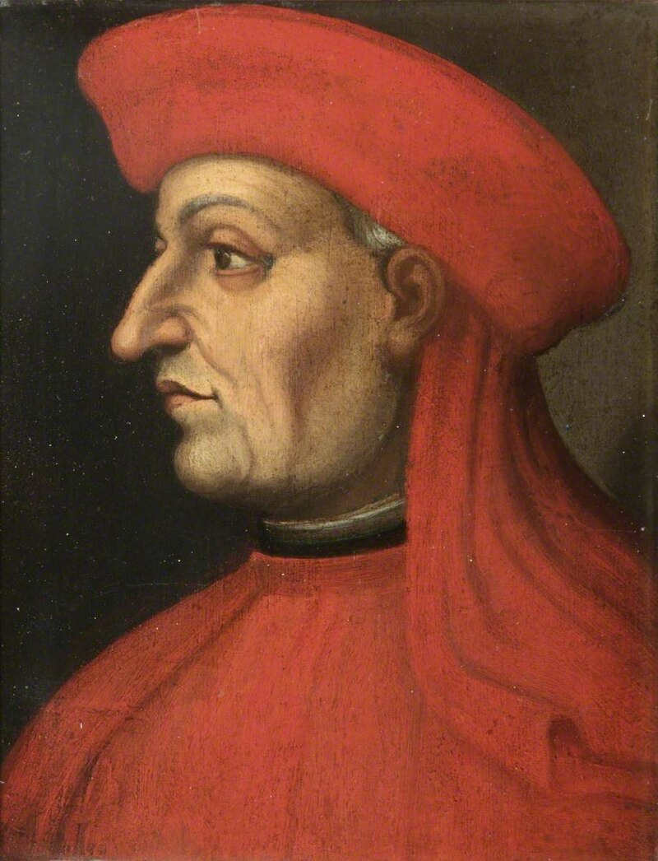 | 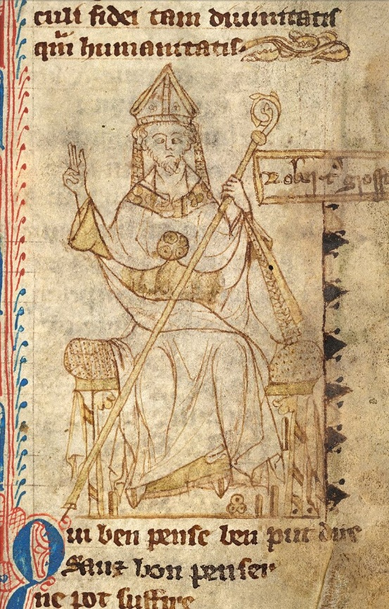

Leonardo Bruni
Lines, David
Aristotle's Ethics in the Italian Renaissance (ca. 1300-1650): the universities and the problem of moral education
Citation:
Hankins J. Notes on Leonardo Bruni’s Translation of the Nicomachean Ethics and Its Reception in the Fifteenth Century. In: et du moyen J. Hamesse T études âge Les manuscrits des traducteurs: Reconstitution de leur méthode de travail. Louvain-la-Neuve: FIDEM ; 2002. pp. 427-447.

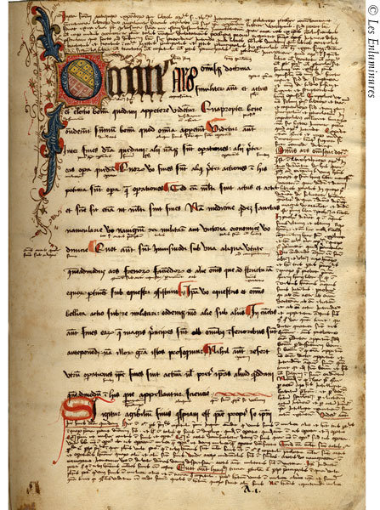
ff. 1r-163r, Aristotle, Nichomachean Ethics, in the Latin translation of Leonardo Bruni, but without his preface or dedicatory letter to Pope Martin V, incipit, "Omnis ars et omnis doctrina…legibus et moribus," but with extensive marginal and interlinear glosses, the first apparently starting "Iuxta sententiam antiquorum expositiorum qui libros Aristotelis super ethicorum…"; explicit, "... status sit optimus et quomodo una quaque res pro constituta sit et quibus legibus et moribus".

Aristotle's Nicomachean Ethics, written in Greek and based on lectures he gave in Athens in the fourth century B.C., concerns the end to which human behavior should be directed. He accepts "happiness" (doing well, making a success of life) as this end, and attempts to show how it can be achieved. For a person to be happy, he says, they must not simply pursue pleasure, but do well those things which are distinctly human, namely the exercise of intellectual abilities. But, as he also explains, virtue is not solely intellectual, and mankind has a moral aspect as well.

The text was first translated into Latin by Robert Grosseteste (1175-1253), bishop of Lincoln, one of the most learned men of the Middle Ages. His translation was not superseded until the fifteenth century, when in 1419 the early humanist Leonardo Bruni (1396-1444), dedicated a new translation to Martin V (Pope 1417-31). An astute scholar of Greek and Latin and the first Florentine scholar to use the word "humanitas" as a term for literary studies, Bruni made some of the earliest idiomatic translations of Greek literature, including works by Homer, Aristophanes, Demosthenes, and Plato. He followed his translation of the Ethics with a translation of Aristotle's Politics in 1437, undertaken at the request of Humfrey, Duke of Gloucester.
Bruni's translation became the first of Aristotle's works to appear in print (at Strasbourg by Johann Mentelin, before 10 April 1469, Goff A-983). Copies of humanist texts produced outside Italy are scarce, and of the dozen or so copies of Bruni's translation of Aristotle's Ethics in North American collections (De Ricci and Bond), none were transcribed in France. The text was most recently edited by Crisp and translated by Broadie and Rowe. For a detailed discussion of this translation, see also Franceschini. See Hankins, pp. 253-254, for list of manuscripts containing the Bruni translation of the Nicomachean Ethics.

