Iliad 3, in Latin version by Poliziano
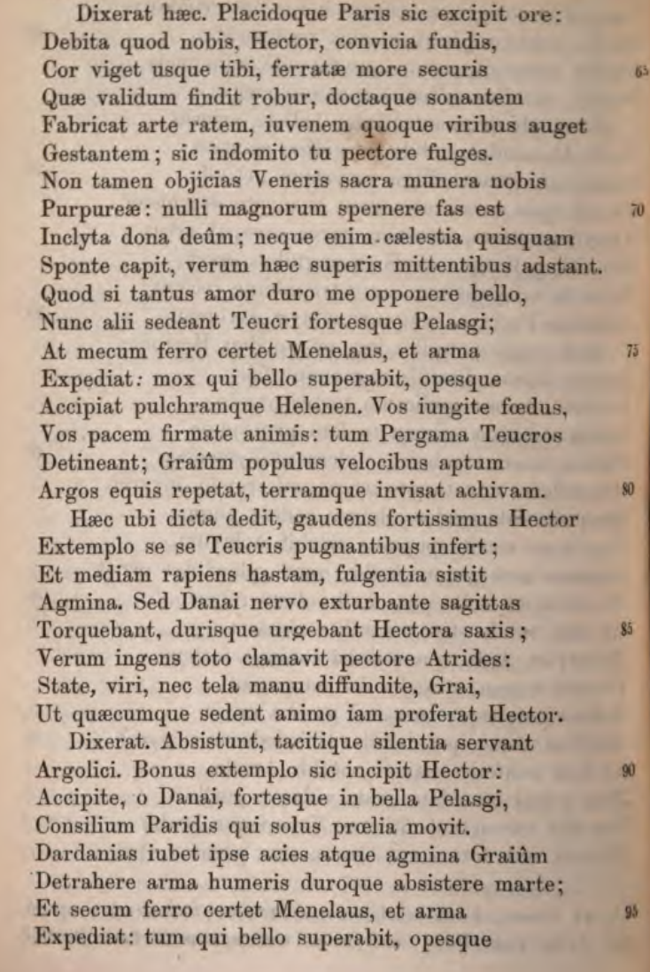
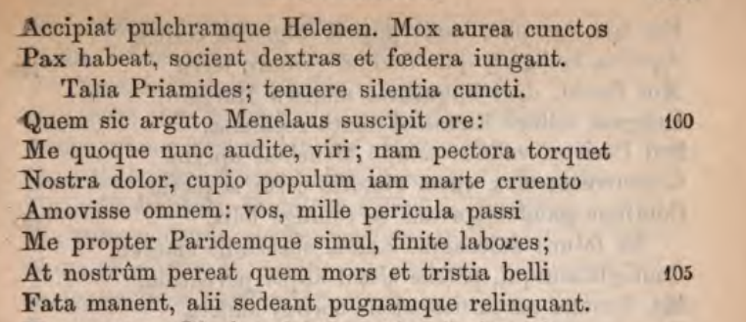
Source: Prose Volgari unedite; Poesie Latine e Greche ed. G, Barbera, Firenze 1867

Book 3 of Homer’s Iliad.
The Iliad was a canonical text in the classical word and also (but to a lesser extent) in the renaissance when it was usually known through Latin versions. This version was made by the fifteenth-century Italian humanist Poliziano (1454 – 1494), a classical scholar and poet.
At this stage there is a dual between Paris (whose abduction of Helen was the cause of the Trojan war) and Menelaus, the cuckolded husband of Helen. Hector, the champion of the Trojans had just roundly criticised Paris: ‘ Paris, you parody, with your wonderful looks, you sex-crazed seducer… won’t you stand up to warlike Menelaus. The Trojans are too soft; otherwise you would have been stoned to death long ago for the trouble you have caused.’

