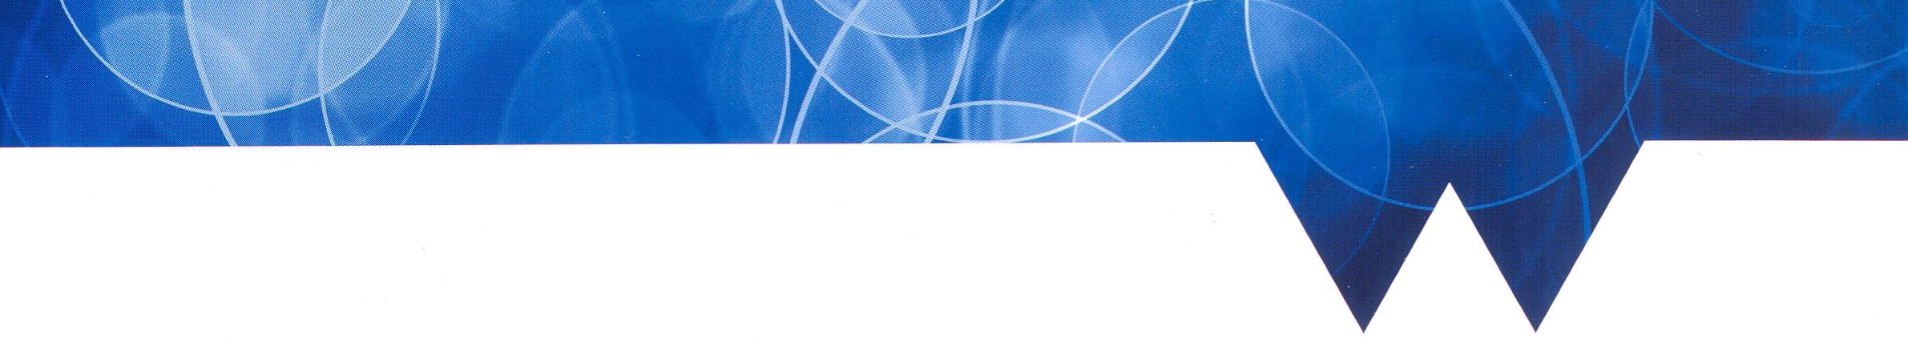
Humanities Research Centre
2017-18 Programme

Seminars begin at 5pm in Oculus (OC1.07) unless otherwise stated. All are welcome!

~ AUTUMN TERM ~

11th Oct Reading Group: Petrarch
25th Oct Alex Russell (Warwick), ‘Naturalizing reluctance: marriage, debt and consent in fifteenth-century England, Bavaria and Chartres’
15th Nov Miri Rubin (Queen Mary), ‘Ecclesia and Synagoga; Thinking about Jews in the Medieval Longue Durée’
22nd Nov Reading Group: Ovid transformed
29th Nov Jonathan Morton (KCL), 'Beyond the Trojan Horse: Craft, ingenuity, and secret knowledge in the High Middle Ages'

~ SPRING TERM ~

17th Jan Ryan Perry (Kent), ‘Making Histories: Scribal Cultures and the Middle English Prose Brut in Fifteenth Century London’
24th Jan Medieval Women’s Writing Workshop, 2-4 pm
7th Feb Julia Boffey (Queen Mary), ‘Here speaketh the author’: foregrounding late medieval English poets in manuscript and print’

7th Mar Reading Group

~ SUMMER TERM ~

2nd May Christiania Whitehead (Warwick), ‘Saintly networks: the Cuthbertine familia post-conquest’

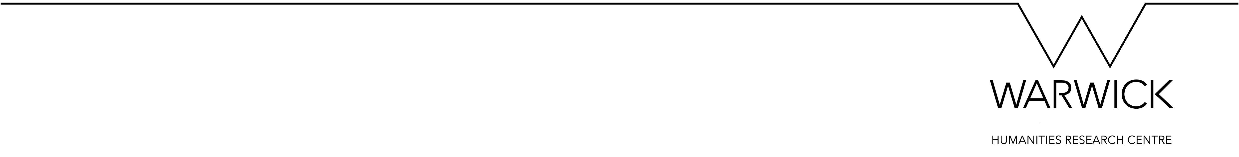
Contacts
Louise Campion L.G.E.Campion@warwick.ac.uk
Jane Sinnett-Smith J.Sinnett-Smith@warwick.ac.uk
@medievalwarwick

