Academic Rhetoric in Early Modern Europe
in association with the London Renaissance Seminar

When: September 7th, 2-5 p.m.
Where: Birkbeck, Keynes Library (Room 114) 43 Gordon Square, London WC1H 0PD

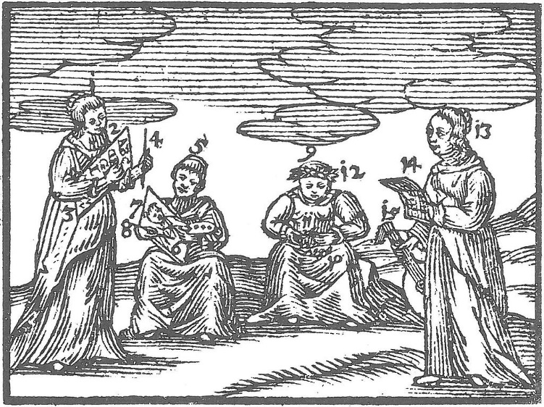

‘Artes sermonis’, from Johann Amos Comenius, Orbis sensualium pictus (1658 Nuremberg edition)

This session will offer six different perspectives on academic rhetorical practice in the early modern period, especially in the predominantly Latin spheres of colleges, schools and universities. Speakers will discuss the theory and practice of written and spoken rhetorical performance on which scholarly authority, individual and institutional reputations, and, frequently, religious and political influence rested in this period. Our talks will consider various rhetorical forms, including declamations and disputations, orations, lectures and dissertations, and plays and poetry composed for public performance.

The ‘Eloquentia Academica’ project has been generously funded by the AHRC ‘Language Acts and Worldmaking’ project, the Ludwig Boltzmann Institute for Neo-Latin Studies, the Society for Renaissance Studies and the Association for Manuscripts and Archives in Research Collections.

2-3:20 p.m.
- Lucy Jackson (KCL), ‘Dramatic Dialogue and Eloquent Allusion in George Buchanan’s Baptistes sive calumnia”
- Sarah Knight (Leicester), ‘Academic apologies’
- Lucy Nicholas (KCL/Warburg Institute), ‘Haddone, eloquii pieridumque decus: Walter Haddon and Sixteenth-century Eloquence’

3:20-3:40 p.m. Tea break

3:40-5:00 p.m.
- William Barton (Ludwig Boltzmann Institute for Neo-Latin Studies, Innsbruck), ‘A Symbol of the Natural World: The Mountain in Verse at Early Modern Oxford’s Lent Exercises’
- Isabella Walser-Bürgler (Ludwig Boltzmann Institute for Neo-Latin Studies, Innsbruck), ‘Friday Afternoon at the Academia Taxiana (1741-56): Disputation and Discussion in Eighteenth-Century Innsbruck’
- Emma Wilson (Southern Methodist University) [TBC]

Please contact Prof. Sarah Knight (University of Leicester; sk218@le.ac.uk) if you have any questions.

