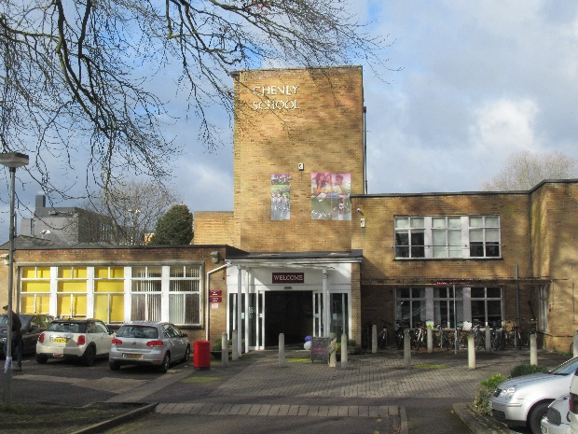
The Festival of Imagined Worlds
On the 9th of February, Bianca Facchini and I (Sharon van Dijk) went to Oxford to represent the Society for Neo-Latin Studies (SNLS) at the Iris Festival of Imagined Worlds, which was taking place at Cheney School. The festival started at 3 pm, and we arrived at 1 to set up. There were various worlds in different rooms, such as Harry Potter World, Tolkien World and C.S. Lewis World. Some of the stalls in a room were related to the imaginary world it was named after, others had some other link to the theme. Our stall was in C.S. Lewis World, which was based in the library.
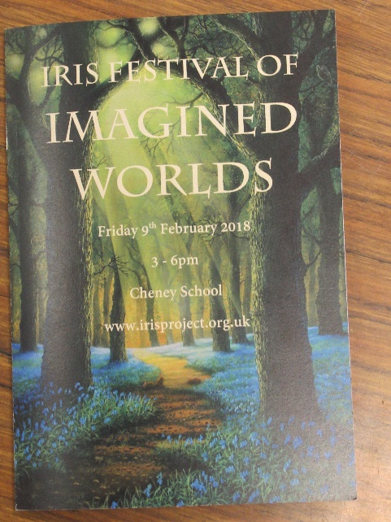
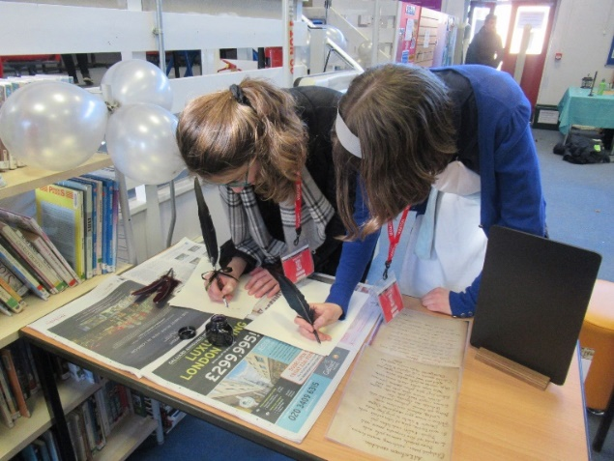
At our stall, we explained visitors a bit about what neo-Latin is, with a short, interactive powerpoint presentation. Starting with the multiple-choice question “Who do you think spoke Latin?” which had as possible answers ‘Queen Elizabeth I’, ‘William Shakespeare’ and ‘Isaac Newton’, we told them a little bit about the importance of Latin in the 16th and 17th centuries; it was the international language and the language of education from when a child began school at age 8 right up until they left university. The imagined worlds that could be discovered at our stall were, of course, also neo-Latin ones: Thomas More’s famous Utopia (1516) and Ludvig Holberg’s Klimii iter subterraneum (1741). Because of More’s novel, the word ‘utopia’ is now used to refer to a perfect society. The adventures of Holberg’s hero reminded many of the visitors of Gulliver’s Travels. Children could have a go at writing some Latin with a quill, just like pupils in the 16th and 17th centuries did. There were some images from manuscripts as inspiration!

There were hundreds of people attending the festival and it was a very enjoyable afternoon. So many people were interested to find out about neo-Latin: children (ranging from the very young up to A-level students), parents, grandparents and other stallholders, as well as academics from related and different fields. Many people were familiar with Thomas More’s Utopia, but unaware that it was originally written in Latin. The quill activity proved very popular too: everyone wanted to have a go! Even the children who were shy or too impatient to talk about Latin in the early modern period were telling each other about the stand where you can write with feathers and ink, and there was often a bit of a queue!
The quiet before the storm (or festival). Some fellow stallholders try their hand at writing with quills.

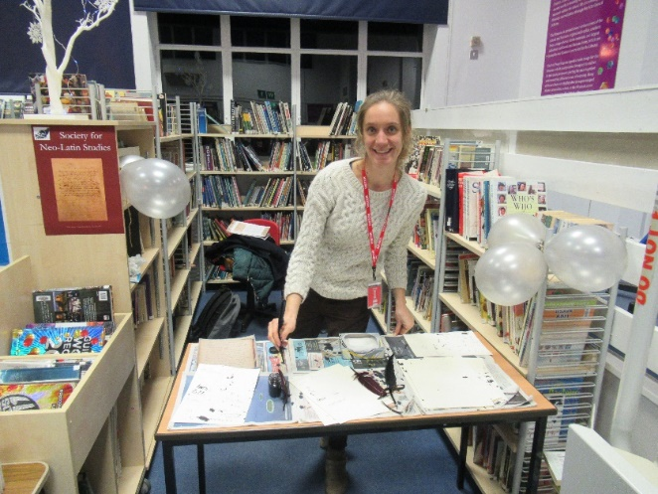

Bianca, ready to help you write your own bit of manuscript!

