INTERNATIONAL STUDY DAY

Ribera’s Art of Violence: New Intersections and Interventions

Dulwich Picture Gallery, London

Monday, 10 December 2018, 10.00 – 17.30

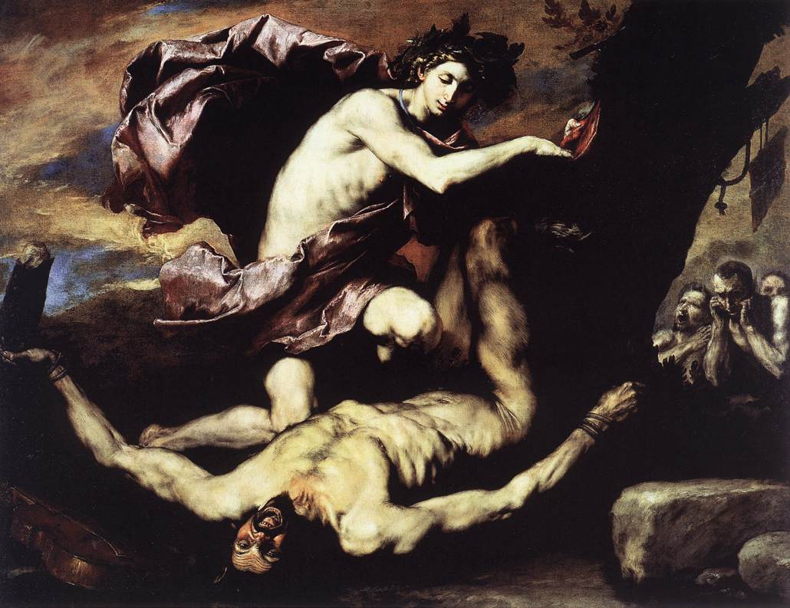

Dulwich Picture Gallery invites you to attend a study day inspired by the exhibition Ribera: Art of Violence (26 September 2018 – 27 January 2019). Examining Ribera’s art from various interdisciplinary perspectives, the event will bring together established and emerging voices to explore new approaches to the artist, his works, myths and audiences. The study day will be structured around the exhibition’s five thematic sections: Religious Violence; Skin and the Five Senses; Crime and Punishment; The Bound Figure; and Mythological Violence. Situating his paintings, prints and drawings within their historical context, this event will address the relevance of Ribera’s violent imagery in contemporary art and thought.

GALLERY SESSION, 10.00 – 13.00

[Chaired by Edward Payne and Xavier Bray]

09.30 – 10.00 Registration and Private Viewing of the Exhibition

10.00 – 10.10 Introduction: Edward Payne (Durham University) and Xavier Bray (Wallace Collection)

10.10 – 10.35 ROOM 1: Religious Violence
10.10 – 10.15 Xavier Bray (Wallace Collection)
10.15 – 10.20 Andy Beresford (Durham University)
10.20 – 10.35 Discussion and Viewing

10.35 – 11.00 ROOM 2: Skin and the Five Senses

10.35 – 10.40 Todd Olson (UC Berkeley)
10.40 – 10.45 Gemma Angel (University of Oxford)
10.45 – 11.00 Discussion and Viewing

11.00 – 11.30 Tea Break

11.30 – 11.55 ROOM 3: Crime and Punishment (Linbury Room)

11.30 – 11.35 Gabriele Finaldi (National Gallery, London)
11.35 – 11.40 Michele Di Sivo (Archivio di Stato di Roma)
11.40 – 11.55 Discussion and Viewing

12.00 – 12.25 ROOM 4: The Bound Figure

12.00 – 12.05 Elena Cenalmor (Museo Nacional del Prado)
12.05 – 12.10 Lorenzo Pericolo (University of Warwick)
12.10 – 12.25 Discussion and Viewing

12.25 – 13.00 ROOM 5: Mythological Violence

12.25 – 12.30 Edward Payne (Durham University)
12.35 – 12.40 Nigel Spivey (University of Cambridge)
12.40 – 12.45 Emma Dillon (King’s College London)
12.45 – 13.00 Discussion and Viewing

13.00 – 14.00 Lunch

PUBLIC SYMPOSIUM, 14.00 – 17.30

[Chaired by Edward Payne and Xavier Bray]

14.00 – 14.10 Introduction and Welcome: Edward Payne (Durham University) and Xavier Bray (Wallace Collection)

14.10 – 14.35 SESSION 1: Religious Violence

14.10 – 14.25 Jack Hartnell (University of East Anglia): Backwards through Bartholomews: Tools and Techniques of Stripping Skin

14.25 – 14.35 Respondent: Helen Hills (University of York)

14.35 – 15.00 SESSION 2: Skin and the Five Senses

14.35 – 14.50 Carlo Avilio (University of Warwick): See with the Fingers, Touch
with the Eyes: Ribera and the Failure of Painting

14.50 – 15.00 Respondent: Joanna Woodall (Courtauld Institute of Art)
15.00 – 15.25 SESSION 3: Crime and Punishment

15.00 – 15.15 Stephen Cummins (Max Planck Institute): Punishing Bodies in
Ribera’s Naples: Torture, Incarceration and Slavery

15.15 – 15.25 Respondent: Helen Langdon (Independent Scholar)

15.30 – 16.00 Tea Break

16.00 – 16.25 SESSION 4: The Bound Figure

16.00 – 16.15 Caroline Fowler (Clark Art Institute): Losing Control: Ribera’s
Examination of Desire and Will

16.15 – 16.25 Respondent: Gabriele Finaldi (National Gallery, London)

16.25 – 16.50 SESSION 5: Mythological Violence

16.25 – 16.40 Bogdan Cornea (University of York): Opening the Body, Opening
Touch: Rethinking Violence in Ribera’s Apollo and Marsyas

16.40 – 16.50 Respondent: Mechthild Fend (University College London)

16.50 – 17.20 KEYNOTE ADDRESS

Javier Moscoso (Centro de Ciencias Humanas y Sociales):
The Liminality of Skin in the History of Pain

17.20 – 17.30 Concluding Remarks: Edward Payne (Durham University) and Xavier Bray (Wallace Collection)

17.30 Close

