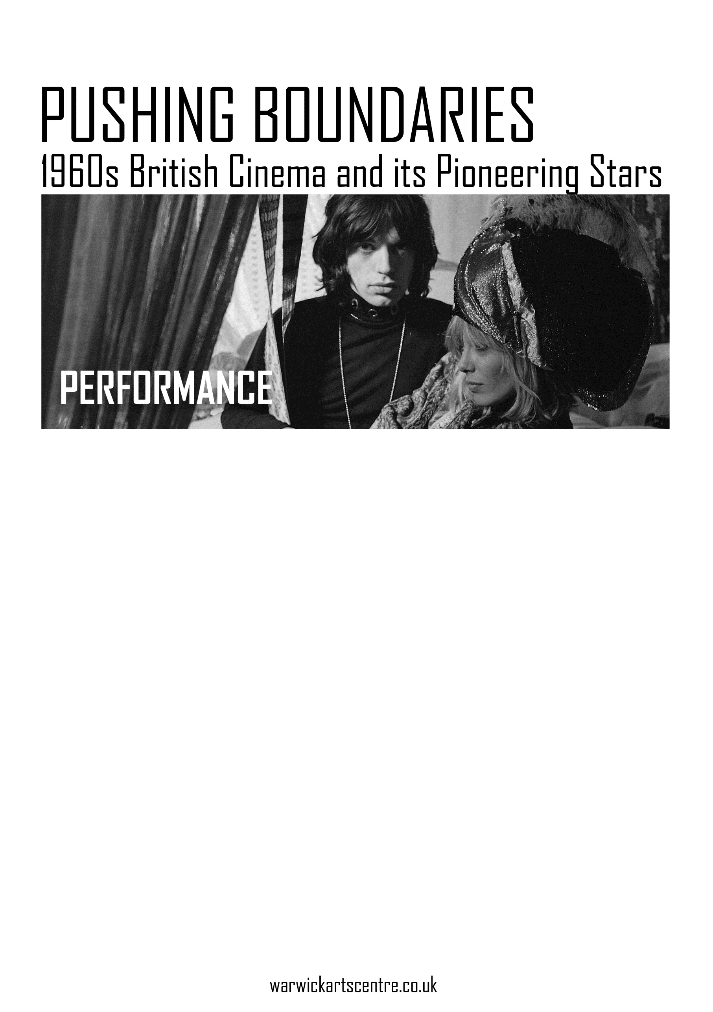

­T [Grab your reader’s attention with a great quote from the document or use this space to emphasize a key point. To place this text box anywhere on the page, just drag it.]

*“Perhaps the last genuinely exotic fruit produced by the bizarre mutations of British society in the 1960s.”*

Alexander Walker, *Hollywood England: The British Film Industry in the Sixties*, 1986.

*Performance* (1970) tells the story of violent gangster Chas Devlin (James Fox) who seeks refuge from the mob in the Notting Hill home (Powis Square) of rock god Turner (Mick Jagger). It is there where Turner, along with Pherber (Anita Pallenberg) and Lucy (Michèle Breton), introduce Chas to their Bohemian lifestyle of sex, drugs, music, and art.

Initially conceived as a light-hearted affair akin to *Alfie* (1966), writer and co-director Donald Cammell developed the script, which became more intense and psychological by introducing complicated themes relating to identity and gender. Cammell was, mainly, influenced by Argentinian writer Jorge Luis Borges, a portrait of whom can be glimpsed on a book cover during a key moment in the film.

Cinematographer-turned-director Nicolas Roeg, influenced by Ingmar Bergman and Alain Resnais, can be credited for the aesthetic of the film with the implementation of the fractured storytelling structure and dizzying editing style.

Cammell’s debauched script and Roeg’s imaginative visual style was met with outrage by Warner Bros. studio executives, who, expecting The Rolling Stones’ version of *A Hard Day’s Night,* shelved the film for two years. While none of the Stones’ hits are included in the final film, the soundtrack does feature Jagger’s ‘Memo from Turner’ (credited as a Jagger/Richards composition), alongside Jack Nitzsche’s beautifully dissonant score.

*Performance* pushed the boundaries with its explicit depiction of drugs and sex (rumours of its unsimulation persist to this day) and subsequently gained cult status, before its contemporary critical re-evaluation, confirmed with its listing at #48 on the BFI’s Top 100 British Films (1999).

- Matt Davies