Excursions, Saturday 23 March 2013, from 12.30pm
We are pleased to offer the following afternoon excursions.
- Please note that these tours will be viable only if a sufficient number enrols for each. To enable us to make arrangements, please confirm your excursion when completing and returning your conference registration form no later than 10 March 2013. Please note that payment must be made in euros (not by cheque or credit card) when you register in person at the opening of the conference in the Palazzo.

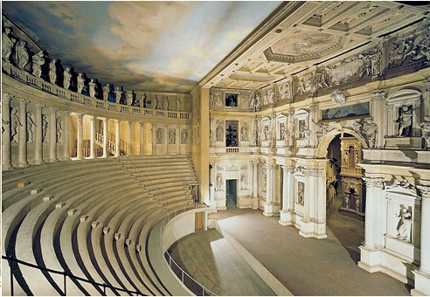
TEATRO OLIMPICO
- A visit to Vicenza, the city of Palladio, by private coach, leaving the Palazzo Pesaro Papafava at 12.45 pm, travelling to Tronchetto by vaporetto, and departing from there by coach at 1.30pm. We expect to arrive in Vicenza at 2.15-2.30. In Vicenza, we will have a tour of the Teatro Olimpico, preceded by a short talk by Paolo Sanvito in Vincenzo Scamozzi’s Odeon or the Ante-Odeon at the Teatro. The coach will bring us back to Venice in the early evening after, we hope, a little time to view Vicenza’s Palladian architecture.

- The famous Teatro Olimpico was designed by Andrea Palladio for the members of the Olympic Academy and constructed by Scamozzi following the great architect’s death. It housed a celebrated production of the Oedipus Tyrannos of Sophocles in 1585. The theatre auditorium and stage setting remain very much as they were in the sixteenth century. A more wide-ranging talk on the Teatro by Paolo Sanvito is included in the conference programme (Saturday 23rd March)

- Provisional cost: 50 euros. This includes:
The coach ticket
Packed lunch
Vaporetto tickets to and from the Palazzo Pesaro Papfava to Tronchetto
Entrance fee to the Teatro Olimpico

- This excursion is available to 40 people.

- Guided water taxi tour of the Grand Canal, leaving from the Palazzo at 3.00pm. This offers an excellent, informative introduction to Venice for those new to the city, lasting for about an hour.
Minimum number: 12
Cost: 30 euros

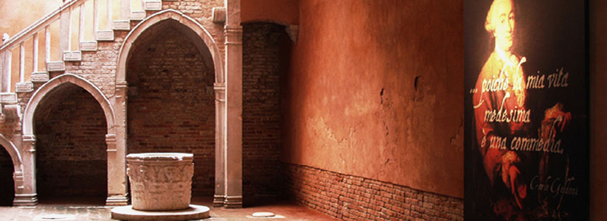

CASA GOLDONI

- Guided tour of the Casa di Carlo Goldoni and the Museo Fortuny
Leaving Palazzo Pesaro Papfava at 1.30pm and visiting both museums on foot and by vaporetto.
- Provisional Cost: 30 euros which includes:
2 vaporetto tickets (between the Palazzo and Casa Goldoni and back across the Grand Canal to the Museo Fortuny)
a packed lunch at the Palazzo before setting out
entrance ticket to the Casa di Goldoni (full-price 5 euros; reduced price 3.50 euros)
entrance ticket to the Museo Fortuny (full price 10 euros; reduced price 8 euros)

Other places to visit on Saturday afternoon (details correct at time of writing)

MUSEUMS AND GALERIES
- The Palazzo Ducale (beside the Basilica di San Marco): the Doge’s Palace, seat of government of the Venetian Republic.
Opening times: 8.30 -17.30 (last admissions 16.30)
Tickets: 16 euros full-price; 8 euros reduced price

- Museum Correr (Piazza San Marco – opposite end from the Basilica): Venice’s civic museum with works by Carpaccio and Canova
Opening times: 10.00-17.00 (last admissions 16.00)
Tickets: 16 euros full-price; 8 euros reduced

You can also buy a Pass for the Museums of St Mark’s Square – the Doge’s Palace; the Correr; the National Archaeological Museum and the Marciana Library; these cost 16.50 euros full-price; 8.50 euros reduced. The pass lasts for 3 months so may be useful if you are staying on in Venice after the conference, or arriving early.

- Ca’ Rezzonico (Dorsoduro): Venice’s museum of the 18th century
Opening times: 10.00 – 17.00 (last admissions 16.00)
Tickets: 8 euros full-price; 5.50 reduced

- Galleria dell’ Accademia: the world’s largest collection of Venetian art
Dorsoduro – beside the Accademia bridge
Opening times: 8.15 – 7.15 (last admissions 18.30)
Tickets: 9 euros full-price
NB Reduced price of 6 euros for European students 18-25 years.
European citizens over 65 have free entrance

- The Peggy Guggenheim Collection (Palazzo Venier dei Leoni, Dorsoduro) – one of Europe’s most important modern art museums
Opening times: 10.00 – 18.00 (closed on Tuesdays)
Tickets: Adults - 14 euros
Over 65 - 11 euros
Students under 26 (with student ID) – 8 euros

Churches

- Basilica di San Marco
Opening times: 10.00 – 18.00

- Santi Giovanni e Paolo, Campo Santi Giovanni e Paolo, Castello
Domenican church dating from the 13th century; contains works by the most important Venetian painters and includes tombs of the Doges and important monuments by leading sculptures such as the Lombardo family.
In the campo you can also see the façade of the Scuola Grande di San Marco and the statue of Colleoni by Andrea Verrochio.

- The Palladian churches: San Giorgio Maggiore, Isola di San Giorgio Maggiore; The Redentore, Giudeca; San Franceso della Vigna, Castello ( façade by Palladio)

- Santa Maria della Salute, Dorsoduro
17th century, Baldassare Longhena. The Salute is quite close to the Peggy Guggenheim Museum so the two can easily be combined in one visit.

- Santa Maria Gloriosa dei Frari, San Polo
13th century Franciscan church with important works by Titian, Giovanni Bellini and Donatello, as well as the tomb of Canova. Combine this with a visit to the nearby Scuola Grande di San Rocco with extensive works by Tintoretto, commissioned to decorate the interior in 1564.
San Rocco opening times: 9.30 -17.30 (last admissions 17.00)
Tickets: 8 euros full-price
Reduced price tickets of 6 euros for young people up to 26.

The island of Murano

- Home of Venetian glass and the 12th century Basilica dei Santi Maria e Donato. Take vaporetto No 13 from the Fondamente Nuove (a short walk from the Palazzo Pesaro Papafava). The vaporetto journey to Murano takes about 15 minutes.

