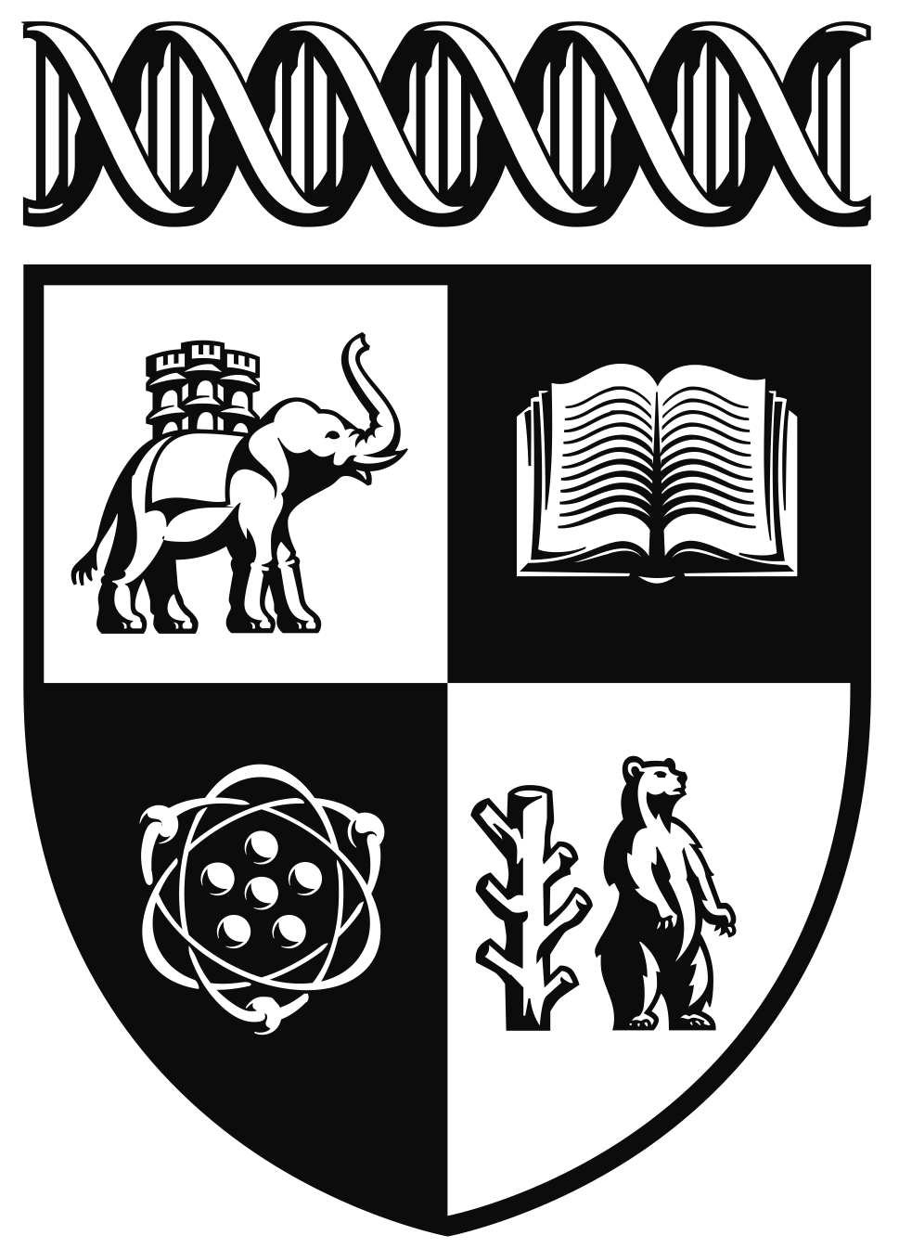

Global Sustainable Development Competition

This Teacher Information & Resource Pack contains everything you need to know about the Global Sustainable Development Competition 2026. Inside you’ll find key dates, judging criteria, entry guidelines, and support materials to help your students take part in this exciting challenge.

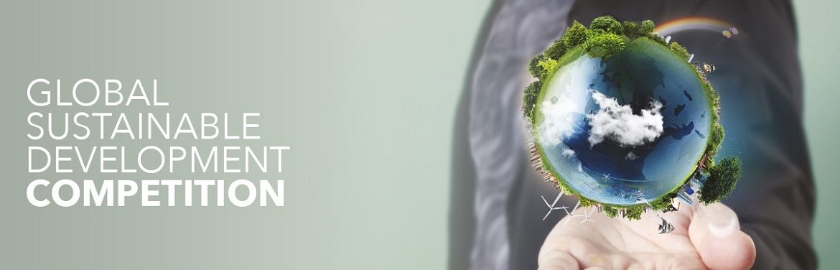
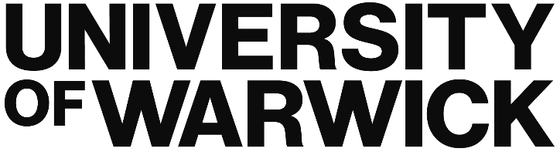
This is the University of Warwick. This is Beyond.

warwick.ac.uk
Introduction
Each year, the Global Sustainable Development (GSD) Department at the University of Warwick runs a competition for Year 11 and Year 12 students (typically aged 15–17). We launched the competition in 2016 to engage talented students from around the world and give them a taste of the kind of thought-provoking, interdisciplinary challenges that are central to studying Global Sustainable Development at Warwick.
Students must respond to one of the three set competition questions, but they have the freedom to choose how they present their ideas. Submissions may take any of the following forms:
- A written essay of 1,000–1,500 words.
- A 4-minute video or podcast essay, or a photo or series of photos accompanied by a commentary of up to 500 words.
- Alternatively, students may choose an artistic exploration — such as a painting, poem, short story, or short film — supported by a commentary of up to 500 words.
This flexibility ensures that entrants can engage with the competition question in a way that plays to their individual strengths, whether through academic analysis, creative expression, or a combination of both.

What is Global Sustainable Development?
The United Nations defines GSD as: “Development that meets the needs of the present without compromising the ability of future generations to meet their own needs.” (UN Report: Our Common Future, 1987).
At the University of Warwick our GSD degrees prepare students to engage with global challenges such as climate change, overpopulation, and global inequalities. We offer single honours and 12 joint honours undergraduate degrees, and postgraduate programmes as well. Our degrees equip students with the expertise, skills, and knowledge that enable them to contribute meaningfully to the debates about these big problems, so that they can make a real difference to the world.
To find out more about GSD at Warwick, please see here.

Why Take Part?
Specifically, this competition encourages students to:
- Think critically and creatively
- Develop valuable research and communication skills
- Explore global issues from new perspectives
- Gain insight into university-level study

The Questions

- How can interdisciplinary approaches (i.e. combining multiple subject areas and disciplines) help achieve the SDGs?

- Can technological innovation help achieve sustainable development, or does it risk exacerbating existing global inequalities?

- Is achieving the SDGs a collective responsibility or an individual one?

Submission Checklist
Before submitting, make sure:

I am aged 15–17 and in Year 11 or 12 (International entrants should be in equivalent year group).
My group members (if any) attend the same school.
My submission is in one of the accepted formats (essay, video, podcast, poem, etc.).
My submission meets the length/size guidelines (if applicable).
It is my original work.
I’ve clearly engaged with a topic related to global sustainable development.
I’ve shown understanding about and/or research on the topic.
I’ve added creativity and originality with my approach to the topic.
I’ve visited the Enter page and followed the upload instructions.
I’ve completed any required consent forms (if under 18).
I’ve included my name, school, and contact information.

FAQs

How can I enter?
You can find full entry details on our website. Final submission date: 4th May 12 AM BST.
Who can enter?
The competition is open to students aged 15–17, in Year 11 or Year 12 in the UK. International students in this age range are also welcome to submit an entry. Entries can be individual or group (group members must attend the same school).

Does it depend on what I study at school?
No. There are no restrictions on subject choices, and we welcome all academic backgrounds – the same way as we do for our single honours degree.

How is the competition judged?
Entries will be assessed by a panel of GSD academic staff and current Warwick GSD students.

What will judges be looking for?
Judges will be looking for: Engagement with the chosen topic, Evidence of research and understanding, and Originality and creativity in approach.

What will the winers receive?
Shortlisted UK-based students will be invited to an on-campus celebration on 4th July 2026, including talks with staff and students. Winners will be announced at this event. International finalists will attend a virtual version of the event. Recognition & Prizes Winners may have their work published on our website. All finalists will receive certificates in recognition of their achievement. A fantastic opportunity to enhance university applications and personal statements.

I am a teacher; how can I help my students?
All work must be the student’s original work. Teachers, you can help by suggesting the competition to students you think could benefit from this opportunity. Please encourage students to take part, circulate this information via newsletters or classroom announcements, and/or add the competition to your school’s enrichment programme.
We’ve seen wonderful engagement from schools in previous years — some winners have gone on to study GSD at Warwick!

