Hello and welcome to Snakes and Ladders!

This is a design thinking inspired activity specifically tailored for students and staff co-creating and innovating in Higher Education.

This handout will guide you through the activity. You are welcome to use the next few pages as handouts and examples in your workshops and activities. We invite you to experiment with the idea and the handout. Do please share your experiments with the team and on the Designing Together LinkedIn Group.

Initially designed for exploring one’s sense of belonging when researching students’ learning journey on an undergraduate and postgraduate module at Warwick, the activity invites participants to explore key moments of belonging in the curriculum with snakes representing moments of not belonging and ladders moments of belonging. Participants can further use colours to pinpoint and reflect on belonging using green, non-belonging using orange, and moments of transition using yellow.

On the next two pages, you will find a Snakes and Ladders template and example with additional participant instructions. Give your participants around 10 mins to complete this and adjust the time based on your group size and activity.

On the final page of this handout, you will find a blank Snakes and Ladders that you are welcome to use and/or to repurpose the activity to suit your needs.

If you have any questions or to share your experiments and upgrades to the activity, please do not hesitate to reach out to Nikita Asnani via this website or on nikita.h.asnani@warwick.ac.uk or Dr Bo Kelestyn bo.kelestyn@warwick.ac.uk.

Thank you and have fun playing!
Nikita, Minali, Bo and the Designing Together team
University of Warwick
Last updated: January 2024

Imagine your student experience as a game of Snakes and Ladders. Think back to explore your moments of belonging. Use coloured pens and this template to capture your experiences and any reflections.

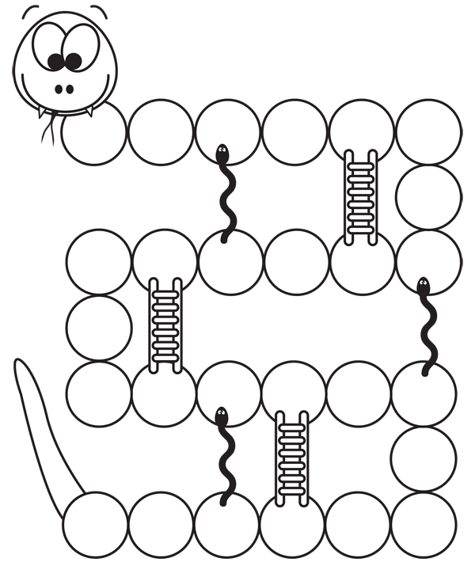

- Snakes and orange = not belonging
- Ladders and green = belonging
- Yellow = transition
- Any other colours or visuals = anything else that is interesting or of significance to you and your experience

Turn this sheet over to see an example J
Snakes and Ladders example with key moments of belonging.

Taking time out to question how I was doing my assignments: just for the sake of it, or experimenting with new ideas?
Beating myself up about not being perfect
Asking my module convener for feedback
Cultural resistance in teams-different people had different levels of understanding
Learning to write in my own words instead of trying to sound ‘intellectual.’

- Snakes and orange = not belonging
- Ladders and green = belonging
- Yellow = transition

