Ancient Global History Module – Option C Assessment: Oiko.world

A reminder of what is entailed:
- Attend the Term 2 (week 11) digital training session (Tuesday 8th January 11am-1pm in H0.60)
- Submit a 250 word plan via Tabula outlining your choice of digital entries + narrative chain by Wednesday 16th January (Term 2 Week 12).
- Complete the following:
  - C1: Digital Entries + Narrative Chain:
    - Create 3 Data Entries on Oiko.world, each with complete database information, primary and secondary sources and a 500 word description.
    - Link these 3 digital entries into a 'Narrative Chain', and complete a title + 200 word narrative chain description.
  - C2: Reflective Essay: Write a 1000 word reflective essay, reflecting on the choices you made, situating them within their historical context, and analysing the impact your entries have had on the wider picture of connectivity represented within Oiko.world.
To see the assessment criteria by which you will be judged, please refer to: https://warwick.ac.uk/fac/arts/classics/students/modules/ancientglobalhistory/assessment/

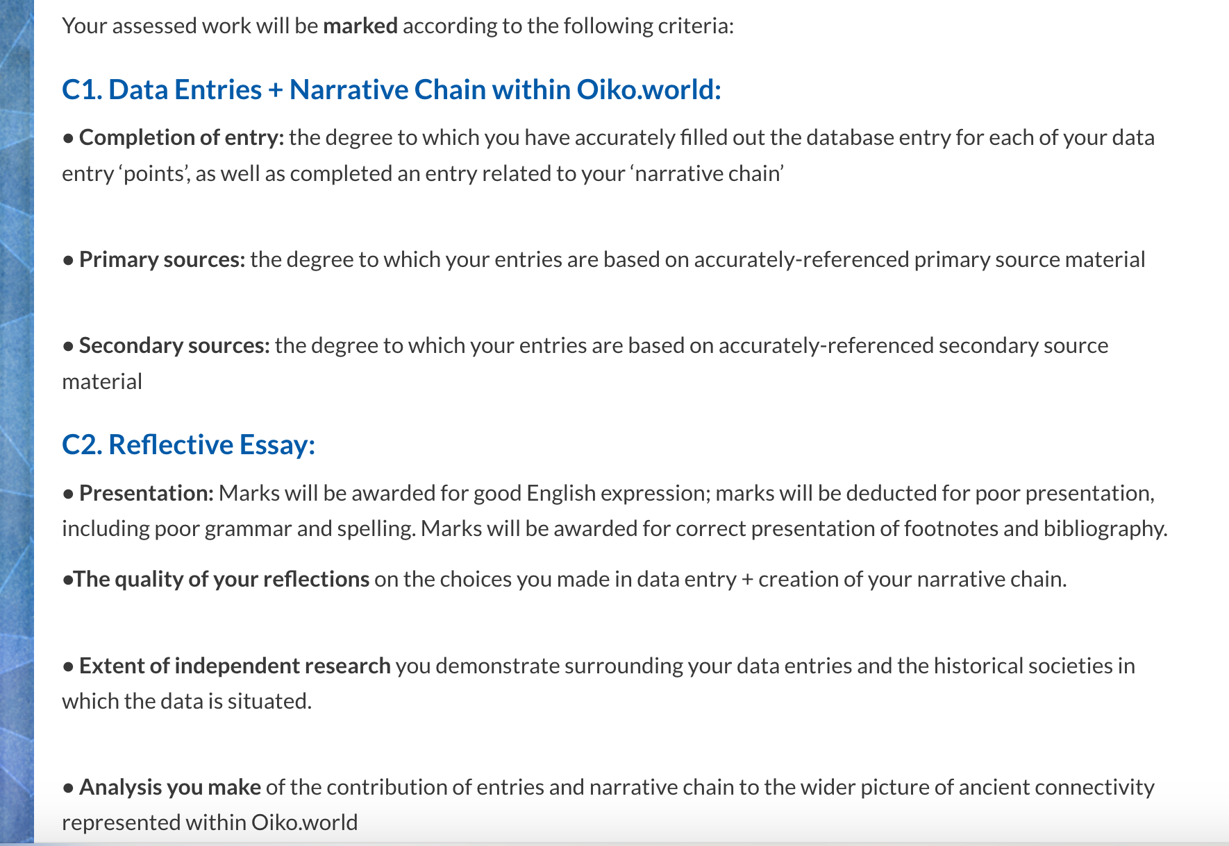

NB – please use either Chrome of Firefox browsers when working on your assessment as portal is best configured for these browsers (both are available as free downloads for PC and Mac).

- Go to https://oiko.world.
- Log in (top right) using Warwick Single Sign-On.
- If you have been authorised for Option C, you will have new ‘pencil icon’ top right. Clicking on it will reveal the ‘Editor tools’:

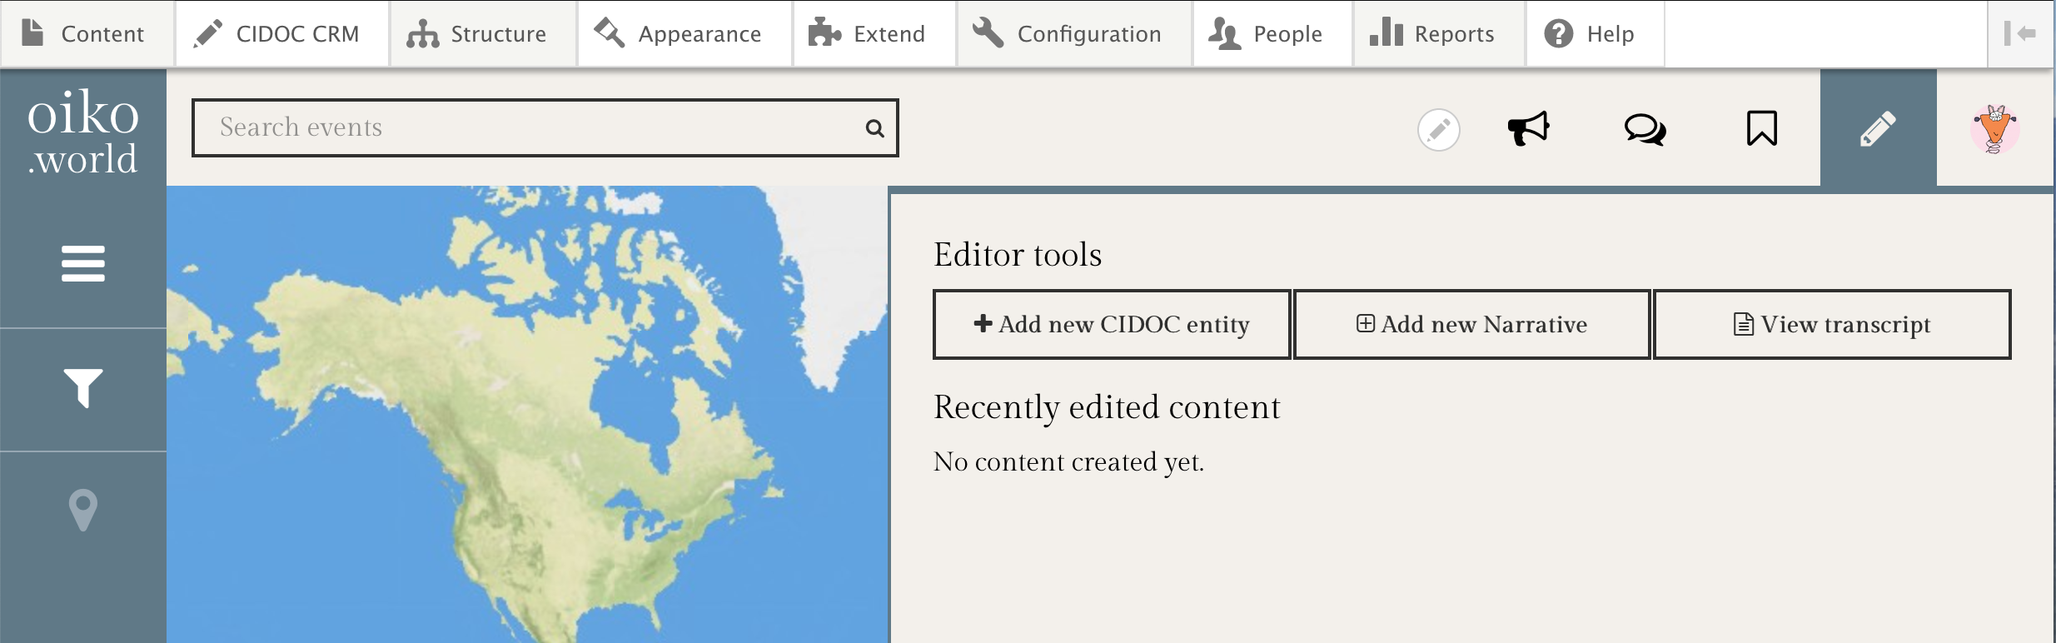

- Click on ‘Add a new CIDOC entity’. You will see this screen:

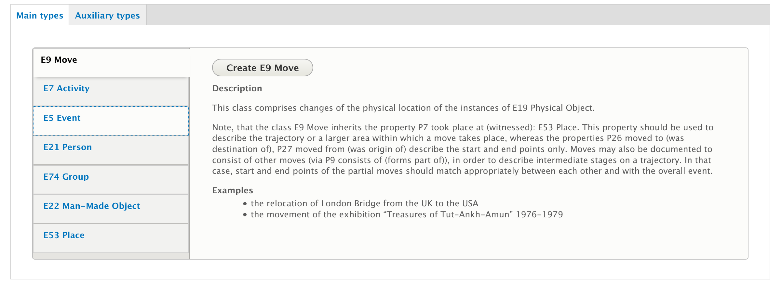

- Here you choose what kind of ‘data entry’ you will be making. Is it an activity, event, person, group, object or place?

Creating the Data Entry (example E7 Activity):

NB – it is best to do all your research on your events first so that you have all the data to hand to enter, as it becomes more difficult to keep going back to add more data to each date entry.

- Click on Create E7 Activity. You will see this screen:

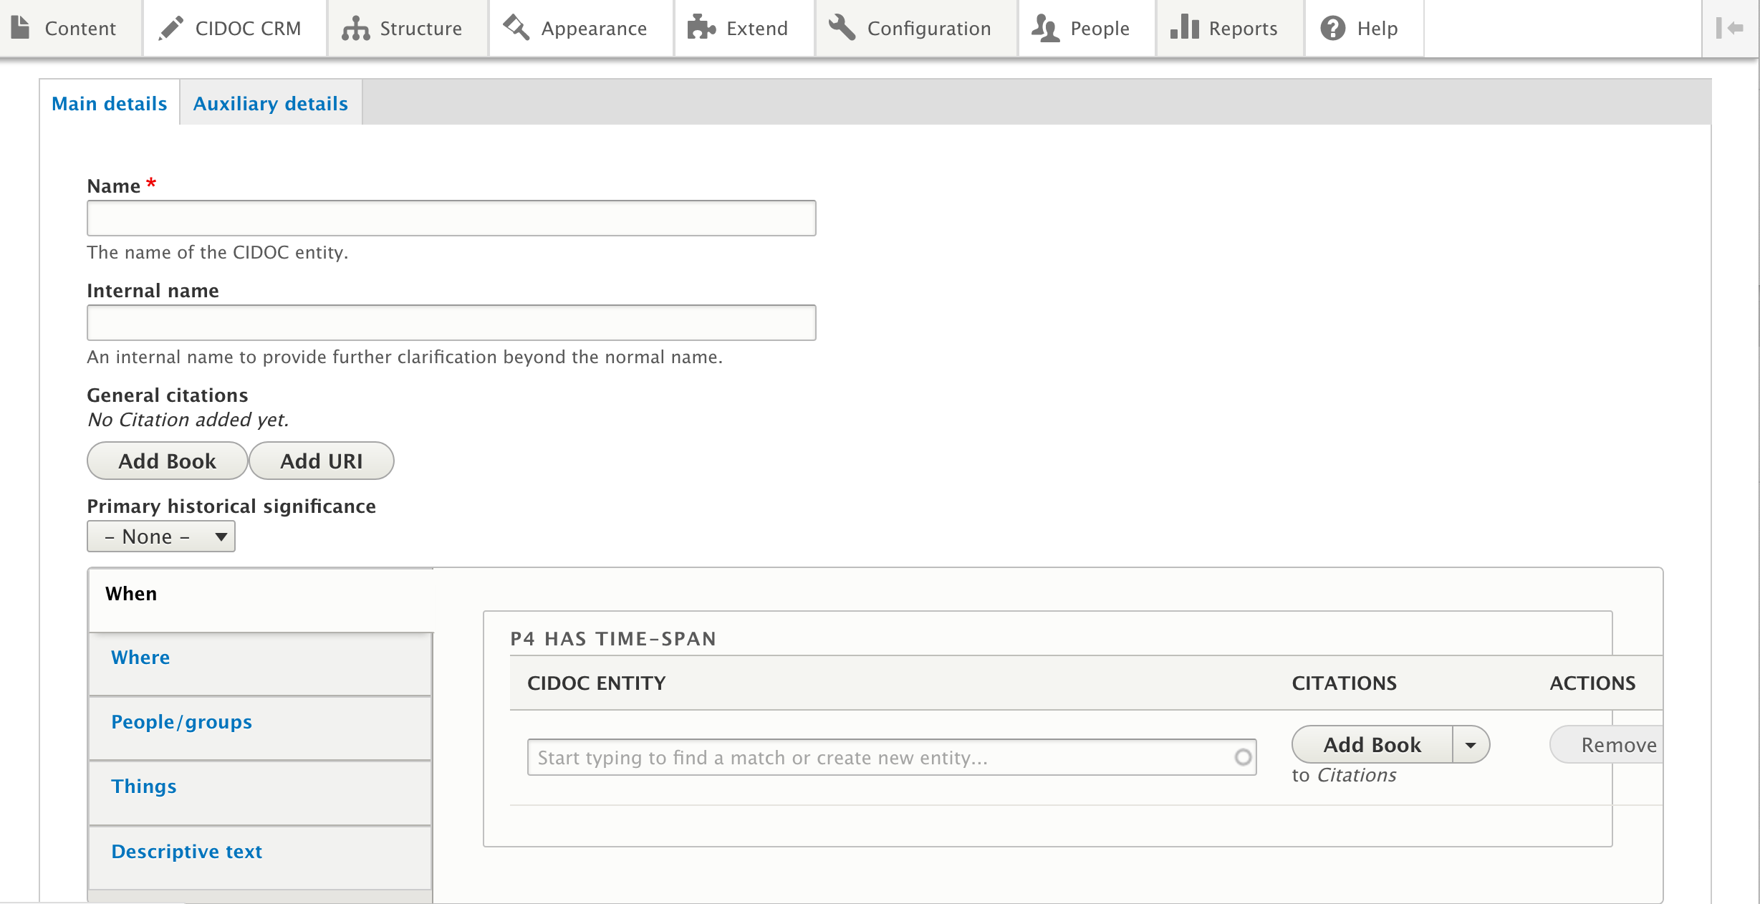

- Add in the name.
- Internal Name: use this if there is more than one name for a place or when more than one place have the same name (e.g. Alexandria – which one?!) (In some entries, you may also have ‘Appellation’ where you can add a different name if a person had two: e.g. Octavian and Augustus.)
- General Citations – Add Book - this is where you add your general bibliography for the entry (both primary and secondary sources). Please use the following styles:
- Strabo Geography 11.1.5
- Abulafia, D. (2011) The Great Sea. Oxford.
- Parker, R. (1985) "Greek states and Greek oracles." In CRUX: Essays in Greek History Presented to G E M de St Croix, ed. Harvey, F.D. and P. Cartledge, 298-326.
The system will auto-suggest if the book has already been used.
There is an input box for you to list the page numbers for this general citation.
- Primary Historical Significance – this is where you decide nature of event (and what colour pin it will have on map)
- When – add date:
  - If date is in the system, it will appear on drop down menu. If not, add full date (BCE/ CE) and then click on ‘Create New Entity’
  - To corroborate date (or any other fact) you can add specific references to primary sources / secondary sources by clicking on Add Book by the specific piece of info and recording source as above.
- Where – add place (again if not in system ‘Create New Entity’)
- People/groups – add names (again if not in system click ‘Create New Entity’). When creating new entities, it will ask you whether this will be a Person or Group – you need to decide. You may well need to add more than one person/group involved in the activity here, so click on ‘Add another’ as many times as necessary.
- Things ‘Occurred in the Presence of’ – there may be others witness to the event that you would like to link into the event. Add as above.
- Descriptive Text – this is where you add your 500 word description of the event.

Remember: until you press ‘Save and Continue to Populate New Entries’ none of your work has been saved.

Continuity: it is crucial for Oiko that we standardise the way data is entered. Check against entries already in the system for how things should be entered (e.g. dates as 1st January 200 CE)

When you press Save and continue to Populate New Entries, the system will automatically take you to complete any of the ‘New Entities’ you have created as part of your data entry. You must complete all the New Entities associated with your Data Entry in order to complete each data entry.

Completing New Entities:

- Each element of When, Where, People, Things you entered will now need to be further specified individually.
- Date:
  - A time-span can be both a single date, or a range to represent a stretch of time. The name for this entity should be the readable expression of that time, like 5th March 317 CE – 17th April 317 CE. Please note that all dates are referred to as CE, rather than as AD as a point of continuity. Below it, the system will attempt to convert the human readable text into the Extended Date-Time Format (EDTF) format. There is a link to the page that explains the EDTF syntax. If you enter in the most ‘digital’ version of that date, the system should be able to convert it for you:

Name: 5th March 317 CE – 17th April 317 CE (easy to read, as will appear on the front page).

Human Readable entry: 05/03/317-17/04/317 (most ‘digital’ version). For BCE dates, add BCE and the system will convert it.

The converted EDTF is: 0317-05-03/0317-17-04 (the format the system requires)
- Place:
  - Here you need to provide a Pleiades URI reference to help system locate it on a map. In a separate browser window, go to https://pleiades.stoa.org and search.
  - If found, click on entry and copy the ‘Canonical URL for this page’ as detailed in the entry. Paste this into Oiko.world – Pleiades URI box and click on Fetch Pleiades URL.
  - For when a place is not found in the Pleiades system.
    - Go to Google maps
    - Search for your location
    - Slowly click/double click on location to reveal geodata (longitude / latitude)
    - Make a note of longitude / latitude
    - Within Oiko.world CIDOC-CRM entry system:
      - In Where / Place entity entry (below map)
      - Find ‘GEODATA’
      - Enter Geodata from Google maps:
        - NB you need to switch around the longitude/latitude co-ordinates from how it is presented in Google Maps. Oiko.world wants the longitude first.
    - You can check that the place has been correctly identified by ensuring that the map representation shows the place in the correct area of the world (where you were expecting it to be!)

See the second half of this guide for more details on entering data for different entities.

When all entities associated with your new entry have been populated, the system will exit the entity edit screen. If you manage to exit before you have completed entering relevant data against all entities, you can see each of them by clicking on the ‘pencil’ to edit at any point.

From the map or timeline view you can search in the top menu bar to see you entry as it appears in the Oiko system (and check all your information has come through)

To re-edit it, click on the Edit button:

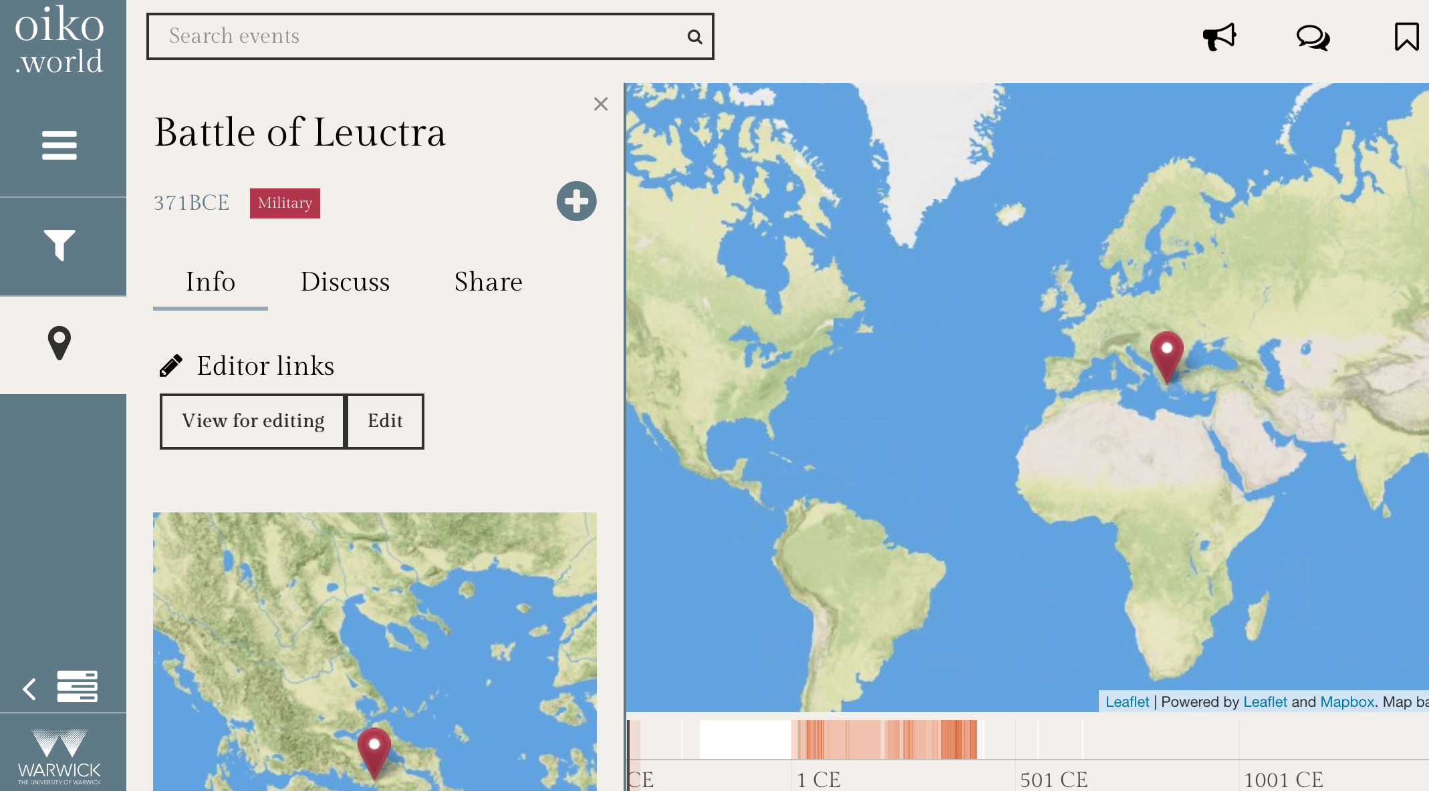

This time you can click on ‘Edit this Place/Date/People’ to change any of the entities you have created in association with the data entry. Remember to press Save every time!

Making the Narrative Chain:

- Once you have your three main data entries complete, you need to link them into a narrative chain. To do this, click on ‘Add New Narrative’ from main Oiko.world view page.

- You will see the following screen. You need to give your narrative a title and a 250 word description.

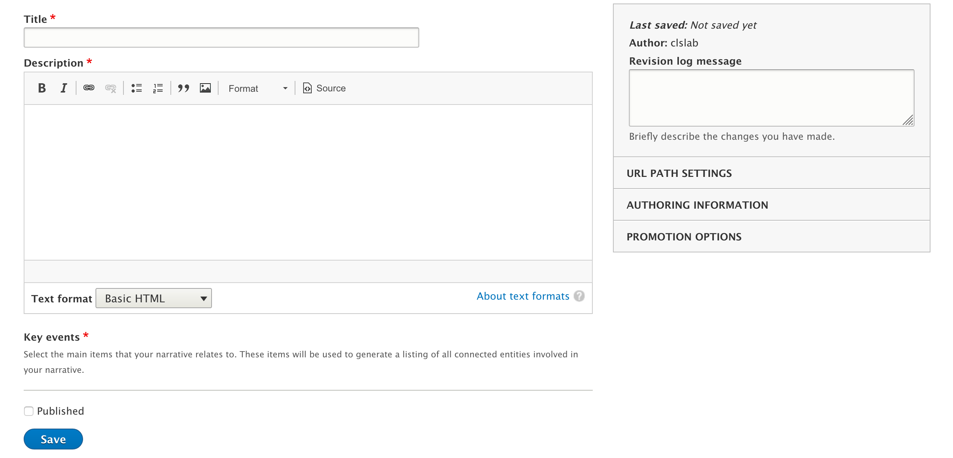

- You also need to link your individual data entries into this narrative. Under Key Events you will see a list of your created entries. Tick on the ones you want to include in this narrative.

- Press Save.

Checking your work:

- You can see your narrative ‘transcript’ including your individual data entries by clicking on ‘View Transcript’ button from the Editor Tools panel.

- You can return to edit your narrative description by finding it in the list of ‘Recently edited content’ or click on the familiar pencil icon in the transcript view. To change any of your data entries, however, see above (changes will then be brought through into your narrative chain and transcript).

Exporting your work out of Oiko.world:

- Select ‘View Transcript’ from the Oiko from the Editor Tools panel.

- When you are ready to export:
  - Find the ‘Print’ option for your browser (File-Print)
  - In the Print dialogue box, under Destination, select ‘Save as PDF’ (note process slightly different for Mac and PC).
  - Your transcript will be saved as a PDF on your computer.

Submitting to Tabula:

- You will have a PDF of your Narrative Chain from Oiko.world
- When you are ready to submit, save your reflective essay also as a PDF rather than word doc (look for file options within Save As dialogue box).
- Taking your 2 PDFs you need to combine these PDFs as Tabula will only allow the submission of a single document.
- You can combine PDFs in various ways. Feel free to use any system you want if you already know how to do this (e.g. Adobe).
- If you would like guidance, do the following:

  - If you use a PC:
    - Download the Power PDF Advanced software from Warwick IT services page (after agreeing to T&Cs): https://warwick.ac.uk/services/its/servicessupport/software/list/pdfconverter
    - Under New from File tab, select ‘Combine into Single PDF’.
    - Select your two separate PDF files and click OK to combine
    - Save this combined PDF
    - Open this new PDF document and check it to make sure it has all elements of the two individual documents.
    - Submit to Tabula.

  - If you use a Mac:
    - Open your Transcript PDF in Preview
    - Select View -Thumbnails
    - Drag the Reflective essay PDF icon into the Thumbnail window of Preview
    - Drag the Reflective essay icon inside the Thumbnail window on top of the Transcript PDF icon. This merges the documents.
    - Click on File – Export to export this new combined file and save it as a new file.
    - Open the new document and check it has all elements of the two original files
    - Submit via Tabula.

DETAIL ON CIDOC-CRM ENTRIES:

Types:

E9: Move:
This is related to an activity in that there is a deliberate change occurring, but it is far more specific in that it allows you to express a change from two locations. This is therefore very useful for changing capitals or migrations, artefacts being relocated etc. See Place for more detail on how to enter this type.

E7 Activity:
This is the most common entry you will make. It might include a battle, a decree, a trial, a meeting; anything where there is an interaction where a person is responsible for doing something.

You will be prompted to include a name for the activity – this needs make clear to what it refers. This means that if you are referring to a peace treaty between Rome and Parthia, for example, the activity title needs to explicitly include Rome and Parthia in that title; in other words, use an appellation specific to that meeting. Though you will be explicitly connecting a person or group that participated in/carried out the peace treaty, this will not be the only peace treaty in the system. There is space below to outline the details of the activity, so the title does not need to be expansive, but it ought to be specific.

This is related to an activity in that there is a deliberate change occurring, but it is far more specific in that it allows you to express a change from two locations. This is therefore very useful for changing capitals or migrations, artefacts being relocated etc. See Place for more detail on how to enter this type.

E5: Event
An event, in contrast to the activity, is a more passive occurrence. It might indicate a volcano’s eruption, a fire, a famine, anything that causes change but is not necessarily acted upon by a specific individual. A nuance of this is that an event can represent a War or a Reign, because it is an overarching classification for something that is made up of many parts. To explain this further, a war is made up of battles (activities) or deaths etc, but the war itself is more like an abstract concept, a label for the collection of activities. Similarly, the reign of a ruler is an assignation of a collection of activities or events that fall within that label. A more in depth discussion of the rationale behind this can be found in the concept section, ‘structuring a reign’.

There are many entries that can be connected to an event, especially in the auxiliary details. These can help tie in the other activities or people that are associated with this event in more complicated ways.

E21 Person
The person type is the easiest to understand when it should be employed, but does have its pitfalls. The main name is the primary one that the person will be referred to. As such, it is important that this is very clear, in the same way as described in naming an activity. It is also useful to use the most popular name – for example, one could argue that Augustus’ name is Octavius, but for clarity, in most cases it is more useful to refer to him by his later name. There is room for alternative appellations in ‘also known as’ which will attach these other names, and an internal name. The internal name is most useful to clear up potential disambiguation issues, as you can put in a common name there, rather than his formal one. So as an example:

Name: Emperor Fu Jian of Former Qin (clear appellation, distinct from any other Fu Jian’s)
Internal name: Fu Jian (common name, for clarity)

Also known as: Emperor Xuanzhao of Former Qin (official name for him as emperor)
In some cases, it is not necessary/applicable to specify a person’s role or affiliation in their name, and you will not need to add the other appellations.

You will also be able to indicate their affiliation in the other details of the entry. In Joining/Leaving you will be able to indicate their ascension/inauguration to a group, and also leaving it, if it is possible for them to leave office, and these options allow for more specific details like inauguration date etc. More importantly, you can enter their position within a group (society) in ‘is current or former member of’, where you can assign what to group they belong and what role they play within that group. To continue this example then:

Current or former member of: Former Qin Dynasty (group)

In the role of: Emperor

E74: Group
Groups are useful collections of people, and are being used to express communities/civilisation within the system (see concepts, structuring civilisation). These can be of any size, from just a few people, to being a group of groups – an expression of a collection of tribes belonging to a particular racial group, for example. This position within a hierarchy is prompted in the tabs on the entry.

E22: Man-made Object
An Object might be something like ‘the Colosseum’ or ‘an axe’. There are not many in the system currently, and it is a useful way of exploring the more cultural side of the expression of history represented by the Oiko project. It is worth noting that the ‘produced by’ entry does not allow you to specify a person that has produced it – it instead creates a specific production event. Therefore you would have:

Colosseum/Flavian Amphitheatre (object) → Construction of the Colosseum (Production) with details that include who by/date/motivated by etc.

Structuring ‘civilisation’

Different cultures (i.e. the Roman Empire, or the Han Zhao Dynasty) are classified as groups rather than as a place. This is partly because there is the capacity with a group to be part of a hierarchy, so to follow our example, a Roman legion might be a small group, part of the Roman army group, which is part of the Roman empire, or any number of tribes can be categorised as being part of a much larger racial group, like the Huns. The other reason for this is that many groups do not have a fixed location or centre to their civilisation. Defining a community or civilisation as a geographical location also presents difficulties because it plays on modern ideas of nationalism, where we define part of our identity or culture by which country we are part of, which is a construct that is strongly related to the boundaries which define it. However, in the 1st to 4th centuries AD, this was certainly not as strong an influence with nomadic groups of people and vast tracts of land were either unclaimed by any ruling community or which belonged primarily to those that lived on it, without any more complex assignation.

As such, a society should be classified as a group, within which its members can be contained. The territory or individual cities of that society can be entered as a place, and connected to the activities and events that the people within the society, thereby associating geographical region to a group of people in a way that does not always have to be the same over time.

Structuring a ‘reign’
The reign of a ruler in nation can be expressed in a number of ways. That the person acts as ruler should be indicated in the details of that person, so they will already be a member of a group (civilisation) acting as leader. You can also enter the activity of them joining (inauguration) or leaving (being deposed) that group. The reign itself should be an event (that could be classified as a result of the inauguration) which might look like this:
Name [Reign of Emperor Person of the Group]
When: [appropriate timespan]
Where: [Capital city] or [society’s territory]
People: [Person who is reigning] AND [Group they are reigning over]
Contains (Auxiliary): [Activity or Event that happens during the reign]
Forms part of (Auxiliary): [Period]

Births and Deaths (Auxiliary entry types)

The action of a person being born, or dying, are separate entities in themselves because they indicate a kind of activity or change of state. When entering these, we need to remember that as this is a separate, but associated event, the name of the event should be ‘Birth of Fu Jian’ rather than the date itself. Within ‘Birth of Fu Jian’ you will be prompted to provide the timespan, which includes the date. This goes against intuition, because when we think of birthdays, we tend to consider the date as a noun, rather than as a property of time; the database can’t make that distinction, so it must have the ‘noun’ (birth event) and the time associated (time-span).

The same applies with deaths – but you have the option to specify whether it was a ‘natural’ death or a killing. All of these (birth, death, killing) have multiple associated entries, so that you can attach the individual’s mother and father, any activities their birth motivated, anything that motivated their murder etc. Do check that you have attached as many entries as you can to create as multi-dimensional an entry as possible.

Structuring a battle
A battle is clearly an Activity, and is for the most part straight-forward. As a note of continuity however, in the section for which people are involved, the following format is advised. In the ‘carried out by’ section, we should have listed people or groups who were actually at that battle, so a specific legion or general of the Roman empire against a particular enemy commander. In participants however, it is advised to include the group to which these people belong, because although not all of the Roman Empire was present at the battlefield, that Roman military leader was representing the Roman group, and the victory would be claimed as Roman, not just as of that one person.
Ideally then, we would have two opposing leaders in the carried out section, and their role as victor or as defender etc can be specified in that section. The opposing societies that the individual represent would then be in the participant section, so that the battle is included in the things associated with that society. Sometimes this individual situation is not quite this simple, so use discretion as necessary, but try to aim for these kinds of connection between military leader and their society in the battle activity.

