Purpose
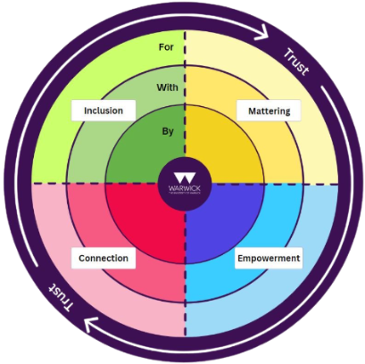
This resource is designed to support you—whether you are designing, reviewing, or participating in initiatives—in discussing and capturing opportunities through the lens of our Warwick Belonging Framework. It helps you identify and strengthen the four key elements that contribute to building belonging:
- Inclusion: Creating environments where everyone can fully participate
- Mattering: Ensuring individuals feel valued and significant
- Empowerment: Enabling agency and self-determination
- Connection: Fostering meaningful relationships
All these elements are enabled by trust, which forms the foundation of true belonging.
This resource also supports you in considering different levels of participation in your initiatives:
- For: Activities and support designed for students
- With: Collaborative efforts developed with students
- By: Initiatives led by and owned by students themselves
How to Use This Resource
Whether you're a staff member, student, or community partner, this guide will help you:
- Evaluate existing programmes through the Belonging Framework
- Design new initiatives with belonging at their core
- Measure and improve the impact of your work on the Warwick community
Join Our Community
The Belonging Learning Circle welcomes all Warwick staff and students passionate about fostering connection on campus. You don't need prior WIHEA involvement to participate and contribute to making Warwick a place where everyone truly belongs. Email inca.o.hide-wright@warwick.ac.uk or Tom.Ritchie@warwick.ac.uk to join.
Inclusion | Mattering
For  With  By | For  With  By
Connection | Empowerment
For  With  By | For  With  By

