Interim Neurodiversity and the Student Experience report (Draft)

Background Literature to the project
Over the past five years, the University of Warwick has seen an increase in the proportion of entrants with a declared disability. Most students that entered the University with a disability in 2016/17 had a cognitive and learning condition. The continuation rate for students with disabilities in 2016/17 was 89.6%, compared with the 96% continuation rate for students with no disabilities (Access and Participation plan 2020-21). The Universities 2018 TEF submission reported that disabled students rated teaching on their course (Disabled Students - 85.2% vs Not Disabled students - 87, 1%), assessment and feedback (Disabled Students -67.0% vs Not Disabled students - 70.0%) and academic support (Disabled Students -77.0 vs Not Disabled students - 81.0%) lower than non-disabled students.

Aim of the WIHEA project
Warwick International Higher Education Academy funded the project. We focused on students with Specific Learning Differences (SpLD) and Social and Communication Differences due to greater numbers of students declaring SpLDs and Social and Communication Differences across Higher Education. We used a social model framework for this project, and the term Neurodiversity was adopted after student and staff consultation. Neurodiversity is an umbrella term for dyspraxia, dyslexia, attention deficit hyperactivity disorder, dyscalculia, Autistic Spectrum Condition (ASC), and Tourette syndrome.
The project was exploratory and aimed to look at.
- Neurodivergent students’ academic learning experiences.
- Approaches that staff use to support neurodivergent students in their academic learning experience.
- staff awareness of cognitive and learning conditions – i.e., neurodiversity.

We aim to create an “inclusive good practice pedagogical toolkit” by doing these three activities. This toolkit would include pedagogical exemplars for staff to use for personal tutoring, academic support, curriculum design, teaching approaches, assessment, and wider student experience initiatives. Exemplars were collected from the Warwick staff community. These exemplars are supported by capturing neurodivergent students learning and student experience voices in pen portraits and infographics. The project is aligned with Warwick’s inclusive education strategy and education strategy.

Methods
Participants

Age
Eighty-five participants completed the full survey (50 partial completions were removed before data analysis). 35%(n=30) of participants were aged between 18-20 years of age, 43% (n = 37) were aged between 21-24 years, 12% (10) were aged between 25-29 years, 8% (n =7) were aged between, and 1 participant was 40+ years of age.

Gender
Fifty-three participants were female, 13 students were male, 1 student was female non-binary, 2 students genderfluid, 11 students were non-binary, 4 students were trans masculine and 2 students preferred not to say.

Ethnicity
Fifty-eight students described their ethnicity as English / Welsh / Scottish / Northern Irish / British, seven students as African, seven students as another White background, one student as Bangladeshi, two students as Chinese, three students as other mixed/multiple backgrounds, two students as Pakistani, one student as another Asian background, one student as Irish, one student as White and Asian, one student as White and Caribbean and one student as preferred not to say.

Degree status
Students were registered in a diverse range of programmes which included: eleven students from degree apprenticeships, postgraduate research, postgraduate taught, 72 students in undergraduate programmes, and one student who preferred not to say. The 85 students were registered on several degree programmes in the Faculty of Science Engineering and Medicine (e.g., Psychology, Life Sciences, Medical School, Mathematics, Medicine, Engineering or WMG degree apprenticeships), the Faculty of Social Sciences (PAIS, Liberal Arts, Philosophy, Sociology, Centre for Education Studies, Applied Linguistics) and the Faculty of Arts (History, School of Modern Languages and Cultures, GSD, Liberal Arts, Classics, School for cross-faculty studies), but some students did not disclose their course of study (we have not reported specific % to ensure data is not identifiable as some departments are small or have small numbers participate.

Disability status
Figure one reports the number of students diagnosed, under assessment, suspected, or self-diagnosed with Dyslexia, Dyspraxia, Dyscalculia, ASC, ADHD and Tourette’s.

Figure one: Disability status.
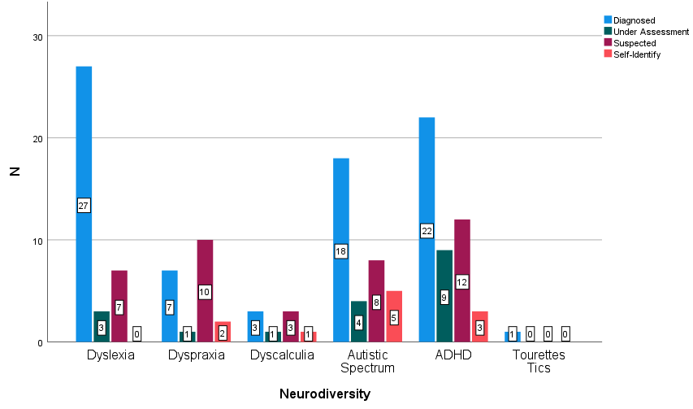
Thirteen students had more than 1 Diagnosis, and table 1 reports patterns of multiple diagnoses. In table one, we have not included students under assessment, suspected or self-identified.

Table 1: Dual diagnosis status

 | Dyslexia | Dyspraxia | Dyscalculia | Autistic Spectrum | ADHD
1 |  |  |  | Diagnosis | Diagnosis
2 |  |  |  | Diagnosis
3 |  | Diagnosis |  |  | Diagnosis
4 |  |  |  | Diagnosis | Diagnosis
5 | Diagnosis |  | Diagnosis
6 | Diagnosis |  |  |  | Diagnosis
7 | Diagnosis |  |  | Diagnosis | Diagnosis
8 | Diagnosis |  |  |  | Diagnosis
9 | Diagnosis | Diagnosis
10 | Diagnosis | Diagnosis
11 | Diagnosis |  |  | Diagnosis
12 | Diagnosis |  | Diagnosis
13 |  |  | Diagnosis | Diagnosis | Diagnosis

Of all students, 53 (62%) students received Reasonable Adjustments (RAs) from the University, such as extra time, rest breaks in exams, flexibility with deadlines, 23 (30%) did not receive RAs and 7 (8%) students were unsure if they received RAs.
Of diagnosed students, four students diagnosed with dyslexia did not receive RAs, six students with ADHD did not receive RAs, and three students with ADHD were unsure if they received RAs. 1 student with ASC did not receive RAs. One student with ASC student was unsure if they received RAs. 1 student with Dyscalculia did not receive RAs, and one student with Dyspraxia did not receive RAs.

Design
The design of the study was a mixed-method approach. The approach includes both quantitative and qualitative design, where findings from student surveys inform focus group interview questions. The project was separated into two phases, and these combined to create the digital inclusive practice toolkit.

- Phase 1: Capturing neurodivergent students’ experience in infographics and pen portraits.
- Phase 2: Capturing staff’s inclusive practice pedagogies and neurodiversity knowledge.

The focus group(s) findings with students helped create/enhance questions for the phase two staff survey about knowledge of neurodiversity.
Procedure and materials
We were particularly interested in encouraging students who are neurodivergent to apply for research assistant positions to help adopt Participatory Action Research (PAR) principles and authentic co-production principles. PAR emphasises participation by members of communities affected by that research and involves cycles of Planning, Action, Reflection, and Evaluation.

To ensure inclusive recruitment approaches, shortlisted student research assistants were provided with interview questions before the interview, clear job specifications, and contact details, and the advertisement included a statement stating, “we particularly welcome applicants who identify as neurodivergent”. As a result of the recruitment approach, PAR approaches were adopted as the research team included neurodivergent and neurotypical members.

After HSSREC ethical approval was sought and granted, we ensured that the design of the phase one student survey was led by student research assistants who collaborated with neurodivergent students to review questions. Only then were survey questions reviewed by the staff research team. Finalised survey questions were sent to HSSREC for amendments, and HSSREC approval was granted. Student researchers and the staff research team advertised the survey on various staff and student networks. The survey was released to students between March 2020 to July 2020. The survey looked at areas such as.

- Presentations
- Group work
- Teaching & Assessment (e.g., course and module design, assessment feedback)
- Online learning provision (COVID-19)
- Approaches the department/students take to increase disabled student’s voice within their department
- Views around communication between central disability service and individual tutors
- Awareness of neurodiversity/SpLD amongst academics and student peers.
At the end of the survey, participants were asked if they like to take part in an online focus group to explore the above areas in more depth. Survey findings and focus groups interviews were analysed. A thank you. Payment of £10 was given to interviewees. Interviews were analysed using thematic analysis. The themes then aided in creating a short report, infographics, and pen portraits of neurodivergent students to include in the “inclusive practice pedagogical toolkit” website and other activities such as a WIHEA masterclass.

In phase two of the study (ongoing), staff were also asked about their understanding of neurodiversity, how much do they think about neurodivergent students when creating course materials, assessment design and delivering lectures, workshops, seminars, personal tutoring, how confident staff are in supporting the needs of neurodivergent students and their awareness of resources available. Staff were then asked to provide inclusive practice exemplars in suggested areas.
- Personal tutoring
- Presentations
- Group work
- Teaching & Assessment (e.g., course and module design, assessment feedback)
- Online learning provision (COVID-19)
- Any approaches to increasing disabled student’s voices within your department
- Views around communication between central disability service and individual tutors
- Engagement in disability training
- Approaches to supporting students who do and do not disclose their disability
- Approaches to raising awareness of SpLD amongst academics and peers in the department.
Results

Personal Tutor experience

Personal Tutors (PTs) are academic staff whose key responsibilities in this role are to be an accessible and approachable departmental point of contact, providing responsive academic and routine wellbeing support and guidance to facilitate your learning development and experience.
Our student survey and focus group interviews have shown differing personal tutoring experiences for neurodivergent students at the University of Warwick. Figure two shows the findings of personal tutoring experiences.

Figure 2 Personal Tutoring and disability

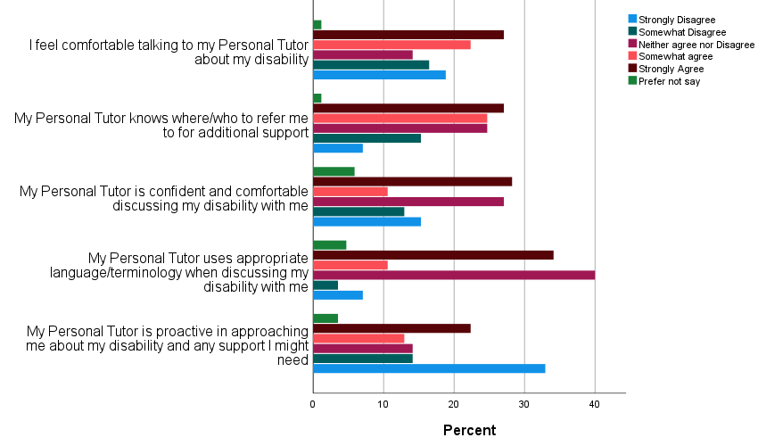

For the question, "I feel comfortable talking about the disability with my personal tutor, 19% of students strongly disagreed, 17% somewhat disagreed, 14% neither agreed nor disagreed, 22% somewhat agreed, and 27% strongly agreed with this statement. Qualitative comments from student focus groups about personal tutoring also reported diverse experiences. Some students felt comfortable, uncomfortable, or felt no need to talk about their disability.

Students who spoke to their personal tutor about their diagnosis described personal tutors as lacking awareness.

"When I first got my diagnosis, I said, oh I found out a couple of weeks ago that I'm dyspraxic and my tutor didn't know what that was and she still doesn't really seem to know like what that means in an academic sort of context"
"I told my tutor and umm I really like my tutor, but she said to me "Are you sure? Well, have you always been dyspraxic or is this a new thing?"
"One of my tutors said to me "oh well you don't seem dyslexic" and I thought oh okay great then that's no worry… [sarcastic] […] it's not like you can't look at someone and tell they're dyslexic"
"I'm not sure if my personal tutor is aware of my 'neurodiversity'. I think there's still substantial stigma attached to ADHD, and although they might not have any prejudices, I don't think my personal tutor is aware of how ADHD affects people. If she approached me about it I'd be happy to talk about it, but I don't want to start the conversation because I don't think she'd know how to help"

Students also talked about how supportive personal tutors were and integral to positive student outcomes.
"she's [new personal tutor's] been great. She said erm "what would you like to work on?". So, she's helped me with my introductions and my conclusions and just helped with my essays and like but because before I'd be getting kind of- like I'd just be passing or get a 2.2 or something whereas in my exams this year I've managed to get a 2.1".

"My personal tutor was the person who supported me through getting my diagnosis in my 2nd year!

"My personal tutor was great in being proactive and asking what she could do to help, if I wanted her to contact my tutors etc. but she wasn't confident/comfortable with terminology, but she was open about this".

"I greatly appreciate the attitude my personal tutor has towards my disability which is talking about it as any other topic- not going out of his way to be clearly uncomfortable or avoid mentioning it altogether, but also not being overly sensitive or patronising about it. he is very straightforward about it, which I feel is very good practice".

"My personal tutor has been incredible. They have worked with me throughout this academic year to help me improve my writing. I am so thankful for all the support they have given me".
"My personal tutor in first year (xxx) was FANTASTIC at letting me know what reasonable adjustments were available. The PT went above and beyond but I know that I had a really unique experience as most of the other people who I know with 'issues' are unable to get support from their PT".

Some students reported not speaking to their personal tutors about their disability.

"My personal tutor is really good, I just feel uncomfortable sharing this part of me with them"

"I have never discussed my suspected disability with my personal tutor"

Students also made recommendations for personal tutoring.

"I do think there does need to be compulsory training definitely about neurodiversity, and about how to approach different disorders and just knowing what they are as well".

"I would love it if the uni provided neurodiversity training for lecturers, so they are better informed about how to support and offer suggestions to students".

"I'd want them to know what it's actually like, […] if you learn about autism, you learn about the classic, like the stereotypical autism, I want them to know that isn't necessarily what they're going to be faced with".
"I think all staff should have to have a meeting and should be educated a bit more on all- on neurodiversity, and about how it can come up differently and how not everyone displays things the same".
I think it's as well like umm understanding what not to say".

Recommendations for personal tutoring:
- Training for personal tutors should include
  - Exploring neurodiversity and specific diagnoses (face to face, webinar or Coursera).
  - Awareness of multiple diagnoses.
  - Training to include uses examples of lived experiences.
  - Awareness of types of reasonable adjustments and why these are needed.
  - Awareness of language bias and DDA act
- To support personal tutoring and senior tutors
  - A named contact that students and staff are aware of for issues around disability within departments.
  - Identifying staff who are good at supporting disabled students to help enhance inclusive personal tutoring practices at Warwick.

The Department
The University's 30 academic departments are organised within four Faculties: Arts, Medicine and Science and Social Sciences. In the Qualtrics survey, students were asked to rate the statements in Figure 3 on a scale of 1-5, with one indicating a "strongly disagree" and a five "strongly agree".
Figure 3: The Department and Disability
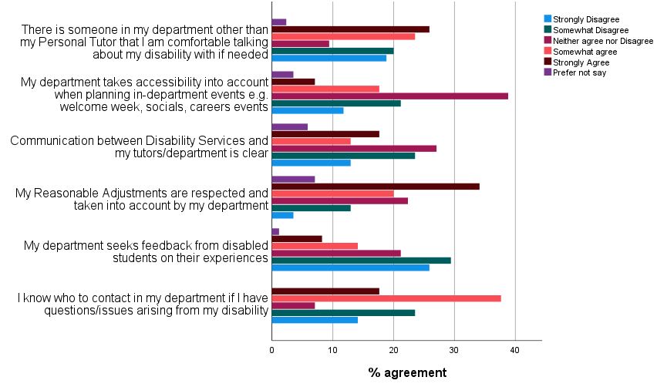
Qualitative comments from student focus groups about departmental support also reported diverse experiences.

"It would be great if they had another contact person that I knew that if I needed any Reasonable Adjustments especially if Personal Tutors are failing […] to go to that person and know that they will be good at their job, and they can provide you with support and they can be like the wealth of knowledge that- about the university system that like the department themselves doesn't know, that would be reassuring" (Halima)

“I do a joint degree, little to no reference to my disability is made by the department that isn't my home department. Not entirely sure if they know I'm dyslexic or dyspraxic”

"I think having one person who just sort of knows what's going on would just be really helpful because then you've not got the going back and forth between all the different tutors which takes likes 2 week and like if you have an issue, you can just resolve it quickly so I think that would be really good" (Karim)

The XXXX school are very good at signposting. And they did talk about it early on, and they talked about it in our application process. So, I think it's quite well signposted up there."

I also got told conflicting pieces of advice by literally 5 senior academics in the department, including the [XXX]…. umm so consistency – that would be really helpful."

"I think the only thing that has been shared kind of generally in my department is like, study skills and productivity skills. But I never click on them. Because I'm always like, 'Well, those are study skills for a neurotypical person. They're not for me.' So, I don't know, there needs to be some kind of balance of like, 'this is specifically for you, and will help you.'"

"I would have preferred them [my department] to know like the ins and outs of how it affects me so that that could have been taken into consideration by my tutors"
"it’s better that they [Disability Services] do it [inform department of diagnosis] for us rather than us go to or tutors and do it because I mean the reactions that we get aren’t always the ones that we want from our tutors. They can be quite sort of- you know, they want us to justify it or whatever and I just think it’s so much better for them to just sort it for us”
Recommendations for Department:
- Departments should consider
  - Ensure that diverse student voices are consulted; via co-production and feedback mechanisms to plan the student experience and academic learning experiences
    - Universal Design Learning principles to student experience
    - DSEPs and DTLs think about inclusive practice when planning events.
  - Identifying staff who are good at supporting disabled students to help enhance inclusive practices within department e.g., named contact.
  - Better dissemination of RAs and communication with disability services if needed, e.g., named contact.
  - Greater communication between departments esp. for joint degrees

Presentations and Group Work

Collaborative work can be challenging for many students. Figure four presents survey results of questions about presentation and group work. Figure 4 survey presents questions on the extent students agreed with statements about presentations and group work.

Figure four: Presentations and group work
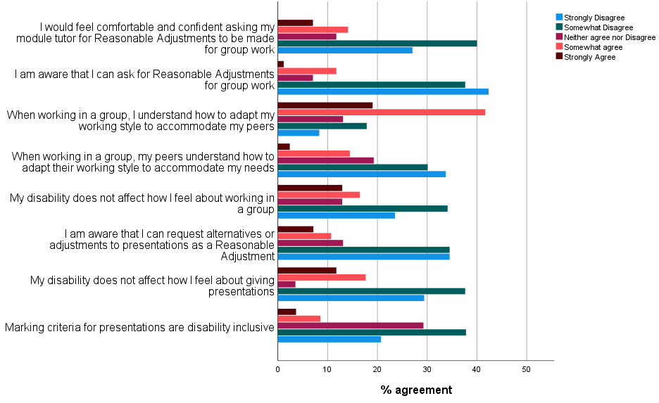

A selection of qualitative comments reported feelings of pressure on time, marking criteria focusing on body language and eye contact, or not being aware or allowed reasonable adjustments on group work/presentations.

“I don’t feel comfortable or confident doing this presentation, or when it’s timed presentations, you’re supposed to fit in the time limit”
I feel I've been marked for things like not making eye contact, and not like using much intonation in my speech and things like that because it's not something I can really control. So, I feel that markers weren't really aware when I was doing them that that was my disability”
“I'm gonna have to like either mask really well, and just make eye contact with everyone and be really stressed, and really kind of like I dunno, put on a persona to do them”
“XXXX don't do reasonable adjustments for group projects”
I hate group work. Didn't know I could request reasonable adjustments. Felt unfairly disadvantaged throughout my degree.
“I guess some things about eye contact to be honest, like when it comes to presentations, umm because, I don’t know how to make eye contact”
“when I do presentations and I'm nervous, it all comes out like all jumbled and I get marked down for that, when it's like my disability, and I don't make eye contact and I get marked down for that, or say I take a title too literally, I get marked down for that and I was just like, I'm trying to- I think to improve on that though, there could be clear- clear mark schemes erm that outline exactly what you’re supposed to do”
“Just take out things like eye contact and intonation, which is really like- if you knew about neurodiversity, you wouldn't put them in”
“Give students the option of maybe pre-recording their presentation, because then you could do it how you want to do it. And, yeah, and then, yeah, just so then they can see you and you can make eye contact with the came”
WIP (Work in progress sessions) are a great way to develop presentation skills within a supportive environment, with positive comments and feedback”

Assessment and Feedback

Students were asked questions about assessment and feedback. Figure five and table four report survey findings on assessment and feedback. There was a strong preference for online exams and needing clearer advice on assessment preparation.

Figure Five: Assessment and Disability 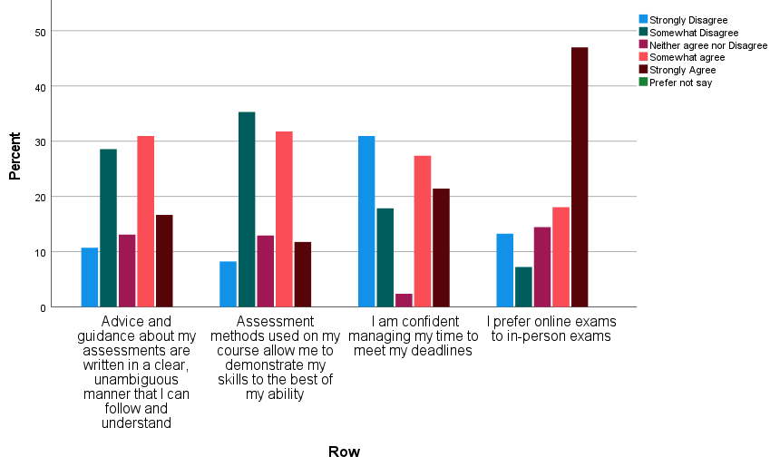

Qualitative comments explored issues with declaring disability for assessments.

“I think when assessments have like quite a long deadline, like if the assessment can be broken down into smaller parts so like this week you should aim to get this done, rather than just be given ‘make a poster’.”
“XXXX are really good at that. Umm the going through like essay plans with you or just like doing a Teams call just to like talk to you to help get you started”
“I don’t like the cover stickers. I think they’re really vague and I think just referring to that website that says basically this person has a condition and they might not be able to spell very well – it’s not enough”
“it would be helpful almost if we could put our- like the name of our disorder on it so that then they could think like “oh okay she’s dyslexic for spelling that might be different or the commas might be wrong or whatever” or “oh she has ADHD so she’s not going to have checked it properly”
“simple bullet-pointed ways is probably best for me just so it’s easier for me to digest the information. But also, perhaps saying like they’re welcome for me to like speak to them about it”
“I think I do and don't prefer online exams - I felt more comfortable with online 24 hour exams but then did an online 2 hour exam and felt it was my best exam so I think I could adjust or work with either online or in person exams”.
“Online exams and open book exams in general are a lot better but coursework replacements are infinitely better than either”.

Feedback

Table 2 shows students’ survey responses to feedback on assessments varied. Many students were happy with clear, specific, and personalised feedback but were unsure if their disability had been taken into account during the marking process.

Table 2: feedback and disability

 | Strongly Disagree | Somewhat Disagree | Neither agree nor disagree | Somewhat agree | Strongly Agree
Feedback on assessments is clear, specific, and personalised | 14.1% | 21.2% | 10.6% | 29.4% | 24.7%
If I have declared my disability when submitting an assessment, this has been taken into account in the marking process | 13.9% | 21.5% | 50.6% | 6.3% | 7.6%

The qualitative comments reported that students wanted more diverse mechanisms of feedback that involved face to face meetings.

“if they could video call […] and just actually talk us through the feedback.”
“with good feedback, even if you've done not great, they'll point out where it is and where you can improve”
“sitting down and discussing the feedback might be more helpful than having a few written lines. And where you could learn from things”
“I think making feedback available online with like actual annotations where they’re talking about would be really good, because sometimes the feedback on Moodle, you could have no idea what they're talking about.

Teaching and Learning

Figure six presents the extent to which students agreed with statements regarding student responses to teaching and learning. Students reported greater considerations needed to be given to accessibility for lectures and virtual learning environments.

Figure six: Teaching and Learning (in-person/blended/online).
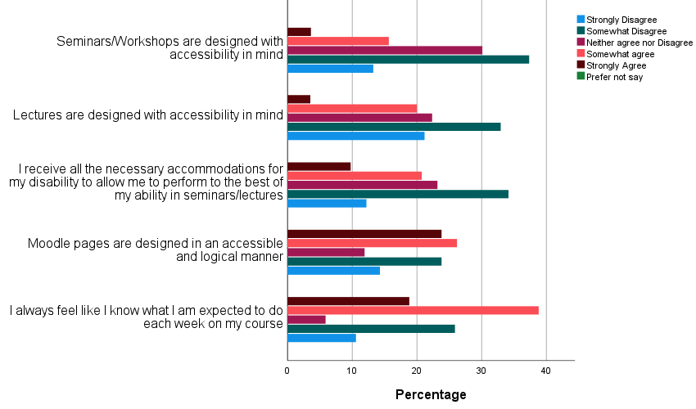

Qualitative comments talked about problems with concentration, accessibility of PowerPoint slides being poor, PowerPoint slides not available or not being notified when they are available.

“When I'm in like a lecture theatre, I just kind of people watch or look at what everyone else is doing. And I kind of zone out, zone in. So, with online, I can just pause it, and then do whatever.”

Seminars, I still miss them, and obviously they’re not recorded. So, it's kind of hard. But what I like about it being on Teams is I can access the chat. So, I kind of have a bit of an idea of what they're talking about. And they put seminar work on Moodle before the seminar starts, so I still have that as a guide. Even though I haven't attended the seminar, I still have that template of what's been said, and what to bear in mind”

“The one thing that is a real bugbear for me is that I cannot always concentrate for that period, and there’s slide, slides have so much information. In funny texts, there's no consistency in how people do their PowerPoints. And so trying to take in information from a screen that's far away, and is now in a different colour and a different font to the one before, and has loads of information on, whilst listening. And then they won’t record them…. So, I think something I really feel that needs to happen is that they do record all of the lectures. And even if they don't want to let everybody have access to them, they need to at least give them access to people who have a reason to need them, like me. Because I would come away feeling so overwhelmed and actually frustrated, and sometimes quite upset.”
“About half of us have it written down that we need the slides beforehand, and they are never done, they never put them up early, I think there’s been three lectures in the year we've had them early. They don’t tell you they’re there, you just have to check Moodle. No one checks Moodle four times a day, like, I’ve got other things to be doing. And then they don’t put them up.”
“The lectures were really good, because obviously, they were all live streamed on Teams, like a Teams live event. So, it's kind of like a YouTube livestream thing where you can, we had a Q&A we could type questions into. And that was either, you could have it have your name, or you could just make it anonymous, which was really good for me, because I'm someone who would be quite shy about asking questions.”
Although I liked having the seminar reading beforehand, I do prefer in person seminars as people engage more. I thought it was inconsiderate and rude that so many people did not engage in the seminars, including the breakout rooms.
“Often only one or no one would speak during seminar breakout rooms which was a shame”.
“Interacting with group work online is hard. I can barely tell when to talk or how people are feeling when in person let alone through a screen. And concentrating all day on my own on online teaching is basically impossible to keep from becoming distracted and disengaging”

Online learning during COVID-19 lockdown

Figure seven present the extent to which students agreed with statements regarding Online Learning during the COVID-19 lockdown. A key point is that 64% (e.g., aggregated strongly agreed and agree responses) of students found online learning more accessible, and responses to questions on accessibility, grades and participation varied.

Figure 7: Online learning during covid-19 lockdown

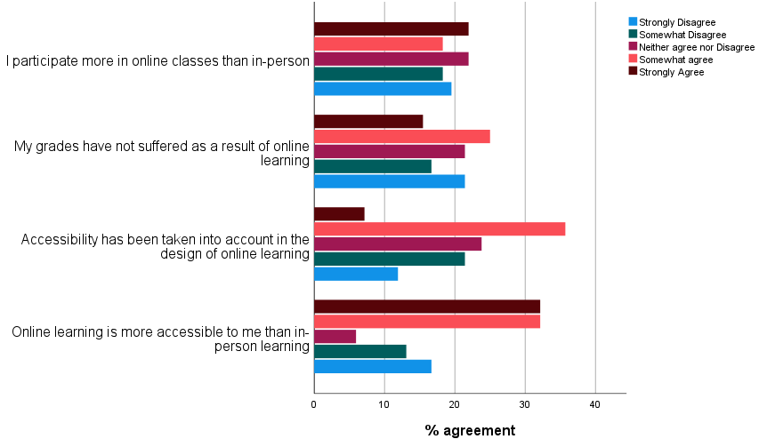

“on the whole, it’s [online learning] been, in terms of lectures, it’s been more accessible for me”
“Some people present their content in a really great way, it’s very simple, it slowly builds on things, it ticks all the boxes for inclusive teaching, and some of them are just like “I’m gonna copy the whole textbook and put it on one PowerPoint slide, have fun”.”

“I think keeping that element of having it all digitised is really helpful and like I know some neurodiverse students prefer having things printed out but maybe having- still keeping things available online as well is really helpful”

“The transcripts of lectures aren't great. I mean, they are alright. But for complex terminology, it just doesn't pick it up. And I follow much better if I can read what I'm hearing at the same time. And the Disability Services have tried to help in the sense that they've got people to update those transcripts. But they've not been updated. Like, I mean, it's taken two months after the lecture was released”.

I now find it very difficult to focus on online learning as there are too many distractions at home
The accessibility of online teaching resources varied widely between modules. Some were really well organised with videos in concise short format (as requested by the department). However, some modules had mostly long, less digestible videos. All lectures did at least make a large effort to produce clear and accurate subtitling though”.

online learning- can produce greater fatigue, as often have to read handout on screen as well as presentation slides (So maybe think about the amount of text on slides), some fonts used make it difficult to read for prolonged periods.

Learning and Teaching recommendations
- Encourage feedback approaches that close the feedback loop
- Provide training on accessibility design of educational material and learning and teaching environments
- Name person to be a member of digital accessibility network on TEAMS
- Where appropriate look at blended learning approaches
- Ensure clear assessment criteria and assessment launch session
- Embed inclusivity as a principle to curriculum and assessment design
- Ensure departments are supported with transcription services.

Awareness and Perceptions

57% of students felt that their peers were not aware of the impact of their disability on their learning, whereas 48% of students felt staff were not aware of the effects of their disability on their learning. Figure-eight presents survey findings on questions on peer and staff perception of disability.

Figure 8 Perceptions and Awareness of Disability
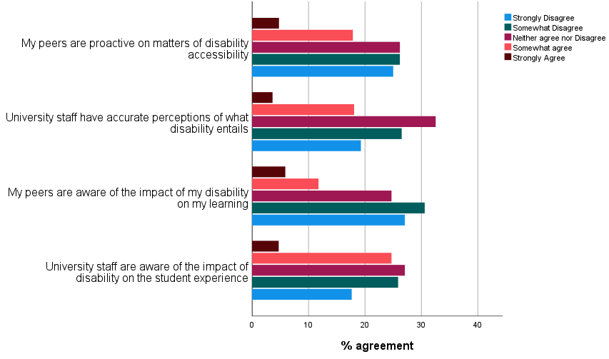
Qualitative comments described stereotypes, reliance on the medical model, more agency and empowerment, greater awareness and training amongst staff and students.

“I'd like an understanding of, especially with females and neurodiversity, we present differently. We're not Sheldon Coopers. I like to refer myself to Amy Farrah-Fowler.”

“I still feel like there's quite a bit of stigma attached to ADHD. I still feel like there's even more stigma attached to the medication for it. Everyone kind of thinks, “oh, well, you know, the only thing that ADHD means you do, it just means you can't concentrate.”
“I think that it affects more than is written like a diagnostic test, and also that like the lines are like very blurred. It’s never quite sat right with me that there’s these like, no one understands your brain, and then they're like, ‘you have this, and you have nothing else..

“understanding that autism isn't this three-year-old boy sitting on the floor, playing with trains and liking timetables, and kicking off when things change. It's a fully capable young student who has made it this far to get to university, and just needs a little bit of extra help, a little bit more guidance.”
“we need to step away from diagnostic criteria and stop- my ADHD is not young boys that can't sit still for example and ASD is not boys that have no emotion and kind of collect trains”.
“optional modules to read more if you know what I mean so people can understand how to be a better friend or understand where, you know, people often aren't trying to be offensive, they just don't understand that that might be upsetting”
“the kind of emotional struggle and what- how- I think a lot of stuff is internalised with neurodiversity, they don't realise what's going on and how fast and anxious their brain thoughts can be”

“an acknowledgement that like okay if we’re at university, we’re just gonna be one side of neurodivergence and I think, well like, I think there’s, well moving away from “functional” terms would be great but I think there’s a lot of kind of perception that like the support we need is not like very much or like it’s constant.”
“have one of the student reps in each department. You know, like obviously anyone who is happy to come forward erm for neurodiverse and maybe they are neurodiverse which would be great”
“do like a neurodiverse panel, where like, there can be like some students and some staff who are neurodiverse and we can do like a panel that’s open to students and staff, talking about erm being neurodiverse and people in the audience can like ask questions and they can answer and they can have like a completely open discussion about what being neurodiverse is and have like an event type thing Talk about it more, normalise it, and don't use stereotypes and use role modelling”
“stopping stereotyping but also showing people that identify as neurodiverse that they can be successful too. It is a struggle, but it doesn't mean that it limits you, I would say. I wish someone said that to me when I was in my early 20s.”
“just to allow students to feel like a little bit more empowered whether they're neurodiverse or not but just to feel more empowered to speak up”
“A lot of people don't feel able to speak up […].Like I think- I think you can easily kind of lose people to the shadows a little bit and I think that can be a real shame because I think everyone has great ideas”
There need to be much better discussion and teaching around the history and current attitude to disability in XXXXX eugenics and public health in particular.
The only support groups were offered at lunch time which meant we sometimes did not receive a screen break for 8hours solid, this is not a reasonable adjustment for support. We need a break too.
“I think people understand like mental health better but other forms of disability they are still very poorly informed. Most people still think dyslexia just means I can’t spell (which whilst is an issue for me) and so often think I’m not really dyslexic or I don’t have it that bad. They don't understand how much harder I have to work to keep up and how easily I get tired from the sheer effort of concentrating. Again, few people understand what autism is like in women and same with ADHD. My close friends are all disabled and neurodivergent so they understand but the general community at Warwick really don't know a lot about disability”.

Recommendations for perceptions and awareness
- Creation of training for staff which focuses on awareness of neurodiversity
- Creation of course/module on disability for students
- Foster agency in the neurodivergent community through representation within departments
- Disability awareness raising within departments for students and staff
- When collecting feedback from students ensure feedback can be looked at according to disability

Next steps….
- We will complete Phase two of the study in June 2022,
- The toolkit will be created in April and the masterclass will be held on 28th April 2022.
- Working to social the project (e.g., SLEEC, Disability taskforce)
- Work with other learning circles and training (e.g., Bystander training, personal tutor training)
- Using lessons from this project for the new learning circle on inclusive policy and practice for disabled students

