Introduction

I am about to enter my third year of my Warwick psychology BSc, and whilst I have no regrets so far, I have seen that this course can definitely be challenging at times. Every resource out there is potentially useful, and that being said, I am collaborating with Dr Jagjeet Jutley-Neilson to offer some advice on what to do with feedback.
Feedback can be encouraging, challenging, scary, motivating and demotivating all at once. It is supposed to affect future performance in a positive way BUT it can affect your levels of confidence and self-esteem – so the way you handle feedback is really important to your future success. Hopefully, this booklet will help you make the most of your feedback and help you achieve your potential.
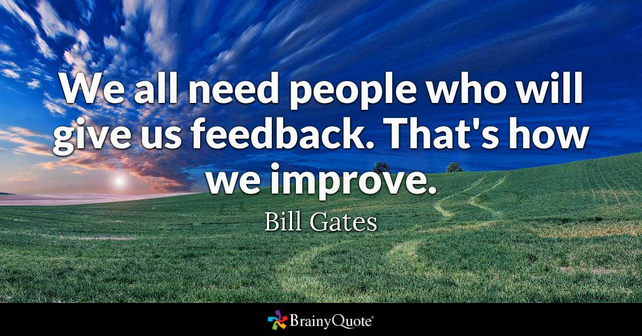
- Calvin Deans-Browne



What is feedback???
Feedback is defined as, ‘information about reactions to a person’s performance of a task’ (dictionary.com). Feedback will include both your strengths and your weaknesses, and is designed to help signpost your progress and justify your grade. Feedback you will be most familiar with is that given alongside your grade on tabula, and this form of feedback should be given to you within 20 days. However, please don’t think this is it! Feedback can be given from a range of places, by a range of people, and you should keep an eye out for it in all its forms.
Where can I find it
A couple of great places to get feedback are:
- From your peers when working on coursework and revision together. This is NOT cheating (unless you are explicitly asked to work on your own) and different people will be able to pick out different strengths and areas for improvement in your work.
- Your personal tutor, it’s part of their job! Make use of your meetings to keep tabs on your progress throughout the year, discussing what you can do to get the grade you want.
- Your lecturers (and seminar leaders), in a number of ways. Your seminars will often involve a workshop where you complete a task and you are given group feedback. Closer to exam season lecturers may also give feedback on how past cohorts have done and highlights areas that they found particularly difficult.
- Moodle is a great resource that should not be overlooked! Listing all the resources available here would take too long, however what I will highlight is the exam feedback made for the previous year’s modules available here.
- Tabula will be the most familiar source of feedback which you should receive alongside your grade for an assignment, but do not neglect it! Consider your grade as a part of your feedback, as it can be used as part and parcel of what helps signpost your progress.

What should I do with feedback?
When you finally get your feedback, you should note your strengths as well as your weaknesses. This can be a lot to remember as you progress through the year, so for each piece of feedback it can be helpful to write down the main points and keep them in a folder. Keeping your feedback organised allows you to see recurring areas of what went well as well as what needs improvement, which makes it easier to focus your development in the right places.
It also allows you to extract the main points from your assessments, so that even feedback for an unusual assessment, that you feel hasn’t been very useful (e.g. feedback for a presentation) can turn out to be more useful than you thought (e.g. taking on board criticism about structure of argument/ breadth and depth of sources etc). If you feel like your feedback in uninformative, you don’t understand it or don’t know what to extract from it, then don’t be afraid to ask your tutor or the module convenor for some clarification.
We know that understanding feedback can be challenging, so we have tabulated the glossary from the Developing Engagement with Feedback Toolkit (Winstone & Nash, 2016) containing confusing and specific terminology. We recommend you read through the whole glossary, taking into account each of these terms as you write your assignments and prepare for your exams.

Term | Definition
Abstract | Being too vague about a point by not explaining it in specific language, or by failing to ground it in theory or to use examples (see also ‘Concrete’).
Address the question | Make sure you’re answering the question that is being asked – students sometimes write about topics that miss the point. Make sure your arguments and material are relevant and clearly linked to the question, and you are not simply writing everything you know about the topic.
Assess the limitations of the study | Weigh up aspects of the study and consider weaknesses that might undermine the validity of the study, and/or suggest ways the research could be improved. The weaknesses could be methodological, but may also be with how the authors interpret and present their own findings.
Balanced argument | While it is often valuable to take a stance, be sure to present evidence for the other sides of the argument.
Clarity | Make sure the reader can easily understand what points you have made by writing clearly, and explaining why you have made these points. Sometimes it’s just a case of writing straightforwardly, and not assuming the reader will automatically know what you were thinking.
Concise | In your work you need to explain ideas clearly but with fewer words – if you have a word limit, make effective use of it! The marker may think you are waffling. Be succinct and avoid needlessly complicated words and phrases.
Concrete | Make sure you’re using clear and specific language to talk about a defined situation or a certain finding, not just vague ideas (see also ‘Abstract’).
Critically Evaluate/ Critically Analyse | Show that you have actively thought about and questioned the claims you are describing or making. Even if the claims are completely valid, show that you haven’t just accepted them at face value.
Depth/Elaborate | Make sure you explain your arguments in detail, using examples where appropriate and working through your ideas rather than simply glossing over them
Flair | Showing a sophisticated or elegant writing style, or presenting evidence in an original and insightful way.
Flow | Creating a coherent argument by connecting points in a logical order to ensure that the work is easy to follow.
Illustrate | Give examples to back up the points you make, ideally using evidence.
Originality | Demonstrating your own thinking, perhaps by drawing upon research beyond the ones you learned about in class, to make an argument that not every student would have thought of.
Proof-read | Reading work back carefully, or getting another person to read it, to check for spelling and grammar mistakes. You should also check that your arguments make sense, and that everything is phrased clearly.
Range of material | Try and use more than just the material provided by the lecturers, and avoid basing too much of your work on just one or two references.
Specific | Give a more precise and detailed account of what is being described, drawing on particular examples.
Structure | Give a more precise and detailed account of what is being described, drawing on particular examples.
Synthesis/Integration | Show how different sources and theories go together to make a good argument. A lack of synthesis could mean your essay reads more like a list of research than an argument.
Transparent | Making sure that the thought-process which underlies your argument is clearly expressed. Even if you have a good idea, it’s not always easy for the marker to see your train of thought.
Unsubstantiated Claims | An unsubstantiated claim lacks evidence. Make sure you justify your argument by supporting each point with empirical evidence and references. This will create a more persuasive argument.

Feed Forward!
Feedforward is an important part of feedback. Feedforward is everything you do to make use of your feedback so that it helps you improve your future grade.
Whilst keeping a record of your feedback is the first step, there is more you can do to make the most of the feedback for each project. Writing an action plan alongside a summary of your feedback is a good way to feed forward. In the ‘What should I do with my feedback?’ section, we discussed how it is helpful to make a summary log of the main points of you feedback including the strengths and weaknesses. Writing an action plan alongside this consists of writing a target and how you are going to achieve it for your next assignments. An example of this is demonstrated below using an adapted version of resource A3 from the Developing Engagement with Feedback Toolkit (Winstone et al., 2016), filled in with responses to genuine feedback I have received in the past year:

Feedback | Target based off feedback | What actions will you take to achieve this target? | How will you know when you have achieved this target?
You’ve drawn on previous research well, putting the current study into context | Continue to do an appropriate breadth and depth of reading | Commit to writing a satisfactory plan of the essay based off reading before I start said essay | Looking at future feedback, I will look for this point to be raised again
There were also some irrelevant sections to your essay (i.e. on publication bias, and the definition of intelligence) which distracted away from the purpose. There were also some overly long sentences. | Keep every point in my essay relevant to the question being asked, and keep sentences succinct | Read the essay question alongside each point made in isolation to check that the points answer the question. Also dedicate more time for proof-reading to ensure that sentences read well. | The essay should be easier to follow when looking at it with ‘fresh eyes’
The interaction should have led you to discount the main effect results | Get the hang of interactions | Speak to PT about them | I should find it easier to write about them in the future, and if I don’t, I need to take further action
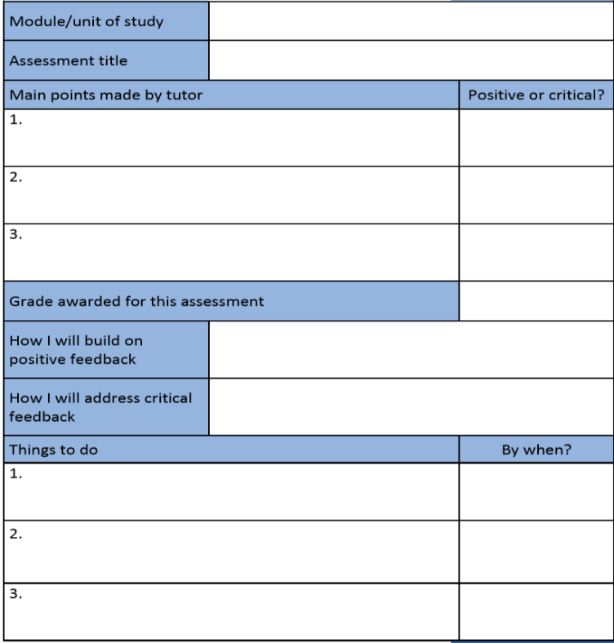
It should be noted that there is no one way of writing an action plan. To the right is another template of an action plan provided by Sheffield Hallam’s student guide to using feedback (Hepplestone, Parkin, Irwin, Holden, Thorpe & Burn, 2010). It may take some experimenting to see what style of action planning is best for you, but however you do it should make it easier to make the most of your feedback.

Reflection
Creating an action plan as described in the previous section is a good way of reflecting on our own learning. Reflection (in this case) consists of making sense of an experience and considering what we could have done differently to get a different (hopefully better) result. As is turns out, there are actually some pretty good reasons for reflecting on our own learning. Sheffield Hallam’s student guide to using feedback lists 5 reasons:
- Reflecting can improve your performance on your future assessments by helping you identify what you did well and where you can improve
- Reflecting is not just important while at university, it is a useful skill to develop and it can help you throughout your future career
- Without reflection, you keep doing things in same way and never improve
- Reflection helps you to understand concepts and principals (sometimes called ‘deep learning’) instead of just knowing the facts (sometimes called ‘surface learning’). Demonstrating an understanding of concepts and principals gained through reflection, will help you to achieve better grades in your assessments
- Some experts suggest that if we practice reflecting after an experience, we can learn how to reflect during an experience - ‘thinking on your feet’

What if I’m not ready for my feedback ☹?
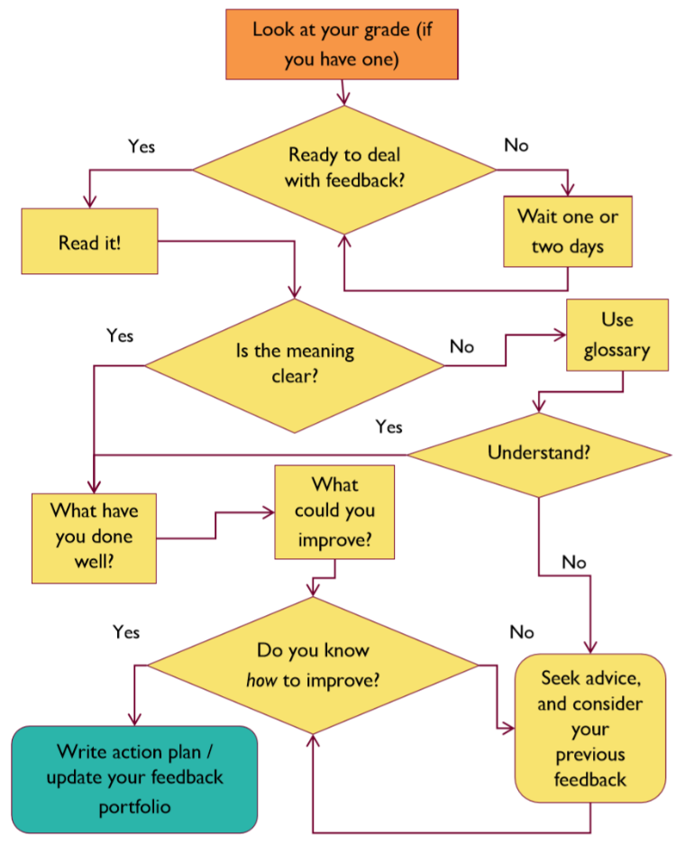
Waiting for and receiving your feedback can be a nerve-racking experience, I know it has been for me! If your feedback is available but if you don’t think you are mentally ready for it, don’t feel the need to look at it immediately. As I have stressed so far, making use of your feedback is integral to your learning, so make sure you are able to make the most of it when you look at it alongside your grade. The following diagram from the Developing Engagement with Feedback Toolkit should help you on your way to deciding what to do at each stage of your feedback.

It is easy to see your grade and make a judgement about well your piece of work has gone BEFORE reading the comments. We are often tempted to see our ‘mistakes’ as being worth more attention than what we have done well. Remember, there are no mistakes – just areas of strength and areas of development. Think of the strengths as tools you have that you already know how to use, and areas of developments as those tools you still need to practice using. Each time you perfect a new skill – this is a new tool to add to your skill set.
Above all, remember that your feedback relates strictly to your work and NOT you as a person. Don’t be hard on yourself if things haven’t gone as well as you hoped – each piece of feedback will just help you to be aware of how to get even better!!

Tips from the professionals
STILL not sure with what to do with your feedback? Never fear, the University of Warwick is filled with intelligent people who are here to help YOU! All departments will issue feedback, and Dr Sarah Richardson in Warwick’s history department has devised 10 points to help students get the most form their feedback, which have since been adopted by the Students Union (Assessment: Marking and Feedback):
- Be confident! Go and see your tutor for feedback! Find out about your tutors’ availability and how they prefer to be contacted.
- Prepare a few questions you want to ask before seeing your tutor. Perhaps email them to your tutor in advance.
- Think about what you want feedback on e.g. structure, analysis, referencing? Be specific.
- Discuss your assignments with other students (this is not ‘copying’).
- Learn how to give constructive, tactful and positive feedback to other students.
- Ask for constructive assignment feedback comments from other students.
- Think about when, where and how you can get feedback – verbal, written, email, audio; from seminars, labs, before/after a lecture, and from other students.
- Be organised – if you want feedback for your next assignment (from tutors or students) – don’t leave it until the last minute.
- Use exemplars of assignments and discuss with other students – this will help you understand what is being required.
- Get advice on how to improve for your next assignment – ‘feed-forward’.

Tips from students
We’ve all been there, we’ve all done it. We’ve each had our disasters, and EVERYONE has a story to tell. As you have hopefully gathered so far, feedback is a part of university life whether you like it or not. We’re all in this together, and I thought it would be a nice way to end this booklet with the opinions of what other students had to say about their views and their advice on feedback. Whilst this is a starting point for you, remember to ask your own friends for what they find useful and challenging about feedback, as well as what they do with it that works well for them. As aforementioned, making the most of your feedback is an interdisciplinary skill, so feel free to ask your friends who study other subjects; they might just have picked up on something students in your department failed to consider. There is no one correct way to make the most of your feedback, but I hope you are now at least closer to finding what works best for you!

How does feedback make you feel?
Feedback can either make me feel very encouraged; confirming that I am on the right track with my work, or it can make me feel as if I didn’t understand anything my teacher was telling me depending on the way the feedback is written depends on whether I interpret it positively or negatively.
Feedback makes me feel good since there’s so much practical advice on how I can improve. It can sometimes make me feel kinda overwhelmed though when feedback comes with a grade but little to no methods of improvement given.
Feedback is extremely useful and makes me feel motivated to improve

How do you avoid being tempted to look at your mistakes OVER what you did well?
Take mistakes as a learning curve and not as something you’ve done wrong
It’s important to be focused on progress and not perfection, if we’re focused on progress both our good bits and our points to be improved can be viewed from a balanced perspective, but if you’re overly critical or want perfection then it’s easy to fall into the trap of seeking the negatives in your feedback a lot more prominently compared to your good bits.

To avoid only seeing my mistakes, I make a conscious decision to keep referring back to the good parts of my work where they had ticked or placed a smiley face on the paragraphs they liked. That way I can be reminded whilst reading the criticism, that I wasn’t completely wrong!
You just have to move on I guess. It’s obviously important to acknowledge where you went wrong, but it’s also very important to give yourself credit for what you did well. I let “ what I did well” motivate me into trying to improve on what I didn’t do so well.

What was your harshest piece of feedback and how did it help you?
Worst feedback was probably from my second year project as I had a lot of flaws in the foundations of my study. The feedback helped me to understand the foundations of research a lot better and gain the knowledge I need to feel more equipped for my dissertation
My worst piece of feedback was for a practical report. I was so confused as I got firsts in all my other reports. It threw me off for a bit but It helped me to not be complacent with my work.

What was your best piece of advice from feedback?
Best piece of advice from feedback is to use APA formatting!
Best price if feedback was a group project for research methods. Jags comments were really nice as she mentioned how creative it was. It helped me with my other pieces of work as it encouraged me to think outside the box when trying to see things from different perspectives.

What are your top tips for dealing with feedback?
Top tip is to always try to use the feedback as methods of improvement rather than an excuse to give up

Even if it’s not what you hoped for, keep an open mind and accept that we always have room for improvement

Take the positives as an affirmative that you are progressing and take the constructive feedback as way to look forward to doing even better next time
Focus on the good things, and focus on the bad things, don’t just focus on your grade

Have the feedback at hand for any related tasks in the future. It's all well and good reading your feedback and understanding it, but if you don't act upon it in the right way, how will you show what you have learnt?
Always go back to the lecturers to go through it with them. There is so much more that they can say and expand on in person compared to on a computer screen. You'll get more support that way and any issues you have can be clarified.

References
Assessment: Marking and Feedback (Retrieved 2019, September 09). Retrieve from https://warwick.ac.uk/fac/arts/history/students/assessment/marking/#feedback
Feedback {Def. 4}. (n.d.). In Dictionary.com Retrieved 209, September 09 from https://www.dictionary.com/browse/feedback?s=t
Hepplestone, S., Parkin, H., Irwin, B., Holden, G., Thorpe, L., & Burn, C. (2010). A student guide to using feedback. Sheffield: Sheffield Hallam University.
Winstone, N. E., & Nash, R. A. (2016). The Developing Engagement with Feedback Toolkit (DEFT). York: Higher Education Academy.

