Exploratory Pedagogic Inquiry Booklet

Week 3. Refining research questions and planning for data generation

Compiled by Richard Smith and John Kirkman (2021), for the Warwick International Higher Education Academy (WIHIEA) Pedagogic Research in Higher Education Learning Circle. Online: http://warwick.ac.uk/epi-info/

Week 3: Refining research questions and planning for data generation

1. Aims and expected outcomes

Week 3 Aims
refine and select research questions;
consider how to generate data which will answer the questions;
make a plan for generating data.

Expected outcomes for Week 3 activity

By the end of this week’s activity, you will have refined the questions you came up with following your week 2 peer-coaching session and you will have made a selection from among them. You will also have considered how to generate data to answer the questions in a way that is ethical and does not interfere too much with your everyday teaching or create added burdens for yourself or students. Finally, you will have made a concrete action plan for generating this data (when? how? who with? etc.).

Week 3 process diagram
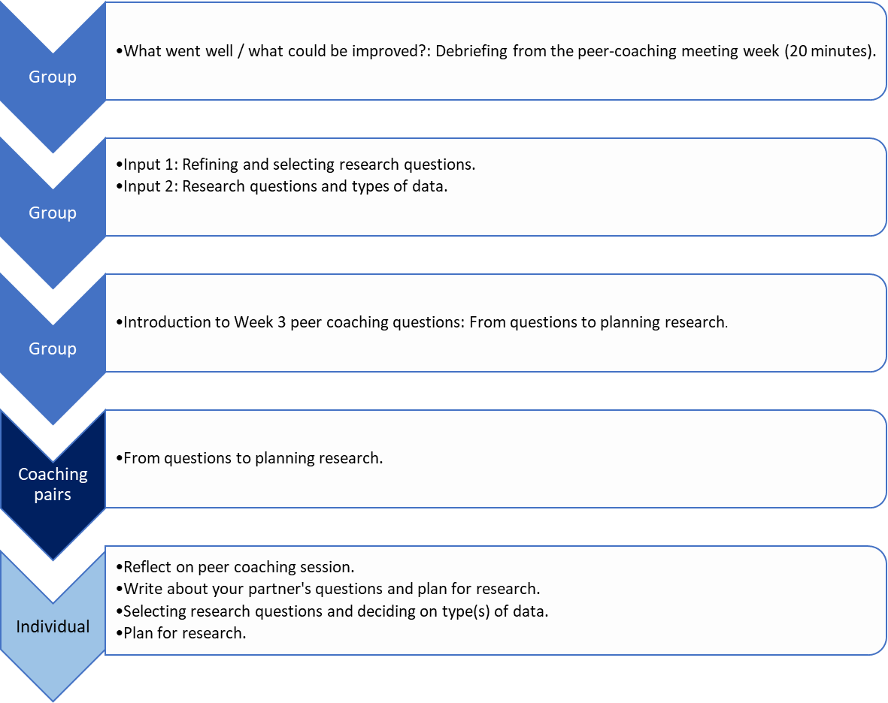

  - Debriefing from peer coaching

What went well / what could be improved?: Debriefing from the peer-coaching meeting week 2 (20 mins. discussion in whole group)

Input 1: Refining and selecting research questions

(10 mins. input as whole group)

What were the areas of uncertainty and associated questions arising from your peer-coaching session in week 2?

e.g.

Overall issue: Students not taking part in synchronous sessions
Area of uncertainty | Possible research question
Meaning of 'take part' | What do I mean by 'take part'?
Students' view | What do students say about their participation?
When they take part / don't take part | At what point do / don't students take part?

What are 'good' exploratory research questions?

'SMART':

STUDY-ORIENTED (oriented towards exploration not (yet) action)

MEASURABLE (possible to answer)

ACCURATE (specific, concrete, well-defined, not too general or vague)
REALISTIC (feasible to answer by you in your current situation)
TOPIC-FOCUSED (related to your overall topic)

Input 2: Research questions and types of data

Example of matching type of data to research questions

Overall issue: Students not taking part in synchronous sessions
Research question | Possible type of data
What do I mean by 'take part'? | 1. + 2. or 3.?  [own perceptions]
What do students say about their participation? | 4., 5., 6., 7.?  [others' perceptions]
At what point do / don't students take part? | 8., 9., 10., 11., 12.?  [behaviour/performance]

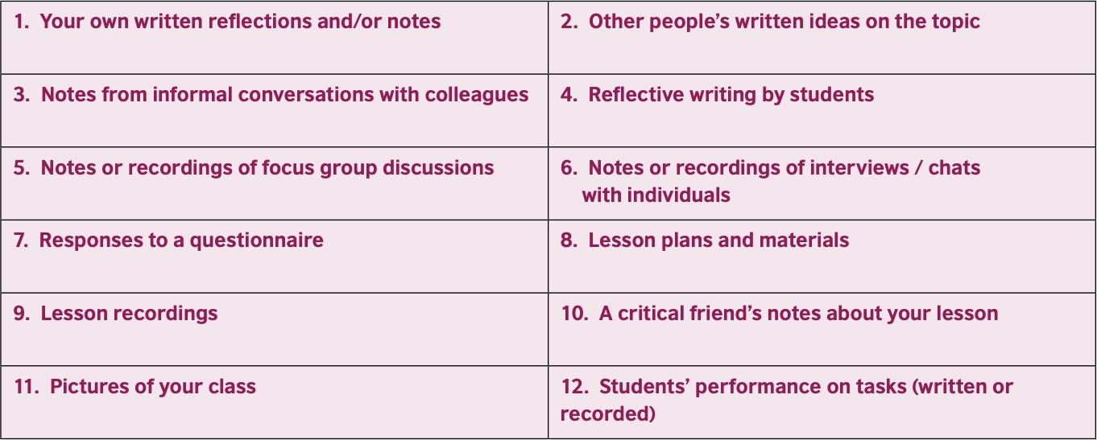
Source: Smith & Rebolledo (2018), A Handbook for Exploratory Action Research (British Council, p. 42)

Peer-coaching: from questions to planning research

Three questions to guide peer coaching

The purpose of the peer-coaching session this week is to help your partner to refine and narrow down their research questions, decide on some data to gather and begin to plan some research.
Split the session into two halves (30 minutes each). Go through questions 7, 8 and 9. for one person, then switch roles and go through the same questions for the other person. Before you begin, read the questions to decide, as a coach, which of the questions you mainly want to ask, as there probably will not be time to ask all of them, and some of them may be overlapping.
As a coach, begin by sharing your recollection of the other person's areas of uncertainty in relation to their focus – and remind your partner of any questions that have already emerged for them -- or go straight into the questions for this week's peer-coaching.
As you listen to your partner's answers for questions 7, 8 and 9, make notes and underline any research questions, associated types of data your partner says they would like to get, and any concrete plans Reflect these back to your partner at the end. You can use the template at the end of this handout for note-taking as you talk.

  - What do you want to explore further, to extend your success / understand your difficulty, and what are your research questions? (10 mins.)
Example prompt questions (choose from these):

What are your main areas of uncertainty at present, in relation to your topic?
What questions have you thought you would like to answer? Which questions are you most interested in?
Which questions will it be most useful to answer? Which questions will it be most realistic to answer?
[talking about a particular question] Is this question Specific / Measurable / Accurate / Realistic / Topic-related enough? Could it be made more so?

Which (two or three?) questions do you choose to focus on?

8. What types of data could you get to answer these questions? (10 mins.)

Example prompt questions (choose from these):

To answer Question X, what types of data could you get or generate?
What would be some advantages / disadvantages of using this kind of data?
How realistic to your current situation is it going to be to get/generate this kind of data?
Are there any ethical issues you foresee in getting this kind of data to answer your question?

9. So, what will you do from now, when and how, and what do you take from [what have you gained from] this peer-coaching process overall? (10 mins.)

Example prompt questions (choose from these):

What's your plan, then, for getting/generating this data that you need?
When will you do it?
What do you need to do to prepare for this? Who will help you with this (if anyone)?
How do you feel differently now, as a result of this three-week process? How likely do you think it is that you will carry out your plan?
What costs have there been in being involved in this process? What benefits have there been in being involved?

7. Individual reflection guidance

Week 3 Individual reflection: Reflecting on your conversation and planning exploratory research

Reflect on peer coaching session
Reflect on the session using the same questions you've used in previous weeks (you can use the template below). You will share some of your thoughts during the next Thursday group session.

Write about your partner's questions and plan for research
Write up the notes about your partner's research questions and plan for research. Send these to your partner for them to reflect on.

- Select research questions and decide on type(s) of data
Reflect on your discussion and on the notes your partner sent. Be ready to share at the fourth group session your thinking about the questions you want to answer and the ways you are thinking of answering them. Writing them into this kind of table might help.

Overall issue:
Research question | Possible type of data

Plan for research
In concrete terms, when will you generate this data, and how? Be ready to share your ideas at the fourth group session.

Partner’s name :………………………………………………………….

Date of Session 3:………………………………………………………..

Note taking during Session 3 (keep this part confidential)

7. What do you want to explore further, to extend your success / understand your difficulty, and what are your research questions? (10 mins.)

8. What types of data could you get to answer these questions? (10 mins.)

9. So, what will you do from now, when and how, and what do you take from [what have you gained from] this peer-coaching process overall? (10 mins.)

Date of Session 3:………………………………………………………..

Note taking during Session 3

[Paste your partner's notes here]

Individual reflections after peer-coaching 3

1) As someone being listened to / As a 'coach'...

How did you feel?/ How did you benefit?/What did you learn?

What made you feel this way/benefit in this way/learn in this way…?

What was the value of this session? Why was it/was it not valuable?

What will/might you do differently as a consequence of this session? / Did questions for further exploration arise for you?

2) About the session overall:

How long did this session take?

What questions did you select from among those suggested in parts 4., 5. and 6? Why did you select these and not the other ones? Did you formulate any further questions? If so, what questions?

What would you add to/modify about the suggested procedure, to make it more interesting/useful?

Any further reflections about Session 3 overall?

Let's discuss your answers to these questions at the beginning of the next group meeting

