Peer Dialogue about Teaching (PDaT)



What: Peer dialogue is a developmental and confidential process which supports colleagues involved in teaching to develop their practice, and thereby improve the student learning experience.
When: Warwick expects all staff who teach to engage in a peer dialogue episode annually. Each academic department has adopted the guiding principles contained in the UoW policy on Peer Dialogue approved by Senate in July 2019.
How: Peer dialogue can take many forms. The essential core elements are:
- Discussion between, and reflection by, participants on their teaching practice
- Formative (to support rather than judge the participants – this is not a Quality Assurance mechanism)
- Confidential to participants (although the fact of participation may be recorded)
- Peer dialogue covers all aspects of teaching, learning and assessment – not just delivering in-person teaching
- Opportunities for sharing good practice and signposting sources of support
It is hoped Peer Dialogue is integrated into a culture which values teaching, and sits alongside other mechanisms to enhance practice and support teaching colleagues and acts as a prompt for wider reflection on practice and development.
It is important to note that while the evidence gathered from the Peer Dialogue process might be used in applications for promotion, HEA Fellowship claims or in nominations for Warwick Award for Teaching Excellence, there is a separation from quality assurance or performance management processes.
There is more information on peer dialogue (including resources) on the ADC webpage.

Peer dialogue and COVID-19
Advice from the Academic Development Centre (ADC)
Classroom observations are likely to be challenging on the physically distanced campus and are probably best avoided unless your observer is happy to come onto campus and there are sufficient spaces in the class for them to observe physical distancing. This itself may be difficult as most rooms will be at capacity. If you do go ahead with an in-class observation we would suggest that the observer situates themselves at the back of the room to ensure that they do not need to turn around to observe student responses. The value of in-class observations under current circumstances are likely to be of limited use, as the context is so very distinctive and practices in the physically distanced classroom are unlikely to represent your usual approach. On the whole we would recommend that you find an alternative to face-to-face observations during this time.
When observing a colleague in an online class, you may find that there will need to be more detailed pre-observation discussion about the ‘delivery method’ (e.g. the technology to use) and how this relates to disciplinary content, compared to what might previously have been a priority for staff.

Myths about peer dialogue
Drawn from resource by the Cambridge Assessment International Education Teaching and Learning Team
- ‘Peer to peer’ is the only way to carry out peer dialogue.
Peer dialogue can take place in pairs but could also involve three or more colleagues working together. Students might be dialogue participants and reviewers rather than colleagues.

- You should only give positive feedback.
This depends what we mean by ‘positive’. While dialogue and feedback must be non-judgemental, there is a risk that there could be no change in teaching if you only say ‘nice things’ about each other’s teaching without saying how you could develop. You can overcome this by carefully pairing up colleagues and making sure you trust and respect each other.
“Staff need to feel safe if they are to be honest about their teaching; and there needs to be a collegial spirit of mutual support among equals if tutors are to accept a collective responsibility for teaching within a department.” Coffield, 2012

- It takes too long.
Time is always a challenge in any professional development activity, so it is essential to focus on what works and be flexible. If you are taking part in a dialogue, you should consider the best times during a term to do this, and when there will be enough time to give feedback. By agreeing a focus for the dialogue beforehand, the time spent is targeted on learning, meaning you use your time more efficiently.

- Colleagues should be from the same department.
Not necessarily, it depends on the purpose of the dialogue. If knowledge of the subject content is crucial, this may be the case. However, belonging to a different department or institution may be beneficial to learn more generally about teaching. This point is highlighted by an English teacher who had the opportunity to work with colleagues from the Languages faculty during their peer observation cycle: “This was useful in the sense that it gave us an insight into how other subject teachers approach their subjects, as well as what resources they use. Certainly, from the French lesson that I observed, I witnessed a pace and challenge that I would like to adopt within my English lessons, as well as resources to go with this.” In a study by Hammersley-Fletcher & Orsmond (2004), staff felt it benefited them to see how other disciplines approached teaching. It is also important that peer observation doesn’t become repetitive or stagnate. This is a risk if it is only ever colleagues from the same department who observe each other.
“More than one study has reported that colleagues who are too close may be unwilling to provide honest feedback about negative aspects of teaching by the observer.”
Tenenberg, 2016

- Peers who observe each other must want to develop the same part of their teaching practice.
You don’t have to both be developing the same part of your teaching. In fact, sometimes it is better for you to have different strengths. For instance, it may be that you pair up with a colleague whose strength is ‘effective use of plenaries’, which is an area you want to develop, and your strength lies in your class involvement, which is what your colleague wants to develop. However, it is worth thinking carefully about who can support you to develop. While you are not expected to copy the exact teaching approaches of your peer, it is worthwhile thinking carefully about whose approach to teaching you feel is closest to your own. This is a good idea, as you are more likely to feel you are able to apply what you have observed your peer do when back in your own classroom.

- I have to agree with the feedback from my peer.
No you don’t, but you do need to be open to receiving feedback. The feedback after an observation gives both teachers the opportunity to talk through their reflections on the lesson. It is not essential for you both to have the exact same interpretation of the events of the observation lesson. Instead, you learn from talking and making sense of what was observed (O’Leary, 2014). It is the open discussion between you that is crucial.

Possible areas for peer dialogue:
- How did I check that all students had made appropriate progress?
- What am I doing in my class to stretch my high-performing students?
- What opportunities did I provide for my students to build on their knowledge?
- How effective was my use of whole-class discussions?
- At which points in the lesson did my students have to think hard for themselves?
- Did the group activity really encourage collaboration between students?
- Were the aims of my lesson clear and were they met?
- Is my lesson/module/course design:
  - Developing an inclusive curriculum
  - Showing disability awareness
  - Liberating the curriculum from a Eurocentric perspective
  - Representing gender, sexuality, race and disability
- How does my lesson/module/course design integrate aspects of the Education Strategy:
  - Employability
  - Internationalisation
  - Interdisciplinarity
  - Student research
  - Inclusive practice
  - Widening participation

Tips for getting the best out of peer dialogue:
- Be clear about what you want to achieve from the Peer Dialogue session.
- Choose something central and relevant to your current educational goals.
- Think in terms of the current situation, your intervention, and the outcome.
- Consider any areas where development is required and explore options for this.
- Share good practice to benefit colleagues.
- Remember, you can include information on your peer dialogue in your appraisal and for promotion.
- Peer Dialogue can be a fertile source of material for publication. Here are a number of journals and periodicals associated with teaching and learning in higher education which may be of interest in developing your discussions and reporting your findings of any interventions.

Peer Dialogue – what next?
To gain the most from your Peer Dialogue activity, consider:
- Presenting and discussing your account of Peer Dialogue at your appraisal
- Presenting your enhancement work to your departmental teaching committee
- Sharing with your departmental teaching committee any generic issues arising, for example suggestions for changes to the use of space or of technology
- Presenting the outcomes of the Peer Dialogue to Student Staff Liaison Committees
- Developing a case study for WIHEA or ADC.
- Leading a WIHEA or ADC event to share your developments with colleagues beyond your Faculty.

Where can I find opportunities for building on my reflections?
You might like to consider the following opportunities to develop your knowledge, skills and understanding of teaching and learning support:
- The Academic Development Programme: where a range of workshops are offered for staff who teach and support learning.
- The APP EXP Pathway is a pathway to professional recognition for work in teaching and learning support. There are four different categories of Fellowship suitable for colleague at different career stages and in different roles. If you are already a Fellow of the HEA you might consider becoming a mentor or assessor on the pathway.
- There are opportunities available through the Warwick International Higher Education Academy some of which are suitable for staff who are not Fellows.
- There are a number of journals and periodicals associated with teaching and learning in higher education which may enable you to pursue an interest or identify where similar work has been done:
- The annual Warwick Education Conference includes a wide range of topics and speakers on teaching and learning support.

Case studies
Below are a selection of case studies and resources. It may be useful to consider the benefits and limitations of each model to help you make a decision about which would best suit your needs and the needs of your learners and colleagues.

ADC model for APP TE
Snapshot
Paired observation of practice

More detail
More detail can be found here – including an outline of the scheme, things to consider and draft documentation.

History
Snapshot
All staff engage in paired peer review each year either as reviewer or reviewee. The pair engage in both an observation of practice and a wider discussion of other materials to provide a richer context.

Policy detail and sample forms available here.

More detail
Peer Review
Why?
- To share best practice​
- To increase knowledge about teaching in the department​
- To enhance teaching​
- For advice and support​
​NOT​
- For monitoring performance​
- To tell people how to teach​

Timing
It is expected that each year all staff will either be reviewers or reviewees. The peer review process will take place early in term 2 (after mid-year student evaluations). The reviewee will be able to choose their observer (from a list to help equalise workload) and the particular class they would like to be observed in and receive feedback on. There will then be a wider conversation based on the peer observation and other contextual materials which will lead to areas of best practice being fed forward to help the Department plan teaching enhancement activities and showcase areas of innovation and excellence.

What might be discussed in the wider conversation and why?
1. Context: numbers of students; level of module; learning objectives; characteristics of learners; characteristics of teacher. This is to take account of the diversity of the lecture or seminar group, whether it is a core/optional module, the teacher’s approach and previous experience and other contextual information which might be helpful.
2. Peer observation: to cover content knowledge; class organisation; teaching methods; presentation; teacher-student interaction; student engagement; supporting materials; formative and summative assessment practices. This provides feedback on the particular class observed. See the reflective questions on the form.
3. Evidence of student learning: for example sample assessments; feedback; grade overviews. This will help highlight areas of assessment and feedback strategies that engage students; that produce good outcomes; and that support diverse learners.
4. Student evaluations and responses to those. This will help conversations on the student voice/engagement.

Reporting
Peer reviewers/reviewees will complete a class observation and a peer review report by week 6 of the Spring Term (which may remain confidential). The recommendations/feed forward to the Department and examples of best practice will be shared at teaching events in the summer term.

What needs to be returned to the Dept
- In what ways does the module align with Dept/University teaching standards and the QAA subject benchmark statement? (this will help us prepare for things like audit/TEF etc.)​
- Areas of good practice, other comments to feed forward to the Department (to help plan teaching enhancement meetings in Dept to further share good practice/ideas)

Challenges
- Organisation/monitoring​
- Sustaining enthusiasm​
- History has not yet involved students which policy suggests is good practice​

Life Sciences
Snapshot
Teams of three are created and introduced to each other at a termly teaching staff meeting. These groups meet outside of the staff meeting and discuss a topic of importance to them and engage in observation of practice.

More detail
Peer dialogue Scheme
Supportive developmental opportunity to: ​
- Gain formative feedback on teaching​
- Observe and reflect on the teaching of others​
- Share perspectives, experiences and creative ideas​
- Focus on key areas and identify priorities for change and development​
- Support and encourage staff members at all stages of their careers

Embedded in Teaching Staff Meetings​
- Change groups of 3 each year and introduce at a meeting​
- Staff development discussions around feedback on assessment, alignment of marking, building rapport with personal tutees​

For the person being observed: ​
- Identify a session that you wish to reflect on. A list of learning sets for peer dialogue will be circulated.
- Peer Dialogue Form on Moodle – make learning set aware to allow for some reflection prior to the session.

During the observation of a taught session: ​
- Make a note of particular events, behaviours and talk as concrete examples for discussion that might provide insights about teaching and learning. ​
- Avoid judgmental statements or interpretations that are not based on evidence available through specific examples.

Debriefing and feedback - supportive​
- Areas of good practice which should be noted to share with other colleagues (and that the person being observed may wish to share at their annual review) ​
- Areas which would benefit from being developed further. How will the person being observed work on these and how will they know whether developments have been successful? ​
- New ideas for practice for both the person being observed and observers

Confidentiality
- Observers should not use the information/record of a Peer Observation for any purpose without prior agreement. The person whose practice is being developed should be able to use the information from the observation in any way she or he considers appropriate, e.g. for annual review, promotion, teaching awards, HEA Fellowships.

Warwick Medical School
Snapshot
Paired observation of teaching practice
Key elements
- Keeping it simple – adaptable to any teaching context​
- Recording participation only - encourages participation and buy-in​
- Sharing good practice extends benefits beyond individual teacher-observers​
- Opportunity to inform departmental teaching development

Department Peer Dialogue policy available here
More detail and sample forms here
Also see Mystery Shopper scheme (below) and here

More detail
WMS Peer Observation of Teaching Scheme
History
POT scheme for many years​
- Patchy uptake from enthusiasts​
​2018/19 - development of department-wide scheme ​
- All teachers (T / R&T) required to participate​
- Voluntary in 2018/19​
- Expected in 2019/20

Key elements
- Formative and collaborative ​(post-observation discussion is central)​
- Confidential to the teacher and observer​
- Only participation monitored​
- Good practice examples collected for sharing ​
- Staff development suggestions collected to enhance support for teaching​

Training for observers
- Online and face-to-face offered​ (No uptake for face-to-face)
- Online training ‘interactive’ through video and reflective log
Observation form (sample forms here)
Simple, structures the process​
(PRE-SESSION) Teacher: ​
- Overview of session aims, observation focus etc​

(OBSERVATION) Observer: ​
- Strengths​
- Suggested developments?​

(POST-SESSION) Joint:​
- Summary of discussion​
- Any development needs identified and how will support​

Reporting form (sample forms here)
Simple online form​
- Staff development: Do you have any suggestions for seminars, events or further support? ​
- Sharing good practice: What was done well and how did it help student learning?​
- Please share any observations regarding facilities or resources that impacted positively or negatively on your teaching session.​

Challenges
- Ensuring participation in a mandatory POT scheme
- Monitoring uptake ​
- Supporting effective engagement

IATL
Snapshot
IATL expects all those who teach on IATL modules to engage at least annually with the IATL peer dialogue scheme. Staff who teach are paired by IATL and can focus upon a specific teaching event (such as a lecture, seminar, tutorial, webinar, lab demonstration, research supervision or something else where students are present) or on something that is not an event (such as, interdisciplinarity, student engagement or blended delivery).

The pair conducts two dialogues. Each participant owns one dialogue and the subject is chosen by the owner (it does not to have to be the same as the partner's). Again this is to ensure the dialogue is truly useful.

The pairing of staff is managed centrally by IATL although staff suggestions for partnerships are welcomed if staff have a preference. As it stands, all staff to date have preferred to be coupled by IATL who chose pairings to ensure a mix, for example, of disciplines so it can support interdisciplinary teaching, type of module, and years of experience with IATL.

The IATL scheme gives the dialogue participants flexibility in capturing the dialogue. It does not need to be a prescribed form. Participants are free to use the medium they want (e.g. podcast, journal, portfolio, etc.) for documenting their journey. This was introduced after IATL gathered feedback from participants about peer dialogue and found many of them reported that they felt constrained by the forms and that forms made the process very formal and less spontaneous (and ultimately less useful).

Regardless of the form in which the dialogue is captured, the dialogue remains confidential, but participants are invited to share their learning as part of the IATL monthly convenors meeting, if they wish. In addition, at the end of each module, convenors must fill in a module report for the department and the external examiner. As part of it, they reflect on what worked, what didn't and they are invited to share the outcomes of the dialogues (again, only if they wish).

More detail
The scheme and supporting documentation can be accessed here – click here.

Applied Linguistics
Snapshot
Applied Linguistics offers a range of flexible options and opportunities to all teaching staff to engage in peer dialogue (see their policy here). One option is participation in 'Peer Dialogue Circle', a series of hour-long sessions and workshops on teaching-related issues of shared interest, led by various colleagues, and taking place weekly (since COVID-19).

Peer Dialogue Circle Meetings
Key points:
Weekly one-hour online Teams meeting
Open to all teaching staff
A supportive environment for peer-to-peer sharing of experiences, concerns, knowledge and solutions about teaching and learning (especially with regards to the move to blended learning).
Format:
- 30 minutes – open discussion
- 15 minutes – presentation (subject decided by the group beforehand and pre-advertised. Presentation delivered by one of the group. Past topics: creating video content, developing Moodle books, sustaining interest in asynchronous materials)
- 15 minutes – Q&A and discussion around presentation

More detail
Peer Dialogue

Before COVID
The Department has always had a pedagogic focus and taken teaching and learning seriously and so welcomed the University Peer Dialogue Policy introduced in Academic Year 2018/2019 which brought in a requirement that departments develop schemes facilitating peer dialogue for teaching staff.
A small Applied Linguistics working group, under the leadership of our Head of Department, Professor Ema Ushioda, introduced a Peer Dialogue policy which offered a range of flexible options and opportunities to all teaching staff to engage in peer dialogue. One option was participation in 'Peer Dialogue Circle', a series of hour-long sessions and workshops on teaching-related issues of shared interest, led by various colleagues, and taking place every two or three weeks during term. Peer Dialogue Circle meetings ran from the start of Academic Year 2019/2020 during terms one and two until interrupted by lockdown. Each meeting was centred on a particular theme (including Wellbeing pedagogy, Co-teaching, and Feedback) and was attended by around 8–10 people (between a quarter and a third of the teaching staff).
After COVID
After lockdown, it was noted that there was a lot of uncertainty amongst staff around teaching and assessment, alongside a more general sense of anxiety, dislocation and isolation. It was decided to revive the Peer Dialogue meetings (renamed 'Peer Dialogue About Teaching' – PDAT below), moving them online (using Teams) and holding them every week for one hour.
These meetings were one of the first uses of Teams in the department and meant many staff gained an early familiarity with it. The meetings again were open to all teaching staff. They were intended to be supportive spaces where peers co-construct knowledge and where the department’s teaching community is strengthened. A key element of the PDAT meetings, for example, has been the sharing of knowledge being acquired by those in the department who were to teach on the pre-sessional English programme delivered over the summer ahead of term one. This sharing of knowledge gained through the early testing of online learning was a real benefit to other members of the department.
The meetings had an open structure at the start. A survey of staff during a short break in the meetings during August led to a slight modification and the resumption of meetings in September saw the introduction of a more defined format. Now the sessions follow this pattern:
- 30 minutes – open discussion
- 15 minutes – presentation (subject decided by the group beforehand and presentation delivered by one of the group)
- 15 minutes – Q&A and discussion around presentation
Learning points
I circulated a questionnaire to staff in the department in August to try to find out what worked with the sessions and what could be improved.
What works
The attendance at meetings increased after they went online during lockdown – mainly, perhaps, due to the fact that staff felt more need to connect with and learn from each other amid uncertainty around the shift to online teaching and assessment. There are now usually around 12–14 attendees each week (some regular, some not so regular), which equates to 40–50% of the teaching staff in the department.
Staff liked the fact that the Head of Department attends meetings, which has meant the Head has been able to disseminate University policy updates quickly and easily to a large number of staff in the department and discuss with them the implications of policies.
Staff have used the sessions to share concerns and experiences, to discuss techniques or technologies they have explored and to share useful links and resources. This has involved peer-to-peer support and co-construction of knowledge which staff have appreciated. Staff share either informally in meetings or through giving more structured presentations during or outside the meetings. Some staff have made short videos or delivered special sessions to share their knowledge outside the PDAT meetings. Meeting notes and resources have been filed online within the dedicated Team for PDAT to enable these to be viewed by all teaching staff, regardless of whether they attended the meeting in order to ensure the meetings are as inclusive as possible.
What changes were made
I asked staff who did not attend why they did not do so, and the key reasons were:
- Timing of meetings
- Childcare issues
- Lack of formal, pre-advertised input
I made changes to try to address these issues:
- Changed to a morning slot, which has proved to be more popular
- Pre-advertised input for each meeting so staff know what to expect (while retaining room for open discussion at the beginning, to enable the meetings to develop organically and meet emerging needs)

Dr Richard Smith (Reader)

Using students
Student reviewers as ‘mystery shoppers’ (Warwick Medical School)
Detailed case study here
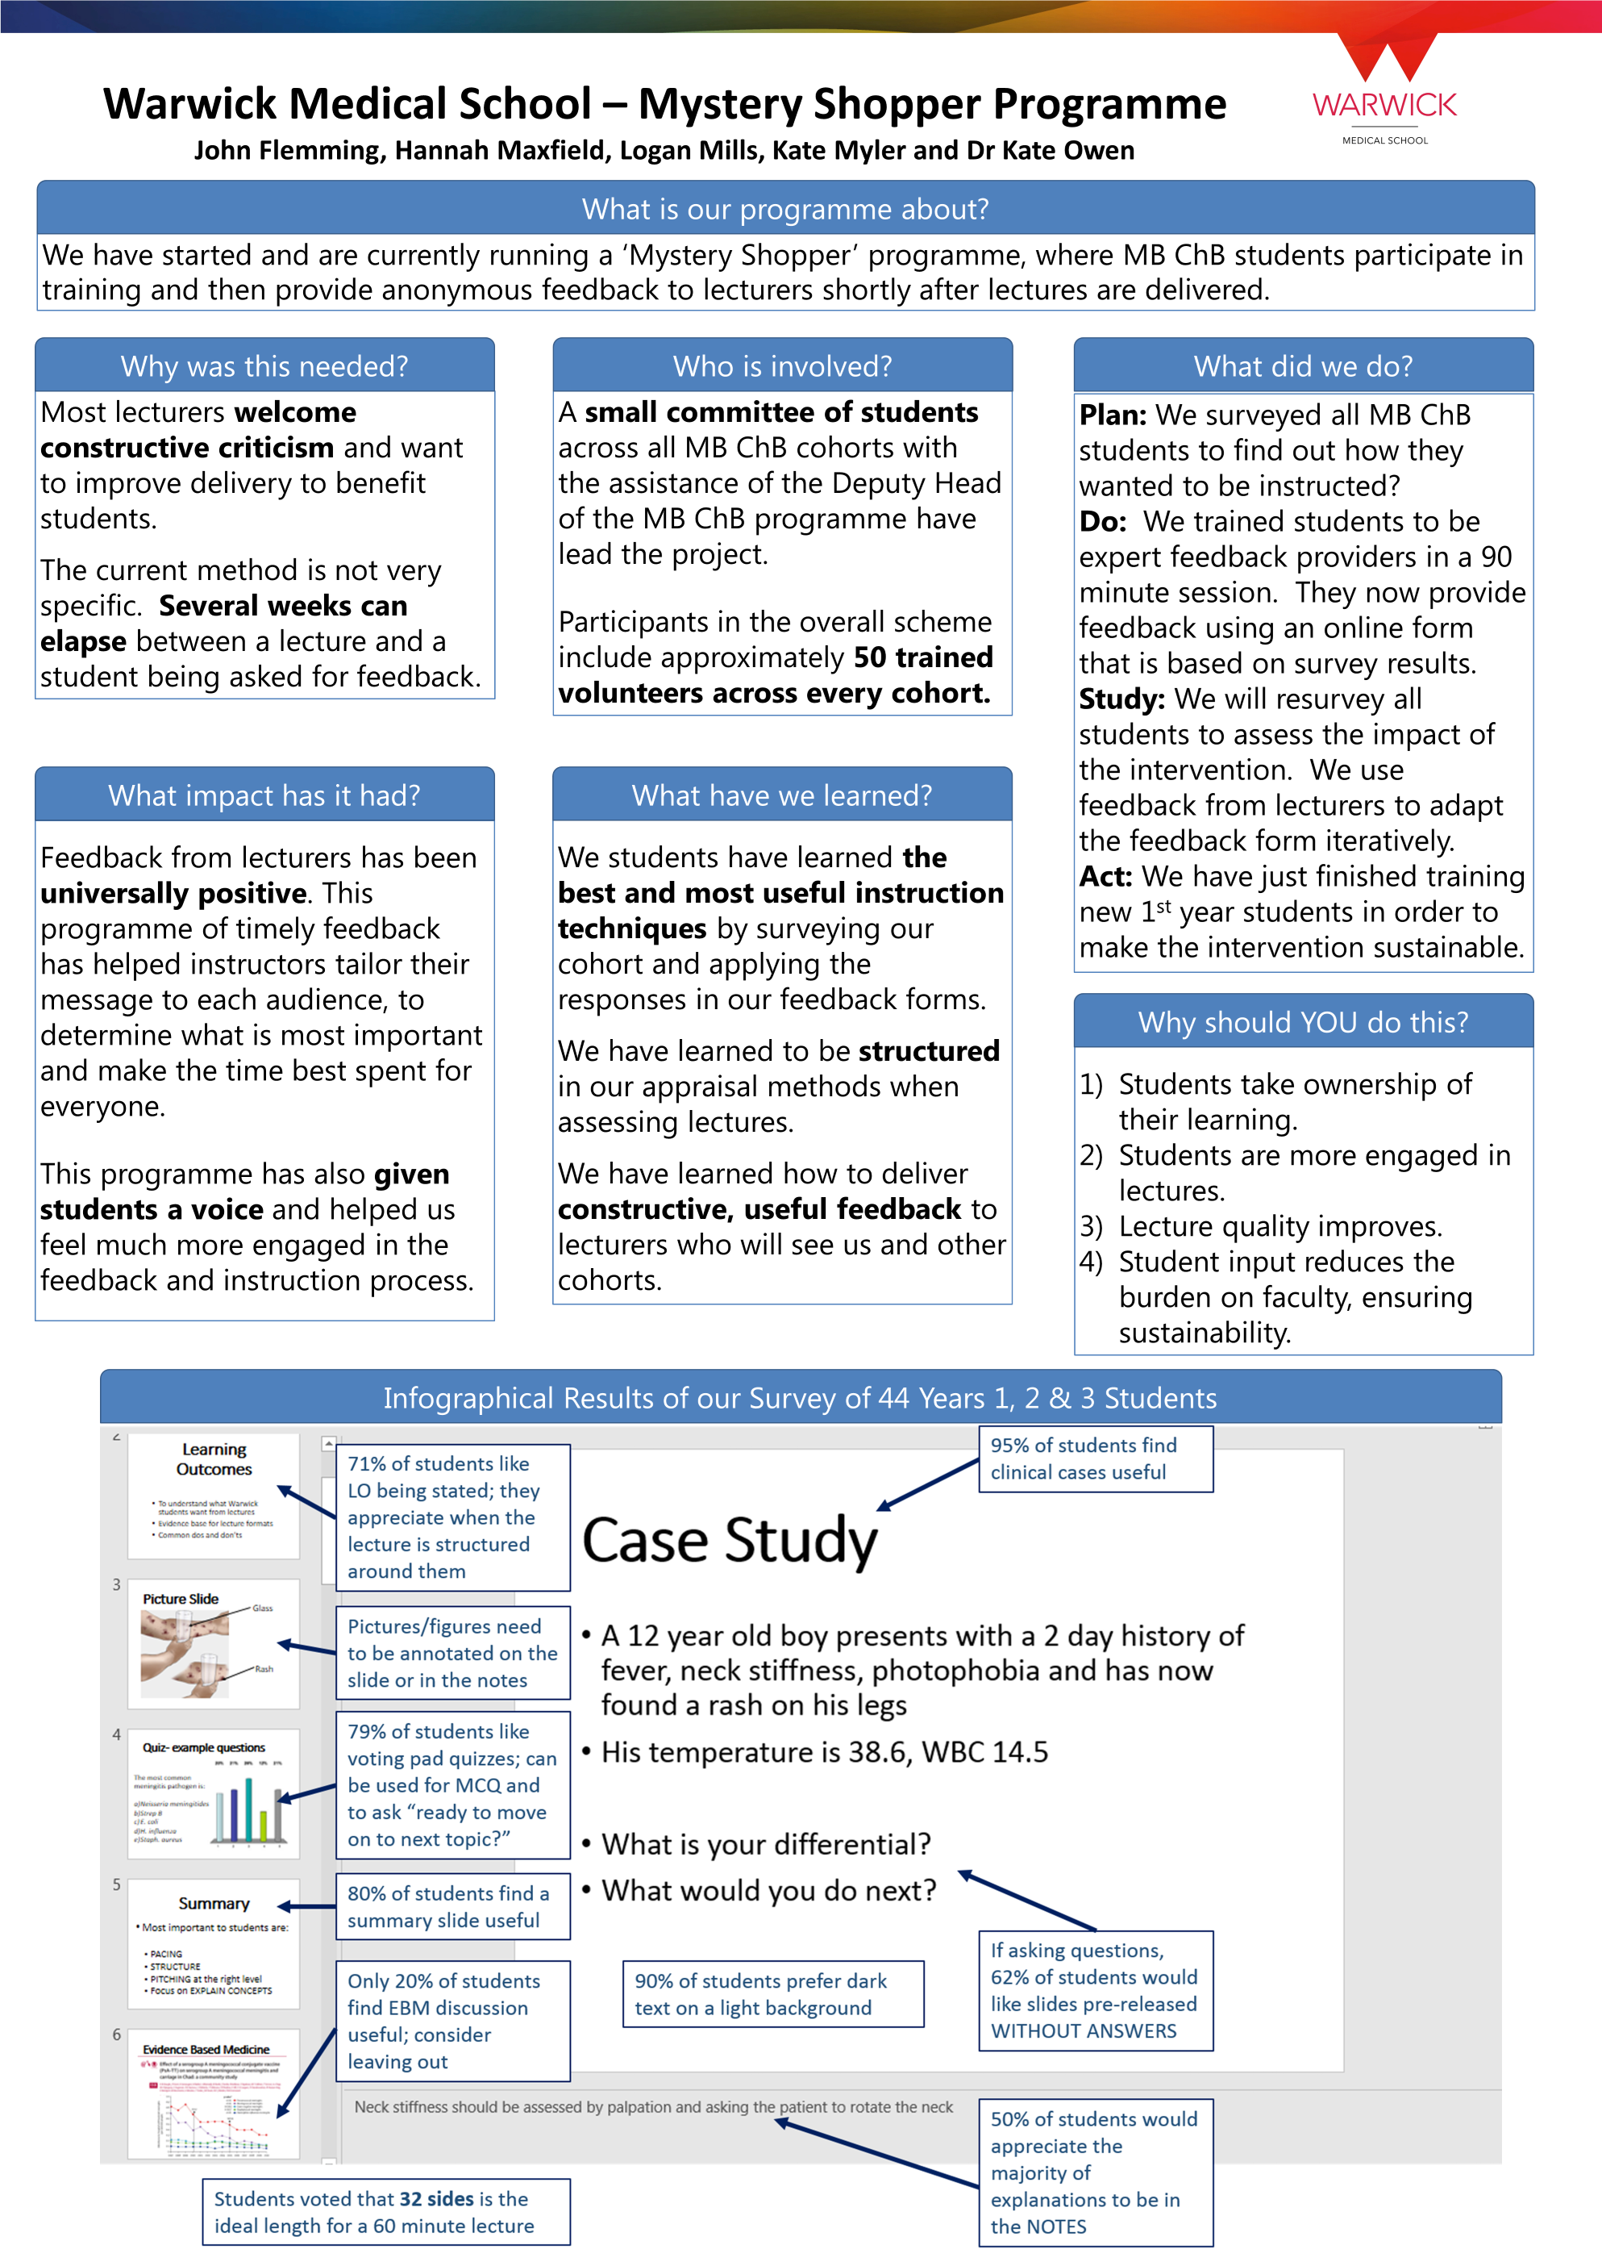

Alternative types of peer dialogue
Resources from the Cambridge Assessment International Education Teaching and Learning Team
Lesson study
This is a model of teacher-led research, which originated in Japan and is used particularly in Maths and Science. A small group of teachers work together to target an area for development in their students’ learning. They then work together to plan the observation lesson. Detailed information is collected during the observation and forms the basis of feedback on how the lesson could be improved (Wiliam, 2016). The diagram below outlines the lesson study cycle.

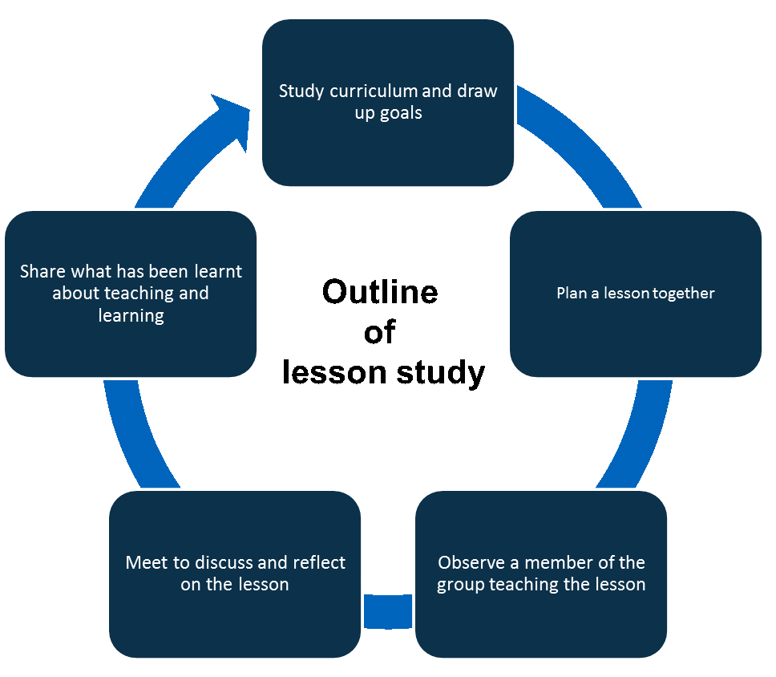

Unseen observation
The main difference between an unseen observation and peer observation is that an unseen observation doesn’t actually involve your peer observing you teach a lesson. (See the diagram below for a detailed outline.) Instead, it involves two colleagues discussing the plan for the focus lesson in a meeting beforehand and the teacher reflecting after they have taught the lesson. In an unseen observation, the ‘observer’ is known as the supervisor. While this may sound authoritative, it is not the case. Their role is to ask questions that encourage reflection and self-analysis. This model emphasises the teacher as an individual and removes the anxiety that can come from being observed.

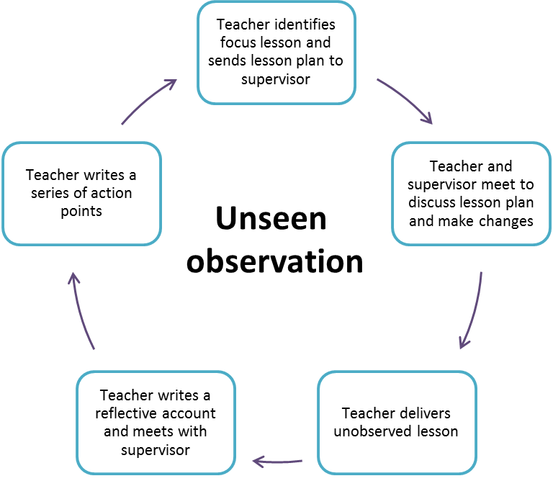

“When someone new comes into the classroom to observe, then the very presence of an additional adult who is not normally present may influence what happens.” Wragg, 2012
Bear in mind that the supervisor will only hear one view of the lesson and has to rely entirely on the honesty and accuracy of their colleague’s account of it (O’Leary, 2014). This approach to observation focuses on teachers taking responsibility for their own professional growth, even when nobody is watching.
This approach may be particularly convenient with asynchronous materials but, as with the unseen observation of live teaching, a missing component is the ability to observe the impact on learners.

Resources
De Montfort University
Diagram to explain Peer Dialogue process

Victoria State Government
Resources on Peer Dialogue (in a school setting but with interesting video case studies)

Further reading
Burbank, M.D, and Kauchak, D. (2003). ‘An alternative model for professional development: investigations into effective collaboration’. Teaching and Teacher Education 19, 499-514.
Coffield, F. (2012). ‘To Grade or Not to Grade’. Adults learning, 23(4), 38-39.
Hammersley‐Fletcher, L. and Orsmond, P. (2004). ‘Evaluating our peers: is peer observation a meaningful process?’ Studies in Higher Education, 29(4), 489-503.
Hendry, Graham D., and Oliver, Gary R. (2012). ‘Seeing is Believing: The Benefits of Peer Observation’. Journal of University Teaching & Learning Practice, 9(1).
Kennedy, A. (2005). ‘Models of Continuing Professional Development: a framework for analysis.’ Journal of In-service Education, 31(2).
O’Leary, M. (2014). Classroom observation: A guide to the effective observation of teaching and learning. London: Routledge.
O’Leary, M. (2017). Reclaiming Lesson Observation. Supporting excellence in teacher learning. Abingdon: Routledge.
Peel, D. (2005). ‘Peer observation as a transformatory tool?’ Teaching in Higher Education, 10(4), 489- 504.
Smith, R., and Starmer, L. (2017). ‘Building Adaptive expertise: Professional learning that works with teachers, not on them’. Australian Educational Leader, 39(4).
Tenenberg, J. (2016). ‘Learning through observing peers in practice’. Studies in Higher Education, 41(4), 756-773.
Wiliam, D. (2016). Leadership for Teacher Learning. Florida: Learning Sciences International.
Wragg, E.C. (2012). An Introduction to Classroom Observation. Routledge: Abingdon.

