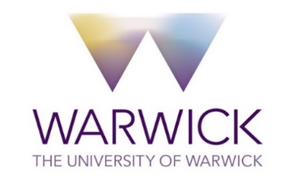

CONSENT FORM

Title of Project: Illuminations: Storied Accounts of Student Facing Workforce Wellbeing
Name of Researcher(s): Elena Riva (IATL), Rachel Dickinson (WBS), Raksha Gohel (SLS), Lauren Schrock (WMG). Nicholas Jackson (Mathematics and Economics)
Please initial all boxes
- I confirm that I have read and understand the information sheet for the above study. I have had the opportunity to consider the information, ask questions and have had these answered satisfactorily.
- I understand that my participation is voluntary and that I am free to withdraw at any time during the workshop without giving any reason and without being affected.
- I understand that no identifiable data will be collected from me as part of this study when submitting any of my writing. This means that once my writing has been submitted to the research team, it will not be possible to withdraw this data as individual responses cannot be identified.
- I consent to researchers removing direct or common identifiers from the dataset at the analysis stage if I have not already done so.
- I understand that data collected during the study, may be looked at by individuals from The University of Warwick, where it is relevant to my taking part in this study. I give permission for these individuals to have access to my data.
- Consent to use of volunteered writing generated in the workshops and/or after the
pre-recorded writing activities.
- I am happy for my data to be used in future research, publications and dissemination events.
- I agree to take part in the above study.

Name of Participant Date Signature

Name of Person Date Signature
taking consent

