Edward II: Company Reflections

Julia Ihnatowicz: Director

When you tell people you’re putting on a production of any play, one of the most immediate and common responses is likely to be along the lines of “Oh right, what made you choose that play?” It’s an even more common question when the play you’ve chosen is a rarely performed piece by a playwright who is known to many simply as the man who was Not-Shakespeare. If you’re going to do Marlowe, at some stage of the proceedings, someone will force you to think about how he compares with Shakespeare and all the ways in which they’re different. In many respects, this is fair enough, and comparisons, when they are not arbitrary, can be extremely helpful on the way to a better understanding of the subject in hand. However, lurking behind the question of “Why Marlowe?” you get the feeling there lies the attitude that it would have been more worth your while staging one of Shakespeare’s plays. It is more than likely that, in the academy and the theatre, Shakespeare will always outrank Marlowe. But then again it is probably fair to say that Shakespeare will always outrank pretty much everybody. So when asked the question “Why Marlowe?” (which I was, on quite a regular basis, through the weeks of preparation, rehearsal and performance), this Shakespeare-shaped shadow cast over Marlowe starts to look like a reason in itself for staging his plays. It was far from being the only reason, but it rapidly and perhaps inevitably became an important one, that, since he’d been consigned to the ranks of “Shakespeare’s contemporaries” rather than “playwright in his own right”, I wanted to give Marlowe some of the attention and stage-time I felt he deserved. It is telling that, of our audience members, only a very select few had seen Edward II on stage before and I don’t doubt that for many it will remain the only production they will ever see.

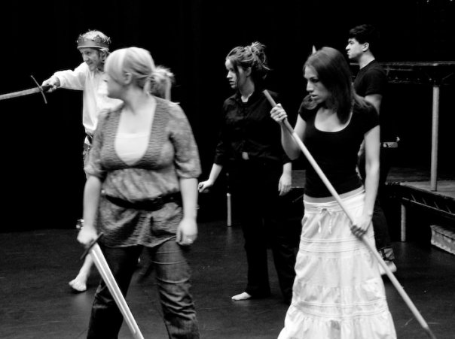Nevertheless, while neglect may point you in the direction of a particular play or writer, it certainly doesn’t make a piece interesting in itself. I owe my acquaintance with Edward II to a production I saw at the Globe Theatre while I was still at school. At the time, I remember being struck by the extraordinary cruelty of the play and its characters and it has subsequently been my impression that, in all his plays, Marlowe was interested in the capacity human beings have to do terrible things to each other. In watching that particular production, I was also unable to ignore the sheer number of characters that cross Marlowe’s stage. As Marlowe wrote it, Edward II has thirty seven named characters, before you get to the extra miscellaneous lords, ladies, messengers, soldiers, attendants and monks (our production had thirty three characters, all told). One of the most challenging and appealing things that drew me to this play is that, as well as the dominant characters who remain in our memory long after leaving the theatre, Edward II is filled with small roles, characters who appear for only a couple of scenes or in some cases for just a few lines before disappearing entirely from the stage. For so much of the play, we are allowed only snippets of stories that we will never see again. For the audience, these may not be the stories that impress themselves most deeply on the memory but, for the actors, playing characters who only appear briefly and about whom we know so little can be extremely rewarding. Such roles demand that the actors employ their own creativity to make sense of these characters and make them live for the audience. With so little to go on, the text grants the actors the space to make use of their own imagination and intellect to create something that is their own. In this respect, Marlowe is only one player in a large ensemble of creators, all on an equal footing.
1 The King's Army

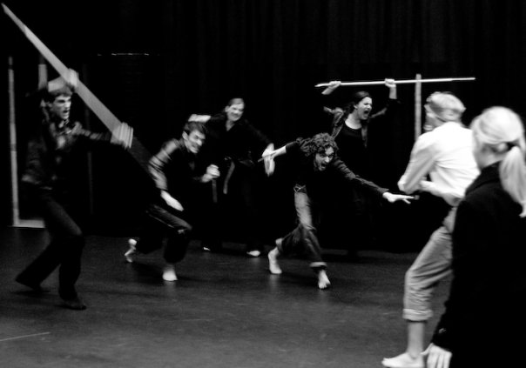Indeed, this is not only true of the minor roles. In theatre generally, but especially in Marlowe’s, the written text constitutes only a fraction of what goes into making the performance. As the text has come down to us, Edward II only contains a very few indications as to stage business, although some of them, admittedly, are among the most unforgettable stage-directions you are ever likely to read. For the most part, however, all we really have are the words spoken; that is, the text provides us only with the verbal life of the play. It is the purpose and responsibility of the company to create the physical, visual and aural life. In this respect, theatre is always essentially a collaborative enterprise. It is no coincidence that the ensemble was placed at the centre of this production. Beyond the five-man strong production team, we had thirteen actors and two musicians who came together to work on the project. As is the case in any production, all members of the company will bring with them their own unique imagination and experience. It seems absurd to me not to make use of that variety and wealth of knowledge that accompanies the performers into the rehearsal room. Why bring fifteen people together to work on something if you’re not going to use what they can bring to the project? Rehearsals were therefore designed to draw out the ideas of the performers themselves. They were often left to work on a passage by themselves, without directorial supervision, to allow them the space to explore their own responses. Moreover, a lot of time was spent, early on in the rehearsal period, building the ensemble. When performers know and understand each other better it not only makes them better at performing with each one another but, perhaps more importantly, through understanding and being comfortable with each other, it makes the rehearsal room a safe space in which everyone is invited and able to contribute ideas. Most importantly, this safe space allows everyone to make mistakes. A large part of rehearsing involves trying things that will not work, exploring options that will eventually be rejected. It is not only vital that the performers know what the other options feel like so that they fully understand the choices they make in performance but it is amazing what can emerge from making mistakes. In rehearsal, the performers must be allowed to experiment and try things, free from the urgency and pressure of finding the “right” option.
2 The Barons' Attack

In approaching this project, my particular interest was in Marlowe’s metre and the ways in which rhythm underpins the whole of his theatre. Starting from this shared basis of rhythm, I wanted to use music to build a physical and aural life for the play that would be just as powerful as the verbal life. Working with jazz musicians from the beginning, the actors were encouraged in rehearsals to discover physical and musical rhythms that could help tell the stories of the play. Through their work with music, the actors were pushed to find new ways of using their bodies to articulate emotions and stories. In performance, music was used almost continuously, running parallel with Marlowe’s verse. Given another week to work on the production, it would have been wonderful to push these physical and aural ideas even further to see whether it would have been possible to tell the stories without using any words at all but only the rhythms of movement and sound. We may have discovered, of course, that it was not possible or that it was not the right choice for this particular project but it is a shame that we did not get the chance to explore the option before deciding against it.

Malik Refaat: Musical Director

As MD on the Edward II project it was my job to arrange a band and provide improvised musical accompaniment and themes to the play. This sounds fairly easy but putting a band together who are willing to give up their time is difficult, and finding musicians who are at a suitable level of ability in terms of improvisation and understanding of music and theatre is no easy task.

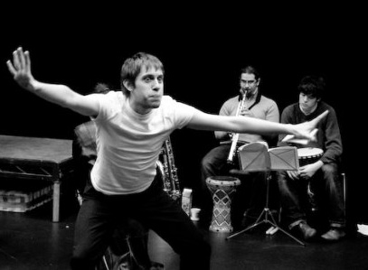The original band for Edward was to be a jazz quartet with the different instruments (drums, bass, piano and saxophone) to play around with emotions and moods or to play themes for characters or to individually tell the stories of characters on the stage whilst still achieving some sort of musicality in the performance. Unfortunately due to technical constraints and the fact that musicians are fickle people we used just saxophone and percussion. This turned out to be a great combination in terms of setting moods and themes and also getting enough emotional colour into the background of the play. The music and percussion really underpins the words or movements of a character on stage.
3 David Ross, Malik Refaat and Eoin Phillips

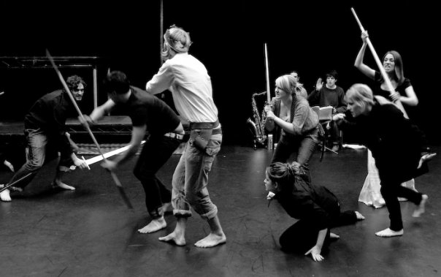To achieve this, the instructions to the band were to watch the characters, play in a given key and just jam along following their movements and tones of voice. We had multiple workshops during rehearsals to get everyone up to speed on this style of performance with the music leading the actors and the actors leading the music and everyone eventually taking the lead from everyone else on or off stage and giving a performance which changes each night depending on how each actor or musician perceives what is happening on stage at any one time. As with anything improvised not one performance was ever the same nor was any rehearsal. This means that everyone has to be on their toes giving it all they've got every night with no time for relaxing and settling into the complacent knowledge that you know what is coming up. This makes for a very edgy performance full of enthusiasm and excitement for all.
4 Battle

As much as I enjoyed this performance I would definitely change the format. I think a bigger band would be more fun to work with and would make for a wider range of emotional and physical settings on stage. I think penning themes and handing them out to the band in advance would be worth trying. Possibly not using a score but a selection of numbers picked at random by the MD but that coherently tell the story being played on stage. I think a useful technique would be to have musicians surrounding the audience so they have their senses worked on from all angles especially as characters can enter from multiple doors or hiding places in a venue.

Simon Nussbaum: Bishop of Coventry, Earl of Pembroke and Lightborne

The show was originally sold on the auditions emails etc. with music – I believe jazz - conspicuously specified as part of the production vision, which led me and several other cast members to envision something involving a large array of musicians and instruments, possibly involving dance movement and singing. In the end of course the show used 2 musicians on djembe drum and saxaphone, very different to the imagined extravagance but ultimately far more satisfactory. Because the notion of ensemble and group process (undoubtedly inherited from the RSC's involvement in the CAPITAL Centre) were put so central to Edward II the musicians were usually referred to as being creative forces for the actors to perform in dialogue with – and so in rehearsal various scenes would be assigned different musical keywords which would then evolve or change depending on the musicians' outlook or the actors' portrayal. While essential to the rehearsal process, I think the main value of the music come the performance was rather more simply to create mood, atmosphere and context for the audience and thus lift some of the burden from the actors – particularly helpful given the minimalist staging. It was also an aid for members of the cast (myself not included) who had monologues and soliloquies heavily reliant on Marlowe's rhythmic verse, giving them an undercurrent of timing and emphasis.

The rehearsal process was notably long, not just in how long before the performance we started but also the workload of hours was substantial from early on. It was also physically very intensive, which inevitably was liable to play negatively on the cast's mood, but on the up side made it feel like real work. I've always found in my acting the physical aspect far harder to control and get right than the vocal, so having such a rehearsal process dominated by physical activities of all sorts has proved extremely valuable. The 'group faction' element of the play took a massive precedence in rehearsal – 'follow the leader' games were the most common and recurring physical element – which was of course important but I felt the main benefit was the indirect benefits to our attention to physical movement, as forming a homogenous lump bunched tightly behind our leader is precisely what we ought not to be doing onstage. As my main character had plenty of time onstage but very little to say in hindsight I am immensely grateful to the physical exercises relating to attitude and posture as Marlowe's propensity to put a lot of people onstage for most of his scenes means most of the cast spent plenty of time skulking, reacting and generally trying to keep the stage picture vaguely interesting. I felt that there could have been greater integration between 'ensemble work' – the kind of rehearsal techniques that could and probably would have been used regardless of what play we were working on – and specific 'Edward II work', as the general way the rehearsal process went was that the first 2 weeks were virtually uninterrupted physical exercise, with specific staging and more conventional rehearsal gradually being introduced. At the time of doing the lengthy physical rehearsals it could be frustrating that we could only trust in hope that once we started working on the play at hand it would become useful.

The autonomy given to the cast for blocking Edward II was for the most part fantastic (the battles probably being the only exception). It meant that we had a greater ability to introduce our own character insights into proceedings, made us more comfortable with the outcome, forced awareness about what we would be doing physically in a scene (again, important when everything you will be doing in a scene is physical and little or none of it is necessary whatsoever to the narrative) and made the whole blocking process evolutionary. It also makes for more efficient rehearsals as the director is not needed to give an overseeing eye to every area and moment before any progress can be made.

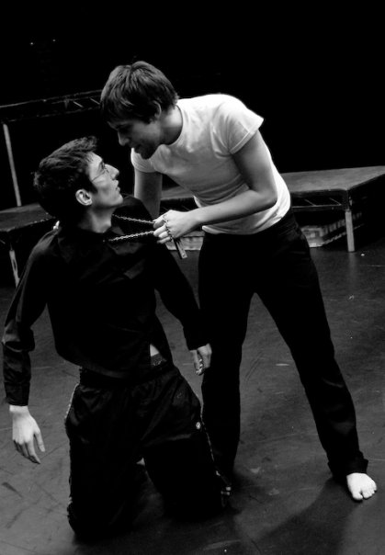Bishop of Coventry - Of course with Coventry the starting point was that familiar reminder of the “massive importance of religion in society” which allowed me to play my opening lines to Edward patronizingly rather than deferentially. Seeing as my time onstage is short and sweet my main aim was differentiation, so I tried to keep myself horizontally restricted to contrast with Pembroke and show some sort of prim dignity, and my voice sonorous and somewhat aristocratic. I mostly blocked the Coventry scene and came upon the idea of having some sort of physical drowning occur onstage. Selfishly this made me happier playing the part at all as it meant something at least happened to me onstage and gave the scene/character some visual interest to the audience. I also thought this conveyed the keyword of 'humiliation' the director gave us for the passage and fit with Gaveston's physical impulsivity.
5 Simon Nussbaum and David Ross

Earl of Pembroke – I originally envisioned Pembroke as an old duffer, principally because I was amused by how much of his role seemed to be to chip in with agreement once a resolution was made and how frequently he was overlooked – I saw him as a geriatric sitting around upstage occasionally popping up to no great consequence. This was of course quite a parody and I'm not sure how much I ever thought of actually playing him like this. When I and the director talked through the character I said I saw 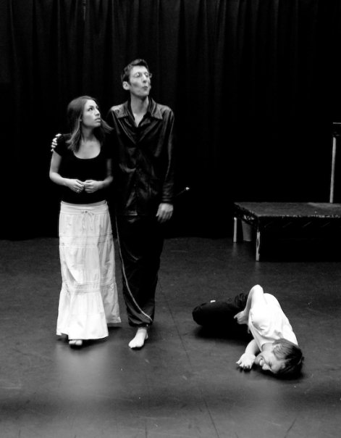him as either younger or older than the barons and we decided upon youth, which was certainly a better direction and prevented me slipping into an egotistical attempt to steal stage-time to recompense the lack of lines Pembroke gets. As the rehearsal process developed Pembroke's youth became more important to me as it allowed the character to be motivated principally by violence, as a real disciple of Mortimer rather than Warwick and Lancaster's more separate political entities. This goes some way to excuse the lack of lines and importance as most of his subjectivity is indistinct from Mortimer. The main challenge – and something which only properly developed late on in rehearsals – was the configuring of relationships between the group of barons. It was only through playing scenes again and again that we found and developed attitudes to one another to give the barons' scenes a greater amount of characterization – important as they are so overridingly concerned with plot and there are few clues in the text about the relationships inside the faction. The suggestion of Pembroke's death was a neat way of both giving some onstage repercussions of the conflict between the King and barons, and also on a practical basis resolving fact that Marlowe – typically showing how little importance the character is of - never bothers giving him an exit after the battles.
6 Maria Askew, Simon Nussbaum and David Ross

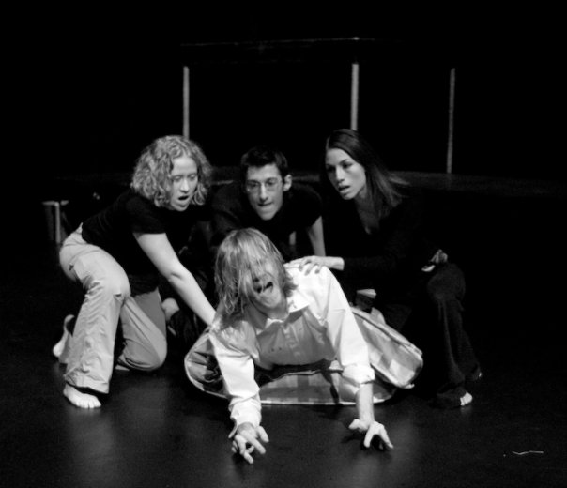 Lightborne – Lightborne is clearly a fun part to have and I enjoyed having the role, as well as being conscious of the need to avoid the temptation to turn his scenes into pantomime. It was also liberating because the role has absolutely no demands of realism, as the character is so outlandish, simply appears in order to serve his purpose to the plot. Once it came to rehearsing the actual sequences (rather than general character work) I found in particular his main monologue intensely problematic, mostly because it needs delivering to an audience for it to be effective and so it never felt natural until an audience was actually present. I also found difficult the switch between talking to Mortimer onstage and then turning to the audience for the rest of the speech, and I'm not sure if I ever really handled this right. For Lightborne's main role as executioner, I went through a real turnaround as rehearsals went on. Initially I had in mind something chillingly passive and detached, and in one of the 'magic space' games I remember acting out a sort of execution along these lines. I envisaged calling for the poker like a surgeon for a scalpel. However as I started rehearsing the scenes with Matt [Edward] I soon realized the need for a rethink, firstly because of the understated way the King's monologues and movement are done, and principally because it became obviously apparent that sticking a poker up his behind as the method of murder – despite us rationalizing the methodology when talking about contract killers in terms of not leaving a mark etc. - was not something which lent itself to the serious professional but someone more enthusiastic and psychotic. I started to play up a sort of glee and a physical impulsiveness, which helped in the build-up as it gave I hope the sense of a trap waiting to be sprung at the right moment. The presence of the mattress allowed me to give a childlike sort of bounce to the character. We also of course gave reference to the latent eroticism of the death, so I always wanted some sort of physical contact, preferably something near romantic, and stroking Matt's long hair became a convenient way of showing this.
7 Edward’s Murder

Performance

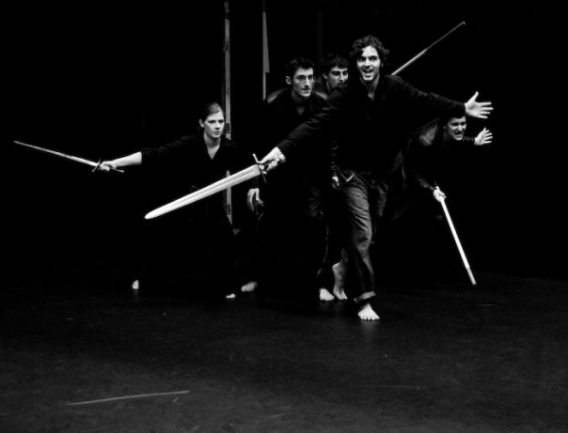It was interesting as part of the cast to note the difference between individual reflections and group reflections. On one of the nights in particular I was massively dissatisfied with my portrayal of Pembroke, yet coming in at the interval expecting universal irritation found plenty of the principles and other actors thought the performance was going very well. As Pembroke I think the greatest gift by Marlowe to the actors (I'm not sure how much for roles other than the barons) is the combination of swift, punchy, direct scenes and not too much substantial time offstage between them. Once playing Pembroke (after my brief turn as Coventry), my onstage time while as with every acting performance could be troubled by flatness and lack of energy, there wasn't the need to contend with a natural boredom of lengthy speeches or dialogue which don't take the audience anywhere (something Matt I'm sure was burdened with and dealt with excellently); and when not onstage it was helpful that there was rarely time for energy levels and mood to subside. In fact the time which felt longest was not when properly offstage but when stood at the back in freeze-frame waiting to reappear – during the which time I would try to manipulate my face into a snarl, grit my teeth and other slightly silly things to keep the mentality of intense anger (we're about to castrate Gaveston) up. On the final night as Lightborne, motivated of course by the knowledge of the final performance and that while Pembroke was my substantial part the moment with the poker is what the audience are most likely to remember, I tried to up the energy levels and physical contortion, and also rubbed a decent amount of hair gel into my hands - a technique which I wish I had thought of or discovered earlier as I felt it was of immense help to my physicality. It was during the rehearsal process but also subsequently that I came to realize just how influential the RSC's Histories Cycle had been to the whole mode of performance, from the importance of group dynamic and ensemble work to the rehearsal process, the strategic multi-roling, the presence of music to punctuate action, to the minimalist staging with one large metallic structure at the back, the stylized battles, the costume choices.
8 The Barons' Army

David Ross: Piers Gaveston and Sir John of Hainault
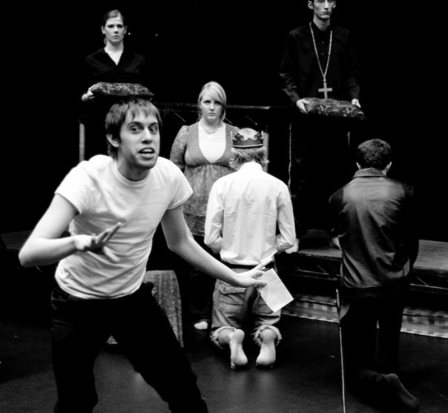Edward II…a play about a gay king with a poker up his bum, right? Well, technically yes, but there is so much more to the play than what that (admittedly awful) summary has to offer. Being in a production of Marlowe’s play opened my eyes, ears and body to the dark power struggles that pervade the play and gave me a deeper understanding of the possibilities of verse in general.
9 David Ross

From early on in the rehearsal period the physical and the textual were brought together. With her ever predictable (often feared!) phrase of “Find something new” Julia forced each actor to simultaneously explore their understanding of a word the actor felt summed up the mood of their character at a certain point in the play as well as expand their ability to use the physical body as a communicative tool. The constant demand for new physical positions pushed me to a subtler understanding of the word in question, which in turn provided a more nuanced reading of the lines themselves. The verse became a pool of physical opportunities as the physical work became a lens through which to study the text. I found this method of rehearsal highly productive and extremely enjoyable and feel that I now have a greater understanding of the connection between body and word.

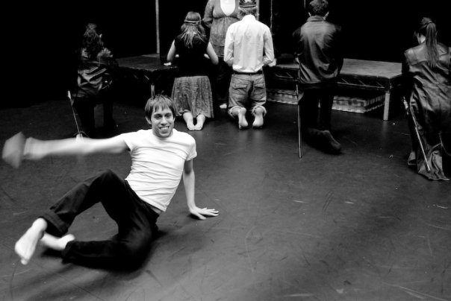Another important exercise came in the use of music throughout the rehearsal period. Across the entire rehearsal time, I felt that the company found its own a distinct rhythm as an ensemble. This helped in our understanding of Marlowe’s use of rhythm in the verse and in terms of the pace of the play as a whole. Each scene had a very marked tone, pitch and speed that came from the work on rhythm that each actor did. I found Gaveston’s rhythm to be quick and playful whilst still being strong – aspects that inflected everything from my movement to my understanding of Gaveston’s motives to my speed of response in conversations with other characters.
10 David Ross

If I were to do the production again, I think it would be interesting to explore the parallels between certain characters and find a means of drawing attention to these, possibly through similarities in physicality. Also I would have liked, at least as an exercise, to explore whole scenes on a more abstract physical plane of communication and find true bodily forms of expression. Nevertheless, the physical work that we did do contributed greatly to my understanding both of Marlowe’s play and the possibilities of bodies as texts to be read.

Alex Knight: Young Mortimer

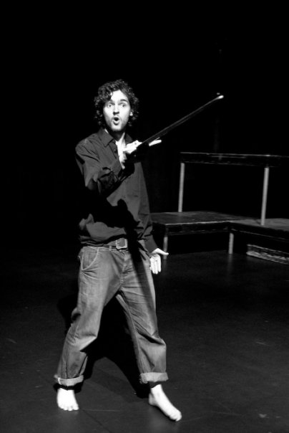Performing in such a space as the new CAPITAL centre studio was an incredible experience for a student theatre production. The fact that we were able to rehearse in the performance venue throughout the rehearsal schedule was as an added plus. It allowed us to become far more comfortable with the space than we would otherwise have been.

In rehearsals we experimented around a huge number of exercises with the body. We were told to walk around the room by the director and suddenly freeze in any position of our choosing. When the whole group had done this the director asked everyone but one person to relax and look at the remaining frozen person. We were asked to describe what we saw in just one word. We would repeat this a few more times so that we had various different actions to choose from. When we had completed this part of the exercise we were asked to choose one of the positions we had seen and to copy it exactly and then to start speaking the different words that had arisen from the groups thoughts on that position. It made us concentrate in minute detail on what our bodies were doing and how we could distort and use them to our advantage when put in our characters.
11 Alex Knight

We looked at how far you could push the body before it breaks. We were placed in partners and both people raised their hands together. When one person moved their hands the other had to follow wherever they took them. We were constantly told by the director to push each other as far as possible until one of us fell over. Only by doing this could we understand how far we can take our bodies. By doing this exercise we able to push our bodies in a huge number of ways showing the huge number of things we could create with just our bodies.

We investigated status exercises with a partner looking to see who held the highest status at that particular moment. We would look at a particular moment between two characters and play it out with one of the couple being the dominant figure. They would assume a dominant position with their body and remain frozen throughout. When they had assumed their position the other person would take up a submissive position to them and likewise remain frozen throughout the exercise. When both characters had finished the director asked them both to do the same thing but now swap the status around so whoever had taken up the submissive position now took up the dominant position. This made it completely clear who was in charge at any one moment.

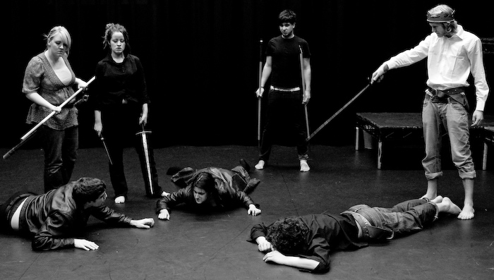To find the overall status of the group and all their characters the director asked us to use our bodies in other ways. We were asked to choose an animal that best suited our characters and to inhabit this animal. When the whole group had chosen we were asked to react and respond to what each other had chosen. This simple exercise allowed us to realise who controlled the highest status in the group whilst allowing the group to use their bodies in new ways.
12 The Barons' Defeat
With all these exercises and the use of such an intimate and exciting venue as well as the support from the CAPITAL centre staff and production team we were able to bring lots of physicality and strength to this production.

Anna Henderson: Queen Isabella, Levune and James

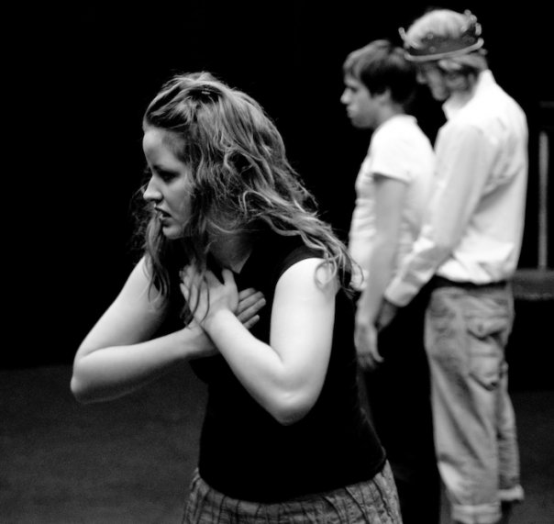When I was cast in the role of Queen Isabella in this production of Edward II I was absolutely delighted. I had previous acting experience, but I had never been involved in a production of this genre and it was really exciting. As a finalist taking EN301 Shakespeare and Selected Dramatist of His Time the production fed directly into my studies and I do not think any experience could compare to the hugely enriching process of bringing such a text to life. The fact that the chosen piece was a Marlowe play instead of the classic Shakespeare provided a fresh challenge and it was exhilarating preparing a performance by a dramatist of such calibre, who in my opinion is rarely given the stage time he deserves.
13 Anna Henderson, David Ross and Matt Goad

As a company we were given the enormous luxury of an eight week rehearsal period and this without a doubt contributed to the success of the performance. We had the time at our disposal in which to form a solid team and practice techniques that helped us slowly craft our characters. I feel that our ensemble theatre worked so well because we took time to get to know each other and the space truly became safe for everybody. From our very first rehearsal we implemented jazz music and worked with the musicians to weave rhythm into whatever we were working on. I learned to treat my body as my instrument and discovered how to play it properly. In other plays I’d worked on we had always started immediately with the script, but this process did not even touch the text initially and this I found very beneficial. Instead, we focused on expressing emotions through physicality, reducing ourselves to the representation of a single word and pushing and stretching the body as far as we were able.

In terms of my own character I was challenged tremendously by the openness of the script. I learnt how flexible this type of drama is in the choices it offers to the actor. It took me a long time to figure out ‘Isabella’s story’! Everyone in the cast had their own individual stories to develop and it was difficult at times to find your motivation, to know why or for what reason your character was speaking. I found the director’s ‘text message’ exercise extremely helpful, boiling down long speeches gradually until you were left with a message of one word. I was doubtful at first that a long speech could be condensed to one word, but I was proved wrong and this is actually a technique I now use in my personal study of Marlowe and Shakespeare alike.

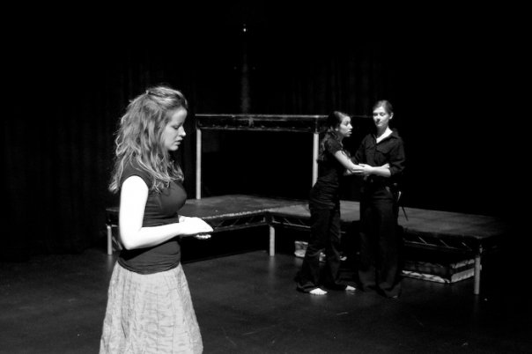Performing in the CAPITAL Studio was without a doubt the highlight of the entire process. Having an audience charged the performance and really made us work to keep the energy flowing. I thought one of the strongest points of the play was the quick pace and I loved the overlapping scene changes, which everyone worked so hard to keep seamless. As performers it was wonderful to witness how enthralled the audience were with the action and as students it reinforced the power that these plays have in performance, a power I find to be slightly diminished on the page.
14 Anna Henderson, Genevieve Raghu and Briony Rawle

Personally I have benefited hugely from this production and I do not think for a second that I am alone. Not only has my knowledge of the play broadened immensely, but the possibilities for acting and staging that we explored have opened my eyes to ideas that I never would have contemplated before. I plan to write on the production as part of my assessment for EN301 and I believe this familiarity with the text is second to none. If only we could work on every play like this, the potential would be endless!

All photographs courtesy of Ashmore Visuals. 

[In this game, the actors sit on chairs in a square, with an empty space in the middle. This is what we call “the magic space”. It belongs to all the actors and anything can happen inside it. One at a time, when they are ready and when they wish to, any of the actors may enter and explore the space. When an actor wishes to enter the space, s/he stands up, at which point everyone else looks down. When the actor inside the space is ready to be watched, s/he stamps his foot to indicate that the others may look up. In rehearsal, actors were invited to explore the space first as themselves and then as their characters. Both the space and the actors became many different things each time a new person entered the space – J.I.]
[In this exercise, the actors are asked to sum up a speech in a ten word text message (which must make loose grammatical sense). When they have formulated their text message, they are asked to boil it down further to five words, then three and finally to a single word. The exercise can be enormously helpful in getting to the heart of a speech very quickly – J.I.]

