Receipt

&

Certificate of Attendance

Young Researchers in Mathematics Conference
14th-16th April 2011
University of Warwick

Name:  Affiliation:  Registration Fee:  Accommodation:  Total Paid:  Receipt No:  Date: | Peter Rowlett  MSOR Network, University of Birmingham  £30.00  £55.00  £85.00  REG52019127  March 21, 2011

go.warwick.ac.uk/yrm2011

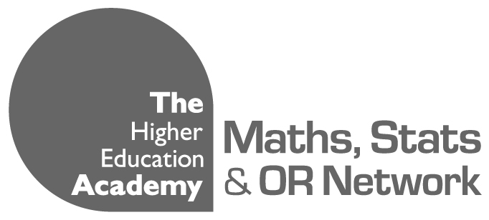
Sponsors

