Brief encounter: traffic dynamics of crowded molecular walkers
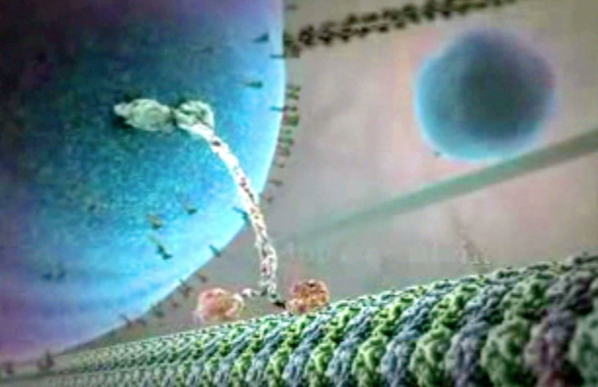
Background & concepts: Molecular motors are nanometer-scale automata that walk along polymer tracks inside living cells, hauling cargoes of molecular parts to specific reaction sites. Most studies of the molecular walking action have concentrated on the mechanics of individual molecules. Each molecule can step forwards or, on occasion, backwards, one 8nm step at a time ¹. Steps are triggered by the binding of the ATP fuel to one of the two feet ². If the next binding site is temporarily occupied, the walker can also pause for a brief period, standing on one leg and waiting until the obstruction clears. If the obstruction does not clear, the walker can detach and diffuse around in solution, land randomly in a different place on the track, and resume progress. In the cell many walkers use the same track at the same time, and crowding effects and complexity (emergence, stochasticity) come into play. Observing the full set of players simultaneously is challenging, but picking out an individual within a crowd and watching its behaviour from moment to moment is easily possible.
Research Objectives: Starting with data that we already have on the stepping behavior of single kinesin molecular motors under defined loads and fuel concentrations¹, develop a stochasticallly stepping automaton. Then investigate what happens when this automaton meets, competes , collides, joins forces with another. Begin to predict collective and emergent behavior, all the while returning to the driving properties of the individual automaton.
Prospective deliverables: A formal description for a molecular walking, including the benefits and penalties of molecular teamwork.
Who would benefit: motor-driven transport is a low-level driving process in eukaryotic biology and is widely relevant. There are specific diseases that arise from defects in motorized transport (Alzheimers, Parkinsons) and drugs that inhibit motorized transport are important in cancer therapy.
Routes to a follow-up PhD: one possibilities include (1) a project that combines experimental work on the dynamics of motor teams and modeling / simulation / with analysis of the data obtained. (2) a combined experimentally and theoretical project on emergent aspects of motor-track interactions: for example, teams of motors that not only move along microtubule tracks, but also influence microtubule self-organisation. (3) a project combining experimental work on the stepping and force generation behavior of small teams (2 or 3 kinesin motor molecules attached to a bead) using optical trapping in collaboration with Nick Carter in the CMCB, with modeling and analysis of this data. Preliminary data are available.
References
1. Carter, N.J. & Cross, R.A. Mechanics of the kinesin step. Nature 435, 308-12 (2005).
2. Alonso, M.C. et al. An ATP gate controls tubulin binding by the tethered head of kinesin-1. Science 316, 120-3 (2007).

