Molecular tugs o'war: collaboration and competition in molecular motor teams
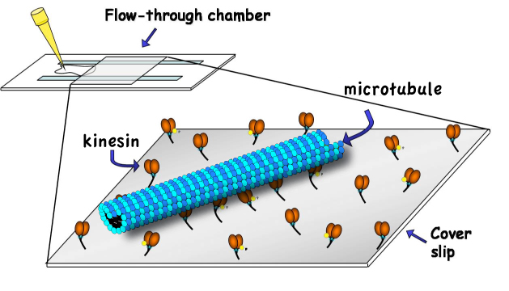
Background & concepts: Microtubule molecular motors are the dominant engines of long-range spatial self-organisation in biology, and there has been considerable recent progress on understanding their single molecule mechanisms. So far however, there has been almost no work seeking to understand the mechanisms by which multiple molecular motors join forces to generate the larger and more sustained unidirectional movements and forces seen in cells. The frontier challenge now is to discover the engineering principles and mechanisms by which the molecular mechanisms of different molecular motors interface effectively to produce concerted force and motion. The proposal is to approach this key problem from a complexity perspective, considering an ensemble of motor automata attached to a surface at a certain spacing. These motors can attach to a track (the microtubule), which overlies the ensemble and is driven to slide across the surface at an observable velocity. Each motor-automaton has a range of behavioural options available to it. For example at any instant it can attach, detach, pause, step right or step left. The challenge is to build a mathematical description of the ensemble properties that makes concrete, testable predictions.
Research objectives: Microtubule motility assays (illustrated), in which microtubules are driven to slide by an active surface of identical molecular motors, are routine in the Cross lab. The analysis will seek to model the collective / emergent behavior as the consequence of a simple decision tree operated by each motor, with decisions depending on the status of other motors attached to the same microtubule. There will be an opportunity to collect motility data from surfaces carrying two different motors. Preliminary data are available.
Prospective deliverables: A formal description for a molecular walking by a multimotor team attached to a surface, with predictive power, identifying the benefits and penalties of molecular teamwork.
Who would benefit: motor-driven transport is a low-level driving process in eukaryotic biology and is widely relevant. There are specific diseases that arise from defects in motorized transport (Alzheimers, Parkinsons) and drugs that inhibit motorized transport are important in cancer therapy.
Routes to a follow-up PhD: possibilities include a project combining experimental and theoretical work on the stepping mechanics of teams of motors attached to surfaces –including motors with opposite directionalities, different intrinsic velocities, and different types of microtubules. Optical trapping work is possible in collaboration with Nick Carter in the CMCB, with modeling and analysis of this data. Work is ongoing with Oxford Physics on optimizing the display of protein motors using DNA nanotechnology. This data is available.
References: Yajima J, Cross RA. A torque component in the kinesin-1 power stroke. Nat Chem Biol. 2005 1 :338-41.
C. Leduc, F. Ruhnow, J. Howard, S. Diez Detection of fractional steps in cargo movement by the collective operation of kinesin-1 motors PNAS USA, 104, 10847-10852 (2007)

