Brief encounter: traffic dynamics of crowded molecular walkers
Rob Cross, Centre for Mechanichemical Cell Biology (r.a.cross@warwick.ac.uk)
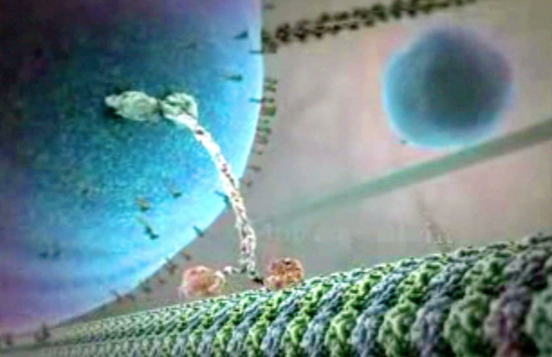
Background & concepts: Molecular motors are nanometer-scale automata that walk along polymer tracks inside living cells, hauling cargoes of molecular parts to specific reaction sites. Most studies of the molecular walking action have concentrated on the mechanics of individual molecules. Each molecule can step forwards or, on occasion, backwards, one 8nm step at a time¹. Steps are triggered by the binding of the ATP fuel to one of the two feet². If the next binding site is temporarily occupied, the walker can also pause for a brief period, standing on one leg and waiting until the obstruction clears. If the obstruction does not clear, the walker can detach and diffuse around in solution, land randomly in a different place on the track, and resume progress. In the cell many walkers use the same track at the same time, and crowding effects and complexity (emergence, stochasticity) come into play. Furthermore, polymer tracks built from tubulin form cylinder shaped tubes with typically 13 tracks on the outside, and the motors can switch between them. Observing the full set of players simultaneously is challenging, but picking out an individual within a crowd and watching its behaviour from moment to moment is easily possible in experiments.
Research Objectives:
- Starting with data we have from experiments on the stepping behavior of single kinesin molecular motors under definedloads and fuel concentrations¹, develop a stochasticallly stepping automaton on a tubulin track.
- Then, making reasonable assumptions on interaction rules, investigate what happens for an ensemble of interacting motors, and verify results and parameter choices against experimental data for a single tagged motor.
- Begin to predict collective and emergent behavior as a function of controllable system parameters such as densities of reactants or temperature, which can lead to interesting suggestions for new experiments.
Wider benefit of research area: motor-driven transport is a low-level driving process in eukaryotic biology and is widely relevant. There are specific diseases that arise from defects in motorized transport (Alzheimers, Parkinsons) and drugs that inhibit motorized transport are important in cancer therapy.
Routes to a follow-up PhD: there are various routes to continue this project for PhD in theoretical and applied directions, such as mathematical descriptions and validation of non-Markovian models for motor dynamics, or simulation of emergent behavior in realistic models with comparison to data from CMCB, which could also be combined with some basic experimental work. Possible supervisors include Rob Cross, Nick Carter (CMCB), Colm Connaughton and Stefan Grosskinsky (Complexity).
References
1. Carter, N.J. & Cross, R.A. Mechanics of the kinesin step. Nature435, 308-12 (2005).
2. Alonso, M.C. et al. An ATP gate controls tubulin binding by the tethered head of kinesin-1. Science316, 120-3 (2007).

