Complexity miniproject 2013: Mechanism of microtubule assembly and disassembly

Supervisors: Dr Stefan Grosskinsky, Complexity Centre / Mathematics
Dr Anne Straube, CMCB / Warwick Medical School

Background:
Microtubules are dynamic, cylindrical filaments that serve as the intracellular transport network and fulfil vital structural and signalling roles in the cell. Microtubules are assembled from αβ-tubulin dimers that attach head-to-tail into protofilaments, 13 of which form a hollow tube of ~25nm diameter. Assembly and disassembly of microtubules occurs at the ends of the microtubules and is tightly regulated by a larger number of factors in cells [1-2].
Pure tubulin and GTP as energy source are sufficient to reconstitute dynamic instability in vitro and allow to study the effect of microtubule dynamics regulators in a controlled system. In this project we aim to propose a model how EB3 increases the microtubule assembly rate and at the same time induces frequent transitions to shrinkage, so-called catastrophes.

Fig. 1: Microtubule dynamics in vitro in the presence of EB3 that marks the growing end. Phases are designated as growth (G), shrinkage (S) and transitions as catastrophe (C) and rescue (R). Scale bar: 5µm. Taken from [3].
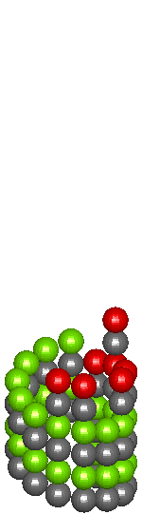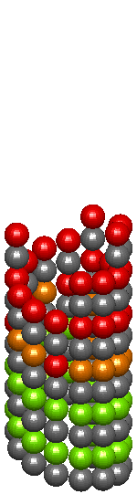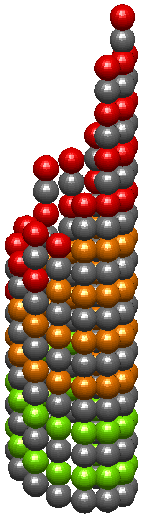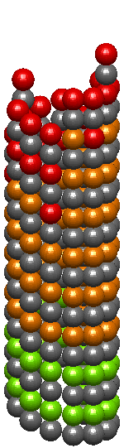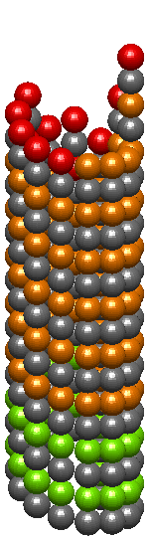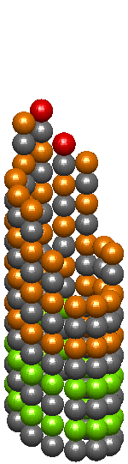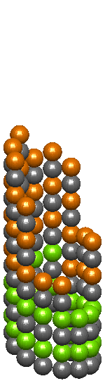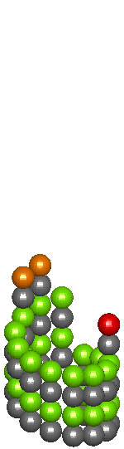
Fig. 2: Tubulin assembly from a stabilised seed. A cap of GTP-tubulin (red) protects the growing microtubule end during growth. Catastrophe occurs when the GTP cap is lost and GDP-tubulin (yellow) is exposed at the end.

Objectives:
To develop a model with the following elements: 13 vectors (protofilaments) with different lengths consisting of subunits in 2 states (GTP and GDP). Growth of the 13 protofilaments is neighbour-dependent due to lateral bonds that stabilise subunits incorporated where neighbours exist. The model should be based on existing models of microtubule dynamic instability [4-7] with parameters fitted to experimental data from the Straube lab. These data show microtubule length fluctuations over time and correlated taper length (i.e. the distance between longest and shortest protofilament). Statistical analysis of the raw data will be required to generate parameters/rules for the model.

Potential PhD project:
The project can expand to include a 3rd state of tubulin (the GTP/Pi-tubulin intermediate), which is recognised by EB3. Correlated data for EB3 intensity distribution at the plus end will directly inform such a model. We analyse microtubule dynamics in the presence of a number of regulators and aim to understand cooperation of regulators at the microtubule end. Thus a further layer of complexity would see addition of the plus end tracking proteins and their interactions to the model.

References:
[1] Howard and Hyman. Growth, fluctuation and switching at microtubule plus ends. Nat Rev Mol Cell Biol (2009) 10: 569-74
[2] van der Vaart et al. Regulation of microtubule dynamic instability. Biochem Soc Trans (2009) 37: 1007-13
[3] Straube. How to measure microtubule dynamics? Methods Mol Biol (2011) 777: 1-14
[4] VanBuren et al. Mechanochemical model of microtubule structure and self-assembly kinetics. Biophys J (2005) 89: 2911-26
[5] Gardner et al. Rapid microtubule self-assembly kinetics. Cell (2011) 146: 582-92
[6] Margolin et al. The mechanisms of microtubule catastrophe and rescue: implications from analysis of a dimer-scale computational model. Mol Biol Cell (2012) 23: 642-56
[7] Piette et al. A thermodynamic model of microtubule assembly and disassembly. PLoS ONE (2009) 4: e6378

