Before suffrage: Women and political participation in Europe 1815-1850
Workshop at the Quaker Meeting House, Warwick City
Saturday 23 November 2019
10.00am -2.30pm
To discuss the spaces and possibilities for women in politics across Europe between 1800 and 1850. The aim is to facilitate a comparative discussion of women’s engagement in political activity across the very different contexts of European states. There will be a series of short (15-20 min) papers to form the basis for a discussion with colleagues from France, Spain, Italy, the UK and elsewhere.
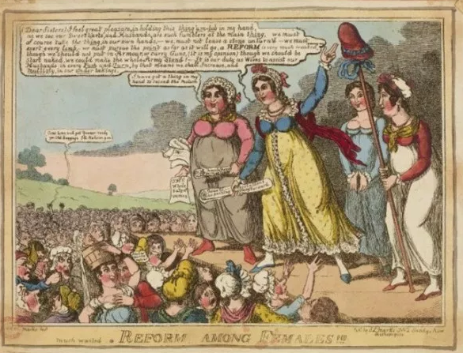
Followed by The Trial of Queen Caroline: A Dramatic Re-enactment in Warwick Court House 4.00-5.30
Expressions of interest to: mark.philp@warwick.ac.uk
Supported by European History Research Centre, History Department, University of Warwick
Programme

Quaker Meeting House, 39 High Street, City of Warwick, Warwickshire, CV34 4AX
9:45 Coffee
10:00 Start
Mark Philp (Warwick) Introduction
Oskar Cox Jensen (QML), ‘Eliza and Sarah Flower and London radicalism’
Anne Verjus (CNRS, Lyon), ‘Wives of French émigrés: what is not political about them?’
Pierre Marie Delpu (Aix-Marseilles), ‘Martyr women in Spain and Italy: Mariana Pineda and Teresa Confalonieri’
12:00
Rosie Doyle (Warwick), ‘Women and participation in Spain and Latin America’
Elisavet Paplexopoulou (EUI) “Friends of the muses”: Greek women's discourses on education (1800-1830)
1:00 – 1:45 Lunch

1:45-3:00
Ruth Mather (Exeter/York), ‘Domesticating Radicalism? Home as a Political Space in late-Georgian England’
Matthew Roberts (Sheffield Hallam), ‘Chartism, Women and Working-Class Feminism in Mid-Victorian Britain’
Conclusion
4:00-5:30
The Trial of Queen Caroline in Warwick Court House, the High Street, Warwick
Dinner 5:45 Aqua Food and Mood, Jury Street 12-14, CV34 4EW Warwick
