
What’s next after your PhD? - Careers, skills, and looking to the future

10:00-10:15 Introduction - Frances Burstow – Training and Skills Committee, ESRC
10:15-12:15 Session 1 - Opportunities
- Academic careers
- Academic careers today - Dr. Tina Freyburg, Dr. Florian Reiche (both Politics and International Studies)
- Standing out from the crowd - Rachel Corke (Institute of Advanced Study)
- Getting published - Professor Chris Warhurst (Institute for Employment Research)
- A window on teaching - Emma King (Learning and Development Centre)

- Non-academic careers
- Careers in research - Professor Ceridwen Roberts (University of Oxford and Social Research Association)
- Research across Government - Dr. Emma Gordon (GESR team, HM Treasury)
12:15-13:15 Lunch
13:15-13:25 Plenary session: So, what have you learned?
13:25-14:45 Session 2 - Skills and capacity-building
Chris Manley and Charlie Cunningham - Senior Careers Consultants, Warwick University - with Clare Jones, Nottingham University, and Carl Jukes, Birmingham University
- Parallel sessions dealing with:
  - Interviews for non-academic jobs: skills for preparation and performance
  - Give the employer what they want! Effective CVs and application forms
14:45-15:00 Refreshment break
15:00-16:30 Session 3 - Contacts and networks
- Networking tales: personal and social networking - Dr. Charlotte Mathieson (Research Fellow, IAS)
- Impact stories - Dr. Jo Angouri (Centre for Applied Linguistics)
- PhD student experiences - Karen Melrose (ESRC DTC student)
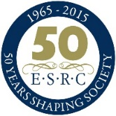
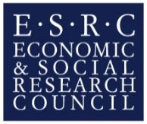
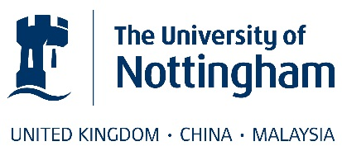
- Speed networking - facilitated by Dr. Emma Smith (Student Careers and Skills)

