Emma Johnson
DEPARTMENT OF cLASSICS AND ANCIENT HISTORY UNIVERSITY OF WARWICK
Aristophanes’ Lysistrata

Abstract
In January 2016, the Classics and Ancient History department put on a production of Aristophanes’ Lysistrata. Through this production we attempted to open up Greek Theatre to a wider audience whilst also exploring the continual political relevance of the comedy. The play was easy to adapt, and audiences reacted very well to the final performances, taking in the sombre moments, enjoying the comedic moments, and learning about the original production values of Greek Theatre. This was explored and researched both through lectures on our Theatre for Schools day, and the two performances in the Warwick Arts Centre.
Methodology
Aristophanes’ Lysistrata was written during a time of great political turmoil in Ancient Athens. It was put on at an Athenian dramatic festival – either the Dionysia or Lenaia - in 411BC, at which point almost the whole of Greece was fighting in the Peloponnesian Wars. The battles which took place in the Peloponnesian Wars claimed a vast amount of lives and the populations of many Greek city-states suffered immensely in their wake. Eventually, Athens and its allies would go on to be defeated in the Peloponnesian wars, being conquered by Sparta and its allies. Aristophanes drama follows the main characters, a woman named Lysistrata, as she proposed that if the women deprive the men of sex then the war will end. This plan transpires to be a success and the warring states finally make peace with each other. In modern times of political or military strife, Aristophanes’ Lysistrata is still looked to as a poignant peace play which shows the foolishness and futility of conflict.
The performance of Lysistrata was put on by a cast and crew of mainly members of both the Classics and Ancient History Department and Society. However there was also help from other departments such as the Computer Science Department and the Theatre and Performance Department. The play was performed to the public on the 24th January and as part of an outreach Ancient Theatre for Schools day, put on annually by the Classics and Ancient History Department. The scale of the performance was the greatest yet in the history of the Classics play. The size of the cast and crew group was significantly greater than that of previous years and the play was performed to approximately 1000 audience members.
The new translation of Lysistrata, provided by Mr Clive Letchford of the Classics and Ancient History Department, made the play more accessible for a modern audience. The cast and crew were dedicated to making the plot and intentions of the piece clear to the audience who may have had little experience of ancient theatre previously. The play as a whole engaged a wide cohort from different disciplines and backgrounds, bringing them together to engage with the satire which Aristophanes produced in Ancient Athens.
We chose to explore the play in a more modern setting, but still retaining an acknowledgement for the historical background of the piece. This was key to both appealing to our modern audience whilst also respecting the foundations of Greek Theatre and the work of Aristophanes.
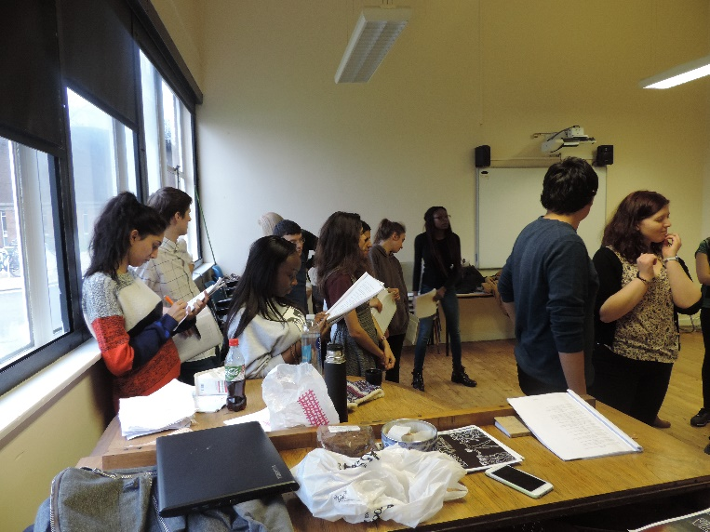
1 Lysistrata Rehearsal

Results
A clear success of the process was the involvement of the play in the Ancient Theatre for Schools day which was put on by the Classics and Ancient History Department. This day reached over 500 GCSE and A Level students, showing them the different aspects of ancient theatre. The day began with a number of talks covering topics such as the political background of tragedy, the nature of the Athenian drama festival and the modern staging of Aristophanes’ Lysistrata.
These lectures were given by both departmental lecturers and visiting academics, as well as the undergraduate play director. These lectures engaged many students from many different backgrounds, informing them of all aspects of the world of Ancient Greek comedy. Students visiting for the day gave very positive feedback, having learned not only about the historical aspects of Greek theatre but also about stylistic choices and production value.
The public performance on 24th January was also an outstanding success. Performed to approximately another 500 members of the public, the play was received very well and comedy was very much enjoyed by a modern audience.
The publicity campaign for the play was also hugely successful. The trailer for the play was very well received and has now been watched hundreds of times on YouTube. Also, the posters which were distributed around Warwick Campus, Leamington Spa and Coventry were highly praised for their design. Further to this, the play was positively reviewed in Warwick’s own student newspaper, The Boar. This review got wide readership and is lasting proof of the success of the performance.
References
- Aristophanes’ Lysistrata Trailer
- The Boar Arts Review of Aristophanes’ Lysistrata
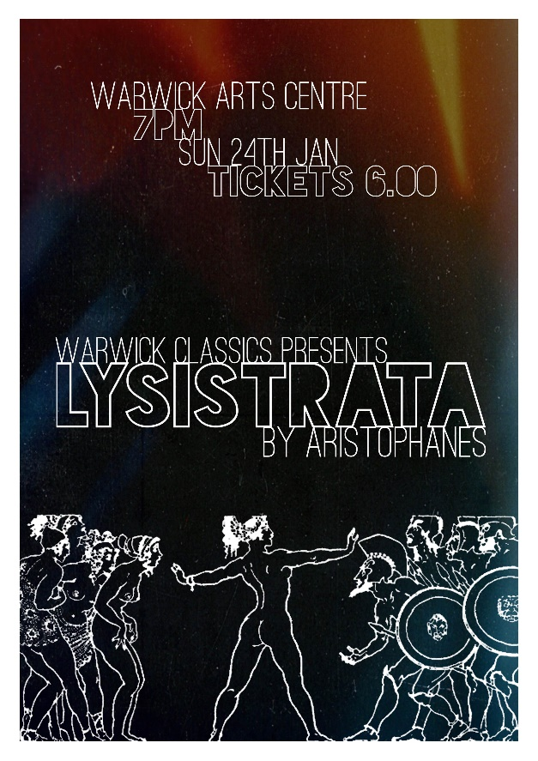
2 Aristophanes' Lysistrata Publicity Poster

