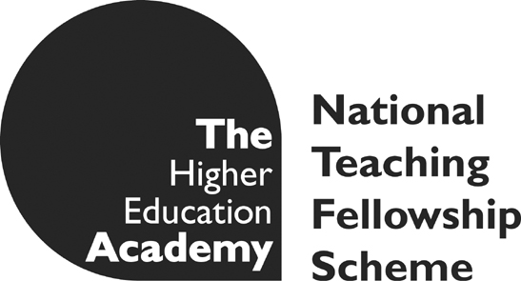
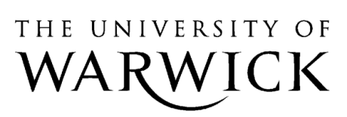

Open-space Learning in Real World Contexts

Edited research interview transcript with PhD student Jeannette Silva Flores (Sociology Department) who participated in the Representing the Other workshop series

Do you think this kind of transdisciplinary group project has a useful contribution to make to the experience postgraduate study? If so, can you develop your reasons?
“Inter or transdisciplinary can be understood as a “heretical view” in Bourdieu´s words. In fact, it is usually seen as a potential barrier because it has a marginal positioning within academia and, consequently, it does not have a clear positioning within the academic labour market. In addition, there are more difficulties when you are looking for research funding from an interdisciplinary perspective instead of from a disciplinary standpoint. However, I believe that this kind of interdisciplinary group project nourishes your experience as a postgraduate student in many different and fruitful ways. For instance, it helps to develop your understanding of other ways of knowing, of other people’s experiences and of other sources of knowledge-production. It helps you to learn and to work in a collaborative, participative and flexible environment instead of a competitive environment. In our experience nobody was better or worse, on the contrary, we were all contributing –in one way or another- to the development of our workshop. In that sense, the success or failure of the workshop was our own responsibility, fact that gave us a lot of freedom. In addition, research-based learning was promoted. Since I am a sociologist, in my particular case, this experience helps me to find the link between my own field of study and visual art, acting, literature, among others regarding some particular questions such as how to represent others and how to comprehend otherness. Because I am in an initial stage of my PhD studies this activity opens up to a variety of possible alternatives methodologically speaking and it helps me to develop my own critical reflexivity. It was also possible raise more questions which is always a source of intellectual joy.”
Would you like to see more innovative and enactive methods of peer review and collaboration, such as this workshop model, promoted through the university?
“Certainly, I would like to see more but under certain assumptions such as clear and genuine educational purposes as we experienced in Verbatim Theatre. In the current context of commoditisation of higher education there is always a risk to become the new commodity just because it can be seen more fashionable as well as more profitable to have “an alternative educational model”. If the purpose is to provide students with a richer educational experience which opens up reflections, resources, critical thinking, flexibility, research-based learning, among other aspects that would help your understanding of social life in a global context as well as your social engagement, I am totally agree with the implementation of more.”
Do you have any thoughts on the method of verbatim theatre (VT)? Do you think it would be useful to apply to different areas of your study/ thought?
“Under the assumptions that we have excellent facilitators as we had, we have enough motivated students, basic equipment and space (e.g. rehearsal room), and enough time we can have a splendid experience of Verbatim Theatre (VT) in which more than to be trained in acting methods or practices what has been done is to discuss/learn/realise how these practices has been shaped by historical, cultural, economic, political, gender factors, among others. In that sense, representations produced within the framework of VT are problematic, contested, and debatable. This fact is not a negative one in any sense; on the contrary, it refers to our human limitations regarding knowledge-production; that is why issues of critical reflexivity, ethics, and ways of knowing are relevant in this context and for those who are positioned as researchers (e.g. my own case). VT helps to develop your social engagement since it is interested in other people’s voices as well as in the hidden, obscure, unknown and maybe problematic world of those who has been discriminated, marginalised, exterminated. In that sense, VT helps other voices to be heard, to be known and to be recognised as other authoritative and valid voices. VT provides you with a fruitful space in which historians (social and oral historians), philosophers, sociologists, visual artists, filmmakers, writers, musicians, practitioners, dancers, among others can contribute to the representation of others. Simultaneously, the complexity of this problem encourages you to work collaboratively, cooperatively; from different perspectives, since there is not only one answer and you are not able to do it in isolation.”

