ASSEMBLYWOMEN AT EDINBURGH FRINGE
This summer, the Warwick Classics Society took Assemblywomen to the Edinburgh Fringe Festival. The ancient play, by Aristophanes, tells the story of Praxagora and the other women of Athens planning together to take over the government from the men. As they introduce their new decrees, the play follows the unpredictable and absurd events over a single day.
We first performed the show in January. The three-show run at the Warwick Arts Centre formed part of the Warwick Ancient Drama Festival. However, the incredible opportunity to revive the show in Edinburgh allowed us to collaborate, develop, and reimagine this comedy once again.
The process started with the script. Taking this chance to reflect on our January performance, we set up a script workshop with the cast to go through the play scene by scene. We asked what they had enjoyed themselves, what they thought had worked before, and what they thought should be changed. During this process, we also reviewed the recording of our previous run to see what the audience had responded to. We found that the sections everyone, cast, crew, and audience, had enjoyed the most were the sections created in rehearsal by the cast, so we decided to lean into this aspect.
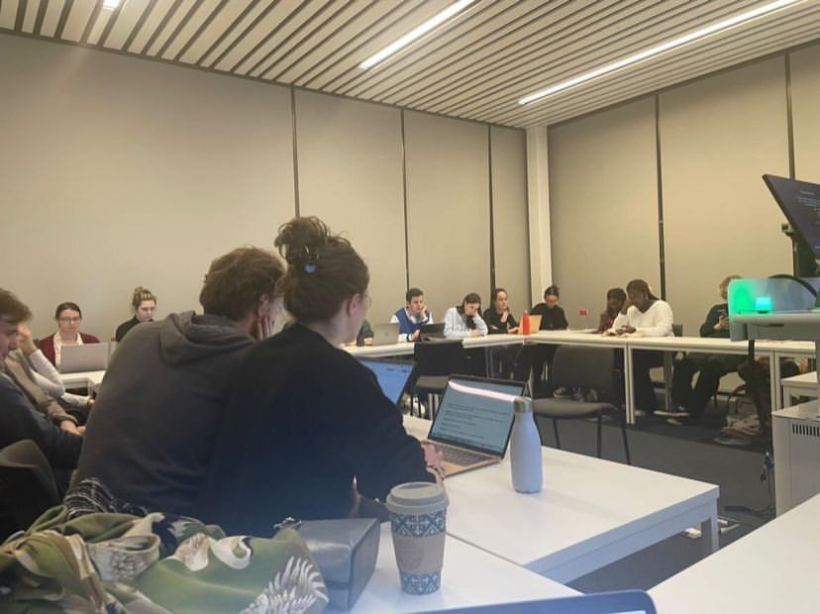
We also wanted to make sure that the play transferred well to the new environment of the Edinburgh Fringe Festival so decided to include more audience interaction where possible. Again, the cast was heavily involved in this, and we worked in rehearsal to determine what would create the response we were looking for.
The cast recalled that some props and costume elements had been originally impractical and suggested changes that would maintain the humour but would be more achievable for the extended run of seven shows. For example, the role of Blepyros, husband to Praxagora, had previously worn his wife’s heels for the whole show. He suggested changing these to pink and fluffy slippers to match the character of Neighbour, still colourful and funny but safer and easier to maintain.
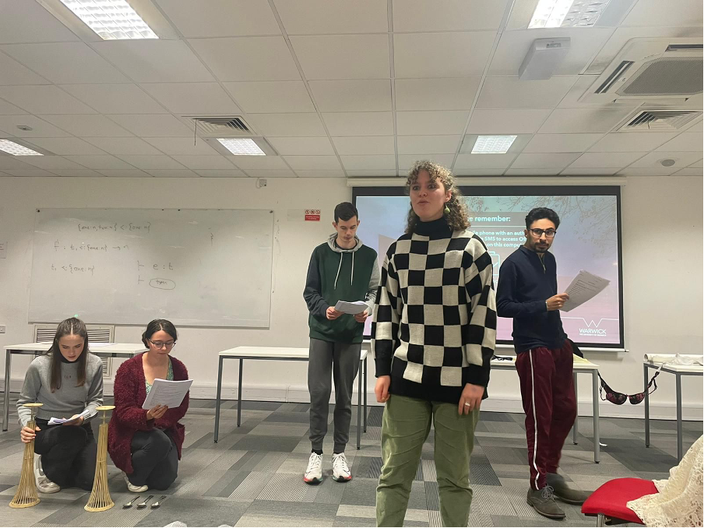
Of course, A significant portion of the planning went into the technical and production elements. One of the major decisions we had to make was the theatre. We decided a smaller theatre would suit our production best. It benefited our budget but also meant we could get the audience more involved and allow that interaction we wanted to focus on.
However, with this smaller theatre came new challenges and considerations; we immediately knew we would have to rethink the whole set. Once more, we spoke to the cast to discover what elements they wanted to keep. Praxagora and the women she gathers at the beginning of the production practice their speeches for the assembly. Previously, they used a large, movable podium, but this had to change for Fringe. After some consideration, we settled on a wooden crate labelled ‘Soap Box’ to create the same effect. This solution maintained the original purpose but was easier to transport, safer, and within our budget to create.
The character of Neighbour wears a dress, like Blepyros, and again intended to be his wife’s, and initially, there was a reveal as he walked out through the door of his house that received a positive reaction from our audiences. Similarly, the women, towards the end of the play, in their comedic chase of a younger man, had used the windows and doors of the set to their advantage. Again, this had received positive reactions. Through many discussions between the Director and the actors, we realised we could use the curtain to the side of the stage for entrances to mimic the effect. This translated brilliantly, especially for the scene with Neighbour, which maintained its response from the original show.
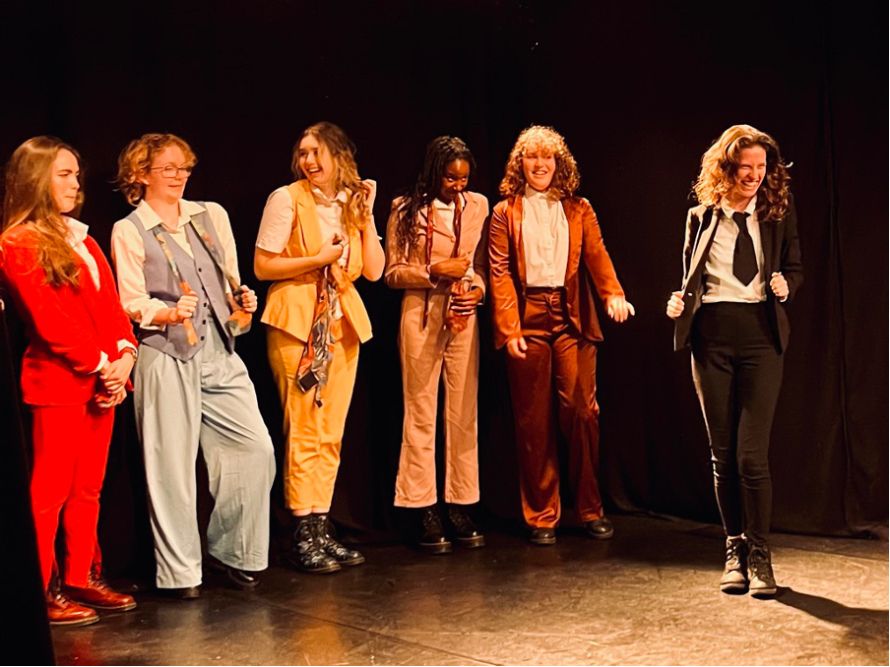
While in Edinburgh, we continued collaborating and adapting as the week progressed. Flyering was crucial, as one of the main streams of advertising for most shows at the festival we needed to take full advantage of it. We split the task between the whole group and had small groups of 2-4 each day. It was a clear measure of everyone’s commitment to the show, as everyone did their part and ensured as many people as possible knew about Assemblywomen.
We also continued to adapt the show, reacting to what the audience responded to and what they didn’t. We found that some of the jokes that had worked well with a bigger audience didn’t translate as we had hoped to the smaller Fringe audiences. The cast and Director collaborated on these issues as the week progressed, and we noted a marked difference, with the final shows being some of the most successful.
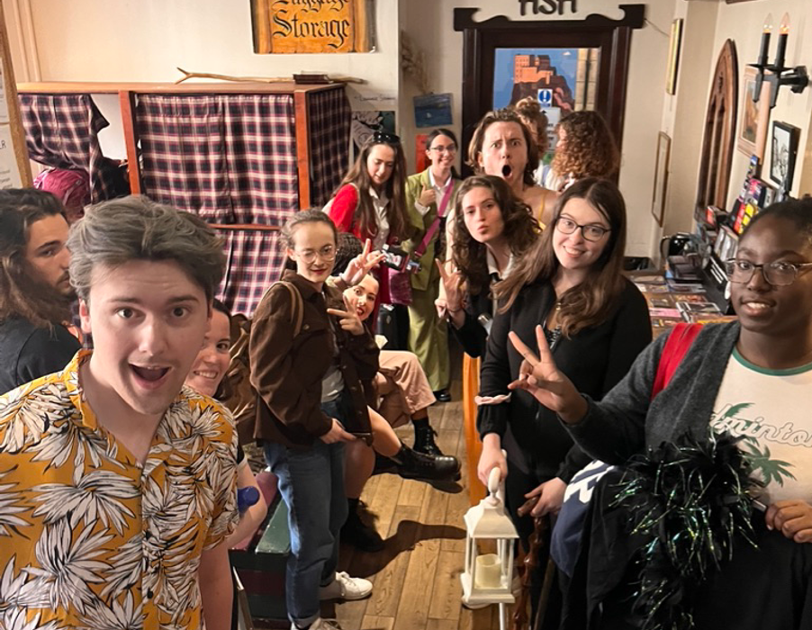
Looking back on the whole experience, the entire cast and crew had an outstanding commitment to the show, both in rehearsals and the performances. There was a significant struggle to schedule enough rehearsals before the second run. With such a big cast, it was difficult for everyone to find times that suited all, particularly with so many deadlines towards the end of the year. However, thanks to their dedication, the show ran smoothly and we were able to develop the production massively.
We achieved a good audience turnout and reaction throughout our time at the festival, and though the process was challenging, the outcome was something to be proud of. The experience was incredibly useful to everyone involved and gave us all a chance to develop so many skills. It also gave another opportunity for public engagement in Classics and with the University of Warwick, reaching new audiences in new ways. The whole team had amazing energy and patience throughout the busy months of planning and the intense show week, helping to ensure a successful run at Edinburgh Fringe.
