A WARWICK STUDENT’S GUIDE TO FUNDING EDINBURGH FRINGE

INTRO

This handbook has been written by a group of students who took a show to Edinburgh fringe, in the hopes of helping future students understand the requirements and options available for budgeting and funding their own fringe production.

First, a bit about our experience at fringe, for context. We are a group of students from the Classics society who worked with our department to produce a play at the Warwick Arts Centre in January 2023, and then took that play for a 7 show run at Edinburgh Fringe 2023. We had a cast of 16 people, and 4 production team; a director, producer, stage manager(SM) and company stage manager(CSM). In short, this was a large scale production, and required a lot of money, which brings us onto this handbook.

Considering how rare an opportunity it is to take a show of such scale to Fringe, we decided to create this handbook in the hopes of future students being able to follow in our footsteps. We will be taking a deep dive into the finances required for a Fringe show, and giving you some ideas on funding options. After reading this handbook, you should have a solid understanding of how to budget your show, and hopefully have an idea of how to raise enough money to meet that budget.

BUDGETING

Budgeting is a very important part of producing a show, whether at fringe or just on campus. If you can’t keep track of your money, you could end up without enough funds to put on your show. Most importantly, if you are receiving funding from a university organisation, you must be able to handle that money responsibly. If you cannot provide a comprehensive budget you may lose your funding.
Don’t worry though! This section will teach you everything you need to know to create a good budget.

How to create a budget

The easiest way to make and edit a budget is by using a spreadsheet. You can use Google Sheets, Microsoft Excel, or any other spreadsheet software to create this, as you don’t need anything complicated. Your spreadsheet will need three main columns: Item, Cost and Breakdown. These titles are fairly self explanatory, but just in case, the first column should contain the different items you need to spend money on, the second column is how much they cost and the third column will be an explanation of these costs, and any notes.

Whichever spreadsheet software you use should have an option to use formulas. This will be very helpful when keeping track of totals. By using a simple addition formula, you can create a total of your ‘costs’ column. This formula is “=sum(B2:B8)” or “=sum(B2,B3,B4)”. The “B2” values are just examples of grid references in your spreadsheet. You can also use a subtraction formula to compare your total budget with your spending, to see how much you have leftover, e.g. “=B10-B12”. These formulas can simply be typed into a box on your spreadsheet, and will update the answer automatically if you change any numbers.

Secondary budgets

This three column budget is the simplest base to start from, but you will probably need more details than this base allows. There are several options available, so just use whichever method is easiest for you and your show. The two main methods would be expanding your base budget spreadsheet, or making other spreadsheets for certain parts of your budget as needed.

The main reasons you would need extra budgets would be to keep track of smaller, specific costs (e.g. props and costumes), and most importantly, to compare your planned costs with your actual costs. It is very unlikely that your projected costs will match your actual spending, so you must keep track of these two numbers, in order to provide a comparison. When you apply for funding you will only know your projected costs, and you must compare your funding with your actual costs to prove how you spent your money.

To compare your planning budget and your actual budget you can either create two separate budgets, one before you start and one keeping track of your spending, or add a second ‘costs’ column, to allow comparisons in one budget.

What to include in a budget

There are many factors to consider when creating a budget, and there will be many things you need to spend money on. Of course, the exact requirements depend on your show, but we had seven main items in our first column; Performance Costs, Accomodation, Travel, Set, Props, Costumes and Marketing. The costs of each of these items can vary widely depending on your exact plans for fringe, so here are some factors to keep in mind when planning your show.

COMPANY NUMBERS

It is very important to think about how many people you are taking with you to fringe. The number of people you take will have a huge effect on your accomodation costs, which may be the largest expenditure needed for fringe. Every person you take will need accomodation, travel, food, and for cast members, a costume. We took 20 people, which meant we needed a very large budget. If you are doing a one man show, everything will be a lot cheaper.

Remember that you will need crew as well as cast, to manage backstage and tech requirements. We chose to take crew with us, which meant four more people in our accomodation. If you do not take a tech person/crew, you should be able to hire someone from your theatre, but this may cost more than taking an extra person.

Think very carefully about how many people you need, and consider asking cast members to multi role, or minimising tech/backstage requirements, to reduce numbers.

THEATRE DETAILS

Another important aspect to consider is your choice of theatre and show details. There are hundreds of theatres to choose from in Edinburgh, with a wide variety of details and prices. Think about how many people will be coming to see your show, as theatres with more seats will cost more than smaller locations. Bit of a tip: be extremely realistic when considering audience size. There are thousands of shows at Fringe, with many well established performers, unfortunately this means a small student production will not fill a massive theatre. Don’t be against the idea of a small theatre. If you are hiring a theatre from a large company, don’t be afraid of asking them what size theatre they think will be best for your show, remember they will understand fringe audiences better than you.

Once you have decided a theatre size, you need to decide how many shows you want to perform. Each extra show is one more day of theatre hire, but also one more night of accomodation costs. Again, look at what options are available with your theatre. A full run (28 shows) will be both expensive and tiring for your cast, but if you only do one or two shows, you will have a very limited experience. We spent 9 days in Edinburgh, and did 7 shows, as we felt this was a good middle ground for our budget.

As mentioned before, you also need to consider your tech requirements and any costs these will incur. A simple lighting rig will be included with many theatre hires, but any specific requirements may cost extra. Again, a smaller theatre may mean that you don’t need to pay for microphones. Think carefully about whether flourishes like smoke machines or elaborate lighting are really necessary. And if you use and sounds or music in your show, make sure to check if you need to pay for licensing or specialised sound equipment.

OTHER COSTS

There are also costs that will be necessary regardless of your numbers, although that doesn’t mean these can’t be kept low.

The most important cost is your fringe application fee. All shows at fringe must pay to be there, but on the plus side, this fee includes your show in the official fringe programme, and on the website and app. The application fee is a set amount, but is more expensive the more shows you do, so consider this when planning your show.

As with any show, you will also need a set, props and costumes. As mentioned earlier, the number of costumes will depend on the number of cast members. You can either try to buy set and props once you are in edinburgh or get them in advance, jus remember at they will need to be transported there. I would recommend keeping your set design very simple. Like with tech, there isn’t much point buying an expensive set, as many shows go for a simple design, and it is much cheaper.

Last, but definitely not least, you will have to pay for marketing. As one of thousands of shows, it is very important to invest in some form of advertisement. You can pay to have your poster put up around Edinburgh, but this can be expensive, and may not be worth it unless you are doing a full run. The best way of advertising is by printing out flyers to hand out in the streets. This is also fairly affordable, as you can get them from Warwick print.

The most important thing to remember is that everyone else at fringe is also on a budget, so don’t be afraid of keeping costs low. You will not be the only show with a simple set/theatre/tech set up. Focus on making your actual show as good as possible, and don’t worry too much about unnecessary extras that will only stretch your budget.

Some example budget spreadsheets

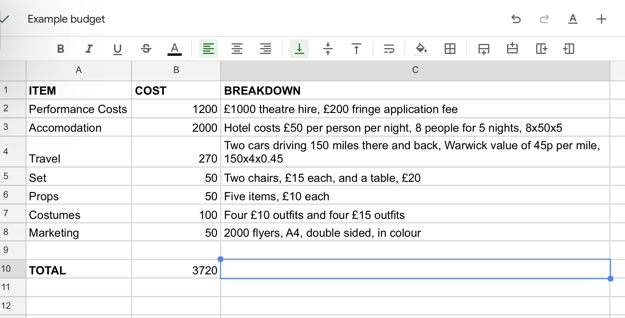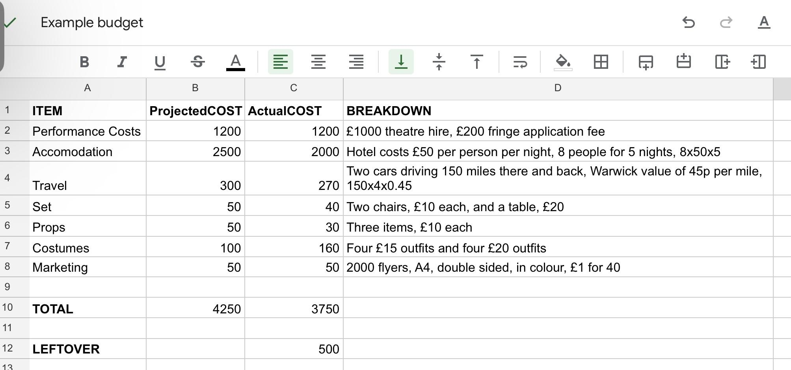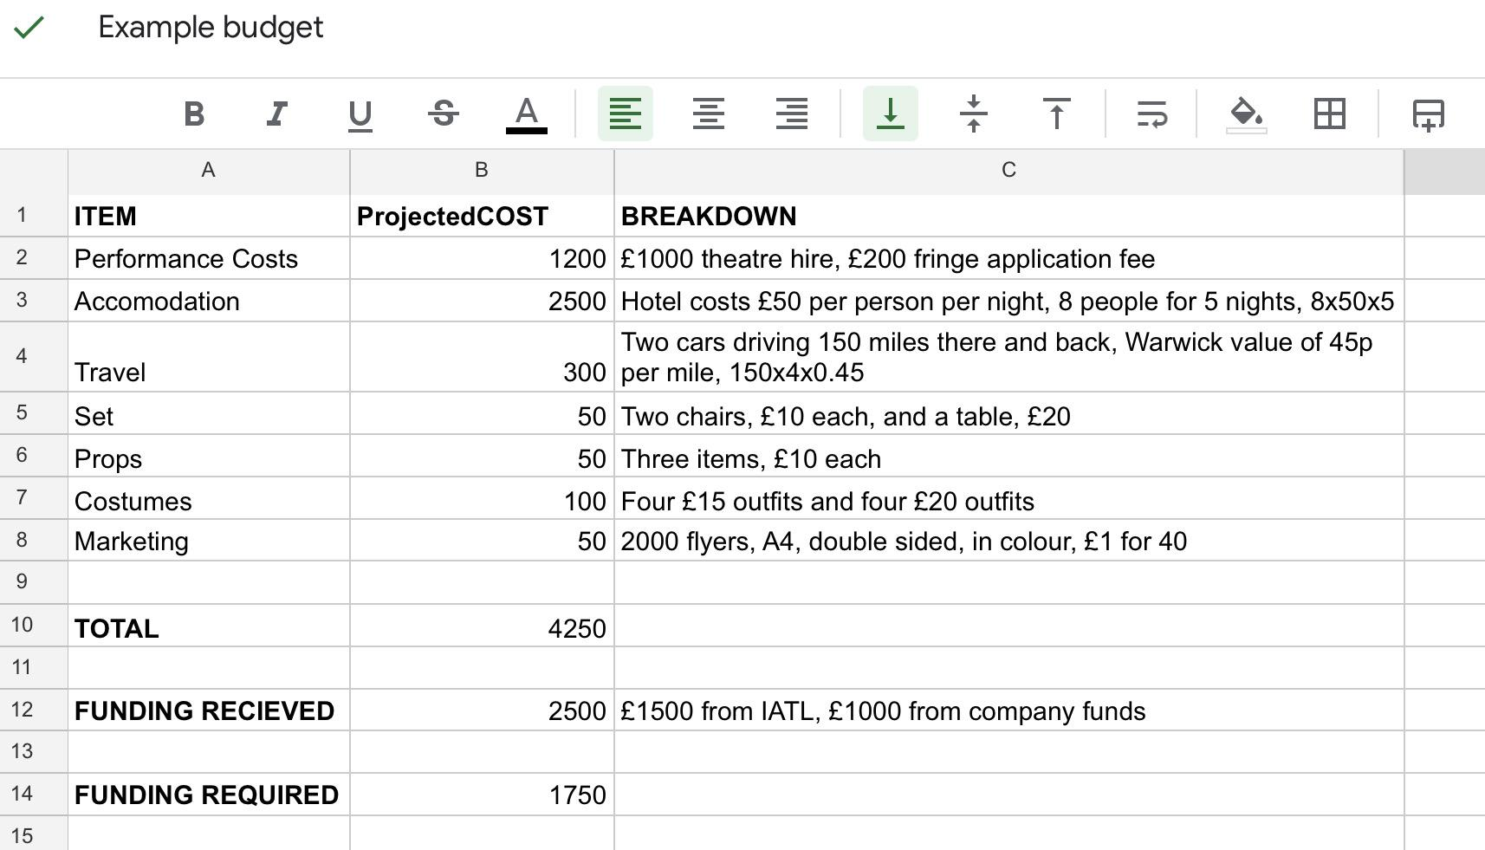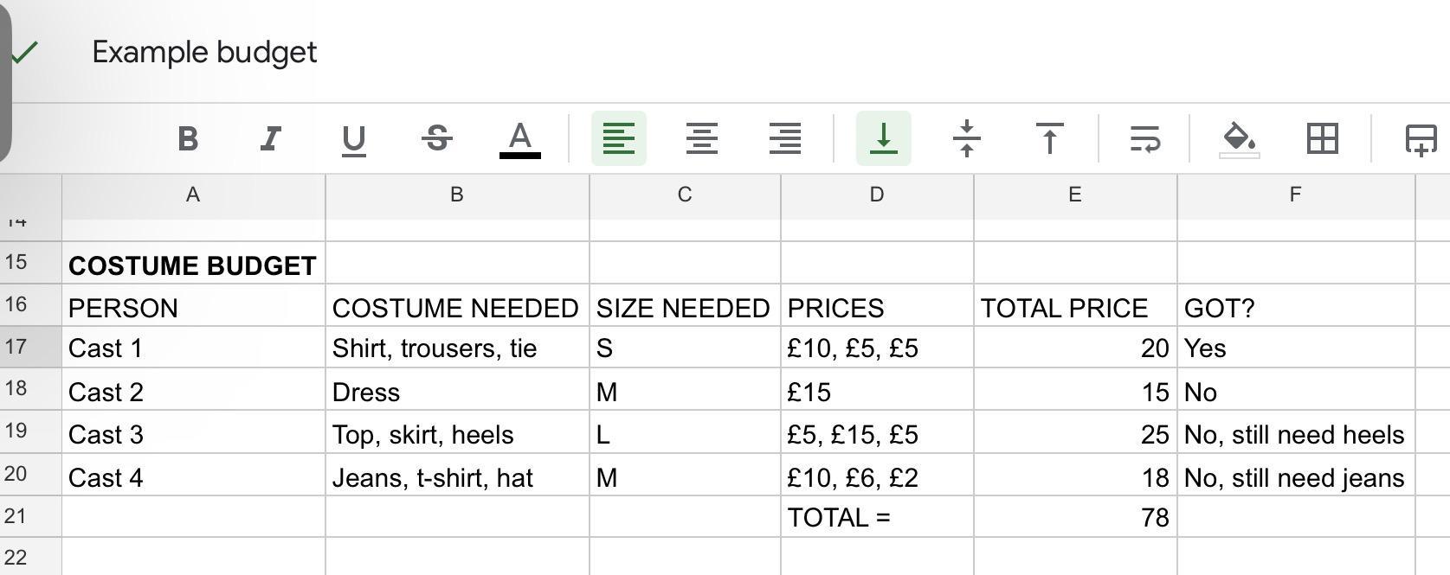

FUNDING

Now that you have researched your predicted costs and made your budget, it’s time to work out where you will get the money from. There are many options available to you, and as Warwick students you have access to several funds for this kind of thing. This section will explore some of the funding options you may want to consider, and how you can go about securing these funds.

IATL

The Institute for Advanced Teaching and Learning, or IATL, is a Warwick department dedicated to collaboration, creation and the advancement of student projects. Through these aims, IATL offer funding schemes for a variety of student-run opportunities. If your trip to Fringe aligns with IATL’s values of student co-creation, outreach and further educational opportunities, you should definitely apply for funding.

IATL offer up to £1500 for student projects, so this could help cover a large chunk of your budget. To apply, you will have to submit a funding request form, complete with all of the details of your production, an explanation of how this project aligns with IATL’s ethos, and a thorough budget plan. An extra bonus of working with IATL is that, because of their focus on co-creation and development, they have many resources available to help you meet these goals. As well as awarding you funding, they will also offer you help towards bettering your project for yourself and your company.

All of the information you will need to work with IATL is on their page on the Warwick website, including their email address and the application form. Make sure you look into IATL funding well in advance, as there is a deadline for applications.

Lord Rootes Fund

Like IATL, the Lord Rootes Fund (LRF) is a scheme set up to help develop student projects. They have a particular interest in “encouraging creativity, innovation and positive impact,” which is what they dedicate their fund towards. If these goals would play a part in your fringe project you should definitely apply for funding.

The LRF offer between £100 and £3000 in funding awards, so could pay for a large amount of your expenses. To apply you will need to submit an application form and a short video on your project. This application needs to include a detailed plan, including your proposed budget, and an explanation of how your project aligns with LRF’s ethos. After your project you will need to submit a report, which should include a thorough account of your final expenditure. Don’t be discouraged by this, as there are many resources available to help you when writing your report.

The LRF page on the Warwick website contains everything you will need to know when applying, including deadlines and the application form. Keep in mind that if you are awarded funding you will only receive 80% of it at first, and the final 20% afterwards, upon submission of your report.

Although applying to IATL and LRF may seem daunting, both of these organisations are very welcoming and supportive of student projects, and thinking about their aims and approaches will help you improve your production, even if you don’t apply for funding.

Other Warwick funding bodies

Warwick funding bodies are not the only option for students raising money, there are many other bodies who may have funding that they would be willing to invest in your show.

For our production we were lucky enough to have the help of our department to secure funding. Through the classics department we were able to acquire funding from the Classical Association. Although this will most likely not be relevant for funding your show, it may be worth getting in touch with university departments or staff to ask if they know anywhere you could get funding from. You could especially look into any associations with connections in your department, as that will make them easier to contact. If you are studying theatre, English, film or anything similar, I would definitely recommend speaking to your lecturers, if they can’t help you with funding they might still have some valuable advice. Even if you aren’t an arts student, many Warwick lecturers are always very willing to answer student questions, and help wherever they can, so maybe look into staff who have a shared interest with your production, and get in touch.

Another option available to students is to work with one of the many student societies dedicated to theatre and production, for example warwick university drama society (WUDS), music theatre warwick (MTW), freshblood theatre writing society, or warwick tech crew society. If you are interested in going to fringe you are probably already aware of these societies, and may already have contacts within them. These societies are full of students who love theatre production, and understand the financial requirements. If you get in touch with them, they will be willing to help as much as possible. This may just be with advice, or they may lend you props, costumes or set pieces. You could also find your cast and tech crew through society members, who may be more willing to work for free and pay towards the trip. Some of these societies also have funds set aside for contributing to production budgets. Of course, a fringe show costs a lot more than an on-campus show, but every little helps.

Raising from other sources

You also have other funding available to you, that would not require applying to an official funding system. These could be ideal if you have a small budget that won’t be too hard to meet, or if you’ve received funding, but need a little bit more.

One of these options is to use some form of crowd funding, for example creating a GoFundMe page, or doing fundraising activities on campus. If you are prepared in advance you may be able to perform your show on campus, then contribute your ticket sales towards your fringe budget. Of course, this would organising another production, so make sure you are able to take on the extra work and organisation that will require.

Another option to meet your budget would simply be to lower it, instead of trying to raise more funds. By this I mean you could explore the option of asking your cast and crew to pay some of their own expenses, instead of using your budget. Of course, this is a strategy that you should be careful with, as asking your cast to pay all of their expenses may discourage people from coming with you. Remember that not everyone can afford a holiday to Edinburgh, even if it is for a great opportunity. You can try to find a compromise, for example, if you pay for accomodation, ask your cast to pay for their own travel and food. Or organise a paid-for group travel, but ask them to pay for half of the accomodation costs. Your cast can also help you eliminate smaller costs by wearing their own clothes as costumes, or lending you props if you need something they already own. These options could save you a lot of money, but will work best if you are confident your cast will be able and happy to contribute.

Profiting from Fringe

One other option to keep in mind is that you may generate a profit from your ticket sales at fringe. In this case, if you are able to, you could pay for some of your expenses out of your own funds, then reimburse yourself with your profits. Or if you ask your cast to contribute towards their expenses, you can offer them a cut of the profits. This prospect may also encourage student societies to help fund you, as your ticket sales could go back into their society budget for the next year.

Remember that this is not guaranteed, so do not rely too heavily on ticket profit, as you may end up losing money. Make sure you do not promise anyone a specific amount that you will pay them back, in case you sell less tickets than anticipated. Most Fringe theatres predict their expected audience turn out at 40%, so keep this figure in mind when working out potential profits. Also, the amount of profit you get will depend on your ticket prices. Don’t be tempted to set them too high, as this will discourage people from buying them, but setting them too low will decrease your profits.

CONCLUSION

Hopefully you now understand the importance of creating a budget and getting funding, but also that there are many options available to you to achieve this. Do not be discouraged by the information in this handbook, even if it may seem overwhelming, this information is here to help you carry out your plan.

My number one tip to remember would be this: always be flexible in your plans. There are so many factors that go into a Fringe show, you will inevitably encounter an issue at some point. When this happens you will have to change you plans, so be willing to compromise, and be completely prepared for any potential issues. This is especially relevant when managing your money.

Although a lot of work, creating a proper budget and ensuring you get the correct funding is very important, and it will help you a lot. Although it may feel very stressful, putting on a show at Fringe is an incredible opportunity, and it is definitely worth it.

