IATL SDA Submission - additional guidance
- How to submit a physical piece to the office
- We are a small team and the office is not always open so if you are submitting a physical piece, please email IATL.modules@warwick.ac.uk to arrange a date and time so that we can ensure that someone will be there to meet you.
- Ensure your project is labelled with your student ID number and module code.
- Remember to submit a digital record of the piece such as a photo along with any written pieces into Tabula before the deadline.
- Check you have fulfilled the assignment brief and any addition instructions provided by the convenor.

*Your SDA will remain with us until our Exam Board. If you wish to have you SDA returned to you, contact the office in June. Any not collected by the end of July will be disposed of confidentially.

- How to submit a video in Tabula

Please do not submit MP4s to Tabula. The files are too large for the system to cope with and can take hours to upload, which can be very stressful for students. Upload your Video to Microsoft Stream.

You will need to submit a word document into Tabula that contains:
- A link to your video hosted in Microsoft Stream
- A plain text transcript from the video
- Any other accompanying pieces or references as set out in the assignment brief.

Short instructions:
- Upload your video into Microsoft Stream

Create a Transcript
- Open the Video Setting tab and under Transcript and Captions, allow it to generate Auto-captions then go in and edit these so they’re accurate.
- Download and save your transcript file.
- Visit https://web.microsoftstream.com/VTTCleaner/CleanVTT.html and upload your file, this will make it into plan text transcript you can then just copy and paste into your word document.

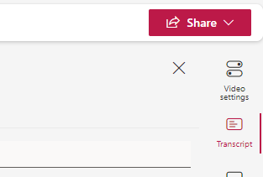
Share with your convenor and Angela Ward so that it can be viewed by the markers
- Click the SHARE icon

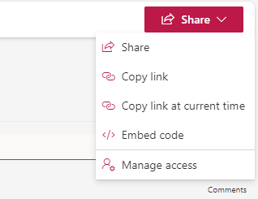

- Select Manage Access

- Go to “Direct Access and click the + sign
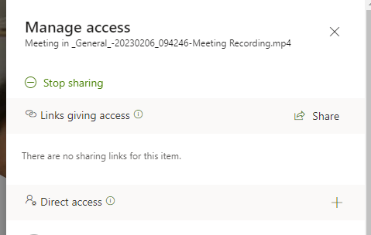

- Add each name in the box labelled “Direct Access”:

It is important to click the pencil icon for each individual and select “can edit”.

If you do not do this, no one will be able to view or mark your work.

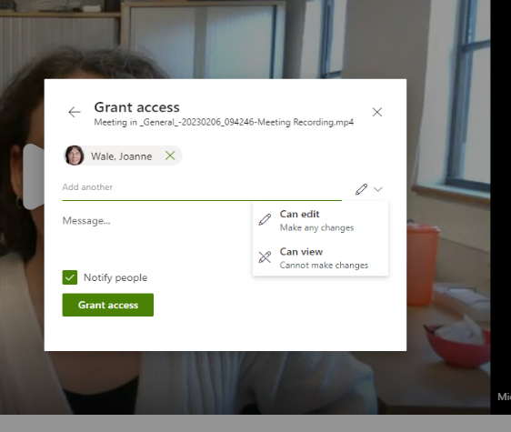

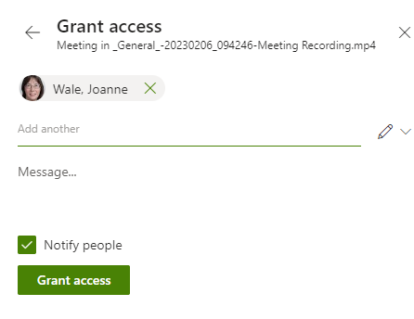
- Select “Grant Access”

To submit into Tabula
- Under the SHARE icon, copy the link and paste this into a word document. The Transcript can be pasted below the link.
- Submit the link and Transcript along with any other accompanying pieces into Tabula before the deadline expires.
- Recheck the assignment brief to ensure you have included all of the required elements of the assignment.

