HOME MAKING AND MAKING VISIBLE; INFORMAL HOME-MAKING IN NORTH EASTERN BRAZIL.

Joseph Brandim-Howson
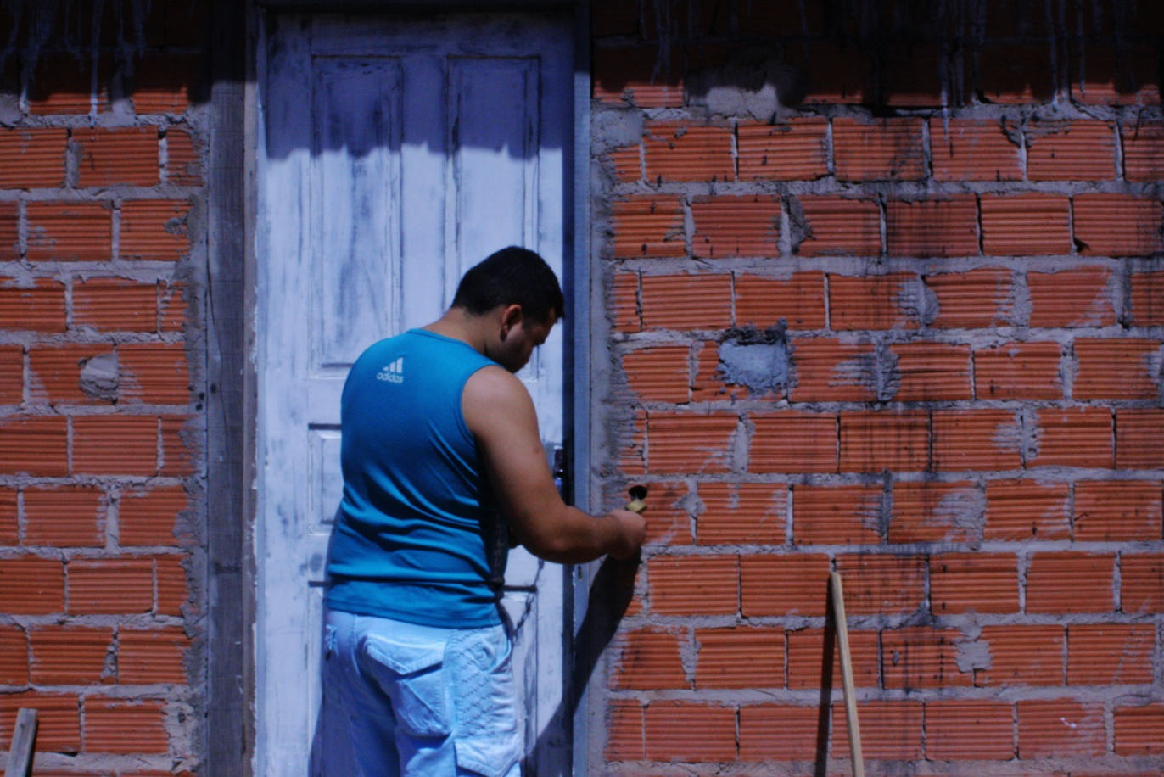
IATL, Warwick

INTRODUCTION
This project is the outcome of a number of different influences which have fuelled a desire to both interact with and map somewhat, an alternative approach to the complex concept of, ‘the city’. At the heart of this project is an attempt to document and celebrate ways of existing and creating identities which take place outside of formal, regulated processes. In particular this piece focuses on the ways of existing and identity creation which are allied to the production and maintenance of living space, a home. In offering this photo-essay I hope to take the experience of those of Nova Esperança (new hope), Teresina, provide academic context and ponder what their experiences provide for a wider discussion on the city, the lived environment, identity and alternative forms of home-making.
NOVA ESPERANÇA
Nova Esperança is a growing land settlement expanding along the south east corner of Teresina’s metropolitan area, close to the established barrio of São Sebastião. Increasing land prices and further delays in government programmes such as minha casa, minha vida have resulted in many citizens pooling together to form community occupations of unused prefeitura land. Depending on many factors (such as; local residents, location, timing in relation to an election) some of these occupations are normalised, others are evicted.
In the case of Nova Esperança, the weight of community support, quick development of local infrastructure and lack of alternatives have meant that (for now) the prefeitura has agreed not to evict the settlement.
Since news of this, the community has grown from an initial small community of 30 (ish) families who initiated the invasion to a community of over 200 families. With the prospect of the legalisation of the settlement, the possibility of tarmac roads, a local school and phone lines is increasing.
Personally, the location of Nova Esperança has particular importance; it is located on the outskirts of the state-capital city of Teresina, Piauí. This is the city in which my mother was born and the majority of my family still live. As a researcher, the context in which Nova Esperança is emerging seems symbolic of wider dynamics in which the cities of developing countries are becoming increasingly subject to the same forces of capitalist development as developed cities. As individual land rights, land speculation, a formal economy and government structures are established, there is the simultaneous erasure of the alternative, informal side of the city.
THE FORMAL/ INFORMAL
As cities move increasingly towards a model in which their very existence becomes a means to facilitate the exchange and flow of capital, a particular aesthetic comes to accompany this political and economic vision; the zones and processes that become both represented and understood as being part of the city are those implicated establishing this vision. As Teresina as a city becomes increasingly incorporated into the dominant capitalist aesthetic, only certain parts of the city are projected as spaces of potentiality or worthy of attention. Instead of seeing the city as a knitted lattice of juxtapositions and interwoven stories, certain threads become increasingly hidden and removed from the city’s script. Thus this representation of the city eschews any obligation the city has as a field of shared life and common rights.
As this projection of the city enforces a “spider-like overlay on [to] the multitudinous city” certain spaces come into view; central business districts, enterprise zones, shopping malls, entertainment districts, transport and communication hubs, universities, gated communities and high-rise blocks. These spaces, which both provide for and feed off of the contemporary city become the formal city; the function, uniform and acceptable city which is a result of the Teresina’s ‘autochthonous’ development. Yet lying to the side and neatly hidden from this overlay is “the endless city – the prosaic, jobbing, informal, making do, surviving, unkept, hybrid spaces occupied by the majority populations [which] blur out of focus, barely acknowledged spaces...” This informal majority is a product of the capitalist city, yet is disowned by the formal as it acquits itself of responsibility through a selective projection of itself.
To combat this double-move which both disenfranchises the informal and then abnegates responsibility, we must shed light on and explore the informal which surrounds the spider-like overlay. In an attempt to bring the whole city back into view, so we can both learn from the informal and be witness to its consequences, we must look across the whole urban territory. If we are to transform the formal through re-awakening it to its interdependencies (showing the business centre and the slum as the same spatial universe) we must challenge the vision of the city which rests on the formal, and bring back into focus (amongst other aspects) the multiple geographies of inhabitation.
METHODOLOGY
Using ‘the lens’ to bring the informal back into focus is therefore a conscious political decision; it is grounded in a desire to explore and celebrate the multitudinous fragments of the city. In using a lens I hope to contribute to a wider body of work which directly aims to widen and diversify the topography of the city, both celebrating the informal and making clear the dependent link between the formal and informal.
Using a lens brings another layer of responsibility onto the researcher as the depth of intrusion into the lives of those researched increases. I tried to use the lens as a way of making friends and celebrating individuals and their homes, instead of solely as an instrument to record and document. I recognise that I have not spent the time necessary to provide a social realist anthropology of inhabitant’s lives and relationships, yet this was not the aim. In spending roughly a week observing and participating in their lives, I hope to use and explore their thoughts and ways of living as catalysts for learning; using these insights to contribute to wider academic and thematic conversations. Thus the photos and commentary which form this essay come from empirical stimulus witnessed within the community of Nova Esperança, but have been taken and deliberated outside of that context. Yet instead of treating these two spaces as independent spheres, I hope this project provides some form of a bridge between the lived and the academic experience.
However with the use of photography I also hope to comment on the political process of academic scholarship and the presentation of scholarly debate. In using imagery and photography, usually outside of the academic canon, there is the desire to engage with pedagogical tools and debates which go unutilised in conservative academic scholarship.
HOME MAKING
Exploring the relationship the residents of nova esperanca have with the city and social-political environment which surrounds them could have been conducted through a number of different methods. I have used the home and the process of home-building in which these families are currently partaking as a gateway.
Despite classical liberal philosophy suggesting that the home as a site of personal and emotive relationships lie outside of the political realm, much Feminist and Marxist analysis has pressed for a political evaluation of what occurs within and around the home. Beginning from a similar point, this analysis considers the home a key sight for social and political understanding. However this investigation turns the focus slightly: instead of taking the home as a sight to study social and exploitative relations, this investigation takes the home as a complex field of feelings and subjectivites; it is a space in which a sense of belonging is anchored and the ultimate sight for the performance of selfhood.
In viewing the home as a site of struggle for recognition and ontological security, the process of home-making becomes a process in which wider political and social themes can be explored. This process is even more defined when the dynamics of home-making in both subjective and structural terms is one of autoconstruction. In this scenario the search for ontological security becomes invested in the very walls and decorations, intended to foster a sense of belonging.
Within the academic literature there is a debate regarding the terminology, between the process of creating a home and the structural dwelling. There is a binary inherited from the thinking of Heidegger and Bachelard in which the concept of the home is understood primarily as an affective concept (an emotional sensibility) and the house as a material concept (a structure, a commodity). Yet if we did away with home/ housing binary and instead thought about the structural and emotive as existing in a related process, then through the ‘home’ (henceforth signifying both home and dwelling) we can capture the dispersed and variant logics which constitute the field of meaning, experience and practice and performance of home. Thus, home is used to signify an assemblage in which discursive formations intersect with material practices through which we can narrate social life.
Within this context, this photo essay hopes to utilise the process of autoconstruction as a site through which to explore the social and political relationship between the formal and the informal, identity and the built environment and home-making.

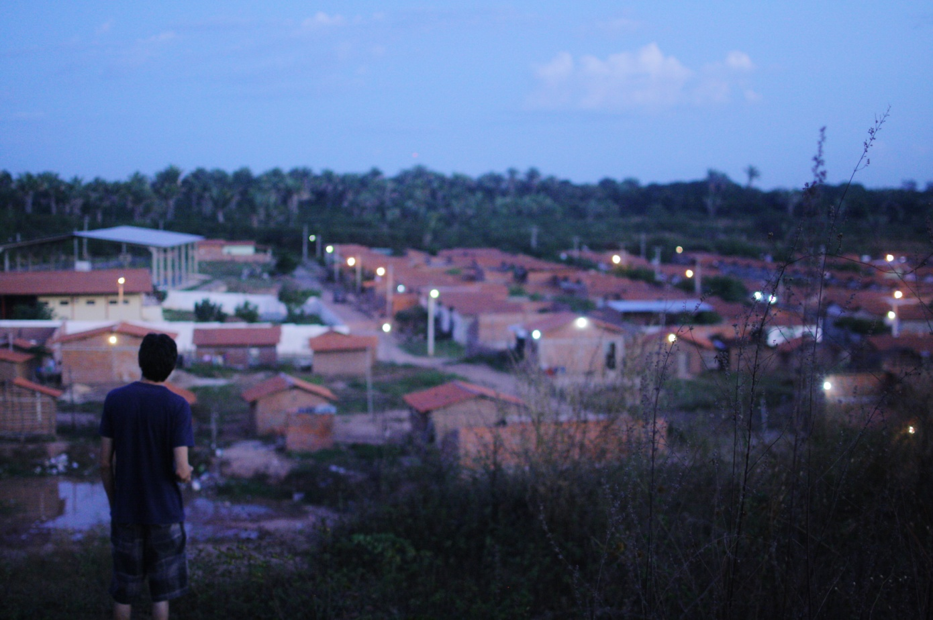
André walked and talked me through the development of Nova Esperança; he began by marking out where the community of Padre Pedro Balzi ended and were Nova Esperança begins. In reality it seems nothing more than a simple access road between developments of housing, however to André it seems much more significant than that. He explains to me how Padre Pedro Balzi was a social housing development funded by the prefeitura; the land which Nova Esperança now occupies was supposed to be phase 2 of this housing programme. André explains how after years of waiting for phase 2, residents in surrounding neighbourhoods (who had been waiting for or hoped to be housed in phase 2) came together to take matters into their own hands. The original invasion involved around 30 couples and families – he reminds me that at this point the land was heavy shrub land; occupiers had to cut their way through heavy vegetation just to erect a simple temporary structure. Once enough land has been cleared the community split the land into lots of 08 x 20 meters - the plot size of homes in padre pedro balzi and the usual dimensions of a padron used by the prefeitura. Depending on the budget and needs of the occupants, homes developed in different forms and shapes; a noticeable feature of Nova Esperança is the diversity in materials and size of home.
Many of the homes are still at an early stage, made from mud packed around a thin wooden structure. André explains how mud and stick walls do not require foundations, are made from local materials and can be easily demolished if families find the money to be able to build with brick.
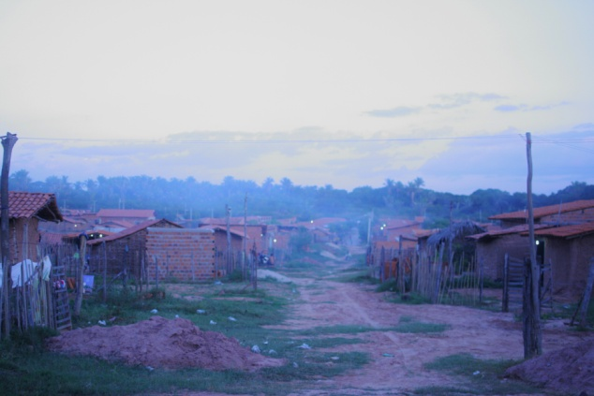
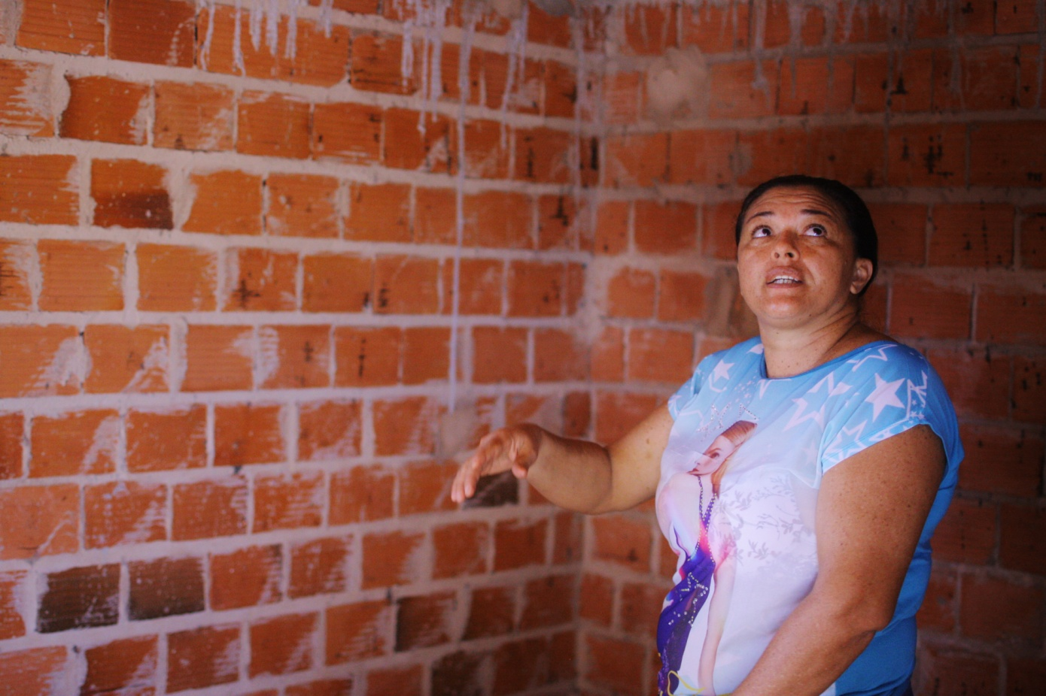
Roseli, a resident of Nova Esperança for almost one year, took great pride in showing how her home had developed over the year and her plans for extension. She explained that the usual model is to build a one-roomed home which combined kitchen and sleeping area (with a partitioned off toilet) from which other rooms would extend when money allowed. She was in the process of constructing the second room. She spoke about how she was beginning to feel strange about moving into two rooms; after living in one, and growing accustomed to this space, it seemed expanding caused anxiety. To her, it was strange that although she had been waiting to have her own space for many years; now she was almost scared of having too much.
When asked about what having her own space meant for her, she was very candid: socially, you are not considered a proper, independent family unless you live on your own (away from parents/ other family members). For her as a mother, until she was part of a proper family, she wouldn’t be considered a ‘proper’ mother.
I was struck by how humbly and gently Roseli went through each detail of the building process. It became clear there her character had become inlayed with the home around her; she worried about moving to two rooms because she felt that she would be compromising her humility.
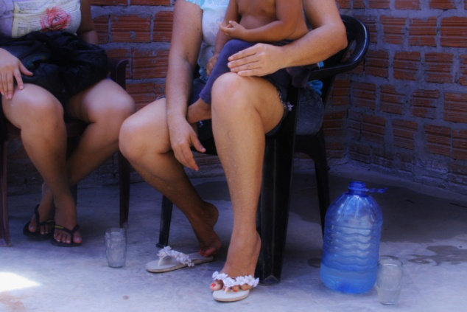
It seems that through the building process, her personal sense of attachment to the structure was much stronger than elsewhere and she was conscious of how the home reflected on her as a person.

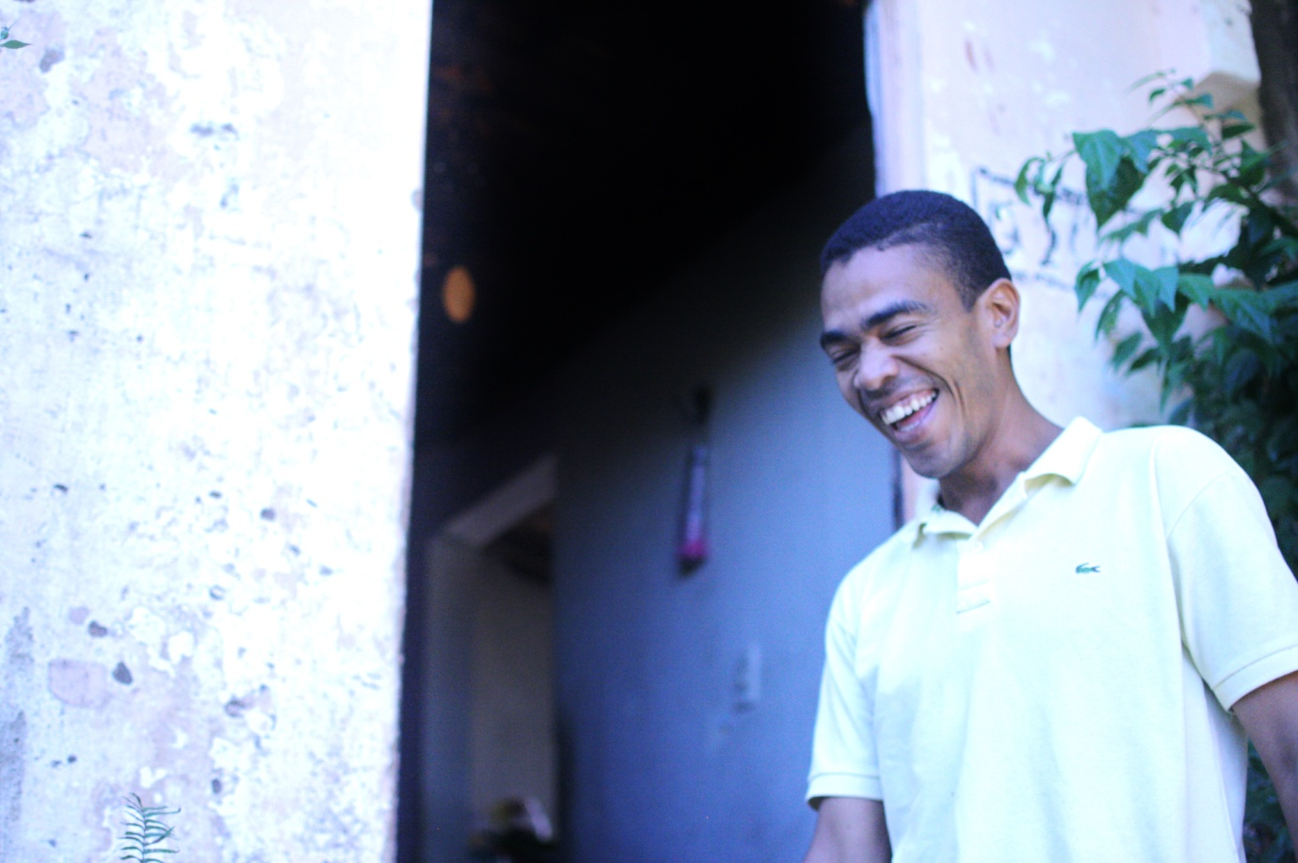
Moisés felt disappointed with how some aspects of Nova Esperança were developing; he was conscious of the roots of the community as a social project which is a product of existing failed systems. In particular, his biggest worry was the beginnings of land speculation within the community. Some plots were being bought and sold for inflated prices between those within the invasion and those from outside. Although these prices were still much less than across much of the rest of Teresina, Moisés was scared of what he felt was a slippery slope for Nova Esperança.
This fear was mirrored in many other residents; as Nova Esperança neared a point in which the prefeitura looked at the potential of regulisation, there was also fear over what would become of this community. Regularisation, although bringing practical benefits, also signified being included in the wider landscape of Teresina. For many, this was a clear point of difficulty; it is the failing of ‘Teresina’ and its systems which forced many of these families to break the law and risk a great deal. As they settled and found their feet, the prospect of being enclosed once again in this system worried them.
Yet despite this fear, there was a palpable optimism in Nova Esperança, not just regarding the future of the community ethos. There was a positivity which was visible between people and between people and their homes (including gardens).
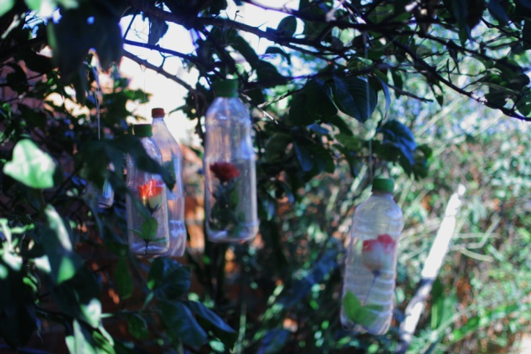

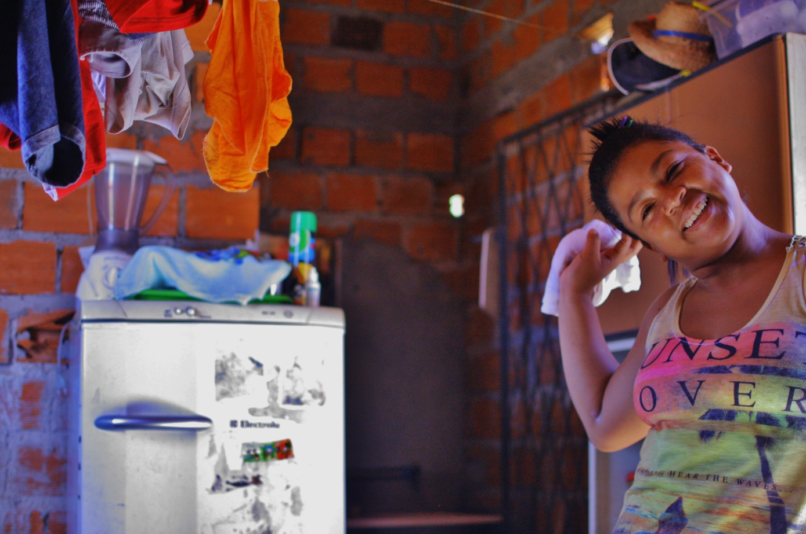
Priscila was one of the first to move to Nova Esperança after the initial invasion and long before land rights were a realistic conversation. She had been waiting 5 years for a home under the minha casa, minha vida programme. Now, with two children and expecting her third, she was exhausted with official procedures. A trained hairdresser, she spent 2 months clearing a plot and digging foundations by hand. Now her one roomed home is filled with memorabilia and reminders of the young, happy family which fill it.
She reminds me that when she moved to Nova Esperança, she secured her plot by providing 2 spools of electrical wire to the community who were in the processes of building a chapel. She felt that this was very symbolic of Nova Esperança as a whole; a place where people gave and helped where they could as equals.
Priscila’s home, despite being one of the oldest, was one of the smallest. Yet she seemed to feel no embarrassment; in fact often her’s was the home where neighbours would descend to gossip and enjoy a cafezinho.
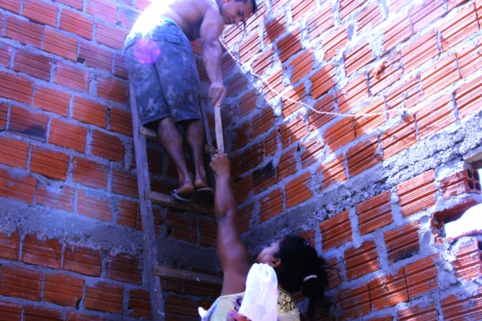
The pride those such as Priscila feel for their homes seems to extend out to the wider community. Priscila explains to me how drugs and alcohol have had minimal footprint in the community (in comparison to most other informal housing environments such as favelas). Fervidly, she describes how hard people have worked for what they have achieved in Nova Esperança; there is a common effort to keep the community a safe and enjoyable place to live.
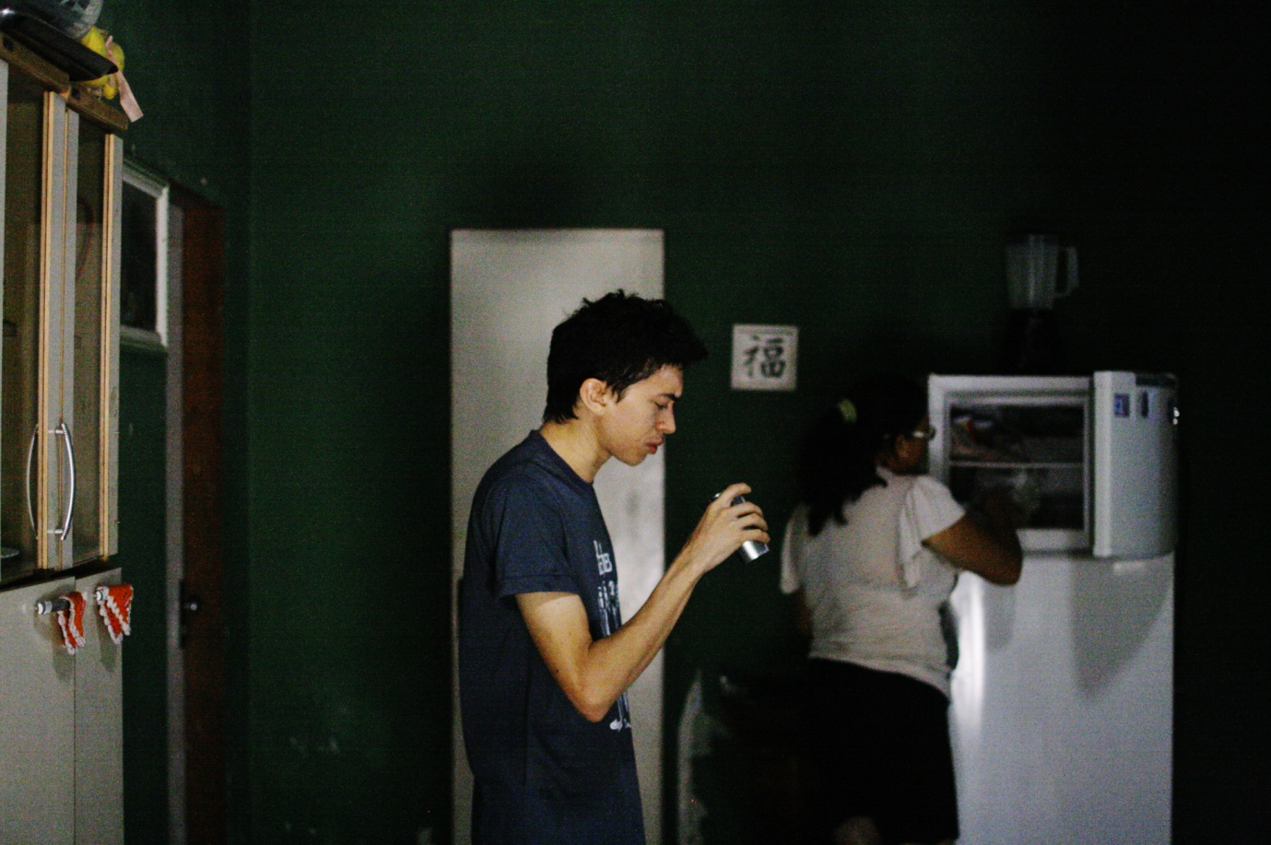
In Rosana’s home, the family are enjoying a recent gift from Rosana’s aunt – a used refrigerator - meaning ice cold water.
Rosana’s home is much more conventional than other homes – plastered walls, bathroom door, kitchen window etc. I asked her what she thought about this. Her response was unexpected; she explained that the house was modelled on her mother’s home. It was a home that (since her mother’s death) she did not have access to, and this home was in some sense, a method in which Rosana tried to keep connected. She felt that is was an honour that her and her children had laboured with their own hands (and the help of her brother, a builder) to complete this home in the form they have.
I asked how electricity and water supplies arrived at Nova Esperança. Rosana replies with a grin - both water and electricity are siphoned illegally. She went on to disclose how in the original invasion there was no option but bottled water and generators; obviously, this was only a practical option for so long. The community clubbed together to buy piping and wire. One early morning, the members of the community set out digging a trench (roughly 200 meters) to the nearest water pipe junction. The effort involved everyone in Nova Esperança, from those digging to those providing refreshments, to those following after filling in the trench. Infrastructural developments such as these have provided the community as a whole a sense of independence and individual homes a level of independence from relatives. Rosana explains that before water arrived, she would go every few days to her aunt’s to fill containers of water.
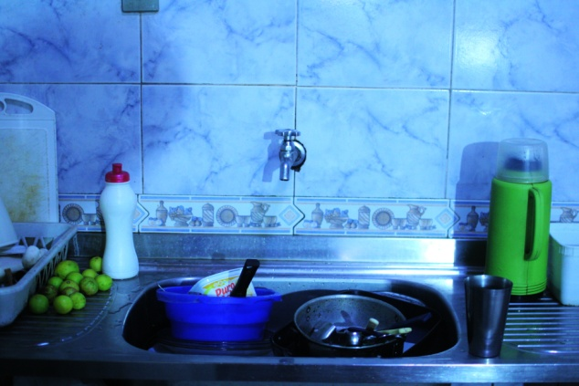
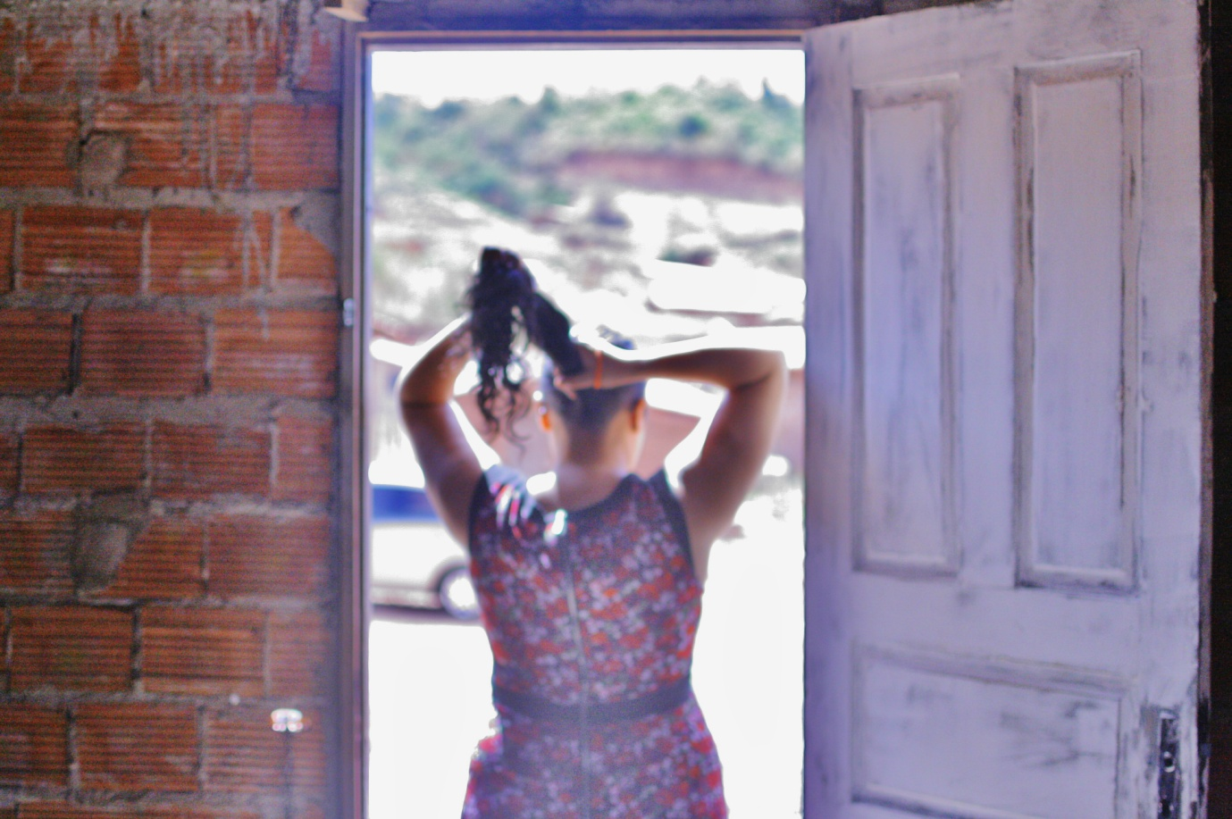
Amanda is a relatively recent arrival in Nova Esperança. Her home is far from having the basic amenities of her neighbours, and so she gratefully uses the gas cookers, showers and refrigerators of others.
She (more than others I met) is much more conscious about the relationship Nova Esperança has to the wider environment of Teresina. She is particularly conscious over bus routes and transport links. She tells me how her partner currently carries their child to school in the morning on the back of his motorbike. Yet to pick them up again, Amanda has a 30 minute walk to the nearest bus stop and then 15 minutes (when a bus sporadically arrives) on the bus – there and back. Receiving some regularised transport link would be a huge benefit to this family.
When speaking to other families about transport it became clear that most of the women particularly, are confined to Nova Esperança. Access for most families came from owning a motorbike, and this was usually taken by the husband/ male partner to work daily. When speaking about transport it was interesting to note a change in the way residents spoke of their relationship between themselves, their homes, their community and wider Teresina. Whereas much of what had been said had regarded their conscious distancing from the formal processes and infrastructure of Teresina, transport seemed an issue where they felt excluded. Having a direct bus to the centre, or at least an area with schools and a few shops, would facilitate life to a huge degree for those such as Amanda.
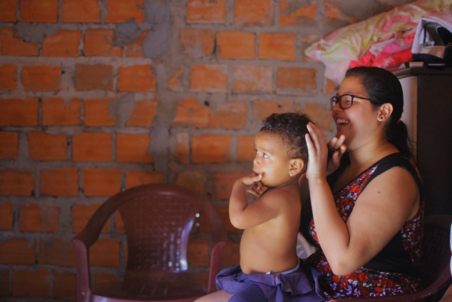

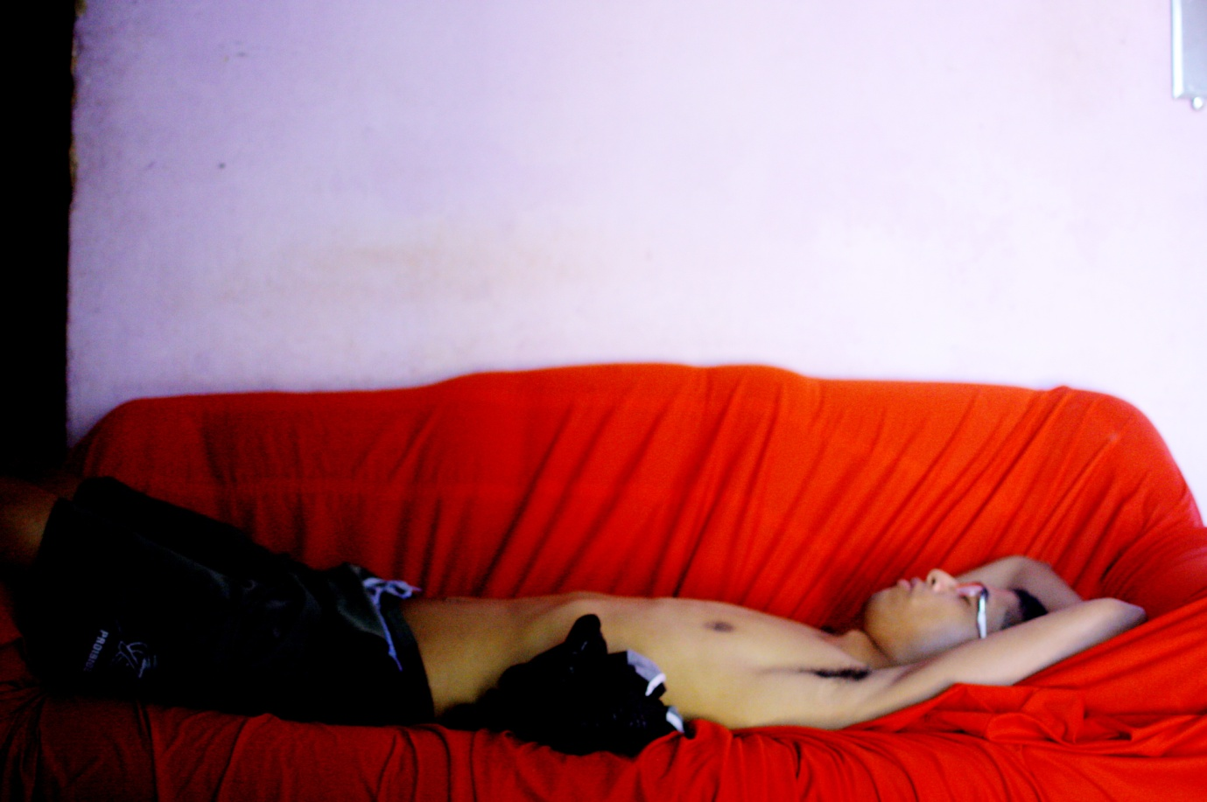
Felipe moved to Nova Esperança after spending time in a federal housing project in Jacinta Andhade. He described how in this project the homes which were built in blocks by the federal government, extended as far as the eye could see in parallel lines. He said he felt claustrophobic there; each and every family, regardless of individual traits and needs, was shoved into the same sized box. His mother lives near the site, and so after the initial invasion, Felipe followed.
The structure of his home is small, yet he says he prefers to live outside in the land which surrounds his home. The structure is purposefully small so that he has more room for his garden and animals.
Through Felipe it becomes clear to see the freedom on offer to residents of Nova Esperança to build homes in a way that suit them and their needs. Each structure is different, like each inhabiting family. All have had experiences of living in other homes, where they have learnt what works for them and what does not. Many, like Felipe, have been frustrated by the singular, constraining alternative of social housing offered to them by both federal and local governments.
Nova Esperança provides the opportunity - for families who are willing to take on the work - the chance to carve out a space and home which fits them.
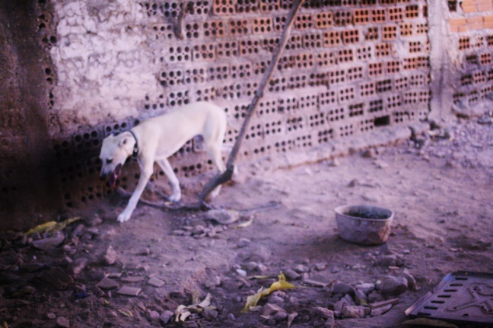
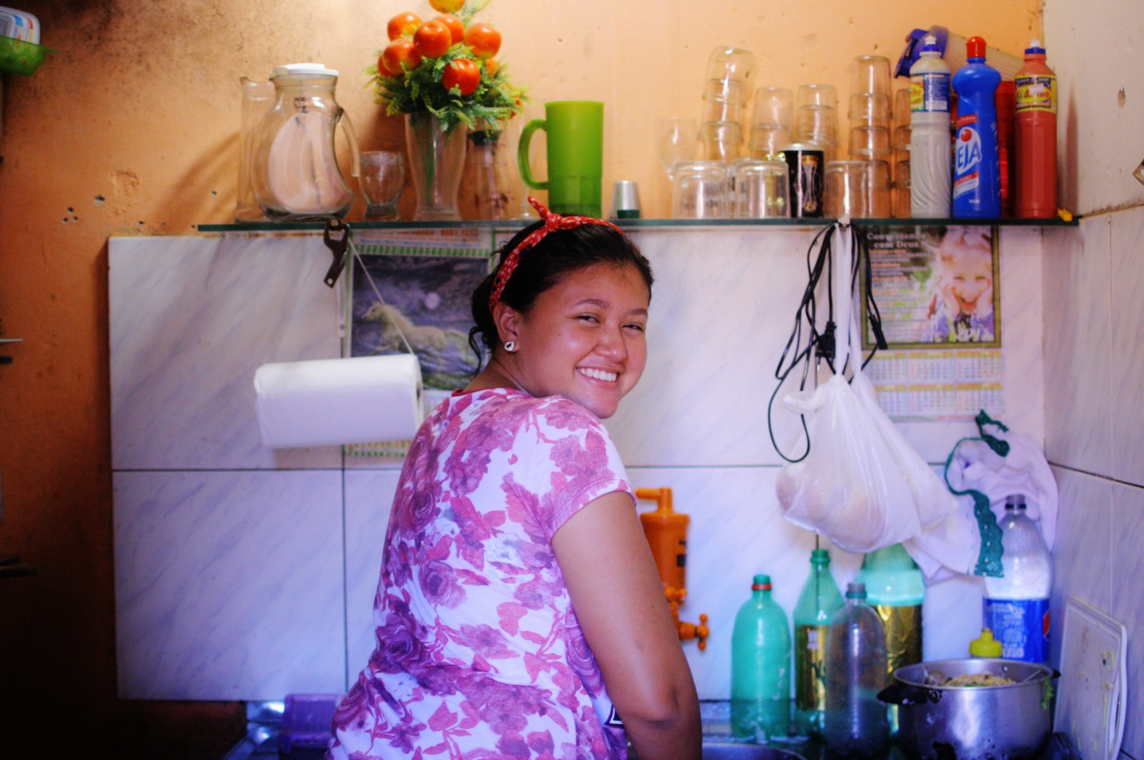
Andresa, like Felipe, is one of the few residents of Nova Esperança without children. Yet this is very much something her and her partner Lucas, are hoping for in the near future. Lucas has recently moved into the home, living their full time; Andresa will remain at her parents, visiting and helping where possible, until after they are married.
Both sides of their families have been involved in the financing and building of their home, and both feel it is a labour of love; it seems to represent the coming together of their families.
Lucas works for the Policia Militar of Teresina. Andresa explains how this created some initial hesitations towards the couple when they first entered Nova Esperança. The Policia Militar is the police force who would, if it came to it, evict the families from Nova Esperança; it seemed strange therefore for ‘one of them’ to live amongst the community. Andresa recognises why such a feeling was present when they first moved, however is glad that they have slowly overcome it. She explains that, although working for the police offers a contract for life, their salary comes irregularly and is often cut if the prefeitura is short of cash. This means they have no chance of a mortgage or borrowing money, and so an occupation such as Nova Esperança was their only chance of living outside of the homes of their parents.
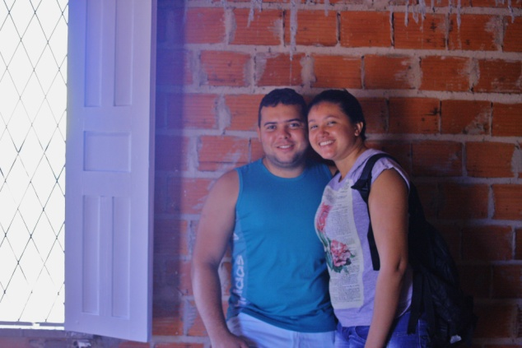
It is interesting to see Lucas, by day a symbol of the formal side of the city, immersed in the informal. When speaking, he seems to see no tension between these two worlds.

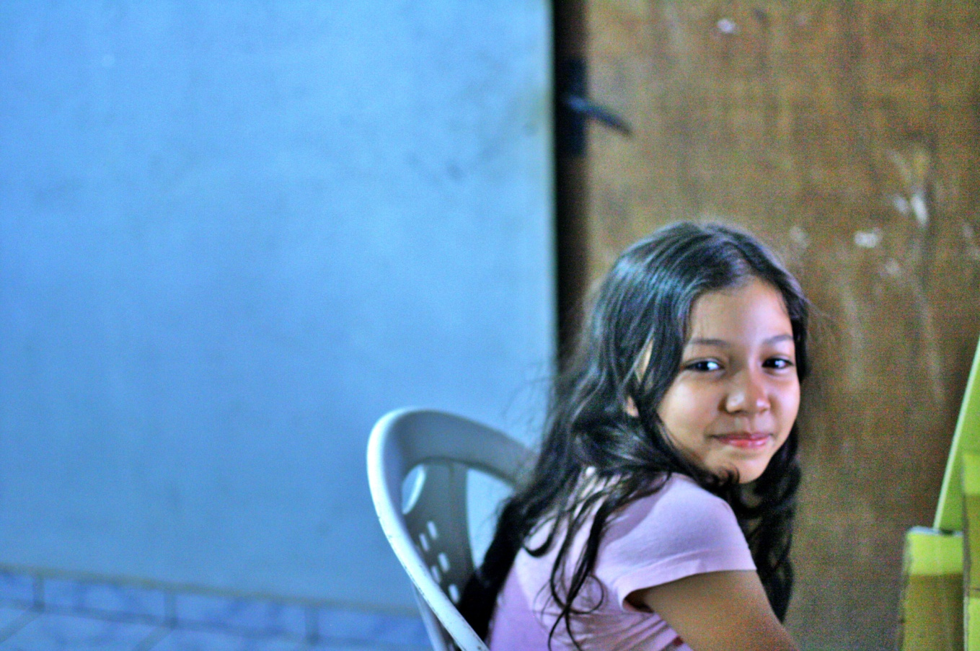
Nivea and her parents moved to Nova Esperança in the initial invasion and are highly respected within the community. Their pride in their home and the wider community of Nova Esperança is clear.
I asked how they felt speaking about Nova Esperança to those who had not visited the community and saw what it offered. I wondered whether people outside of the community knew much about it.
Nivea’s mother Nice, explained that few know of the community and this makes it hard when filling in bureaucracy and so on. There is no CEP (post code) for the area and no official road names; this means a difficult process of getting correspondence sent to relatives. Although this obviously provides practical difficulties, this process also seemed symbolic of the way the formal ignores the informal and develops processes which provide no room or option for its existence. Nova Esperança, despite its many successes and opportunities it provides for its inhabitants, is unrecognisable to the formal side of the city.
I spoke to Nivea about how she felt when describing where she lived to her friends at school and people outside of the community.
She notes how few know where she lives, and when she visits friend’s houses for birthdays and so on, she notes the difference between their communities and Nova Esperança. Yet he confirms that Nova Esperança is a much better place to play and spend the weekend; it is much more open, wider streets, less cars and many trees to climb.
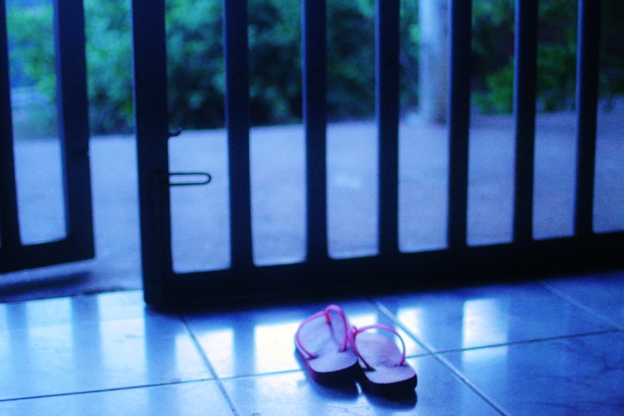

CONCLUSION
Nova Esperança is a symbolic name which seems to inspire an ethos in the community which is recognised and lived. Those of the community who I had the pleasures of meeting were conscious of what their lives in Nova Esperança signify, in terms of a rejection/ isolation from the formal side of the city. Yet being outside of the formal and the recognised leaves an individual and family in a vulnerable position; a place in which ontological security is necessary. Building their homes in this context, can be seen as the structural manifestation of families attempting to construct their identities outside of formal spaces. In investing their search for security into the walls around them, the notion of a distinct category of structural/ affective concept of the home is dissolved; instead a hybrid process of assemblage can be witnessed within Nova Esperança.
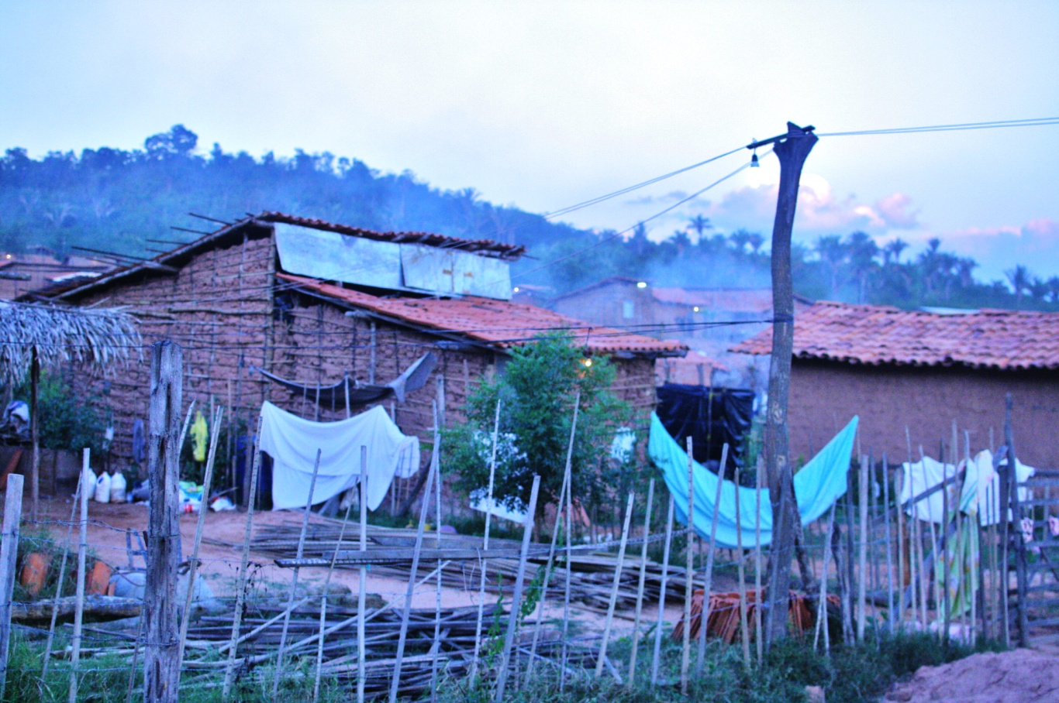
These homes, although varying in shape and size between the community (and even more so when compared to the rest of Teresina) provide a crooked and contorted map to the lives its inhabitants are trying to build in this prosaic, informal, hybrid space. It is a built environment that speaks in contrast to the formal, offering the inclusion and networks of empathy and care which so often lack in the increasingly isolated ‘city’.
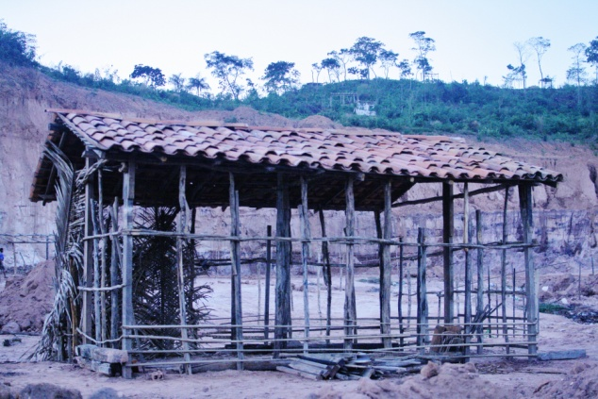

With thanks to IATL and the residents of Nova Esp, especially André Ananda and Roseli Campelo.

REFERENCES

In comparison to the UK system, the prefeitura signifies the city council, with powers over local infrastructure, schooling, planning and social care.
The common term used by the original community to describe their efforts is invasão (invasion).
Amin, A. 2013. Telescopic Urbanism and the poor. City: an analysis of urban trends, culture, theory, policy, action. 17:4, pp. 476-492.
Burdett, R, and Sudjic, D, eds. 2011. Living in the Endless City. London: Phaidon.
Amin, A. 2013. Telescopic Urbanism and the poor. City: an analysis of urban trends, culture, theory, policy, action. 17:4, pp. 476-492.
Fischer, B. 2014. Cities from Scratch: Poverty and Informality in Urban Latin America. London: Duke Press.
Larkin, B. 2011. The Politics and Poetics of Infrastructure. Annual Review of Anthropology. 42, pp. 327-43.
For instance, the photography of Michael Wolff and Daido Moriyama.
Cox, N and Federici, S. 1975. Counter Planning from the Kitchen: Wages for Housework a Perspective on Capital and the Left. New York: Wages.
Jacobs, J and Smith, S. 2008. Living Room: Rematerialising Home. Environment and Planning A. 40, pp. 515-519.
Noble, G. 2004. Accumulating Being. International Journal of Cultural Studies. 7 (2), pp 233-256.
Blunt, A and Dowling, R. 2006. Home. London: Routledge.
McFarlane, C. 2011. The City as Assemblage: dwelling and urban space. Environment and Planning D. 29, pp. 649-671.
Crary, J. 1990. Techniques of the Observer. New York: MIT Press.

