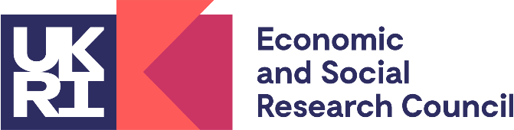
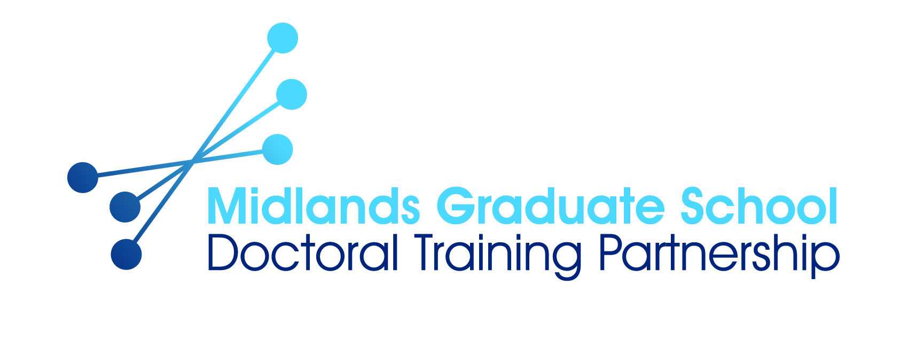

CHISEL - Clear Health Information Supporting Empowered Lives
ESRC DTP Collaborative Studentship

University of Nottingham and the NHS Nottingham and Nottinghamshire Integrated Care Board (ICB)

The Midlands Graduate School is an accredited Economic and Social Research Council (ESRC) Doctoral Training Partnership (DTP). One of 15 such partnerships in the UK, the Midlands Graduate School is a collaboration between the Universities of Warwick, Birmingham, Nottingham, Aston Leicester, Loughborough, De Montfort and Nottingham Trent.

The University of Nottingham as part of Midlands Graduate School is now inviting applications for an ESRC Doctoral Studentship in association with our collaborative partner, the NHS Nottingham and Nottinghamshire Integrated Care Board (ICB), to commence in October 2026. The studentship is available to students with home fee status only.
The project. Forty-two percent of working-age adults in England struggle to understand everyday health information, creating serious barriers to informed medical decision-making and patient safety. This project will feed into national efforts to improve health literacy by identifying which medical terms are difficult to understand and how this affects the reading of healthcare materials.
The PhD will address three core questions:
- What is the processing cost of common vs. less familiar medical terms?
- How do readers process these terms during reading?
- Can we predict which words an individual is likely to know, enabling tailored, accessible communication?
To answer these questions, the PhD student will design and run experiments to measure the recognition difficulty for medical terms and use eye-tracking to assess their processing difficulty in reading. Advanced analysis techniques will be used to analyse the data and identify problematic words to feed into the development of a brief, easy-to-administer tool that healthcare providers can use to personalise written communication. The student will collaborate closely with the Nottinghamshire Integrated Care Board and benefit from interdisciplinary training in psycholinguistics, health communication and analytic methods.

We are looking for an enthusiastic, hard-working, candidate who wants to contribute to making health communication accessible, with the potential to reduce health inequalities and improve patient outcomes across the East Midlands. The chosen candidate will join a strongly multidisciplinary team and develop academic skills related to the review of the literature, research design, and data analysis. The skills acquired will prepare the candidate for a variety of career pathways not only in academia but also in private and third sector organizations involved in developing health innovations. Candidates should have a strong academic background in some of the following areas: Linguistics, Cognitive Psychology, and/or advanced statistical modelling (e.g., mixed-effects models, machine learning and network analysis). A Master’s degree (with distinction/merit) is desirable. Current Master’s students are encouraged to apply, indicating their expected degree classification.

Application Process

To be considered for this PhD, please complete the Collaborative Studentship application form available online here: https://forms.office.com/e/MYPbwryCTU. Applicants will be required to upload an anonymised CV, anonymised cover letter, and transcripts as part of the online application process.

Application deadline: Friday 14 August 2026

Midlands Graduate School ESRC DTP

Our ESRC studentships cover fees, a maintenance stipend, and extensive support for research training, as well as research activity support grants. Support is available to both home and international applicants. For further details, visit: www.mgsdtp.ac.uk/studentships/eligibility/.

Informal enquiries about the research or the School of Psychology prior to application can be directed to Ruediger Thul, ruediger.thul@nottingham.ac.uk, or Walter van Heuven, walter.vanheuven@nottingham.ac.uk.

