

Midlands Graduate School Newsletter – June 2025

If you have any items that you would like us to include in the next newsletter, please send them to esrcdtp@warwick.ac.uk and mark the subject ‘Newsletter Item’.

- MGS Conference 2025
- MGS Mentoring Scheme
- Applied Epistemology Workshop 2
- Bluesky
- PhD as a parent
- NCRM Research Methods Rendezvous
- UKRI Policy Internship Scheme
- DTP Student Successes

MGS Conference 2025

The MGS conference 2025 (Extra)Ordinary Experiences? Approaching Everyday Lives In Social Science Research was held at the University of Birmingham on Monday 23 June.

The MGS team would like to say a massive congratulations to the organising team for a great day of engaging talks which showcased the breadth of exciting research being done across our institutions. Thanks to everyone who participated in the day.

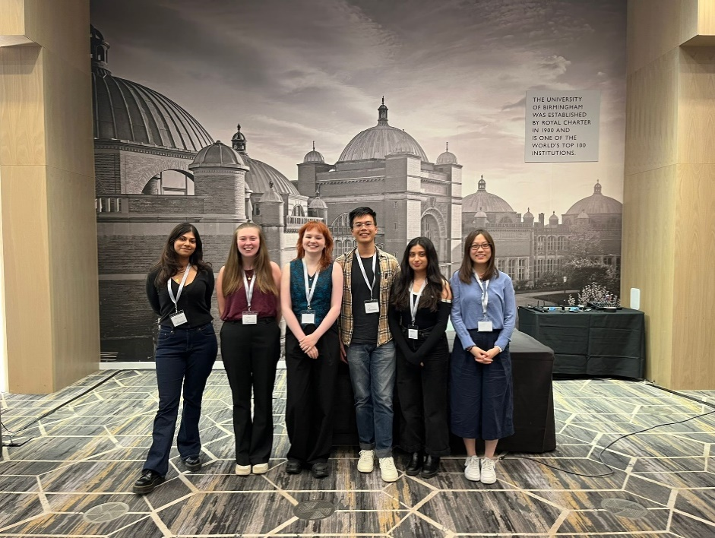

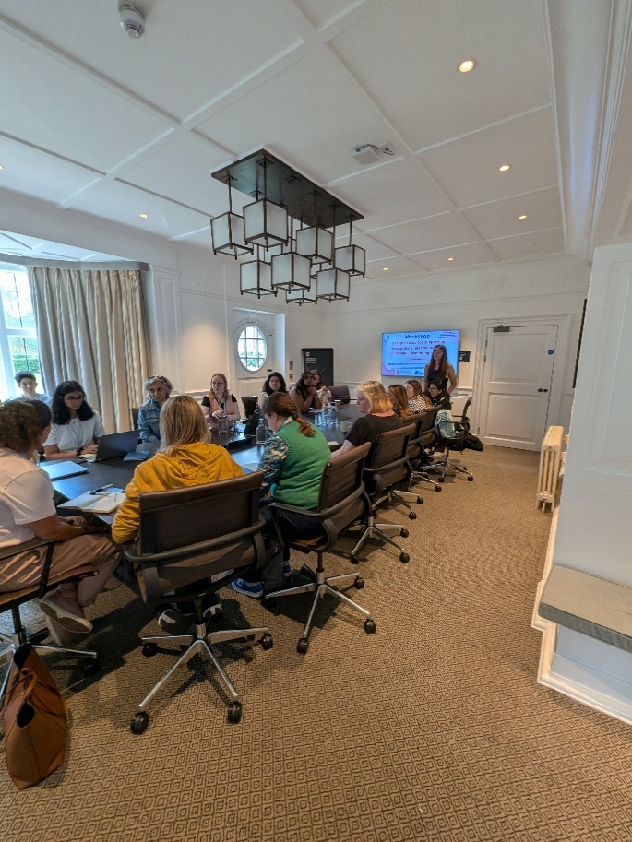

MGS Mentoring Scheme

Ahead of a new cohort joining us in October, we are looking for volunteers for mentors to be matched up with incoming students.

The MGS mentoring scheme is intended to be a mutually beneficial experience which facilitates the sharing of advice, creates links between researchers in different cohorts, and strengthens ties in the postgraduate community. We will endeavour to pair you with a student from your pathway and institution, but this may not always be possible.
If you are interested in acting as a mentor please complete the form here (password: MGSStudents2017): https://warwick.ac.uk/fac/cross_fac/mgsdtp/resources/mentoring/

A training session for mentors will be delivered online in September, and the central MGS team will be on hand for support throughout your tenure as mentor.

Applied Epistemology Workshop 2

In the second of our applied epistemology workshops, we will delve into the question of whether social objects—like institutions, social structures, or norms—are ‘real’. More so, we will ask the question what ‘reality’ even means when we are thinking and talking about social objects. The morning session focuses on foundational debates, while the afternoon explores critical realism as a useful framework for studying social reality.

This is an online Teams workshop which will run between 10-12 am and 1-3 pm on Tuesday 1st July 2025.

The day will be facilitated by Ben Kotzee, Professor of Philosophy of Education at the University of Birmingham and Deputy Director (Training) of the Midlands Graduate School ESRC DTP.

The session will be interactive, although no participant will be made to speak.

Register to attend: Complete this MS Form. You will be sent a calendar invitation on Monday 30th June with details about how to join.

More details: https://warwick.ac.uk/fac/cross_fac/mgsdtp/news/seminars/applied_epistemology_2/

Bluesky

The Midlands Graduate School is now on Bluesky! Follow us to keep up to date with events and activities across MGS: https://bsky.app/profile/mgsesrcdtp.bsky.social.

PhD as a parent – blog post from Michelle McLean

DTP student Michelle McLean has written a blog post about her experience of studying for a PhD part time and work, study, and family life.

Check out Michelle’s post here: https://intranet.birmingham.ac.uk/student/news/public/apr-jun25/project-manager-student-mum-my-journey-back-to-university.aspx

If you are a student with parental or caring responsibilities you may also be interested in our Parents & Carers Network – more information here: https://warwick.ac.uk/fac/cross_fac/mgsdtp/news/studentnetworks/#PCN

NCRM Research Methods Rendezvous

The Research Methods Rendezvous (RMR) is a unique opportunity to explore puzzles, ideas and questions, and begin to transform them into research that is important, feasible and impactful.

The RMR is a free, innovative, online initiative designed to be a source of inspiration, a research incubator and a networking opportunity. Based on two half-day intensive sessions in autumn 2025, the RMR explores two parts of the research process:
- I wonder: the curiosity that sparks our research (10 September)
- How can we: the process of shaping those sparks into tangible projects (29 October)

Between the sessions, a seven-week collaboration period enables participants to co-shape the development of ideas. Applications to participate are open until Wednesday, 2 July 2025.

During the two sessions, attendees will hear presentations from other researchers on early-stage ideas and help to develop them. There will also be a seven-week collaboration period between the sessions.

Further information about the event and a link to the application page are available here:
https://www.ncrm.ac.uk/training/RMR/index.php

UKRI Policy Internship Scheme
The UKRI Policy Internships Scheme for 2025/26 is now open and the closing date for applications is 4pm on 8 September 2025.

The scheme provides the opportunity for doctoral students funded by the Research Councils of UKRI to undertake a three-month placement at one of a selected group of highly influential policy organisations. During their internship, the student undertakes training and experience on a policy topic agreed with their host partner that is relevant to both parties. The intention of the scheme is to embed students in an environment where they can engage with the process of converting research outputs into policy. These internships equip students with transferable skills and training relevant to the future career paths that the student may choose.

Full details of how to apply, including links to the online application form and guidance documents are available through the UKRI Policy Internships Scheme webpage.

DTP Student Successes

This section of the monthly MGS newsletter celebrates the successes of our funded students. This can include news about thesis submission, jobs, publications, anything you would like to share! If you would like to be featured in one of the newsletters, please contact either your local DTP administrator or esrcdtp@warwick.ac.uk directly.

This month, congratulations to:
- Jaroslava Barbieri (Political Science & International Relations, University of Birmingham) has passed her viva!
- Rob Booth (Sport & Exercise Science, Loughborough University) has passed his viva!
- Emma Quinn (Sport & Exercise Science, Loughborough University) has been awarded ‘best oral presentation in the social sciences’ at the WiSEAN Conference 2025
- Maria Kolitsida (Sport & Exercise Science, University of Birmingham) has published on her current research into self-harm in dance: https://www.tandfonline.com/doi/full/10.1080/1612197X.2025.2522404
- Warwick DTP alumnus Cat Jones has published a paper based on her PhD research in the Education pathway: https://www.tandfonline.com/doi/full/10.1080/00131911.2025.2506802

Best wishes,

The Midlands Graduate School ESRC DTP Team
Aston University
University of Birmingham
De Montfort University
University of Leicester
Loughborough University
University of Nottingham
Nottingham Trent University
University of Warwick

www.mgsdtp.ac.uk
Follow us on Twitter @mgsesrcdtp


