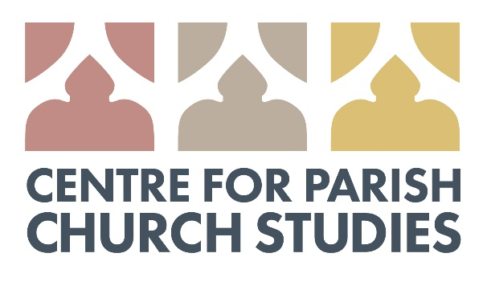
ANNUAL CONFERENCE
What is an appropriate (re)use for a church?
Saturday 20 October 2018
St Martin-at-Palace Church, Norwich
CALL FOR PAPERS
The Academic Board of the Centre invites proposals for its inaugural conference, organised around the theme: ‘What is an appropriate (re)use for a church?’. The keynote speaker will be Prof William Whyte (St John’s College, Oxford), author of Unlocking the Church: The lost secrets of Victorian sacred space (OUP, 2017).
Papers may address all aspects of using working churches for ‘secular’ events or purposes (e.g., village shops), or reusing redundant buildings: what is and what is not an appropriate reuse? How do these impact on the building itself, as well as on its community? Papers should be no more than 20 minutes in length, to allow for questions and discussion.
Proposals, comprising a 200-word abstract and short biographical note, should be sent to the Director, Dr Nicholas Groves (nick.groves@norwich-churches.org) by 14 July 2018.

