
THIRTEENTH WARWICK SYMPOSIUM ON ARISH RESEARCH – 16 MAY 2015
‘WARWICKSHIRE PARISHES: HISTORY AND LEGACIES’
Report by Paula McBride, MA (Warwick)
Celebrating the fiftieth anniversaries of both the University of Warwick and the Warwickshire Local History Society (WLHS), over 35 delegates came together on Saturday 16 May 2015 to build on long-standing – personal, academic and institutional – links between the co-organizers. The Symposium aimed to showcase the parishes’ key cultural roles across all ages. Alongside, stalls by the Kineton & District Local History Group and Warwickshire Local History Society promoted research on their respective interests (Figure 1).
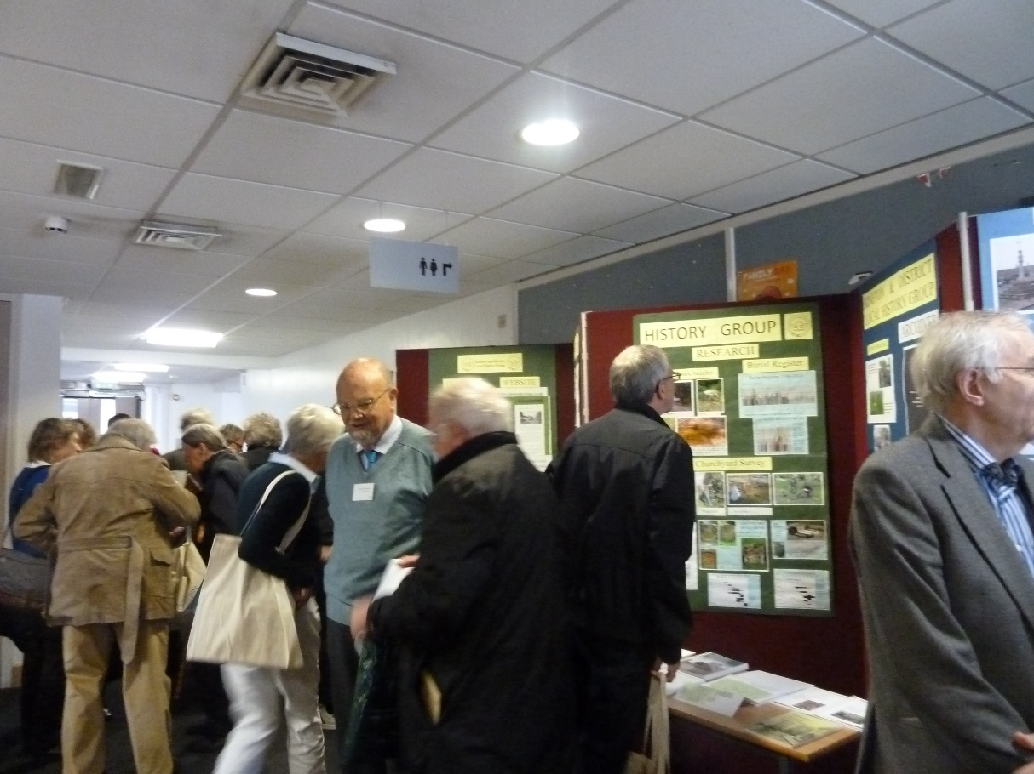
Figure 1: History society stalls at the Symposium. Picture by Paula McBride.
In his introductory address, Beat Kümin (Warwick) welcomed the delegates, and noted the wide backgrounds and interests that had brought them together for this collaborative initiative. Two principal questions should guide participants: In which ways have parishes shaped the county of Warwick in the past (referring e.g. to ecclesiastical life, local government, communal identity, social networks …), and what role(s) can they play in its future (e.g. in relation to religious / ecumenical cultures, local services, social work, heritage industry …)?
The keynote address by Robert Swanson (Birmingham) investigated the ‘little local difficulties: parochial problems in pre-Reformation Warwickshire’. He presented a selection of cases within pre-Reformation parishes that contribute to the construction of narratives both for Warwickshire and ultimately for England as a whole. Professor Swanson (Figure 2) emphasised the availability of sources usually overlooked by historians as being too difficult to use and ‘not even having the advantage of being entertaining!’, yet helping to close the gaps in microhistories. An important question was that of ‘Which Warwickshire?’ Its territory has changed over time, and so the ‘messiness’ of overlapping medieval boundaries could be a shock to the researcher – which parish belonged to which county or indeed which hundred? In fact, the parish was much rather a component of an archdeaconry or a diocese. It was primarily shaped by canon law, not the secular jurisdictions. To talk generally of ‘the parish’ glosses over the complexity of the individual microhistories of the 9-10,000 parishes in pre-Reformation England, each with its unique mix of relationships and tensions, both internal and external. Each parish tale, often incomplete due to the lack of source survival, can be seen as part of a larger story. Most centre on clerics and their problems, however the laity also played a part, as parishioners, participants, even victims. The first group of cases concentrated on the succession to benefices and the challenges between rival claimants, often through the courts, but just as often through physical violence, as in the case of the parish of Aston Cantlow, fought over by the two Augustinian priories of Maxstoke and Studley. Another important issue was that of parishioners against their clergy or against each other, often when there was a weak or contested sense of parochial identity, such as at Little Packington, where a clash between an incumbent and two parishioners over non-payment of tithes was taken before the bishop’s court. Disputes over burial rights could bring moments of drama – the obligation and requirement that parishioners should be buried in their parish church could even be gruesome, as in the case at Napton, where a corpse was illicitly removed from its grave and carried off to nearby Hardwick, the grave-robbers triumphantly shouting ‘We have hire, we have hire’! Our speaker concluded that at the moment we have little more than isolated episodes even in the microhistories of the individual parishes. Maybe in time, however, these episodes could be assembled into a grand narrative of parochial history in pre-Reformation Warwickshire. Looked at in hindsight, the case studies represented ‘little local difficulties’ – their impact was precisely local, yet played out at many levels, even internationally, and so they deserved to be restored to the historical record.
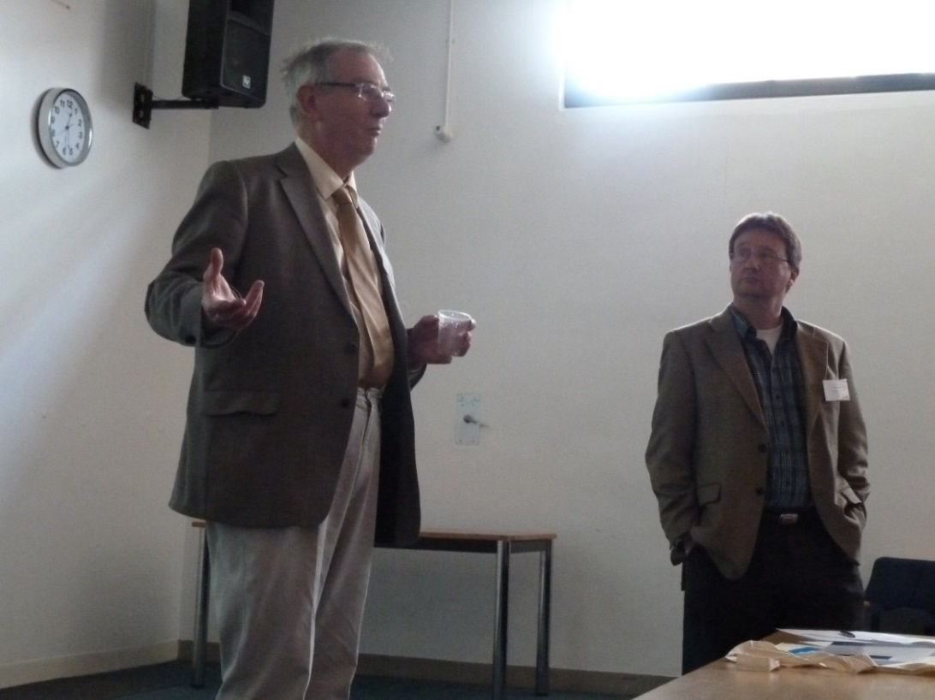
Figure 2: Robert Swanson (Birmingham) and Beat Kümin (Warwick). Pic by Paula McBride.

Following lunch, the first afternoon session featured short ten-minute presentations offering interesting insights into ongoing parish projects:
Kristi Bain (Norwich), speaking on ‘The Medieval Churches of Norwich Research Project: City, Community and Architecture’, publicised a survey of the surviving 31 Norwich churches building on precedents by Francis Blomefield in the 1740s and Alan Carter in the 1970s. Today’s project attempts to look at not only those churches still standing, but also the 26 parish churches that were lost in the sixteenth century (St Olaf at Pitt Street) or through the attacks on Norwich in World War II (such as St Michael at Thorn). It is hoped the survey will be completed by 2017, accompanied by a two-volume analytical catalogue of every church – a ‘one-stop shop’ for historians of Norwich churches.
Patricia Cox (Chester) emphasised the importance of church court materials in connection with her ‘Chester Consistory Records Project’, aiming for an illustrated online database of the earliest surviving cause papers, together with a full Latin transcription and translation of each document. The website, to be hosted by the Warwick Network’s My-Parish platform, aims to make this complex yet rich source more accessible to a wider audience. Any interested parties wishing to help with the transcribing and translation would be very welcome.
Trevor England (Solihull Local History Circle), presented a series of ‘Solihull town centre photographs c. 1900’, focusing on buildings in Drury Lane and Mill Lane before they were lost to time with the redevelopments of the 1960s. Solihull emerged from a combination of two Doomsday manors and thrived until the fourteenth century, when it went through centuries of decline up until the advent of the railway. Indicators such as rooflines and the existence of ridge poles provide building historians with clues on the age of particular properties.
Andrew Foster (Kent) reported on the progress of ‘The Churchwardens’ Accounts Database’, aiming for a complete listing of surviving English and Welsh extant churchwardens’ accounts between the fourteenth century up to around 1850. It will provide locations and extent of runs of material, and a summary guide to income and expenditure totals. The current estimate of approximately 3,000 sets may well be surpassed in time. Once the structure has been finalized, the database will be uploaded to My-Parish.org sometime in Autumn 2015; in the meantime Andrew appealed for help in populating the database, and for further research at record offices. The project is led by Valerie Hitchman, who can be contacted at v.hitchman@kent.ac.uk.
During ‘Local Memorials’, David Freke (Kineton & District Local History Group) examined the results of two churchyard surveys, one taken in St Peter’s of Kineton in 2010 and the other some 35 years ago in Warmington parish, complemented by searches through the local histories and parish registers. Some of the memorials were losing or indeed had lost their details due to the ravages of time and weather, and so the still-discernible shapes of the artisans’ work were often the only method of dating early modern monuments. The speaker asserted that headstones were a new art form emerging from the seventeenth-century based on the classical models found on travels in Europe, disseminated to stonemasons in Warwickshire and other counties. Styles such as small-and-square and shielded panels, barley-sugar twists, baroque and Gothic were evident in still-dated memorials, and so these could be used in the dating of other stones.
Brenda Murray and Jill Tompkins Bailey (Spirit of Berkswell Project) promoted their new website http://www.berkswell.org/, acknowledging the help of the Revd Dr Mark Bratton and York’s ‘Christianity and Culture’ team alongside the parish council, the local school and the Berkswell History Society. It is hoped that the website will facilitate access to a synopsis of previously ‘lost’ archival local history, and direct scholars to the locations of the full archival holdings. Brenda also gave a brief account of her research on the history of Berkswell Hall, which will also be available through the website.
In ‘Chilvers Coton and Astley: How far were their schools parish institutions?’, David Paterson (Nuneaton) emphasized the strong links between parish and school which diminished only in the late twentieth century. Schooling in Chilvers Coton and Astley was linked by the patronage and parochial connections of the Newdegates, the local landowners, from around 1735 until the late nineteenth century. The Newdegates offered free education only for the children of parishioners, the Chilvers Coton School being administered also by parochial representatives, however some children living just over the boundary on the north end of Edward Street in Nuneaton took advantage as the school was free to attend, consequently impacting on the school and parish. For Astley School, between 1844 and 1914, up to 30 per cent of children attending the school came from outside the parish, being from Stockingford, Arley and Bedworth. Later Astley became a more intimate and friendly parish school again. David would be interested to hear from other researchers in the field.
Andrew Thomson (Winchester) completed this session with a survey on the ‘Warwickshire Activities of the Consistory Courts of Worcester’. He offered a ‘glimpse’ of the extent and limits of the control of the church over the laity and its decline over the seventeenth century as evident from the attendance rates, charges and verdicts. The numbers of people summoned per Michaelmas Term from the Deanery of Warwick to the consistory court at Worcester in the 1610s was in the 30s and 40s, but by the 1670s and 80s this had shrunk to an average of seven or so a Term. Most interestingly, the balance of charges appears to have changed over the century, too. Moral and religious charges ran ‘neck and neck’ in the 1610s but by the 1670s and 80s ‘moral’ charges seem to have disappeared and the charges were overwhelmingly ‘religious’. Therein lay the downfall of the church courts because, with the Toleration Act of 1689, it became much more difficult to prosecute religious offences.
The final session of the day included three research papers. The first, by Ruth Barbour (Warwick / WLHS) considered ‘Church Memorial Tablets: Reflections of Secular Power? Memorials to Catholics in Warwickshire Parish Churches’. Recent research by John Bossy and Gabriel Glickman has cast doubt on John Henry Newman’s unduly pessimistic Second Spring Sermon, which referred to ‘a few adherents of the Old Religion, moving silently and sorrowfully about’ at the end of the eighteenth century. Indeed, as the speaker argued, Warwickshire’s Catholics seem to have both flourished and maintained amicable relationships in small rural communities such as Ilmington, Budbrook, Coughton and Wootton Wawen. Evidence can be found in surviving material culture within Warwickshire Church of England parish churches in the form of memorials incorporating traditional Catholic wording such as ‘Requiescant In Pace’ (as seen at St Marys of Ilmington; Figure 3) and through the use of Catholic iconography. Further examples including the Ferrers of Baddesley Clinton and the Throckmortons of Coughton suggest that there is room for a larger study of the phenomenon and a need to reassess the ‘myth’ of the suffering of all Catholics during the times of the penal code and before emancipation.
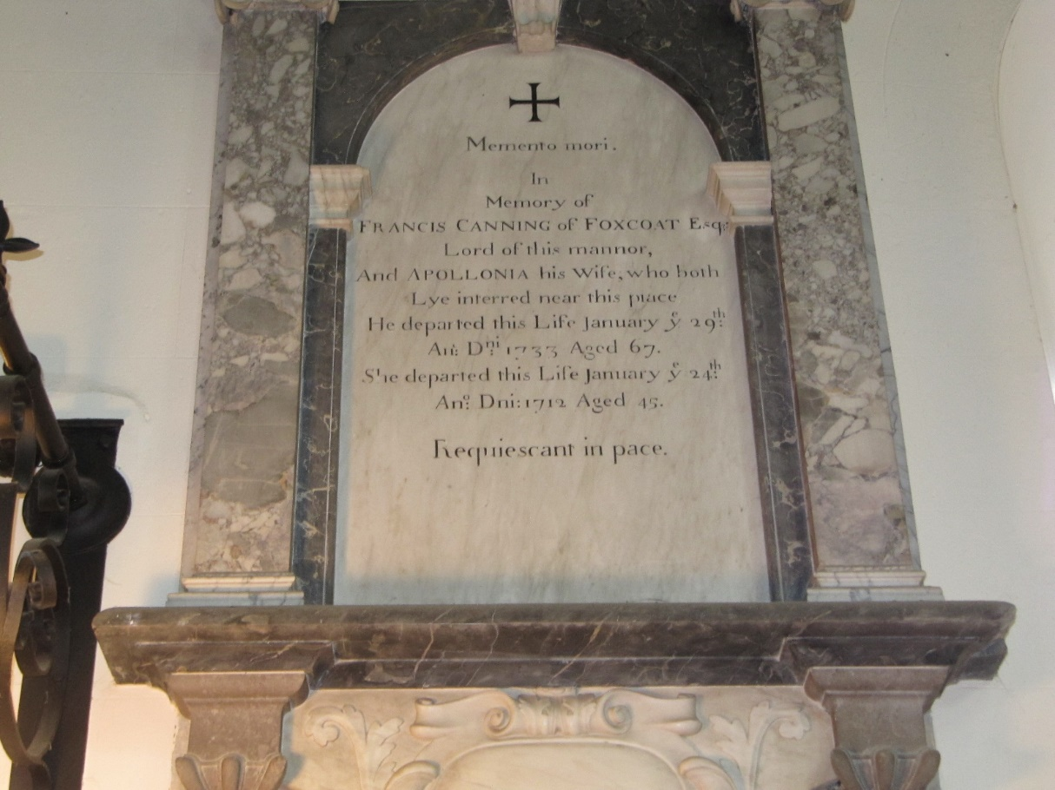
Figure 3: Memorial to Francis and Apollonia Canning, lords of the manor,
in the nave of St Marys of Ilmington. Picture courtesy of Ruth Barbour.
In ‘“The malice and envy of my parishioners”: Conflicting Religious Cultures in the Warwickshire Parishes of Wixford, Haseley & Burton Dassett, 1655-1720’, Maureen Harris (Leicester / WLHS) considered the social values and aspirations of ministers on the one hand, and churchwardens and parish inhabitants on the other. Evidence of religious in the case studies showed that the long-cherished ideals of parochial harmony ‘operating through negotiated consensus’ cannot be taken for granted. At Haseley, for example, a dispute over Anglican Communion reveals a dissenting churchwarden and severe tensions over parish culture. The parish of Wixford saw the minister Timothy Kirke, described as ‘the captain of Oliver’s army’, survive an attempt to remove him from the parish after the Restoration in 1661. Eight years later, however, when attempting to destroy a yew tree dear to Catholic sympathisers, Kirke was struck violently in the chest. Later, the Wixford parish register (WCRO DR17/1) was ‘cut and mangled by papists’. Both the register and the tree became powerful symbols of parish divisions and fights over festive and godly culture. Previous assumptions about the powers of the established Church over the laity must be challenged, since Warwickshire parishes illustrate clashes of religious cultures from the Middle Ages right up to the twenty-first century.
In the final paper of the day, Angela Nicholls (Warwick / WLHS) discussed ‘Competitive philanthropy: parish charity in early modern Warwickshire’. She focused on the complex motivations behind donations and charitable bequests, as well as the impact on the local parishes they were intended to benefit. The speaker argued that altruism and self-interest could be difficult to separate, due to philanthropy offering a public and often ostentatious display of status, wealth, virtue, influence or personal memorialisation in an attempt to emulate and even better other local benefactors. Warwickshire wills show numerous donations to found almshouses and pay for their maintenance, to fund schools and to donate to ministers. One example was that of William Willoughby of Nuneaton, who left funds for gowns for four aged people, fuel for almshouses, books for children, and money to the godly minister at Whitsun. Not to be outdone, Thomas Oken left most of his fortune to the town of Warwick to be spent e.g. on the provision of almshouses for six people and the payment of the salary of a schoolmaster. When three of his almshouses were destroyed in the Great Fire of Warwick in 1694, Oken’s charity built replacements and supported additional places. While some charitable donations were made anonymously, public displays of generosity became gradually more evident. In the charity bread shelves at St Mary’s, Warwick (Figure 4), the names of the benefactors were prominently recorded. In Fillongley, school boys were clothed in different colours depending on the source of their support, making us wonder if there were fights between the blue and green boys!

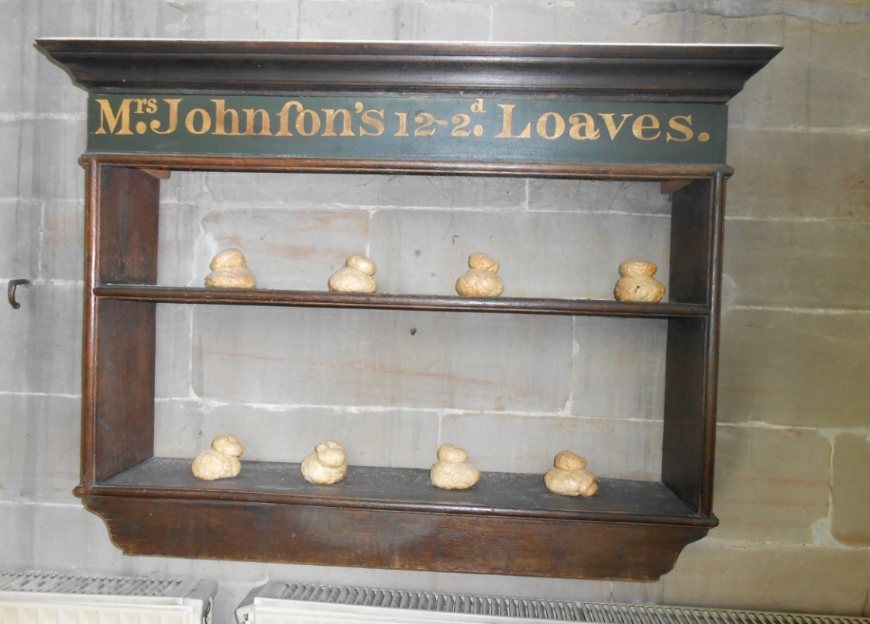
Figure 4: Charity bread shelves in St Mary’s Church, Warwick. Pic courtesy of Angela Nicholls.
In his closing comment and outlook, Beat Kümin opened the floor to general discussion about the parish as a historical entity and its dynamic evolution. When did the idea of the parish begin? When did it become less ‘compulsory’? Also, more work is required about the parish of the present, which exists in a multicultural society, and further trajectories. The Symposium thus offered some new perspectives on the parish’s past, the situation of the present and the challenges involved in making it tangible and accessible to communities of the future.
Looking ahead, the 2016 Symposium is likely to celebrate the launch of the churchwardens’ accounts database with papers examining this key parochial source.
The Warwick Network for Parish Research gratefully acknowledges the support of
The Humanities Research Centre & Warwickshire Local History Society
For abstracts of the papers and pictures from the proceedings, see
http://my-parish.org/events/parish-symposium-2015.

