What was migration like in the past?
Come along to find out!
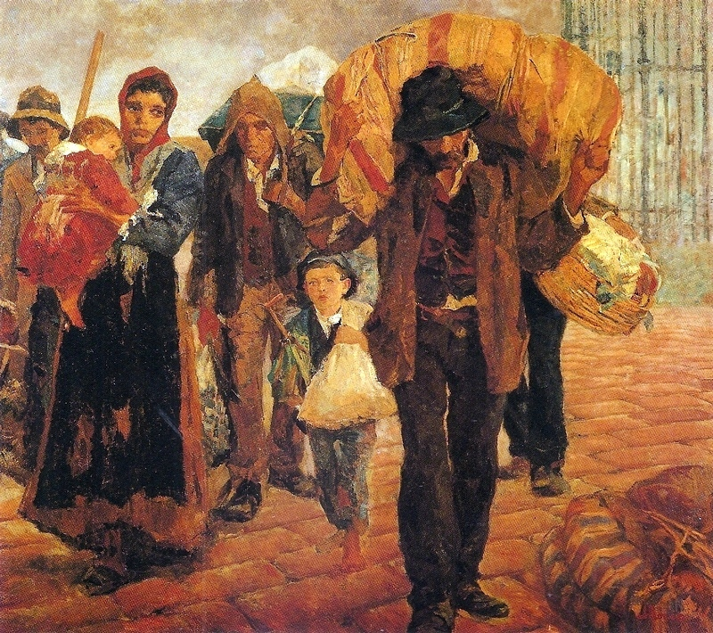

  - Friday 6 July, 5:30-7 pm
St. John the Baptist Church, Jordan Room, Church Lane, Berkswell, CV7 7BJ

Join historians from the University of Warwick for an evening of round table discussions about parish migration.
Invited speakers will start the evening off by brief presentations on a range of topics including short-distance migration, religious mobility and differences and similarities between the past and today.

Light refreshments served and there are plenty of parking spaces at The Bear Inn.

Register your free place at
http://bit.ly/parish-migration

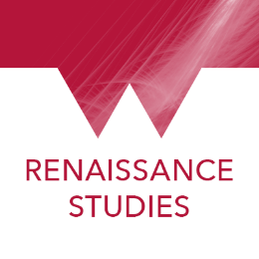

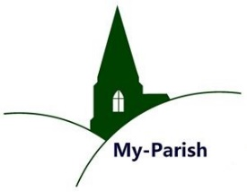
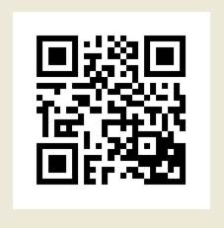

This event has received funding from the European Union’s Horizon 2020 research and innovation programme, Marie Skłodowska-Curie Actions, Project: MIGMED 65711

