Sixteenth Warwick Symposium on Parish Research

University of Warwick, Humanities Building, 12 May 2018

‘Parishes and Migration’

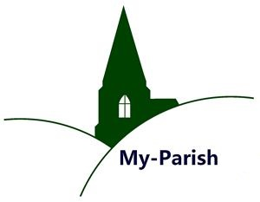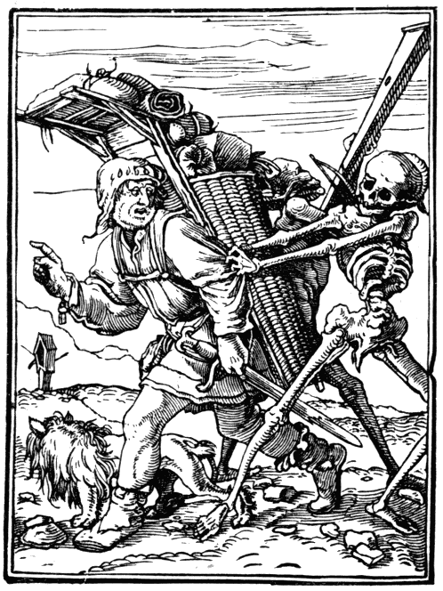

10.30–11.00 Registration & coffee (Humanities, Floor 4, Graduate Space)

11.00–11.15 Beat Kümin, Warwick: Introduction (all sessions in H5.45)

11.15–12.30 KEYNOTE – Richard M. Smith, Cambridge:
55 years since Laslett's ‘Clayworth and Cogenhoe’:
What have we learned about pre-modern mobility?

12.30-13.30 PANEL 1 – Irish Migration, chaired by John Reeks, Bristol
Phil Batman, Leicester: The Fate of Irish Potato Famine Immigrants in a York parish
Bethany Marsh, Nottingham: A grim spectacle: the migration and
relief of ‘Irish’ refugees in London, 1641-1651

13.30–14.30 Lunch (Graduate Space, Fourth Floor Annexe)

14.30- 15.30 PANEL 2 – Religious Identities, chaired by Bernard Capp, Warwick
Felicita Tramontana, Warwick: Migration in Palestine parishes
David Fletcher, Warwick: Strangers and Pilgrims on the Earth’:
The mobility of nonconformist clergy after the 1662 Great Ejection

15.30-16.00 Tea

16.00-17.00 PANEL 3 – Local communities, chaired by Angela Nicholls, Warwick
Tom Roberts, Liverpool: ‘By the Venecian Shipps’: Resituating the Italians in Elizabethan London
Marion Hardy, Exeter: Inter-parish, transhumant and transient
migrants in Devon c. 1600-1800

17.00–18.00 Concluding remarks by Andreas Holzem, Tübingen/Cambridge & Beat Kümin followed by general discussion and wine reception

Further info: http://warwick.ac.uk/my-parish/parishsymposia/2018migration/
Contact: my-parish@warwick.ac.uk / Woodcut: Hans Holbein, ‘The Pedlar’ (1538)

