Seventeenth Warwick Symposium on Parish Research

Parish Participation

University of Warwick, Humanities Building, Saturday 18 May 2019

CALL FOR PAPERS

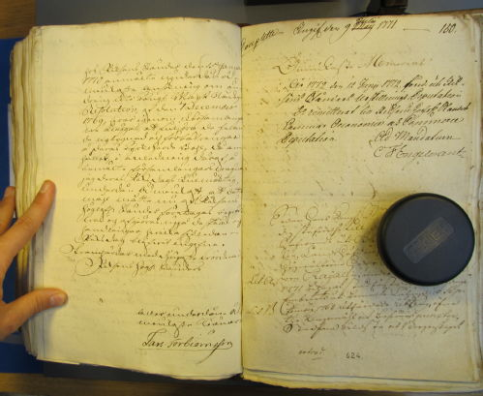

Our annual symposium will take place at the University of Warwick on Saturday 18 May 2019 between 10.30 and 18.00. It explores the different ways in which locals and non-residents got involved in parish affairs, for example by attending masses or sermons, serving as officeholders, paying for additional clergy or furnishings, challenging liturgical innovations, making presentations or taking collective initiatives – as in this 1771 petition by three parishes to the Swedish diet. More generally, the meeting also considers how local communities helped to shape larger historical processes and government structures at given times.
Co-organized with Prof. Malin Lennartsson (Linnaeus University, Växjö), the Symposium will place a particular emphasis on Scandinavia. However, for comparative purposes, papers on other regions are also warmly encouraged. We now invite 1-page proposals from postgraduates, early career researchers and faculty staff researching ‘parish participation’ broadly defined. The Warwick Network for Parish Research can offer speakers free registration, lunch/refreshments and budget travel within England.
Please send abstracts for 15-minute papers together with a short biographical note to b.kumin@warwick.ac.uk and malin.lennartsson@lnu.se by 8 February 2019.
For further information contact Beat Kümin (History) and/or visit:
http://warwick.ac.uk/my-parish/parishsymposia/2019participation/
We gratefully acknowledge funding from:
The Humanities Research Centre, University of Warwick
Parish Petition taken from the records of the Swedish Diet in the Riksarkivet, Stockholm.
