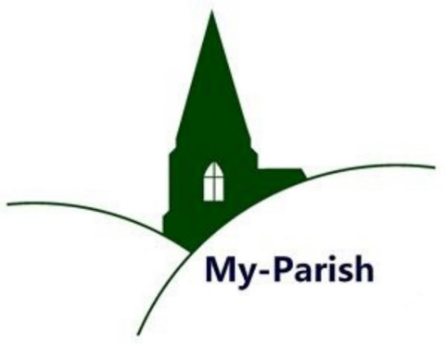
Parish Participation
Seventeenth Warwick Symposium
on Parish Research
University of Warwick, 18 May 2019
Report by Bethany Marsh (Nottingham)

This year’s symposium was co-organised by Beat Kümin (History/Warwick) and Malin Lennartsson (Linnaeus University/Växjö) with the support of the Humanities Research Centre. The thematic focus was ‘Parish Participation’. The speakers explored various types of participation by locals and non-residents across England, Scotland and Scandinavia. These included parish office-holding, parish politics, court procedures and poor relief.
The first panel of the day focused on ‘Officers and Politics’. Dave Postles (Hertfordshire) offered sceptical reflection on the role of constables in parishes, through the lens of early modern comedies by Philip Massenger, Thomas Middleton and Ben Johnson. Donald Spaeth (Glasgow) reflected on petty conflicts within parish communities, thus challenging the notion of harmonious relations. The second panel addressed the ‘Duties and Tensions’ of parish participation. Helen Gair (Nottingham Trent) considered participation in Kirk sessions in Scotland and the unofficial role played by neighbours in reporting offenses and acting as witnesses in court. John Morgan (Manchester) followed with his paper concerning parish participation in environmental concerns, namely water management and the multifaceted roles of dikereeves.
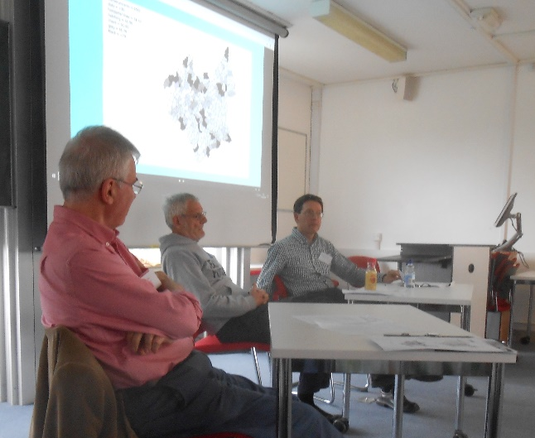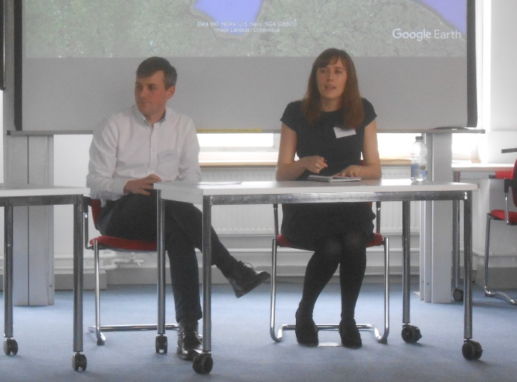
Andrew Foster (Kent), Dave Postles & Donald Spaeth (left) and John Morgan & Helen Gair discussing the themes of panels 1-2.
The third session, ‘Parish Engagement in Early Modern Scandinavia’, broadened the geographical scope of the conference to consider the Scandinavian experience. Malin Lennartsson began the panel with an exploration of Swedish parish records. In particular, Lennartsson noted the differences to the situation in England, where they were largely produced by the laity and considered the property of the community. Churchwardens’ accounts, for example, were passed onto the new parish officer every year. In Sweden, however, church records were produced by the rectors themselves and treated as their personal property. Miia Kuha (Jyväskylä) discussed secular law courts in eastern Finland. She noted how peasants partipated in the courts and have an input in parish decisions, though church officials ultimately had the final say on important matters. Arja Rantanen (Jyväskylä) then considered the role of parish scribes, who were elected officials in Scandinavia and therefore played an important formal administrative role. Finally, Ella Viitaniemi (Tampere) explored the role of deans as ‘middle men’ in the administrative hierarchy of the church in Sweden, often acting as conduits between the parish rector and cathedral chapter. Their duties, for example, included guidance for local clergy, checking parish resources, ensuring proper sermons were being preached and distributing information.
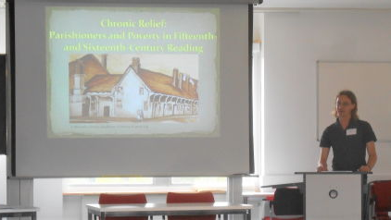
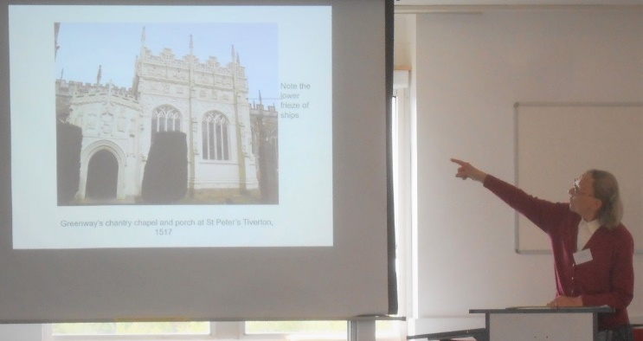
The fourth and final panel of the day, ‘Poverty and Charity’, considered parish participation in poor relief. Joe Chick (Warwick) noted the changing responsibilities of the parish between 1495 and 1601, showing how both institutions and parishioners were involved in poor relief well before this became a statutory duty for the laity. Marion Hardy followed with detailed examples of benefactors who established almshouses, grammar schools, chapels and gave money to the poor in Devon between 1500 and 1800.
Joe Chick & Marion Hardy addressing delegates in Panel 4.
Several themes emerged across the four panels, culminating in an interesting general discussion at the end of the day’s proceedings. Firstly, a number of papers demonstrated how the divide between formal and informal participation was often unclear and in many circumstances informal involvement in parish affairs was valued as highly as the role of elected officials. Gair’s contribution on Kirk sessions showed how parishioners were active participants in court sessions and played a key part in maintaining religious and social conformity. They may have had an unofficial role in the disciplinary process, but their participation was central to the functioning of court sessions. In the case of parish welfare, Chick and Hardy noted how the poor rate became more formalised over the course of the sixteenth and seventeenth centuries. However, other informal measures of relief – such as donations to poor boxes, hospitality to neighbours and testamentary bequests to the poor in wills – persisted and were still viewed as important to reducing poverty. Thus informal participation in parishes was central to the functioning of parish affairs and also allowed those who were not able to participate formally– due to age, sex or social status – to have an important and active role within the parish community.
Secondly, several papers focused on parish office-holding, which over the course of the early modern period became increasingly specialised. Spaeth showed how the courts were used in parish politics as a means to settle petty disputes and were often used as a means of exacting personal gains. Morgan, meanwhile, highlighted how the role of parish dikereeves, responsible for water management, emerged in the sixteenth and seventeenth centuries in response to the expanding functions of local government in political, social, religious as well as environmental matters. At the same time the specific portfolios of officers contracted in order to increase efficiency, though how efficient these officers were in reality was questioned by Postles.

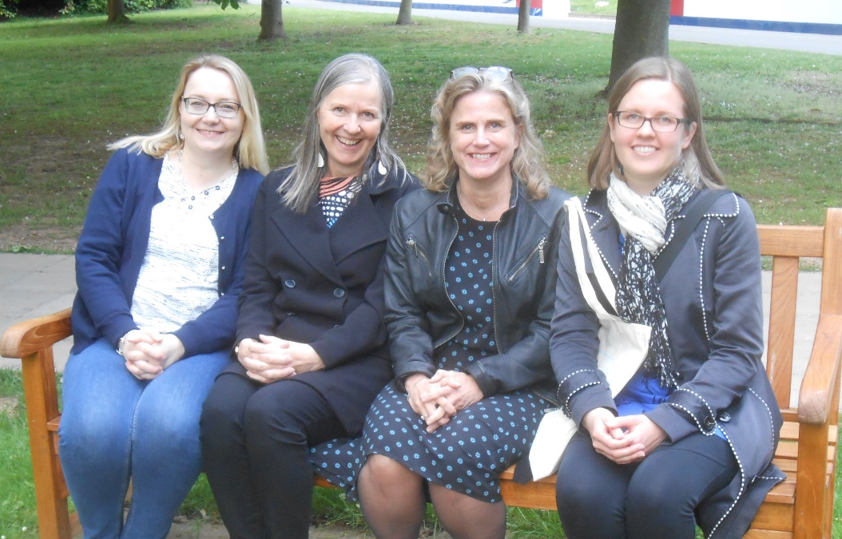
Ella Viitaniemi, Arja Rantanen, Malin Lennartsson and Miia Kuha
presented research on Scandinavian parishes in Panel 3.
Finally, the four papers dedicated to Sweden and Finland provided a helpful comparative element. During the general discussion, the similarities and differences between England, Scotland, Sweden and Finland moved to the centre of attention. The question of how and why certain languages were used for particular documents, for example, was raised. Multiple languages were used in documents both in the British Isles and Scandinavia: Finnish and Swedish in Finland, Latin, English and Gaelic in England and Scotland.
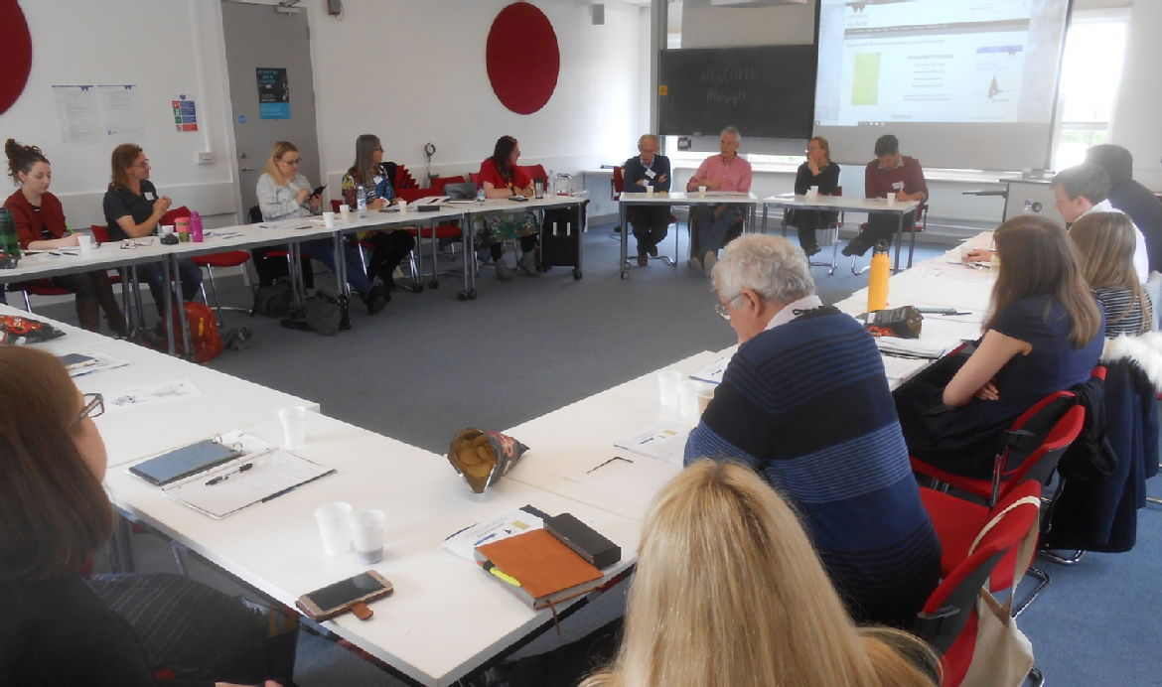
Concluding remarks and panel discussion led by Bernard Capp (Warwick), Andrew Foster, Elizabeth Tingle (De Montfort) and Chris Langley (Newman).
For further Symposium resources and general information on Parish Network activities please visit the Parish Network homepage at http://warwick.ac.uk/my-parish.
Pictures: Beat Kümin

