Seventeenth Warwick Symposium on Parish Research

University of Warwick, Humanities Building, 18 May 2019

‘Parish Participation’

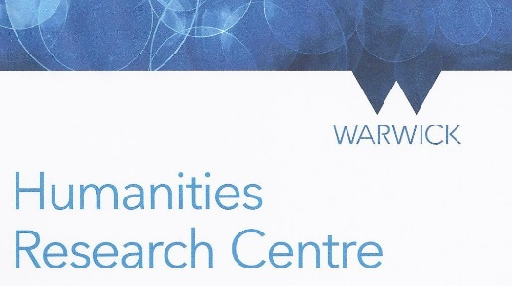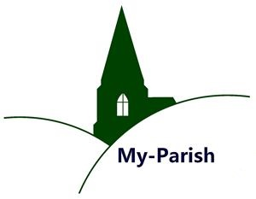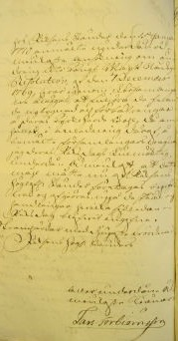

10.30–11.00 Registration & coffee (Humanities, Floor 4, Graduate Space)

11.00–11.15 Beat Kümin (Warwick): Introduction (all sessions in H5.45)

11.15–12.00 PANEL 1 – OFFICERS & POLITICS, chaired by Andrew Foster (Kent)

Dave Postles (Hertfordshire): Parish office-holding: some sceptical reflections

Donald Spaeth (Glasgow): Parish politics and the names of parish officers –
What lay beneath the ideal of neighbourliness?

12.10–12.55 PANEL 2 – DUTIES & TENSIONS, chaired by Bernard Capp (Warwick)

Helen Gair (Nottingham Trent): Parish participation and the church court –
Kirk session discipline in sixteenth-century Perth

John Morgan (Manchester): Participation in water management in early modern English
parishes

13.00–14.00 Lunch (Graduate Space, Fourth Floor Annexe)

14.00–15.30 PANEL 3 – PARISH ENGAGEMENT IN EARLY MODERN SCANDINAVIA
chaired by Elizabeth Tingle (De Montfort)

Malin Lennartsson (Linnaeus): Swedish parish records in comparative perspective

Miia Kuha (Jyväskylä): Negotiating parish affairs in court – Encounters of parishioners
and authorities in late seventeenth-century Eastern Finland
Arja Rantanen (National Archives of Finland/Jyväskylä):
Parish scribes, local administration and political culture

Ella Viitaniemi (Tampere): Active middle men, enlightened reformers? The agency of deans
in the late eighteenth-century Swedish realm / Western Finland

15.30–16.15 Tea

16.15–17.00 PANEL 4 – POVERTY & CHARITY, chaired by Chris Langley (Newman)

Joe Chick (Warwick): Chronic relief – Parishioners and poverty in fifteenth- and sixteenth-
century Reading

Marion Hardy: ’Heaven is the reward of charity’ – Benefactors and their parish charities

17.00–18.00 Concluding remarks, general discussion and wine reception

Further info: http://warwick.ac.uk/my-parish/parishsymposia/2019participation/
Contact: b.kumin@warwick.ac.uk / Pic: Swedish Parish Petition (1771). Riksarkivet.

