Eighteenth Warwick Symposium on Parish Research

Remembering the Parish

University of Warwick, Humanities Building, Saturday 16 May 2020, 10.30am-6pm

CALL FOR PAPERS

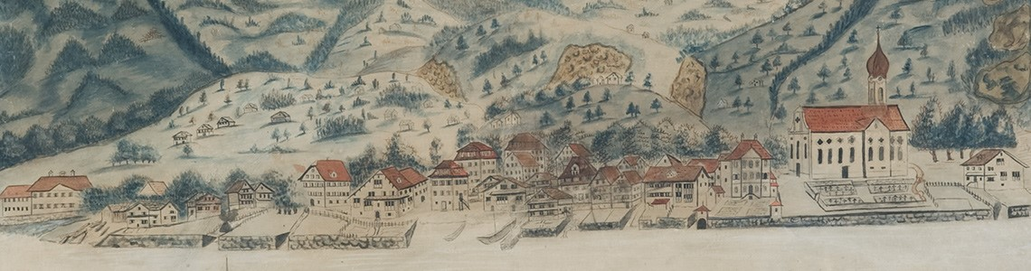

The 2020 Symposium of the Warwick Network for Parish Research addresses the theme of remembrance very broadly defined. Contributions might explore ‘lost’ parishes or churches, the evidence from chronicles, reminiscences about particular communities / characters / rituals, conceptual approaches to local memory, case studies of monuments, buildings or landscape features, long-term transformations, visualizations of architectural aspects or settlement evolutions, source editions or other related topics.

We have been fortunate to secure keynote addresses by:

Stefan DORNHEIM (Dresden)
Confession and Memory. The Lutheran Parsonage as an Agency of Remembrance

Nicola WHYTE (Exeter)
Remembering the Parish Landscape
The Parish Network now invites proposals from postgraduates, postdocs, faculty and independent scholars researching any aspect of ‘parish remembrance’. We can offer speakers free registration and complimentary lunch / refreshments during the day but delegates have to make / cover their own travel arrangements.
Please send 1-page abstracts for 15-minute papers together with a short biographical note
to b.kumin@warwick.ac.uk by Friday 28 February 2020.
For further information contact Beat Kümin (b.kumin@warwick.ac.uk) and visit:
http://warwick.ac.uk/my-parish/parishsymposia/2020remembering/.
We gratefully acknowledge the support of Warwick’s
Humanities Research Centre & European History Research Centre.
Damian Camenzind, ‘Prospect of Gersau’ (1813). By kind permission of Gersau District Council.
