Eighteenth Warwick Symposium on Parish Research

Remembering the Parish

Webinar on Saturday 7 November 2020, 10.00 am – 6 pm

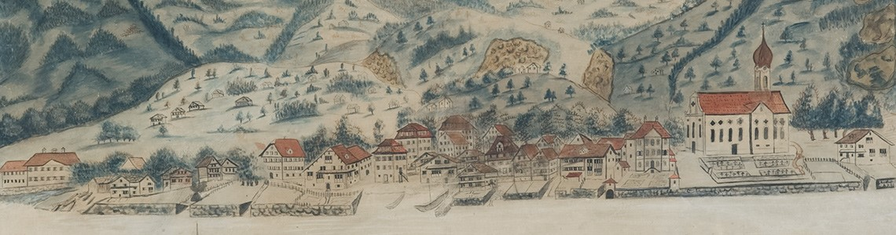

10.00–10.15 Welcome & organization
10.15–11.15 KEYNOTE ADDRESS, chaired by Beat Kümin (Warwick)
Nicola Whyte (Exeter), Remembering the Parish Landscape
11.20–12.20 PANEL 1 – BUILDINGS, chaired by Marjolein Schepers (Brussels/Ghent)
Lydia Fisher (Exeter), Removed and rearranged: Recovering medieval stained glass from 19thC accounts
Michael Roth (Heidelberg), Church foundation stones as time capsules in an early modern European perspective
Michael Sewell (Essex), Use of siege ruins in Colchester in the long nineteenth century
12.30–13.10 PANEL 2 – COMMUNITIES, chaired by Joe Chick (Warwick)
Mary Carrick (Independent), A very peculiar parish: Wawne, also Waghen in Holderness, East Yorkshire
Alexander Hutton (King’s, London), Remembering and forgetting the English historic county since 1945
13.10–14.00 Lunch Break
14.00–14.50 PANEL 3 – RECORDS, chaired by Andrew Spicer (Oxford Brookes)
John Craig (Simon Fraser), Record keeping and remembrance in early modern London parishes
Stanisław Witecki (Kraków), Recollections of 18thC everyday life in egodocuments of Polish-Lithuanian priests
15.00–16.00 PANEL 4 – REVOLUTION, chaired by Andrew Foster (Kent)
Ian Atherton (Keele), Remembering the English Civil Wars in parish registers
Fiona McCall (Portsmouth), The wickedly wicked times: loyalist memories of the interregnum parish
Imogen Peck (Coventry), Veterans, commemorations and the politics of the parish in early modern England
16.00–16.20 Tea break
16.20–17.00 PANEL 5 – ENVIRONMENTS, chaired by Maria Tauber (Warwick)
Hannah Reeve (Newcastle), Perambulation in Yorkshire: Boundary beating in the long eighteenth century
Hàìghlèàgh Winslade (Winchester), Parish churches in the downland and their connections to the landscape
17.00–18.00 GENERAL DISCUSSION AND OUTLOOK, introduced by Nicola Whyte

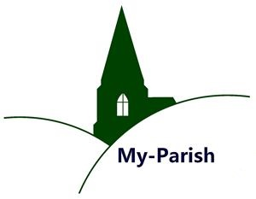
Pic: Damian Camenzind, ‘Prospect of Gersau’ (1813), by kind permission of Gersau District Council.

